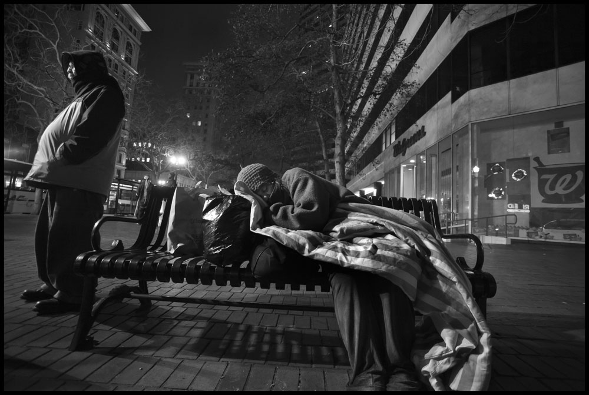

Alameda County Health Care for the Homeless Program

Health Care Needs Assessment of
Persons Experiencing Homelessness in Alameda County

2014-2015

Cover Photo ©2015 by David Bacon

This project was supported by the Health Resources and Services Administration (HRSA) of the U.S. Department of Health and Human Services (HHS) under grant number H80CS00047 Health Center Cluster grant amount $2,939,000. This information or content and conclusions are those of the authors and should not be construed as the official position or policy of, nor should any endorsements be inferred by HRSA, HHS or the U.S. Government

Executive Summary
In Alameda County, at least 4,300 persons experience homelessness on any given night, and at least 18,000 persons – over 1% of Alameda County residents -- will experience homelessness during the year. The causes of homelessness are based primarily on structural factors: a lack of affordable, adequate housing worsened by economic, health and social disparities -- in other words, a safety net that permits millions of persons to fall to the streets. Individual factors that push people towards homelessness include poverty, mental illness, substance use, disability, injury and illness, and family instability.
Patient data from this Alameda County Health Care for the Homeless Program needs assessment supports national findings that persons experiencing homelessness have much higher premature morbidity and mortality than the housed population, and experience higher rates of chronic diseases, mental disorders, substance use, communicable diseases and functional and behavioral impairments than housed persons.
Because of high levels of serious health conditions among the population of persons experiencing homelessness, and the high costs of uncoordinated treatment, there is an urgent need to address the health care needs of persons experiencing homelessness. Simultaneously, recognizing that housing is health care, we must address the underlying reasons for homelessness itself.
This report presents Needs Assessment findings of the Alameda County Health Care for the Homeless Program, carried out in 2014-2015. The goal is to identify health care capacity and deficits, and improve coordination for care and resources for persons experiencing homelessness, within our larger goal of ending homelessness in Alameda County.
Major findings include:
- Homeless persons are experiencing levels of mortality and morbidity at rates much higher than the general population.
- While an increasing number of homeless persons are gaining medical insurance, there are significant barriers to accessing primary, behavioral and specialty health care services, especially services specifically tailored to the complex needs of persons experiencing homelessness.
- Emergency rooms are still the most frequent – and the most expensive – source of medical care for persons experiencing homelessness. Emergency room and hospital-based treatment are inefficient and extremely costly manners to solve complex health conditions compounded by homelessness.
- Persons experiencing homelessness are growing older, averaging 50 years of age. Aging homeless persons suffer from age-related conditions similar to a housed population 20-30 years older than them.
- Stakeholder interviews reveal a great deal of fragmentation among the many county-wide providers who care for homeless persons. Persons experiencing homelessness interact with hospitals, social service agencies, HMO payers, nursing, criminal justice system, city outreach staff, outpatient clinics, free clinics, shelters and service providers, without sufficient coordination or adequate resource-sharing.
- While on a county-wide level, mental health services and access are improving, the high level of mental health needs among homeless persons means a great shortage of integrated mental health services.
- Substance abuse interventions and resources are hard to access, fragmented and not aligned with emerging and best practices for persons experiencing homelessness.
- There is a need for increased medical respite. Thousands of persons experiencing homelessness are released from area hospitals onto the streets, exacerbating their health conditions and making re-admittance and mortality more likely. Yet only 18 medical respite beds exist in the county.
- Even with expanded Medi-Cal and Denti-Cal enrollment, there is a great need for increased capacity and access to dental services for persons experiencing homelessness.
Recommendations
- Expand availability of Housing First-based permanent housing for persons experiencing both episodic and chronic homelessness, with housing coordination located throughout the system of care throughout all regions of Alameda County.
- Ensure that dedicated access to services specific to persons experiencing homelessness is expanded at primary care, mental health, dental, substance use and benefits programs throughout the county.
- Expand care coordination throughout the system of care, including hospitals, emergency departments, social services, criminal justice, housing providers, mental health, substance use treatment, etc. In addition to coordination of care, it is critical to track and account for costs (and cost savings) related to care of persons experiencing homelessness.
- Expand Permanent Supportive Housing combined with appropriate Critical Time Intervention and Assertive Community Treatment for persons with high needs (especially aging, vulnerable behavioral health, and chronically ill populations).
- Expand coordinated street outreach services to identify and support vulnerable unsheltered persons living in streets, encampments, cars, etc.
- Expand countywide training approaches to develop the capacity of homeless programs and staff to implement and provide evidence-based practices (EBPs) and emerging best practices in the field of homeless health care and housing services.
- Introduce targets relating to the health of homeless persons in local health plans, including financial targets to support programs addressing homelessness in medical and behavioral care.
^{Photo © 2015 David Bacon}

Table of Contents:

Page | Chapter
3 | Executive Summary and Recommendations
5 | Table of Contents
6 | Chapter 1: Introduction and Methods
8 | Chapter 2: Findings: Demographics and Root Causes of Homelessness in Alameda County
12 | Chapter 3: Findings: Prevalence of Homelessness in Alameda County
18 | Chapter 4: Findings: Health Issues of Persons Experiencing Homelessness
22 | Chapter 5: Findings: Key Subpopulations Among Those Experiencing Homelessness
32  34  36 | Chapter 6: Findings: HCH Survey of Persons Experiencing Homelessness  Chapter 7: Findings: Stakeholder Interviews  Recommendations and Priorities
 | Appendices:
40 | Appendix 1: Alameda County Homeless Resources Maps and Descriptions
56 | Appendix 2: HCH Patient Survey Results
63 | Appendix 3: Health Care Utilization by Homeless Persons in Alameda County
76 | Appendix 4: Key Barriers and Health Indicators among Persons Experiencing Homelessness (HRSA Required Needs For Assistance indicators)

Chapter 1:
Introduction & Methods

Background
Alameda County Health Care for the Homeless Program (ACHCHP) is a Health Department-based 330(h) Health Care for the Homeless Program operating with Federal HRSA/BPHC Health Center 330(h) funding since 1988. ACHCHP’s target population is persons experiencing homelessness throughout the entire Alameda County. ACHCHP ensures that health care services, including primary care, dental, mental health, recovery and case management services are available to persons experiencing homelessness. Under federal HRSA/BPHC regulations, ACHCHP is required to demonstrate and document the needs of our target population, updated as appropriate.
Focus of Needs Assessment
This Needs Assessment is designed to support ACHCHP’s mission of improving the health status of homeless persons throughout Alameda County, and will be used to inform community planning and mobilization in our common goal of ending homelessness in Alameda County.
The 2014 ACHCHP Needs Assessment has four areas of focus:
  - Estimate the yearly prevalence of homelessness in Alameda County;
  - Describe key demographics and subpopulations among those experiencing homelessness;
  - Map and describe the key health care resources and utilization by persons experiencing homelessness;
  - Identify health care needs and barriers faced by persons experiencing homelessness.
Methods
The population of persons experiencing homelessness is very heterogeneous, and data sources are varied, and even definitions of homelessness differ according to sources. In order to assess health care services among homeless persons residing in Alameda County we used a variety of data sources, both primary data and existing (or secondary) data:
- Prevalence of Homelessness: To determine the total numbers of persons experiencing homelessness in Alameda County and broadly describe demographics of the overall population, we used the four following sources of data:
- Alameda County Point In Time Homeless Count (2013)
- Alameda County HMIS homeless services utilization data (2013)
- Countywide UDS health care utilization data (2013)
- Alameda County School District homeless student data (2013)

- Homeless Demographics and Subpopulations: In describing and highlighting the key demographics and subpopulations among persons experiencing homelessness, we have drawn from the following studies:
- HOPE HOME Study of Aging Homeless in Oakland UCSF 2013-2015 (a study of persons 50+ and over experiencing homelessness.
- RTI Urban Health Study II 2011-2013 data set (a study of active drug users in the East Bay)
- Inside the Social Safety Net, a 2013-2014 evaluation of the General Assistance program carried out by Roots Community Health Center on behalf of Alameda County Social Services Agency
- Alameda County AIDS Housing Needs Assessment 2014, produced by Spiegelman and Associates for the Alameda County Community Development Agency and Housing and Community Development Department.
- Area-specific homeless utilization and recommendations from Livermore Mayor’s Summit on Homelessness (5/2014), and Eastern Alameda County Human Services Needs Assessment carried out in 2011, and the April Showers homeless services survey in San Leandro 2013.

- Utilization and Services: To describe utilization of community health care resources by persons experiencing homelessness in hospitals, emergency departments, community clinics, etc., we utilized the following sources of care utilization data:
- California Office of Statewide Health Planning and Development (OSHPD) hospital discharge utilization data (2011-2013)
- Alameda Health System ambulatory care and psychiatric homeless utilization data (2013-2014)
- Alameda County Medically Indigent Care Reporting System (MICRS) utilization data (2012-2013)
- ACHCHP UDS health care utilization data (2012-2013)
- Community assets mapping carried out by HCH staff Oct/Nov 2014 compiling current homeless health care resources.

- Needs and Barriers: Primary source data was created to identify and articulate the needs and barriers experienced by persons experiencing homelessness. This was done in two ways:
- Survey of 150 persons experiencing homelessness, and receiving (or not receiving) ACHCHP services at locations throughout Alameda County
- Stakeholder interviews of 14 key homeless services providers, including health care, shelter, outreach and housing providers.
Staff of the Community Assessment Planning and Evaluation unit of the Public Health Department supplied additional demographic and statistical data, as well as providing support in methodology, secondary sources analysis, and the carrying out of surveys.

Chapter 2:
Alameda County Demographics and Root Causes of Homelessness
- Alameda County:
Alameda County covers 739 square miles and extends from the San Francisco East Bay to the rim of the California Central Valley. The County shares borders with Contra Costa, Santa Clara and San Joaquin counties and the San Francisco Bay, has rugged rural reaches, and agricultural expanses as well as densely-populated urban centers. And no area of the County—a mix of urban, suburban and semi-rural communities—is untouched by homelessness. Dense urban cities such as Oakland, Berkeley, Fremont, Hayward, and Newark are just a few of 14 cities and unincorporated areas served by the Alameda County Health Care for the Homeless Program (ACHCHP).
The County is noted for its geographical, economic and ethnic diversity, with almost two-thirds of its population being ethnic minorities. Alameda County’s 2013 population of 1,578,891 has grown 9.4% from 2000, making it the 7th most populous county in the state. The most recent U.S. Census data report that non-Hispanic Whites make up 34 percent, Asian & Pacific Islanders 29 percent, Latinos 23 percent, Blacks 13 percent, and American Indians and Alaska Natives 1 percent of the county population. Females comprise 51 percent and males 49 percent of the population. Approximately 43 percent speak a language other than English at home (U.S. Census Bureau 2012). Between 2000 and 2010, there was an increase in the number of Asian/Pacific Islanders and a decline in the number of Black/African Americans in Alameda County.
Alameda County is best characterized by high levels of social and economic disparity and a high level of racial residential segregation (See Figure 1). More people live below the poverty level in Alameda County than in any other Bay Area community .Ninety-one percent of the residents of very low income neighborhoods in the county are people of color. Local communities of formerly migrant seasonal farm workers, some newly arrived and some more solidly established, continue to grow. Some of the highest rates of home foreclosures in the US are combined with some of the nation’s highest rental and housing costs. Increasing employment, health and educational disparities create systematic exclusion from health care for poor and working-class persons — in close proximity to some of the best medical resources in the world.
Alameda County contains seventeen HRSA-defined Medically Underserved Areas (MUAs) and at least fourteen Medically Underserved Populations (MUPs). These are locations and populations lacking access to basic primary care, mental health and dental health services—especially in the southern regions of the county.
Neighborhood and Population Poverty and Health
In Alameda County, neighborhood poverty and health outcomes are very closely related, showing a clear social gradient in health. With each increase in neighborhood poverty, there is a decline in life expectancy (Figure 2). There is a nearly seven year difference in life expectancy between the affluent neighborhoods and those with very high poverty in the county (Figure 2). Mortality and morbidity rates for conditions such as hypertension, asthma, stroke, heart disease COPD, diabetes, are significantly higher in lower income neighborhoods than more affluent neighborhoods across the county.
Figure 1  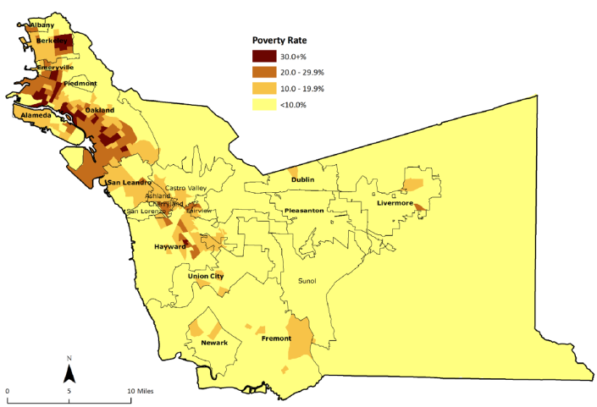 | Figure 2  Alameda County Life Expectancy by Neighborhood Poverty Level—A Social Gradient in Health  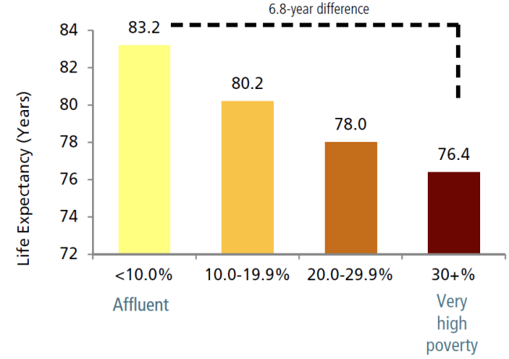
Source: CAPE Unit Alameda County Public Health Department
Root Causes of Homelessness in Alameda County
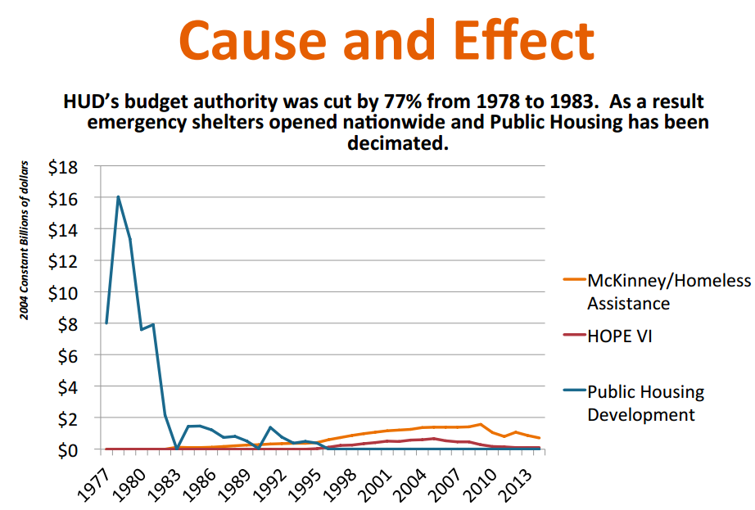
In Alameda County as throughout the United States, an ongoing history of discriminatory policies and practices tied to race, ethnicity, and socioeconomic status has produced differences in access to resources like housing, and opportunities for health across neighborhoods. Intentional policies and systemic conditions-- like mental health deinstitutionalization, discriminatory mortgage underwriting, redlining, income disparity, unemployment and underemployment, cuts to safety net and health programs, unequal school systems, tremendous growth in the penal system targeting of communities of color -- have created the conditions for concentration of poverty, housing instability and homelessness especially among poor communities of color.
Figure 3
Nationally, homelessness was legislated through government policies beginning in the 1970’s, as the federal government dramatically decreased its role in providing housing and safety net programs, slashing HUD budgets by 77% between 1978-1983 (See Figure 3). The widespread emergence of homelessness was viewed as a temporary local problem which would be corrected by market forces, emergency shelters and homeless assistance programs. These efforts have failed to address the underlying problem of insufficient funding for low-income housing.
Source: Without Housing, WRAP 2014
Current Housing Burden in Alameda County
In 2013, Alameda County had a affordable housing shortfall of 58,480 units, meaning that there are only 36,000 low income units available for the 100,000 (60,905 extremely low-income and 40,000 very low-income) neediest households in the County. From 2013-2014, only 2,000 new housing units were built countywide (almost all not affordable), while between 2010 and 2014, over 100,000 new residents moved to Alameda County, either drawn by high tech jobs or forced out of San Francisco.
Rising rents and Bay Area-wide gentrification are increasing the burden on low-income renters in Alameda County (Figure 4 and Figure 5): Oakland had the highest rent increases in the United States at 9.1 percent in 2014, with mean 1 bedroom rents now at $1,934, a 41% increase since 2010. 13.2% of the county population (208,413) lives below the federal poverty level. This includes 53,547 persons living on SSI ($877/month) and 21,000 persons receiving cash assistance such as General Assistance or TANF. Recession-related foreclosures resulted in 25,000 homes lost in Oakland between 2007 and 2012, not just affecting homeowners, as 40% of persons evicted due to foreclosures were tenants.
Figure 4  Percentage of renters paying 50%+ of their Income for Housing  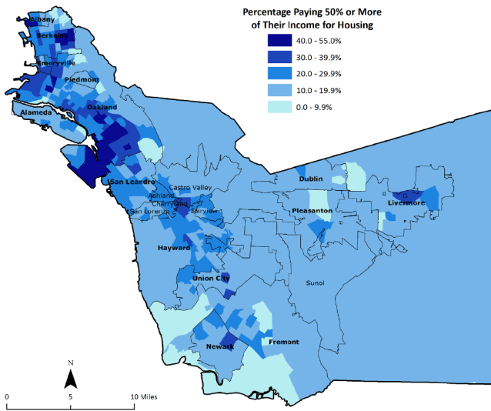  Source CAPE, 2014 | Figure 5  Stages of Gentrification – Oakland 2014  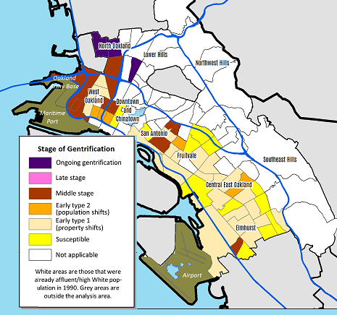  Source Causa Justa, 2014

Even as Alameda County’s shortfall of affordable homes has become more acute, the State of California has reduced its direct funding for affordable housing dramatically. State Housing Bonds are exhausted, meaning the elimination of tens of millions of dollars in investment to provide homes to low- and moderate-income households in Alameda. The elimination of Redevelopment funds led to a loss of more than $56.7 million annually in local investment in the production and preservation of affordable homes in Alameda County. Exacerbating the state cuts are continued cuts in affordable housing by the federal government. Cuts to HOME and Community Development Block Grants (CDBG) have resulted in the loss of another $8.7 million in county funding. This adds up to an 89% decrease in state and federal funding for affordable homes in Alameda County since 2008.

Chapter 3
Findings: Prevalence of Homelessness in Alameda County
Homeless Prevalence in Alameda County
Accurately determining the number of persons experiencing homelessness is complex and political, with risk of underreporting and differing definitions of homelessness. Methods used to count homeless persons include: Point-in-time count or PITC, a count the number of homeless persons in a given point in time; and Homeless Services Utilization Count, of which we look at the numbers of persons who received homeless services (health care and housing/support services and school homeless services). Through these data sources we can develop an estimate of the number of people who experience homelessness over a given period of time (period prevalence count). Finally a Homeless Registry can be utilized to gathering detailed, person-specific data about persons experiencing homelessness that service providers can then use to expedite housing, determine the scope of homelessness, and track changes over time.
Definitions of Homelessness
There are three federal definitions of homelessness, each depending on funding source:
Entity: | HUD – Department of Housing and Urban Development | HHS/HRSA | Schools/Department of Education
Funding Source applied to: | HUD housing, Supportive Housing Programs, Emergency Solutions Grants, Shelter+Care, HMIS data system | Health Center programs including HCH Program and FQHC Community Health Centers. | Eligibility for school district-based support services for homeless students.
Reference: | 24 CFR Parts 91, 582, and 583 | Section 330 of the Public Health Service Act (42 U.S.C., 254b) | McKinney-Vento Act Sec. 725(2); 42 U.S.C. 11435(2)
Definitions including places or place of residence: | - Streets or places unfit for human habitation  - Shelters or transitional programs  - Fleeing from domestic violence  - About to be evicted  - Does not include persons who are doubled up in an unstable situation | - Streets, shelters, programs, and includes persons who are doubled up in an unstable situation. | - Streets, shelters, programs, and includes families who are doubled up due to lack of alternative accommodations.

Alameda County Point In Time Count January 29, 2013:
Beginning in 2003, Alameda County HCD has conducted a point-in-time biennial Homeless Point In Time Count (PITC) per HUD mandate. The PITC data and analysis is available at http://www.everyonehome.org/resources_homeless_count.html. The last PITC was held on January 29, 2013. On that night, surveyors identified 4,264 persons as experiencing homelessness. Of those, 1,927 were sheltered (living in shelters or transitional housing) and 2,337 persons were identified as unsheltered, living on streets, cars or places unfit for human habitation (Figure 6).
Alameda County’s 2013 Point In Time Count uses a methodology based on the federal Housing and Urban Development (HUD) definition of homelessness. HUD’s definition excludes persons in precarious living situations, sleeping on floors or couches of families or others, living day-to-day or week-to-week in motels or SROs, in tenuous overcrowded situations, or trading sex for shelter. Persons in these homeless situations, defined as homeless by HRSA and Department of Education, are not represented in these counts.
Figure 6
The Point In Time Count does not include in its count unsheltered homeless persons living out of sight, not using support services, and who cannot be identified to participate. These are the hardest to reach groups. Point-in-time counts overestimate chronic homelessness and underestimate short periods of homelessness such as persons and families whose homelessness is episodic.
Source PITC, 2014
The Point In Time Count counts those experiencing homelessness on a single night. To estimate how many persons will experience homelessness throughout the year, extrapolation is utilized. According to HUD, multiplying the PITC number by 2.45 would produce an estimate of total persons experiencing homelessness as defined by HUD criteria, or 10,452 persons. According to analysis published by the Urban Institute (2000), multiplying the PITC single night count by a low of 4.15 to a high of 5.18 can give a rough estimate of yearly prevalence of homelessness, under an expanded HRSA definition. This suggests that between 17,695 persons and 22,087 persons experienced homelessness (as defined by HRSA) in Alameda County in 2013

Homeless Services Utilization Count: Homeless Management Information System (HMIS)
Utilization of homeless services is another way to estimate the total number of homeless persons. Since 2003, Alameda County HCD has implemented a County-wide Homeless Management Information System (HMIS) as a requirement for recipients of HUD funding. Many, but not all, county homeless shelters, housing and services providers input utilization data into the HMIS. Homelessness is defined using the narrow HUD criteria (not including persons that are doubled up). Alameda County Housing and Community Development counted a total of 9,978 persons utilizing HMIS services for 2013.
In addition to undercounting the doubled-up and hidden homeless, not eligible for many services, this number likely undercounts the number of persons who denied homeless services for other reasons, those who do not seek services, and services providers who do not report data in the HMIS system.
A broad overview of demographics of these 9,978 persons experiencing homelessness who utilized county HMIS homeless services in 2013 is in Figure 7. This population is 55% male, disproportionally (57%) African American, over half have medical insurance, a third have zero income, and 15% have employment income, and the average age is just below 50 years old. 18% of the households are families with children, 82% single persons..
Figure 7

Source HMIS, 2014

Homeless Services Utilization Count: Homeless School Count
The School Count is a method to include homeless families that normally do not access shelters, are more likely to be doubled up or living in motels, and are not likely to be counted in a Point In Time Count. The McKinney-Vento Act provides support services for homeless children attending public and charter schools throughout Alameda County .
Figure 8
The Alameda County Office of Education collects data on homeless students from 17 school districts and charter schools in the County. The total count for 2013 was 4,573 students registered as homeless (See Figure 8). This is an undercount, as it does not include children not enrolled in public preschool programs, and homeless children and youth not identified by school officials.
Although all these 4,573 school children were eligible for educational assistance, 76% of them are ineligible for HUD-funded shelter, short-term or permanent housing programs, as they are living in doubled-up or in a motel, and do not fit HUD/HMIS criteria for homelessness.
Source ACOE, 2014
According to HMIS homeless utilization data (shelters, support services), 38% of children in families meeting HUD homeless criteria are under age 5, and not of school age. Thus the true count of homeless children is higher, or 7,376 children aged 0-18. Assuming that there is an average of 2 children per family, and an estimated 50% of these families headed by a single parent, there are at least another 5,531 adults living with the homeless children. Based on the 2013 Homeless School Count, an estimated 12,908 persons living within family units (including parents and children under 18 years) experienced homelessness in Alameda County in 2013. Again, this number includes only those living in family units, and does not include single persons.
Finding: Homeless Prevalence in Alameda County 2013
Following the HHS definition of homelessness (including doubled-up persons), and utilizing the methodology used by Urban Institute, ACHCHP estimates that a minimum of 18,000 Alameda County residents experienced homelessness at some point during 2013. This number, likely an undercount, amounts to some 1.16% of the total Alameda County population.
Based on countywide HMIS utilization data capturing city of last residence, we can roughly estimate the total numbers of persons who experienced homelessness in 2013 by city in Alameda County (Figures 9 and 10):
Figure 9
Figure 10: Estimated yearly prevalence count of persons experiencing homelessness in Alameda County by city:
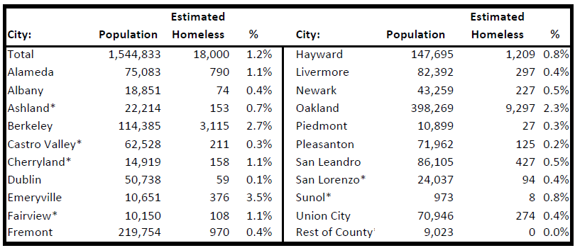

Homeless Registries:
Increasingly, communities are creating local homeless registries. These are detailed, by-name lists of persons living in shelters, cars and streets, as identified by outreach workers, volunteers and social services providers. A registry can be used to define the scope of homelessness, track changes over time, and most importantly, prioritize those most vulnerable and those at risk of dying on the street, to be connected with housing and services that meet their needs. Homeless registries are currently maintained in dozens of US cities, promoted by the work of 100K Homes campaigns throughout the country.
The Alameda County Behavioral Health Care Services, EveryOne Home and HCH Program have developed a pilot homeless registry for Alameda County, called Home Stretch. Home Stretch will build a single list of chronically homeless people prioritized by vulnerability, barriers to housing, and cost to other systems such as health care, social services and law enforcement through the use of a coordinated assessment. The prioritized list will be used to match highly vulnerable homeless people to permanent housing and services more effectively than our current system. Referrals to this registry come from 30 different community partner agencies.
There are 259 persons currently on the Home Stretch list. These persons are all chronically homeless, 60% men, with an average age of 48 years, and 82% have a history of involvement with county behavioral health (mental health and substance use) services. 50% of persons on the Alameda County Home Stretch list have been homeless for over than 5 years.

Chapter 4
Findings: Health Care Issues of Persons Experiencing Homelessness
Mortality and Morbidity
Findings from nationwide studies show that mortality (rates of death and premature death) and morbidity (rates of disease) are substantially increased among persons experiencing homelessness. Death rates for persons experiencing homelessness vary, but typically are 3-4 times those of the general population . This is especially noteworthy for example, among younger homeless women, who have from 4 to 31 times a greater risk of dying compared to similarly aged housed women, and persons recently released from prison, who experience a 5-7 times higher rate of death. Most frequent causes of death for persons experiencing homelessness include heart disease, opiate overdose, and violence and unintentional injuries.
Homeless Death Counts – Dying on the Streets
The Alameda County Coroner’s office presently does not record homeless/housing status of decedents, making it hard, though not impossible, to determine how many persons are dying while homeless in Alameda County. Many other health departments (Sacramento, Seattle, Portland, Denver, Philadelphia, NYC, and Santa Barbara) maintain and produce annual reports of deaths of persons experiencing homelessness, and analyze this data to develop community responses. Below are statistics from a few localities:
Locality | Time Period | Amount of deaths
Sacramento, CA | 2003-2013 | Average 46 per year
Seattle King County, WA | 2010 | Average 60 deaths/year
Denver, CO | 2012 | 140 deaths in 2012
Portland, OR | 2011 | 47 deaths
Santa Barbara, CA | 2009-2011 | Average 49 deaths/year

Most homeless death counts are carried out by Medical Examiners who only analyze deaths of individuals who appear to have died from specific causes or circumstances such as accidents, toxic substances, or outside of medical care (at home or on streets), and do not include persons experiencing homelessness who die under medical care of a physician. As such, the most frequent causes of deaths on the streets include substance abuse/overdose, unintentional injuries, suicide and homicide.
Health Problems of Persons Experiencing Homelessness in Alameda County
Conditions experienced by homeless persons on the streets or in shelters often exacerbate existing health conditions, or create new ones, and complicate medical treatment plans. It has been well documented that homeless people experience health problems at rates higher than housed people. Poor diet, substance use, chronic daily stress and exposure to the elements increase displaced people’s risk for complications of chronic illness and premature mortality. Health conditions requiring regular, uninterrupted treatment, such as diabetes, hypertension, tuberculosis, HIV, addictions, and mental illness, are extremely difficult to manage without a stable residence.
Medical Conditions among Persons Experiencing Homelessness
Site of Service | HCHP Mobile Clinics (street shelter, TRUST Clinic)  2012-2013 | HCHP Contracted Clinics 2012-2013 | AHS Highland Emergency Dept  2014 | Alameda County Hospitalization Data  2011-2012
Rank
1 | Mental Health Involvement | Hypertension | Injuries/Violence | Mental Health Hospitalization
2 | Respiratory infections | Diabetes | Mental Health Involvement | Skin and tissue infections/disorders
3 | Musculoskeletal Pain | Musculoskeletal Pain | Alcohol/drug-related | Respiratory
4 | Dental Problems | Women’s Issues | Musculoskeletal | Circulatory/heart
5 | Podiatry/Foot | Respiratory related | Hypertension | Alcohol/drug-related
6 | Hypertension | Mental Health involvement | Pain/Chronic Pain | Gastrointestinal
Source HCH Data 2014
The above lists the six most common health problems seen by medical providers treating persons experiencing homelessness at HCH mobile clinics, HCH contracted clinics, the Highland hospital Emergency Department and at countywide hospitals. Among the most common health problems for adult men and women were mental health and substance abuse related disorders. However, mental health and substances use are generally not the primary reasons that clients sought medical care, as infections, pain and other issues are often primary reasons, especially in mobile clinic settings.
Prevalence of Selected Conditions:
The below findings are selected health conditions of particular importance and impact upon persons experiencing homelessness. These and other conditions are explored in more detail in APPENDIX 3.
- Diabetes: The HCH Program estimates that approximately 16% of persons experiencing homelessness in Alameda County suffer from diabetes, over twice the rate of the county general population. This rate is estimated according to the racial, class and socioeconomic makeup of persons experiencing homelessness in Alameda County, as well as compounding factors such as diet, stressors, drug and alcohol use.
- Hypertension: The rate of hospitalization for hypertension for persons experiencing homelessness is twice the county baseline rate. A high number of homeless persons are tobacco smokers, and have diet and weight issues. An estimated 50% of homeless persons are thought to have high blood pressure, and 35% of homeless patients surveyed by the HCH Program identified hypertension as a health issue for them.
- Tobacco Use: A strong downturn in tobacco use in Alameda County is not reflected in the population of persons experiencing homelessness. An estimated 80% of persons treated by the HCH program are current smokers, as compared to 11.7% countywide.
- Depression and Other Mental Health conditions: The HCH Program estimates that at least 50% of the population of persons experiencing homelessness has had at least one major depressive episode in the past year, as compared to approximately 9% of the general population who have experienced severe psychological distress in the past year. 53% of HCH survey respondents reported that they cannot access mental health care when needed.
- Substance Use: In the 2013 Point In Time Count, 73% of homeless persons who reported substance abuse were unsheltered, living on the streets. Substance misuse is involved in at least 25% of homeless ED visits, and substance use was the single most common factor involving the top 20 high ED utilizers. Significant barriers to care exist, with 48% of HCH patients surveyed reporting that they couldn’t access substance abuse services when needed.
- HIV Infections: Although HIV seroprevalence is about 0.33% of the total county population, the amount of persons experiencing homelessness with HIV in Alameda County is twenty times higher, or around 4.3%
- Oral Health: Through client surveys and chart reviews, the HCH Program estimates that 70% of persons experiencing homelessness have not visited a dentist in the past year. Improved dental access was identified as a key concern of 60% of homeless patients surveyed by the HCH Program, and 40% reported current dental pain and problems.
- Age-related Conditions: As the homeless population ages, incidence of cognitive age-related conditions (functional and cognitive impairment, falls, urinary incontinence) increase dramatically. Homeless 50+ year olds have higher rates of age-related conditions than a general population comparison 20 years older .
- Unintentional Injuries: Unintentional injuries account for at least 10% of AHS ED visits, higher than the general housed population. Injuries include falls, assaults, burns, head injuries, poisoning, traffic injuries, and self-harm. Traumatic brain injury is an important category of unintentional injury in homeless population, and is thought to be a risk factor for both becoming homeless and remaining homeless.
The above conditions are explored in more detail in APPENDIX 3, Health Care Utilization of Homeless Patients, and in APPENDIX 4, Key Barriers and Health Indicators among Homeless Persons in Alameda County.

Chapter 5
Findings: Key Subpopulations of Persons Experiencing Homelessness
Identified in this needs assessment are subpopulations among the larger group of persons experiencing homelessness. The following key subpopulations and issues have been identified through studies, analysis of services and through interviews with providers.
- Aging homeless 50+years
- Persons with mental illness
- Persons using drugs and alcohol
- Indigent Persons receiving General Assistance
- Undocumented Persons/Day Laborers
- Persons with Criminal Justice System involvement
- Homelessness and food insecurity
- Homeless Youth
- Dental issues

Aging Homeless in Alameda County:
The HCH Program is a participant in the UCSF HOPE HOME Study, a longitudinal study of the health of persons 50+ who are experiencing homelessness. Researchers interviewed a cohort of 350 persons and followed 213 of them. Key findings emerging from this important study include the following:
- The average age of unsheltered adults in Alameda County has increased to 50 years – the number of persons who are over 50 years old and experiencing homelessness has quintupled since 1990 (Figure 11). On any given night, there are at least 1,500 persons aged 50+ unsheltered on Alameda county streets.
Figure 11
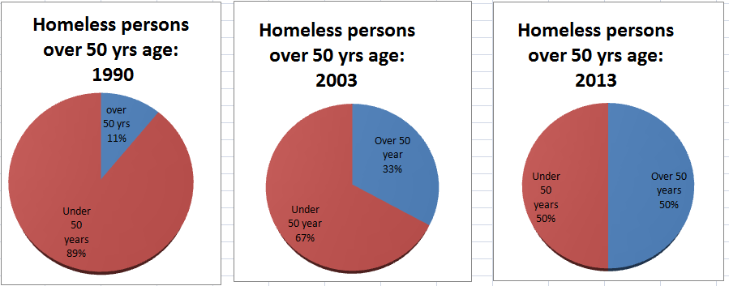
Source HOPE, 2014

- Contrary to the perception that older homeless people have been homeless for their entire adulthood, 40% of those surveyed were never homeless prior to their 50th birthday. This means that for a growing number of elders, specific circumstances: death of spouse or relatives, job loss, illness, are precipitating factors in becoming homeless.
- Persons 50+ experiencing homelessness have health problems similar to those 20-30 years older. Homeless 50+ year persons have much higher rates of chronic disease, disability, “geriatric conditions,” cognitive impairment, and hospitalizations than the general population of their age. Dental and oral health issues are of serious concern, tobacco, drug and alcohol use are high. Mental health conditions (depression, anxiety, psychosis) are very high, as well as histories of trauma (as both children and adults), and traumatic brain injuries. Some key health issues faced by 50+ persons experiencing homeless, identified in the HOPE HOME Study are listed on Figure 12:
Figure 12
Source HOPE, 2014

- Services directed at older adults should recognize that aging happens earlier in poverty populations: those 50 and older should be considered “older” for purposes of service provision.
- There are many opportunities for prevention of homelessness among older persons: those who are housed and in the workforce prior to age 50 and then experience a crisis (loss of job, death of family member or spouse) could likely be identified and offered stabilization services before homelessness starts. Others, with cognitive impairment, substance abuse and mental health problems will need more support: Supportive housing or other interventions will be appropriate
This study reinforces ACHCHP’s observation of a growing population of aging persons without housing – shut out of the work force, often disabled and unable to qualify for Medi-Cal or SSI disability income until age 62, frequently becoming homeless due to illness, loss of a job or death of a spouse or family member. At age 62 most persons qualify a social security income of $830/month – exactly the Federal Poverty Level but too much to qualify for food stamps – and not adequate to afford housing, food, utilities, transportation and health.
Although seniors 62+ qualify for subsidized senior housing, ACHCHP conducted a survey of county senior housing providers in 2014: 9 out of 10 of the county’s 137 low-income senior housing apartments had closed waiting lists, and the “open” 16 had waiting lists ranging from 2-8 years.

Mental Health Conditions and Homelessness: “The Walking Wounded”
According to the 2013 Point In Time Count, an estimated 20% of Alameda County’s homeless persons suffer from serious mental illnesses (SMI), including schizophrenia, major personality disorders, schizoaffective disorders, and serious bi-polar disorders are among the most common. This means on any given night, some 1,100 persons with SMIs are homeless in Alameda County. In past 10 years, the number of homeless with severe mental illness counted in the Point In Time Count has doubled. About 60 percent of persons with serious mental illnesses are unsheltered, sleeping on the sidewalks, in parks or wherever they can find a spot.
ACHCHP works closely with the Alameda County Behavioral Health Care Services (ACBHCS) and the Alameda Health System (AHS) to improve treatment, support services, access and housing opportunities for homeless persons with SMIs. ACBHCS has been the funding and implementation of Full Service Partnerships (FSP) – services-enriched supportive permanent housing – for homeless persons with SMIs.
There is not enough money for permanent, supportive housing for those with mental health issues. Funding from the Mental Health Services Act -- or Proposition 63, which passed in 2004 and placed a 1 percent tax on individual income of more than $1 million – was used to create permanent supportive housing in 2006 and 2007, but now much MHSA funding is being used to sustain supportive services, and new sources of housing funds have been cut in recent years.
There is a tremendous level of “lower-acuity” mental illnesses – including depression, anxiety, and other mood disorders – among persons who are experiencing homelessness. These conditions, although “lower-acuity,” are extremely debilitating, carrying tremendous impacts on physical health. Left untreated, homelessness can exacerbate these conditions, deepening physical and mental illness, isolation, and causing chronic homelessness. For patients using HCH clinical services, mental health services are not a first priority, but even still, mental health co-involvement is diagnosed very frequently, and is the sixth most common factor (behind hypertension, diabetes, musculoskeletal pain and dental issues) that HCH patients are treated for.
Until recently, in Alameda County, persons with low-acuity mental health conditions could not access County mental health services, as the program treated only persons diagnosed with severe chronic and persistent mental illness. The “walking wounded,” are estimated to be some 50% of the patients treated by ACHCHP – were left to try to patch together some sort of care as best they can, often with the help of ACHCHP case managers and clinicians. Their needs for intensive therapy, diagnosis and case management is provided by the ACHCHP TRUST Clinic. Additionally the ACBHCS is working with Community Health Clinic Network providers to strengthen the provision of integrated behavioral health care within a primary care setting for persons with “lower-acuity” behavioral health diagnoses.
Approximately 30-50% of lower-acuity mentally ill homeless are dually-diagnosed with co-occurring substance use disorders. There is a great shortage of recovery programs for homeless persons. At any given time, all of the 16 residential recovery programs are full, with waiting lists of up to 3-6 months for entry.

Drug and Alcohol Users
Persons experiencing homelessness are disproportionately affiliated with serious health problems, including the frequent use of alcohol and other drugs which heighten the morbidity rate among the population.
Interviews with homeless services providers reinforce the finding that the level and provision of adequate drug and alcohol recovery services in Alameda County at all levels has been insufficient, fragmented and in large part lacking important innovative and evidence-based treatment services such as: medical model treatment services, integrated mental health and substance use services, outreach services, peer-based recovery programs, supportive living environments, and intensive case management services.
In the 2013 Point In Time Count, 30% of homeless persons counted reported chronic substance abuse, and of those reporting chronic substance abuse, 73% of them, or 1,000 persons, were unsheltered on the night of the count. The percentage of persons experiencing homelessness that report chronic substance abuse in Alameda county has hovered around 30% for the past ten years.
The Urban Health Study II is a longitudinal study of 2,094 active drug and alcohol users in Oakland, carried out by RTI for UCSF. This study is still underway, and researchers shared data on the 51% (1,061) of the participants of the study who were experiencing homelessness. 32% of persons surveyed were living on the streets, cars or abandoned houses, 48% were doubled up, 8% in shelters or programs.
Some of the key lessons from this data include:
- Difficulties in accessing basic needs: The majority of homeless persons with drug and alcohol had difficulty in finding basic resources such as shelter, places to wash and use bathrooms, clothes and food. See Figure 13:
Figure 13

Source RTI 2014
- Tremendous criminal justice system involvement with persons experiencing homelessness: Almost everyone surveyed -- 99% of men and 89% of women -- had a criminal justice history; and over half of all persons surveyed – 61% of men and 46% women – had been arrested in the past year.
- Recent experiences of violence and trauma: 60% had learned a friend/relative/acquaintance was killed recently; 25% had witnessed a shooting; 13% had been the victim of assault; 11% of women had been sexually assaulted, 11% of men had been shot at (Figure 14):
Figure 14
Source: RTI 2014

- Mental Health Co-Factors: Drug users experiencing homelessness reported that they had been diagnosed with depression, anxiety, bipolar disease, schizophrenia, and PTSD at rates much higher than average (Figure 15):
Figure 15
Source RTI Intl, 2014

- Unmet Health Care Needs: Although over half of the persons surveyed had health coverage, some 55% reported having unmet dental needs, 25% reported that they couldn’t access mental health services as needed, and 25% reported trying and being unable to access drug/alcohol recovery services within the past six months.

General Assistance Recipients:
Alameda County’s GA Program, administered by the Alameda County Social Services Agency, provides qualified, indigent individuals with a maximum cash loan of $336 per month for a total of 3 months (“three month time limit”) during any 12 month period. Undocumented individuals are not eligible for GA. Homeless individuals who qualify for assistance may opt to live in a shelter through Community Housing and Shelter Services (CHASS). GA recipients who are deemed to be “unemployable” due to mental or physical disabilities are able to receive cash payments beyond 3 months, and depending on severity of disability, are referred to county or community programs for benefits advocacy.
To assess the impact of budget cuts and programmatic changes on Alameda County’s GA program, the Social Services Agency carried out a comprehensive analysis of the GA program. Roots Community Health Center produced a report and evaluation of the existing GA program regarding its impact on GA recipients. Following are key findings among the population of GA recipients experiencing homelessness:
- Approximately 1% of the Alameda County population receives GA in an average year.
- Employability: The percentage of persons on the GA caseload that are determined to be unemployable due to physical or mental disabilities has risen to from 24% in 2010 to a rate of 78% in 2013.
- Homeless/Marginally Housed: The majority of GA recipients are homeless or precariously housed. 47% of GA survey respondents are doubled up, 16% in their own apartment, and 15% on the streets, 8% stayed in a rented room or in transitional housing, and the remaining 15% were previously incarcerated, or staying in a drug treatment facility, or hospital.
- Criminal History: 61% of GA survey respondents have criminal records which present a barrier to employability.
- Place of residency: GA recipients are likely to be Oakland residents, see Figure 16:
Figure 16

Source Roots,2014

- GA utilizers can be looked at in two groups, “first time users” who are applying for GA for the first time, usually as a result of employment loss and termination of unemployment benefits; and “Frequent Users” who have received GA in at least 3 of the preceding 6 years:
First Time GA Users | Frequent GA Users
- Rate follows unemployment rates  - 25% of current GA caseload  - 60% Men  - 56% African American, 20% White | - Rate stays same regardless of unemployment rate  - 35% of current GA caseload  - 73% African American  - 50% African American Men
- Reductions in GA spending: In 1991-1994, Alameda County allocated as much as 4% of the total operating budget to the GA Program. After plummeting significantly in 1994, funds directed towards GA have trended between approximately 1-2% of the budget, and, during the past 6 years, budgetary expenditures on GA have remained below 1.3%.

Undocumented Persons Experiencing Homelessness
An estimated 225,000 undocumented persons, making up 15% of the county population, are excluded from subsidized housing, food stamps, entitlement programs, education, most jobs, and medical coverage under the ACA. Frequently, migrant field and farm workers, undocumented immigrants often “end up” in Alameda County after unsuccessfully seeking agricultural jobs, and must compete for hard-to-find “day labor” jobs, for low wages in vulnerable and dangerous settings. Day laborers, mostly single men, almost exclusively must live in overcrowded tenuous living situations, in encampments or on the streets.
Although citizenship status is not reported in patient registration, undocumented persons make up at least 20% of the homeless persons treated on ACHCHP mobile health clinics (1,251 at three Day Laborer sites only), and, in 2014, an estimated 21% of homeless patients treated at AHS outpatient clinics (see Figure 17). For HCH mobile services patients, almost all undocumented persons are of Latin American origin, mainly Guatemala and Mexico. Undocumented homeless persons treated at AHS outpatient clinics are of a more mixed origin status, 80% are Latina/o, and 20% are from other countries around the world.
Figure 17 | Source HCH data, 2014
Day laborers treated by the HCH program frequently suffer from stress-induced mental (PTSD, depression) and physical illnesses (skeletal-muscular and podiatric injuries, fungal infections, skin rashes and exposure, as well as infectious diseases. Most day laborers speak Spanish only, and some only speak indigenous languages, presenting severe challenges for receiving adequate medical care for often-complex cases. As there are only eight shelter beds in Alameda County for monolingual Spanish speaking persons (Oakland Catholic Worker Shelter), Latina/os are vastly underserviced in the shelter population. Finally, neighboring counties of Contra Costa and Santa Clara have passed legislation to prohibit undocumented persons from receiving non-emergency medical services, increasing the burden on Alameda County’s HealthPAC indigent care program.

Re-Entry: Homelessness and the Prison System
Between 2010-2013, approximately 12% of the homeless men treated on ACHCHP mobile clinics were men who are on parole, probation or had some involvement with the state prison system. The California prison system is now the largest provider of mental health care in the state. However, a large number of seriously mentally ill prisoners are not diagnosed and treated while incarcerated. The California prison population has aged, with four out of 10 age 40 or over, with one in seven prisoners 50 or older, many with multiple health problems. As the healthcare costs for prisoners have soared, increasingly common are expedited releases for prisoners with complex medical problems. It is estimated that 39% of the 125,000 prisoners released each year in California are released at risk of “residential instability”. Two thirds of GA respondents surveyed replied that they had become homeless within three months of being released from prison.
A county goal for jail system realignment process is to address housing and health services for persons being released from county jails. At least 18% of the 957 persons on the Alameda County Post Release Community Supervision caseload were identified as homeless in 2014. Under the realignment housing program, ex-offenders who are identified as lacking housing are referred to three community based organizations (Abode, Berkeley Food and Housing Project, and East Oakland Community Project) for shelter, transitional and long-term housing assistance. Between July 2012 and June 2014, this program assisted almost 200 ex-offenders, providing housing related exits to 126 of them.
Law Enforcement and Criminalization of Homelessness: Homeless persons, especially mentally disabled homeless persons, face harassment, citations and jailing by local law enforcement agencies and private security firms. In 2010, HCH program consumers participated in a survey carried out by the Western Regional Organizing Project, in which the outreach found that 76% of mentally-disabled homeless persons had reported being stopped, ticketed, harassed or arrested due to “quality of life” offenses, and 59% of these had reported having Bench Warrants issued for their arrest. Over 40% of homeless persons with severe mental illness have been jailed at some point in their lives.
Homeless and Caring Court is a special court session is focused solely on the homeless and formerly homeless and meets bi-monthly to resolve nonviolent infractions and misdemeanor cases, such as traffic violations, tickets for public intoxication, trespassing, or sleeping in a park after dark. The program serves about 300 persons experiencing homelessness per year, and receives funding from the Foundation of the State Bar of California and the Administrative Office of the Courts, among other groups. Program records show that between 2004 and 2012 the program helped 1,940 defendants resolve 6,020 misdemeanor and infraction cases.
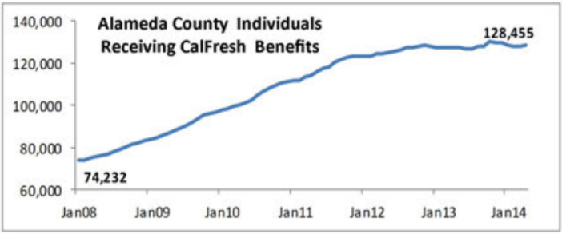
Although homeless people have no choice but to perform life-sustaining conduct in public places, many cities continue to treat these activities as criminal.
Figure 18
Food and Nutrition
As poverty and hunger increase, 33.8% of the adult population is food insecure, overall county obesity rate continues to be a problem as 53.2% of the population is overweight or obese, while children’s obesity rate remains at 10%. The number of individuals receiving CalFresh benefits
Source: Human Impact Budget Report 2014,
(food stamps) has risen 120% in the past six years (Figure 18). For homeless persons, access to nutritious meals is a serious problem. Obviously, the lack of opportunity to cook – or be cooked for – at home, limits homeless persons to eat, when they can, at “cheap” fast-food restaurants, in soup kitchens, church meal programs, and when possible, in shelters.
The impact of “food insecurity” on the minds and bodies of a homeless person is profound – the combination of hunger, lack of nourishing food, stress, and ingestion of fatty (fast food) and starchy and salty (soup kitchen) foods greatly impacts the health of persons already suffering from — or at risk of – hypertension, chronic heart disease, diabetes, high cholesterol, and depression.
In Alameda County one in five residents visited the Alameda County Food Bank's 275 distribution agencies.. The Food Bank is sometimes able to provide a “homeless basket” of foods that are easier to prepare without a kitchen, on an occasional basis to homeless persons.
In 2014, FEMA Emergency Food and Shelter National Board Program announced another round of cuts to Bay Area safety net food and shelter programs. This has meant an end to funding which the HCH program had utilized for emergency shelter, motel voucher and emergency food for homeless persons.
Homeless Youth
The 2013 Point In Time count identified about 435 young persons, aged 13-24, as homeless in January 2013. This is about 10% of the entire homeless population. The population of youth experiencing homelessness includes persons who have spent their entire lives in a permanent state of housing precarity, fleeing from abusive environments, living in homelessness, between various caretakers, and/or shuttled through institutions such as foster care, etc. These homeless youth suffer disproportionately high rates of chronic physical and mental illness at an early age, and have a high rate of contact with the law enforcement and legal system.
Oral Health
Dental health contributes in important ways to overall health. Research has pointed to possible associations between chronic oral infections and cardiovascular disease, stroke, fatal heart attacks, bacterial pneumonia, and premature birth, as well as making the control of diabetes more difficult. In addition, attentive oral health care can contribute to early detection of a wide variety of other illnesses. A thorough oral examination can detect signs of nutritional deficiencies as well as a number of systemic diseases, including microbial infections, immune disorders, injuries, and some cancers. However, only an estimated 30% of persons experiencing homelessness in Alameda County were able to access dental care in the past year.
A priority need for all homeless subpopulations in the county is access to dental exams, prophylaxis and opportunities to treat dental problems while they are more minor, before the only affordable treatment for acute pain and infection is tooth extraction. Missing teeth severely affects the self-esteem of people experiencing homelessness and impact efforts to seek employment and reintegrate back into mainstream society. But most importantly, lack of access to dental care for homeless individuals results in pain and suffering and permanent loss of teeth with serious, long-term consequences for both nutritional and overall health.
In Alameda County, Denti-Cal benefits have returned for many adult services. However there is a severe bottlenecks in accessing dental care. The majority of dentists do not accept Denti-Cal, because of the low reimbursement rates. According to partner interviews, the folding of CHIP into Medi-Cal means a prioritization of children’s dental care, meaning long delays and waits for adult services at safety-net clinics.
In the HCH Client Surveys, 70% of respondents named dental access as their most pressing need, second only to housing.

Chapter 6 Findings:
HCH Survey of Persons Experiencing Homelessness

In September/October 2014, HCH staff and partners carried out a survey of persons both utilizing and not utilizing HCH services. A three page survey was given at HCH sites, at subcontractor sites, and in street/outreach settings, in Berkeley, Oakland, Hayward, San Leandro, and Newark. A total of 150 persons completed the survey. Support in creating and interpreting the client survey was provided by the Community Assessment Planning and Evaluation division of the Public Health Department. Key demographic factors of survey respondents generally resembled that of HCH program patients, county HMIS homeless services utilizers. The demographics breakdown of respondents are found in Appendix 2 of this Needs Assessment.
Overall findings are shared below, detailed in Appendix 2, and incorporated into the overall recommendations of this Needs Assessment. Overall, client surveys show a population who cobble together fragmented care, suffer disproportionately from chronic and acute health care problems, and face many barriers accessing care.
Hunger and Poor Nutrition: Almost a third of respondents reported that the often go hungry. Most respondents eat at soup kitchens, two thirds do not receive food stamps. Eighty percent of respondents are not able to cook for themselves, and 27% of them couldn’t do so even if they had access to cooking facilities.
Fragmented Health Care: Persons experiencing homelessness use the Emergency Department as their primary source of medical care.
Emergency Department use: 62% surveyed responded that they had used Emergency Departments in the past year, including 45% of respondents who identified Highland Hospital ED as a source of medical care. ED utilizers averaged 3.5 ED visits per year, and 34% of ED visitors reported no visits to other medical clinics during the year.
Frequent Hospitalizations: Almost 30% of respondents reported hospitalization within the past year, averaging 3.4 times, and 34% of them reported no visits to other medical clinics during the year.
Poor Utilization of Primary Care Health Homes: 45% of respondents reported no visits to community, outpatient or primary care clinics. 23% said that they use the HCH van or Abode HOPE clinic services, and a small number used free clinics or the VA.
Many Barriers to Care Reported: Respondents reported barriers to dental, primary care, substance use and mental health care, frequently citing lack of transportation, inability to pay, dissatisfaction with providers, long waits, and other barriers to care.
Frequent Health Problems: 96% of respondent reported some sort of health problems. Dental problems were most common, followed by hypertension, optometry and foot care needs. In almost all categories, health problems were reported at a much higher rate than housed population.
Concurrent Mental Health and Substance Use: Almost a third reported mental health problems and one in five reported drug problems and one in five reported alcohol problems. Of those who reported a mental illness, almost 40% reported a concurrent drug use problem. Of those reporting drug problems, 56% reported a concurrent mental illness.
Self Reported Needs: Not surprisingly the overwhelming need was for housing and housing assistance, marked by 72% of the respondents. Other highly rated needs were dental care, access to food, medical care, transportation and clothing, mental health counseling, case management, substance abuse treatment, job help and cell phones.
Findings are detailed in Appendix 2.

Chapter 7:
Findings: Stakeholder Interviews
We know that the causes of homelessness are based primarily on structural factors: a lack of affordable, adequate housing, combining with economic, health and social disparities -- in other words, a safety net that permits millions of persons to fall to the streets. Our common goal is to build a stronger safety net that ensures housing and health care for all. At the same time, our common efforts to improve the health of persons experiencing homelessness mean work on an individual patient level to stabilize mental health, substance use, acute and chronic health issues, income, legal and family problems.
At least 200 different entities (governmental and community) provide some sort of services to persons experiencing homelessness in Alameda County, in at least 370 locations throughout the county. It is critical to hear the voices of those who provide services and advocate for the needs of persons experiencing homelessness.
Stakeholder Interviews:
A series of stakeholder interviews was carried out by HCH staff in October-November 2014. In-depth interviews were carried out with 15 homeless health and services providers throughout the county. Stakeholders were given a standard list of questions and invited to share impressions. Findings are shared below and are incorporated into our recommendations.
Overall findings from these interviews support a perception of fragmented homeless support services and a need for more coordination of homeless services throughout Alameda County. Key findings around this issue include:
- Barriers in coordinating on patient care across the system of care, from hospital admittance, care and discharge, to services in income and benefits, legal assistance, criminal justice, shelter, and especially permanent housing.
- Lack of communication between major systems around patient costs and utilization, especially critical around vulnerable and costly high utilizer patients who need extra coordination.
- Providers described an environment in which homeless providers must be an expert at multiple systems -- often without adequate training -- to provide a range of critical services for an ever-changing number of clients, lacking the bandwidth to follow complicated patients through complex systems in a timely manner.
Other key needs frequently expressed by providers included:
- The need for more dedicated housing stock; Improved training and capacity for mental health services integrated in case management;
- Health care and housing for homeless persons with high needs or serious mental health disorders;
- Substance use services, including expanded medical-model and evidence-based treatment options;
- Integration of more housing coordination into homeless services;
- Lack of sufficient respite care and hospital discharge resources.
- The need for expanded outreach for hard-to-reach street homeless, along with expanded linkages between street outreach providers and housing and system of care.
Finally, while stakeholders lauded HealthPAC and the County’s implementation of the Affordable Care Act, there was a consensus that delays in access to primary care, dental, mental health and substance use treatment is still a huge barrier for persons experiencing homelessness. Especially noted was the difficulty that newly-eligible homeless persons have in accessing much-needed dental care.

Chapter 8:
Recommendations and HCH Program Priorities

Countywide data collected by Alameda County Health Care for the Homeless Program supports national findings that persons experiencing homelessness have much higher premature morbidity and mortality than the rest of the population, with higher rates of chronic diseases, mental disorders, substance use, communicable diseases and functional and behavioral impairments than the housed population.
Because of high levels of serious health conditions among the population of persons experiencing homelessness, and the high costs of uncoordinated treatment, there is an urgent need to address both the health care needs of persons experiencing homelessness, improve coordination of care and resources, while working to address and mediate the underlying reasons for homelessness.
Recommendations
- Expand availability of Housing First-based permanent housing for persons experiencing both episodic and chronic homelessness, with housing coordination located throughout the system of care throughout all regions of Alameda County.
The premise of Housing First is that housing will: improve the health and social status of a person experiencing homelessness, improve their use of primary care and outpatient services, and reduce their utilization of hospitals, jails and emergency services, thereby reducing costs. Housing must be a first-line response to the personal health problems of homeless individuals. The creation of additional affordable housing must be understood as a critical public health responsibility, to correct health disparities, control of communicable disease and for efficient and effective health care planning and spending. The Alameda County Public Health Department has long understood the role of housing as a determinant of health, and has played an historic role in developing and enforcing housing standards. The health effects of modern homelessness demand that the County renew and broaden its advocacy role to insist that affordable housing is a necessary prerequisite to eliminate homelessness.
- Ensure that dedicated access to health care services specific to persons experiencing homelessness is expanded at primary care, mental health, dental, substance use and benefits programs throughout the county.
Even with expanded Medi-cal enrollment, a key finding of the HCH patient survey is that persons experiencing homelessness report delays in accessing critical care services like primary care, dental, mental health, substance use and specialty care services. Health system constraints and provider limitations prevent most clinical providers from providing the comprehensive, patient-centered care that persons experiencing homelessness require. Primary health-care services specifically tailored to homeless individuals have been shown to be more effective than standard care and are more likely to achieve higher quality of outcomes. Examples of dedicated homeless health care include the HCH TRUST Clinic, HCH mobile dental case management, and comprehensive care provided at the AHS HOPE Clinic, and same-day clinical access at AHS’s Same Day Clinic.
- Expand care coordination throughout the system of care, including hospitals, emergency departments, social services, criminal justice, housing providers, mental health, substance use treatment, etc. In addition to coordination of care, it is critical to track and account for costs (and cost savings) related to care of persons experiencing homelessness.
There is a great need to identify vulnerable and high-risk individuals, many of whom are high utilizers of certain types of care. Current care systems are siloed, providers are unaware of others working with patients There is a need to track vulnerable individuals, measure their system usage and the effectiveness of their care, and understand both costs, and cost savings, on an per-user basis.
A tremendous initiative to share information across systems is San Francisco Department of Public Health’s Coordinated Care Management System. This unified data sharing system links together human services providers, housing providers, heath care including hospitals, clinics, long term care, outreach, mental health and substance use, public health, emergency medical services and private hospitals, clinics and programs. This approach must be multidisciplinary, collaborative and coordinated, and include families, patients and providers to engage clients and coordinate care planning.
- Expand Permanent Supportive Housing combined with appropriate Critical Time Intervention and Assertive Community Treatment for persons with high needs (especially aging, vulnerable behavioral health, and chronically ill populations).
Permanent supportive housing is a successful, cost-effective combination of affordable housing with services that helps people live more stable, productive lives. PSH is a proven, efficient way to address homelessness by helping people who face the most complex challenges, such as mental illness, chemical dependency, and HIV/AIDS, become stably housed. While some persons experiencing episodic homelessness may need a “light touch” i.e., linkages to housing, resources and services, it is important to identify and provide for those who will need more intensive, long-term care and support, to reduce debilitating and costly chronic homelessness.
- Expand coordinated street outreach services to identify and support vulnerable unsheltered persons living in streets, encampments, cars, etc.
There are currently only a handful of dedicated homeless outreach workers covering the entire county. A strong model of homeless outreach involved dedicated staff, providing geographically coordinated outreach services, identifying and engaging with vulnerable hard-to-reach persons, to provide or facilitate site-based services (medical, mental health and substance use) and linkages to permanent housing. These outreach staff perform important public health roles, for example during extreme weather, natural disasters or in disease outbreaks. ACHCHP is currently working to develop a street medicine outreach team based on successful models in Pittsburg, and Santa Clara. A countywide system of best practice in terms of homeless outreach can be found in Philadelphia, with well-coordinated homeless outreach, crisis services, safe havens and cafes, housing first teams, and cold weather responses.
- Expand countywide training approaches to develop the capacity of homeless programs and staff to implement and provide evidence-based practices (EBPs) and emerging best practices in the field of homeless health care and housing services.
A well-trained workforce equipped to implement evidence-based practices (EBPs) is a critical component of preventing and ending homelessness. While there has been an increasing emphasis on implementing EBPs in homeless service settings, a gap persists between research and practice. The most important clinical and social work is done in settings (clinics, shelters, streets) where demand for services is great, resources are scarce, and access to training is limited. There is a pressing need to identify feasible training approaches that can enhance providers’ capacity to implement empirically-supported approaches. Examples of homeless-related EBPs mentioned in stakeholder interviews include: Motivational Interviewing, Trauma Informed Care, Medical Respite, Integrated Dual Disorders Treatment, Trauma-Focused Cognitive Behavioral Therapy, and Harm Reduction.
- Introduce targets relating to the health of homeless persons in local health plans, including financial targets to support programs addressing homelessness in medical and behavioral care.
Providing clinical health care for homeless individuals requires a special skill set not routinely taught in public health, public administration or in medical schools. Major funders of countywide health care services, such as the County, the CHCN and HMOs such as Alameda Alliance for Health and Anthem Blue Cross should take steps to ensure that appropriate benchmarks for homeless care are established and met, including standards for timely access to care, screening for homelessness and housing precarity, and standards for development of engagement, interpersonal relationships and peer support, integration into community resources, appropriate clinical care and advocacy activities.

HCH Program Priorities
- Expand access to care for persons experiencing homelessness:
Expand homeless access to dental services. Contracting for dental care, especially for high-need patients, combined with dental case management. Evaluate effectiveness of current dental contracting. Partner with AHS for expanded access at HGH dental clinics and exploration of mobile dental services to expand screening and preventative dental care. Coordinate and advocate with HealthPAC for expansion of dental services. Partner with key community providers to monitor access and quality of dental care for persons experiencing homelessness.
Expand homeless access to Primary Care services in Hayward area. Persons experiencing homelessness in the Hayward and South Hayward area face poor access to primary care and dental services. A priority is to increase same-day and same-week homeless access to the new Hayward Wellness Center, improve coordination and access to care at Tiburcio Vasquez Health Center, increase coordination with are mobile clinic providers (HCH and HOPE van) and area homeless services providers.
- Integrate Housing and Care Coordination into HCH Services
TRUST Clinic: Open TRUST Clinic permanent site as part of HCH scope of services. Develop and carry out screening and linkage of disabled homeless from mobile clinic sites into TRUST Clinic services to provide ongoing comprehensive mental health, substance use, benefits and primary care services and expedite access to benefits for indigent disabled person.
AHS Care and Housing Coordination: Expand coordination and linkage between HCH social workers and outreach staff and AHS Homeless-focused Care Team for care coordination of homeless patients receiving services at AHS outpatient clinics and HCH mobile clinics.
County Housing Coordination: Expand coordination and linkage between HCH Program (management, social workers and outreach staff) with Alameda County Behavioral Health Care Services Housing Services Office, especially around Housing First initiatives such as Home Stretch, Welcome Home and Homes for Health.
- Initiate Clinical and Care Coordination-based HCH-AHS Mobile Clinic services:
Implement mobile clinic services care team led clinically by Alameda Health System clinicians, integrating HCH social work, providing psychosocial assessment, housing and care coordination to patients served in mobile clinic setting. Goal care team is to supplement urgent acute and chronic care with ongoing care coordination (primary care homes, housing services coordination, access to behavioral health services).
- Expand Outreach Services
Implement Street Medicine program to provide street-based clinical and care coordination outreach services to homeless persons on streets and encampments. Key partners will be contracted care providers, current outreach providers and community partners.
- Better Incorporate Patient Voice into HCH Services
The HCH program will commit to improving patient input and feedback into HCH services, through carrying out annual client surveys and patient satisfaction questionnaires. Program will also strengthen consumer role in program governance.

Appendix 1:
Alameda County Homeless Health Care Resources

The Alameda County Health Care for the Homeless Program
The Alameda County Health Care for the Homeless Program is the primary service provider in the County for the population of persons experiencing homelessness, offering services at some 40 sites throughout Alameda County, at mobile clinic-based sites, HCH clinics, subcontractor clinic and community programs, and Alameda Health Systems outpatient clinics. Figure 34 is a map of services delivery sites on the HCH Program federal scope of services:
Figure 34

The following is a more descriptive overview of the safety-net health care resources used by indigent, uninsured and homeless persons in Alameda County, both as part of the ACHCHP Scope of Services, and in the larger community. This table includes approximate numbers of persons served annually and wait times for services:
Health Program utilized by homeless persons |  | Type |  | Wait for enrollment / appt | # homeless treated / yr
Sites on the ACHCHP Scope of Services
Alameda County Health Care for the Homeless Program | LHD-based HCH program, Mobile van visits 30 homeless sites; contracted health care and enabling services throughout County |  | Mobile clinic visits most sites on a monthly basis. |  | 2,300
Alameda County Health Care for the Homeless TRUST Clinic | LHD-Based HCH program Clinic with behavioral health, case management and housing services, |  | 2-6 mo wait on Social Services Agency “queue” for enrollment. |  | 220
Alameda Health System  Highland Hospital, Same Day, Eastmont, Hayward and Newark Clinics, (John George Psychiatric Pavilion, Fairmont Skilled Nursing and Physical Therapy not on HCHP Scope of Services). | Safety-net hospital, 5 subrecipient FQHC clinics, specialty care, dental, psychiatric hospital, long-term care, skilled nursing, emergency department. |  | 2-4 months primary care; up to 6 months specialty care.  Same Day appointments at HGH Same Day Clinic |  | - 5000 homeless Outpatient  - 1100+ Hospitalized  - 2,500 homeless ED patients  - 1,500 homeless psychiatric hospitalizations
Axis Health Clinic, Livermore, Pleasanton | FQHC Clinic 2 sites in East County |  | 2-3 months wait for new appointment |  | 1100 patients
East Oakland Recovery Center | Community substance abuse recovery program. Contracted by ACHCHP. |  | No wait |  | 1500 patients  2500 visits
La Clinica de la Raza, Oakland | FQHC + dental  2 sites. Dental and Optometry contracts with ACHCHP. |  | Wait of 1-3 months for new appointments |  | 718 patients
Lifelong Medical Care, Berkeley & Oakland | FQHC + dental  5 sites. Primary Care and enabling svcs contracts with ACHCHP |  | 2 month wait when enrolling new patients; |  | 451 patients
On Site Dental Foundation, South County | Mobile dental service contracted by ACHCHP. |  | Weekly visits to ACHCHP shelter sites. |  | 200 patients
Second Chance Recovery, Newark | Drug/Alcohol recovery contracts with ACHCHP |  | No wait for service |  | 500 patients  3000 visits
Tri-City Health Center Fremont | FQHC primary care, 3 sites. Contracted by ACHCHP. Primary care provider for Abode HOPE mobile clinic. |  | 1 month wait, same day drop ins available. |  | 918
West Oakland Health Council, West Oakland and East Oakland | FQHC 2 sites. Contracted by ACHCHP. |  | 2 month wait |  | 723
County and Community-Based Homeless Health Care Services
Alameda County HealthPAC | Persons below 200% FPL who are not eligible for Medi-Cal enrollment. |  | Indigent primary and behavioral coverage (1115 Waiver). 1 month wait for enrollment. |  | All uninsured homeless are eligible. Approximately 39,000 persons enrolled.
Alameda Alliance for Health | County nonprofit HMO serving most low-income Medi-Cal recipients. |  | Primary Care, Specialty Care, Mental Health – Medicaid (Medi-Cal) provider |  | Persons on Medicaid/ Medi-Cal
Asian Health Services, Oakland | FQHC Clinic sites |  | 2 months next appointment; no homeless services |  | 14
Alameda County Behavioral Health Care Services Agency | Mental Health Service Sites throughout County; Mobile Crisis Unit; ACCESS phone.  Subcontracted MH services and D/A services |  | Severe Persistently Mentally Ill persons only in Service Teams. |  | 1,507 homeless treated for BH  2,005 homeless treated for D/A
Berkeley Mental Health | (Berkeley) Mental Health Services |  | Severe Persistently Mentally Ill persons only |  | 750 year
Children’s Hospital | FQHC clinical and hospital care for children experiencing homelessness |  | Children |  | 3,500
Dental | Alameda County Medical Center Dental Clinic |  | Safety net County dental provider. 1-3month wait for appointments or drop-in. Episodic only. |  | 700
Dental | 4 FQHC dental: WOHC, Lifelong, La Clinica, Native American Heath Center, Tiburcio Vasquez. |  | Dental services, Clinic patients only; long waits for Medi-Cal covered dental services, no services for uninsured. |  | 300
Free Clinics | Berkeley Free Clinic, RotaCare, Malta Clinic, Suitcase, Ashland, Street Level |  | Very limited Primary Care, dental, volunteer services. Lotteries for high-need services |  | Unknown.
Full Service Partnerships (service-enriched housing partnerships) | MHSA funds |  | Scattered sites, case management, Lifelong. All wait lists closed |  | 2,400 units in County;  100-300 slots available annually
Healthy Oakland – Healthy Communities Clinic | Non-FQHC nonprofit community clinic |  | Homeless and re-entry primary care services no wait |  | Unk
HOPE Van – Abode Housing Fremont | Mobile clinic homeless in South County. Street outreach services in South County |  | 4 South County mobile clinic sites, outreach efforts, collaboration Tri-City Health Center |  | 900 patients,  2,264 mobile clinic visits  2,060 outreach encounters
Juvenile Justice Center | Youth inmates |  | Primary Care and Mental Health |  | Unknown
Methadone and Harm Reduction Programs | 4 methadone programs; four needle exchanges, HIV harm reduction outreach. |  | Not County-funded, self-pay or Medicaid, |  | -
Native American Health Center Oakland | FQHC + dental  2 sites |  | 1-3 month when enrolling new patients |  | 90
Outpatient recovery Programs | 6 longer term outpatient recovery programs |  | Dual Diagnosis Many inaccessible to uninsured |  | -
Prison Health Care Services | Santa Rita Jail and Oakland Jail |  | Primary Care and Mental Health |  | -
Residential Recovery Programs in Alameda County | 16 residential recovery programs ; 1 detox, 311 beds on any given night |  | Much greater demand for recovery services: Wait up to 6 months |  | -
Tiburcio Vasquez Health Center Hayward | FQHC  2 sites |  | 2-4 month wait when enrolling new patients |  | 105

FQHC Clinics
There are currently nine Federally Qualified Health Centers operating in 33 locations throughout Alameda County, all of whom provide some levels of health services to persons experiencing homelessness. In addition to these permanent sites, there are also 27 School Based Health satellite clinics operating in Alameda County. Figure 35 is a map of the major permanent FQHC clinic sites in Alameda County:
Figure 35

Hospitals:
There are seventeen hospitals serving Alameda County, including emergency departments at twelve hospitals. Health services are provided at two jails in Alameda County, for adults at Santa Rita jail in Dublin and for minors at the Juvenile Justice Center in San Leandro. Overall, there are 2,969 hospital beds at 21 facilities, as well as 383 skilled nursing beds in Alameda County, with 107,000 total hospital discharges annually. Figure 36 is a map of Alameda County hospitals with some utilization by persons experiencing homelessness:
Figure 36
HIV Clinics, Free Clinics and Community Clinics:
There are seven free clinics providing clinical care to uninsured persons including those experiencing homelessness in Alameda County, however none in the Tri Valley (east) County, and none south of Hayward. There are also several community clinics that serve a low-income population or that provide specialty services such as hepatitis care. Finally, safety net HIV clinical care is provided in four HIV clinics, in addition to other community clinics and private providers (Figure 37)
Figure 37

Behavioral Health Resources for Homeless Persons:
Out of the 52,470 persons treated for mental health conditions by the Alameda County department of Behavioral Health Care Services, at least 2,019 were screened as homeless, however, this is surely a great undercount, as 17,065 were counted as “unknown.” Behavioral health services for homeless persons in Alameda County include 5 psychiatric inpatient hospitals, mental health clinics and integrated primary care/mental health clinics, a range of youth, adult and senior mental health services, adult support centers, outreach and supportive and group housing for persons with serious mental illnesses. These services are mapped on Figure 38:

Figure 38

Mobile Medical Homeless Services:
In addition to the three organizations providing mobile clinical care (the HCH Program, Abode’s HOPE Medical Clinic, the Kerry’s Kids mobile pediatric clinic), mobile HIV prevention services such as Cal PEP provide some testing and referrals to homeless persons, and harm reduction services are provided to an injection drug-using population at sites in Oakland, Berkeley and Hayward. See Figure 39:
Figure 39

Dental Care/Optometry:

Figure 40 shows mobile dental services provided by the HCH Program at three sites in Alameda County, while safety net dental care is provided at the Highland Hospital dental clinic. Dental care is provided at five FQHC Clinics. Some limited dental services are provided by free clinics in Berkeley, Oakland and San Leandro. As of 2014, persons experiencing homelessness have had limited success (due to long waits) in accessing dental services at 50 dentists and clinics who are now accepting Denti-Cal. Optometry services are also a newly-returned Medi-Cal covered service, however glasses are not covered by Medi-Cal at the 58 optometrists currently accepting Medi-Cal. There are three sources of free optometry/glasses services, in Berkeley’s Suitcase clinic and HCH Program subcontracts at La Clinica.

Figure 40

Drug/Alcohol Recovery and Treatment Services:
There are limited, and often hard to access drug and alcohol treatment and recovery services available to persons experiencing homelessness. These services, shown on Figure 41, can be grouped into four areas: detox/sobering centers; inpatient or residential drug/alcohol recovery facilities; outpatient and community recovery programs; and finally methadone programs for persons using opiates. In 2013, the HCH program provided drug/alcohol services to 1,128 persons experiencing homelessness, while the Alameda County Behavioral Health Care Services funded substance abuse services for at least 2,005 persons experiencing homelessness. Due to the scarcity of drug and alcohol services in the East County, Axis Community Health Center has recently expanded integrated drug and alcohol recovery services into primary care services available to homeless persons.
Figure 41

Emergency Shelter and Housing for Persons Experiencing Homelessness:
Currently, Alameda County currently has approximately 713 emergency shelter, and 1163 transitional housing units for the estimated 4,500 persons experiencing homelessness on any given night. During winter months, shelter capacity can be augmented by “warming stations” which open on rainy or cold nights in eight locations, providing up to 165 additional indoor cots or mats.
The number of emergency shelter beds has dropped by 35% from 2009, from 1,104 to 713 beds. This is due to cutbacks in transitional and emergency housing due to State and local budget cuts. Transitional beds reduced from 1,274 to 1,163, a drop of 9%. There are currently 1,876 total beds in Alameda County, a drop of 21% from 2009’s 2,378 beds. Consequently, the number of persons who are unsheltered has increased by 19% between 2009 and 2013. See Figure 42 for shelter locations:

Figure 42

Support Services for Persons Experiencing Homeless
Some the services provided to persons experiencing homelessness include drop-in centers (all located in the North County region, except one in San Lorenzo); street outreach services (only four organizations providing this critical service); HIV support and prevention services; benefits advocacy services (mostly located in the North County region); and other services such as day laborer and immigrant services, disability services, senior services, etc. Please see Figure 43 for a map of these services:
Figure 44

Services for Homeless Veterans:
Homeless veterans account for an estimated 9% of the persons receiving HMIS homeless services throughout Alameda County in 2013. A veteran who has received an honorable discharge could qualify for Support Services for Veterans Families and connect with services and housing by accessing one of the SSVF agencies, and can connect with the Veterans Administration for medical and mental health care. See Figure 45:

Figure 45

Services for Homeless Youth:
Unaccompanied transition age youth between ages 14 and 24 make up an estimated 10% of sheltered and unsheltered homeless, according to the 2013 Point In Time Count. Specialized services to try and meet the needs of this population are mapped on Figure 46:
Figure 46

Meal Sites and Food Pantries for Persons Experiencing Homelessness
Most meal sites are sponsored by church groups, providing a meal weekly or monthly. A few larger sites, such as St. Vincent DePaul provide meals daily. Food programs and meal sites are concentrated more in the North County area, and are difficult to access in the southern and eastern reaches of Alameda County. Meal sites and food pantries are coordinated by the Alameda County Food bank, serving some 49,000 adults, children and seniors in Alameda county every week, annually serving one out every five county residents. Figure 47 shows regular meal sites which can be accessed by persons experiencing homelessness. This map is not comprehensive in showing the food pantry sites used by persons experiencing homelessness:
Figure 47
Homeless Hygiene: Toilets and Showers for Unsheltered Homeless:
The 2013 Point In Time count estimated at least 2,337 Alameda County residents living unsheltered, on the streets on a single night in January 2013. At least three thousand more persons were staying in shelters or sleeping informally (doubled up, couch surfing). For persons experiencing homelessness, access to hygiene facilities such as toilets and showers, is essential for human dignity and maintenance of personal and public health. However, Figure 48 shows that hygiene facility access is extremely limited in Alameda County:
Figure 48
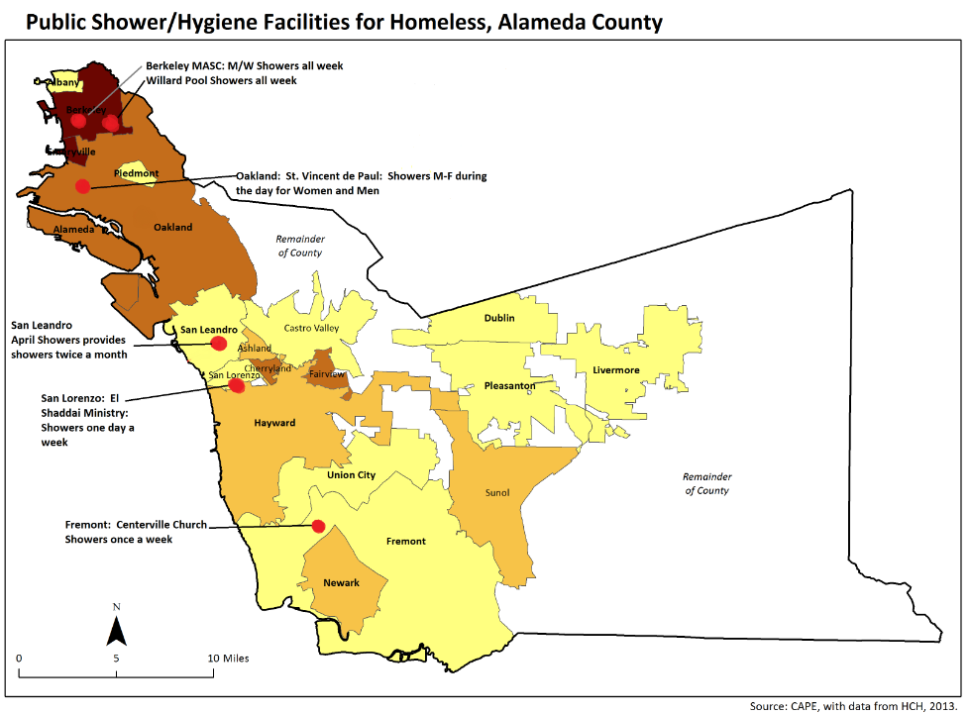
Showers: There are only six locations where unsheltered homeless persons can shower in the County, only four accessible in a daily basis, all four in the North county.
Toilets: The only city maintaining an inventory of toilets available to homeless persons is Berkeley. However even in Berkeley there are no 24-hour toilets available. This applies to all cities in Alameda County, as public park toilets are locked at night. The city of Hayward has only two public toilets in downtown, both of which are locked at night. In the absence of public toilets, homeless persons must attempt to use private businesses or are forced to defecate or urinate in public.
According to the Occupational Safety and Health Administration (OSHA) requirements for restrooms in the workplace roughly equate to two restrooms for every forty employees. With 2,337 persons unsheltered at a single point in time, this would require a minimum of 60 accessible public restrooms throughout the County. Investment in public restrooms to meet the needs of the homeless population and the public in general are being carried out in several cities, including San Francisco, Denver, Portland. Such measures help homeless individuals meet their basic needs, improve public and personal health, and alleviate the strain on libraries and private businesses, and on law enforcement officers who ticket people who are homeless for public defecation or urination.
Appendix 2:
Complete HCH Survey of Persons Experiencing Homelessness in Alameda County

HCH Patient Survey:
In September/October 2014, HCH staff and partners carried out a survey of persons both utilizing and not utilizing HCH services. A three page survey was given at HCH sites, at subcontractor sites, and in street/outreach settings, in Berkeley, Oakland, Hayward, San Leandro, and Newark. A total of 150 persons completed the survey.
Baseline profile of persons surveyed:
Total 150 Persons Completed Survey
Sex | Men 77%  Women 23%
Race | African American 34.5%  White 32.4%  Latino 20.7%  Native American 6.2%  Not filled out/other 6.2%
Age | Average age: 50  Range 22 to 80 yrs old
Length of time Homeless | 63% have been homeless 1 or more years.
Source of Income | 71% have no income (GA, none, odd jobs, recycling). 5% have a job, and 33% have SSI, VA or a pension.
Medical Insurance | 35% are uninsured (including those with HealthPAC indigent coverage).
Length of Residency in Alameda County | 51% have lived in Alameda County all their lives. 36% have lived for over 5 years.
Born in US? | Yes: 79%  No: 21% (Guatemala, Mexico, Honduras, El Salvador)

Current living situation:
49% of the respondents lived outside, on the streets, in encampments, cars, garages, sheds, boats, and buses. 18% of respondents were staying in shelters, transitional housing or recovery programs, some 15% reported being doubled up, and 12% reported they were living in motels or in transient SRO hotels. A few respondents had their own place, either persons who had just moved in to housing, and folks who were doubled up but considered their shared quarters stable enough to be called “their own place.” See Figure 19:

Figure 19

Length of homelessness/Residency in Alameda County
Source: HCH 2014
The majority of persons had been homeless at least 1 year, and a quarter of respondents had been homeless for over 5 years. 37% had been homeless less than a year. The majority of persons surveyed had lived in Alameda County all their lives. 3% had relocated within the past year. 11% had lived here between 1-5 years, 36% over five years, and 51% for their entire lives. See Figures 20 and 21:
Figure 20 | Figure 2  Source: HCH 2014

Food and Nourishment:
About half of the respondents said that they eat at soup kitchens and a third at shelters and transitional programs. Two-thirds did not receive any food stamps. Over a third reported that they feel like they do not eat healthy enough. Almost a third reported that they often go hungry, and 27% said they could not cook for themselves. About one in five reported that they managed to cook for themselves at least occasionally by sharing a kitchen, or improvising a cooking facility in a campsite or hotel room. A frequent comment of respondents regarded a lack of nutritious food in soup kitchens. See Figure 22:
Figure 3

Sources of Health Care:
Respondents were asked where they have gone recently when they are sick or need health care. Almost 60% surveyed responded that they used Emergency Departments as a source of health care, including 45% of respondents who identified Highland Hospital ED as a source of medical care. Only 31% indicated that they utilize community clinics. 23% said that they use the HCH van or Abode HOPE clinic services, and a small number used free clinics or the VA. See Figure 23:
Figure 23
Source: HCH 2014
Recent Hospitalizations
29.4% of homeless respondents reported 1+ hospitalization visits in past year: Of those who did have at least one visit, the number of visits ranged between 1 and 20 visits, and average among those who did visit hospital was 3.4 visits. 34.1% of those who reported a hospital visit in past year reported no visits to medical clinic in past year (14 persons). See Figures 24 and 24:
Figure 4 | Figure 25  Source: HCH 2014

Recent Emergency Department Utilization:
61.7% reported 1+ ED visits in past year. Of those who did visit the ED, the number of visits ranged between 1 and 25 visits. The average among those with ED visits was 3.5 visits. 34.1% of those who reported an ER visit in past year reported no visits to medical clinics in past year (38 persons). See Figures 26 and 27:
Figure 26 | Figure 27  Source: HCH 2014
Medical Clinic Utilization:
45% of respondents reported no visits to community, outpatient or primary care clinics. 55.0% reported at least one medical clinic visits in the past year. Of those who did have at least one visit, the number of visits ranged between 1 and 26 visits. The average among those who did visit clinics was 4.0 visits. See Figure 28:

Figure 28
Source: HCH 2014

Respondents were asked to identify some of their most important needs, checking from a supplied list and being asked if there were other needs. Not surprisingly the overwhelming need was for housing and housing assistance, marked by 72% of the respondents. Other highly rated needs were dental care, access to food, medical care, transportation and clothing, mental health counseling, case management, substance abuse treatment, job help and cell phones. See Figure 29:
Figure 29
Source: HCH 2014
Identified Health Conditions:
Respondents were asked to list any health conditions that they suffered from. 96% of respondents indicated that they had some sort of health problems. Almost 40% reported dental problems, and over a third reported hypertension, and optometry needs (need glasses). Almost a third reported mental health problems and one in five reported drug problems and one in five reported alcohol problems. Of those who reported a mental illness, almost 40% reported a concurrent drug use problem. Of those reporting drug problems, 56% reported a concurrent mental illness. Overall, the most frequent responses are in Figure 30:

Figure 30
Source: HCH 2014

The other category included: Chronic pain, especially musculoskeletal, hearing problems, hernia, hip replacement, bladder and incontinence, heart problems, hepatitis C.
Self-rating of health:
46.2% of respondents rated their health as fair, poor, or very sick, while 49% rated their health as good or better. Over 57% reported that they feel they are not employable due to physical or mental disabilities. See Figure 31 and 32:
Figure 31 | Figure 32  Source: HCH 2014

Access to Medical Care & Services:
A goal of the survey was to determine how persons experiencing homelessness feel they are able to access quality care that they need. Many respondents did not answer some or all of the questions, but clearly respondents felt that they cannot access dental, substance use and mental health services when they need them. Surveyors reported a significant number of persons indicating that they can access medical care in a timely manner by “going to the Emergency Room.” Below are some of the responses provided by respondents to questions around access, barriers and patient satisfaction. See Figure 33:
Figure 33

Source: HCH 2014

Appendix 3:
Health Care Utilization among Persons Experiencing Homelessness in Alameda County

Alameda County Health Care for the Homeless Program
In 2013, The Alameda County Health Care for the Homeless Program provided services to 10,013 homeless patients, representing some 56% of the estimated 20,000 persons experiencing homelessness in Alameda County. Over a period of 5 years, the number of patients served by the HCH Program has grown by 28%.
In 2013, 10,013 homeless patients were served in 37,352 visits. Medical care was provided to 8,200 persons in 22,320 medical visits. 3,487 persons received non-medical services such as drug/alcohol recovery, case management, benefits, and other enabling services in 14,989 service encounters. 2,048 persons were treated on HCH mobile clinics, TRUST Clinic or other HCH sites in 7,500 encounters. 2,840 persons were treated at subcontracting programs and clinics in 14,877 encounters, and 5,958 patients were treated at Alameda Health System outpatient clinics in 15,124 visits. Figures 49 and 50 provides a breakdown of HCH services by patients and visit location
Figure 49  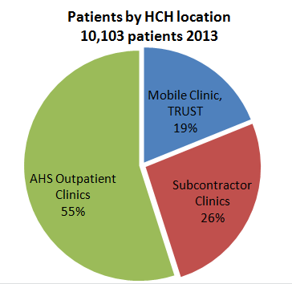 | Figure 50  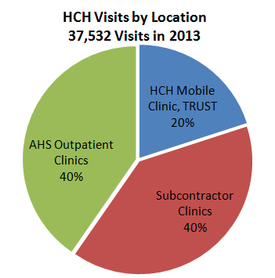  Source: HCH 2014

Throughout the HCH program, the median age of HCH patients was 47 years old, and, 51% of patients were female. On mobile clinic HCH clinics, the median age was 48 years, while 59% of patients served were men. In 2013, almost 80% of patients served were uninsured, and persons of color made up 85% of patients served. All patients served were under 200% of the Federal Poverty Level, and 98% below 100% of the FPL. See Figure 51 and Figure 52:
Figure 51  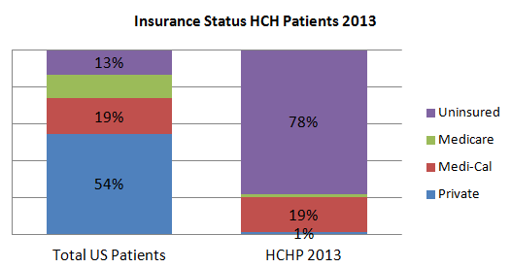  Source: HCH 2014 | Figure 52  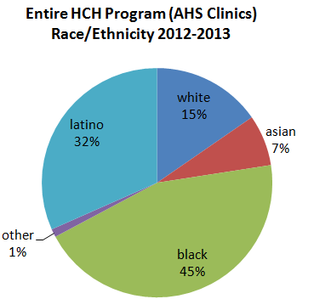

Housing status (where a homeless person is currently living) is very diverse throughout the HCH program. On mobile clinics and TRUST program, 12% of patients treated reported living on the streets, 37% doubled up with others, and 43% in shelters, programs and transitional housing. In subcontracted clinics and AHS outpatient clinics, 63% of patients served were doubled up, 22% in shelters or programs, and 7% living on streets.
2012-2013 Two-Year HCH Utilization Overview:
In assessing HCH medical and social services utilization, we chose to look at the last two calendar years, 2012 and 2013. In these two past years, 15,410 homeless persons received services in 70,562 encounters throughout the HCH program.
Medical Services:
In analyzing medical services provided we evaluated all ICD9 diagnosis codes, V codes for patient characteristics and procedures, associated with each patient visit, not just the primary diagnosis. This is because many patients will be treated for a simple complaint, while underlying issues, such as hypertension, mental health or substance use are noted by clinicians as secondary conditions. Diagnoses were organized into groups in order to better understand the nature of a very heterogeneous group of patients.
During CY2012-2013, HCH Program provided clinical medical services to 12,518 persons experiencing homelessness in 44,182 medical visits. These medical visits took place on HCH mobile medical clinics at 28 sites throughout Alameda County, at the HCH offices, the TRUST Clinic, the St. Vincent stable site clinic, at 7 subcontracted community clinics, and at 5 Alameda Health System outpatient clinics.
HCH Program-wide medical utilization: Figure 53 is a list of the diagnosis types for homeless medical visits throughout the HCH program, including subcontractor medical and dental clinics, and HCH mobile services, including mobile dental services, TRUST Clinic and AHS outpatient clinics. The most frequently made diagnoses and co-conditions among patients experiencing homelessness were chronic diseases like hypertension and diabetes, followed by dental treatment, and treatment for musculoskeletal problems. Mental health and substance use were frequently reported diagnoses and co-conditions:
Figure 53
Source: HCH 2014

HCH Directly-Provided Mobile, Dental, St. Vincent and TRUST Clinic Medical Utilization: The frequency of diagnoses for patients directly treated by HCH clinicians on mobile medical clinics, the TRUST Clinic and St. Vincent stable site clinic is shown on Figure 54. Patients treated at these sites were 43% African American, 28% Latino and 19% White; almost 60% were men, with a median age of 46 years.
Figure 54
Source: HCH 2014

Among patients treated directly by HCH programs (above), the overwhelming majority of mental health diagnoses were among patients at the TRUST Clinic, due to the frequency and intensity of mental health treatment provided to disabled indigent homeless TRUST Clinic patients. Almost all TRUST Clinic patients had mental illness diagnoses and involvement, while patients treated on mobile clinic and St. Vincent clinic had fewer, but often undiagnosed and unreported, mental illness and substance use involvement. The most common diagnoses and conditions among patients treated on mobile clinic included musculoskeletal pain, respiratory infections and problems, dental conditions, foot and skin problems, and hypertension. The TRUST Clinic had an average of 6 mental health visits per person, mobile medical clinics averaged 1.4 visits per patient, while the mobile dental clinics averaged 5.8 visits per patient.
AHS Outpatient Clinics: Finally, Figure 55 shows diagnosis groups ranked by frequency for homeless persons treated by clinicians at 5 Alameda Health System outpatient clinics (Eastmont, Highland, Newark, Hayward and Same Day Clinic) in 2012-2013. During the two past years 8,457 homeless patients were treated in 30,000 visits at the five AHS outpatient clinics:
Figure 55
Source: HCH 2014

Of patients treated at the five AHS outpatient clinics, the most frequent diagnoses and co-conditions included hypertension and diabetes. Other frequent conditions included musculoskeletal problems, women’s health issues, and respiratory conditions. Mental health involvement was frequent, and alcohol/drug involvement was not frequently reported at outpatient clinics. The median age of outpatients was 45 years old, and females were 57% of outpatient visitors. There were an average of 3.6 visits per patient during the two years 2012-2013.
Enabling/Support Services:
Case management, alcohol/drug counseling, food, housing, health education, enrollment and other support services, defined by HRSA as “enabling services” were provided to 81% of patients treated on HCH sites, mobile clinics, and community subcontractor sites (excluding AHS clinics). Almost all patients treated on mobile clinics received enabling services from HCH social workers. By far, the most common enabling services provided to clients experiencing homelessness included alcohol and drug recovery services (including counseling and referrals), food assistance and housing assistance (including referrals to shelters, housing case management, and assistance in locating permanent and emergency housing). See Figure 56 for an itemization of the type and frequency of enabling/support services provided by the HCH program:

Figure 56
Source: HCH 2014

Other Homeless Medical Clinics in Alameda County:
Low-income persons, including those experiencing homelessness are served by 10 Federally Qualified Health Center (FQHC) clinics (including the HCH program), who provide annual Uniform Data System reporting to HRSA/BPHC. In 2013, all Alameda County FQHCs reported a total 17,526 persons experiencing homelessness. This number includes duplication, with some patients receiving services at numerous clinics. See Figure 57:
Figure 57
Source: UDS 2014

While the HCH Program keeps detailed data on homeless persons served through the program, most FQHCs are not required to screen for homeless status, meaning an undercounting of persons experiencing homelessness. Beginning in 2014, the Alameda County Health Care Services Agency has mandated documentation and reporting of homeless status on persons treated under the county’s indigent health care program HealthPAC. But for the large percentage of patients who receive medi-cal, screening for homelessness and adjusting health care and social services to support persons experiencing homelessness is not standardized at most clinics.

Hospitalizations of Persons Experiencing Homelessness
The California Office of Statewide Health Planning and Development (OSHPD) keeps figures on patient who are admitted to hospitals, including very limited reporting on persons identified as homeless. Currently OSHPD requires hospitals to identify homeless persons by code ZZZZZ in their zip code. As most persons experiencing homelessness are able to supply some sort of address, a large, unknown number of homeless persons are not marked down as such in OSHPD reporting. OSHPD does not follow homeless Emergency Department utilization. The ACPHD CAPE unit provides the following data analysis of homeless hospital utilization for the calendar years 2010-2012:
Homeless Hospitalizations by Location 2010-2012
Eleven medical hospitals and three psychiatric facilities in Alameda County reported 3,286 hospitalization discharges of 1,915 persons identified as homeless, identified by code ZZZZZ (Figure 58). These ZZZZZ patients are actually a small subset of all persons experiencing homelessness, however the data still provides a window to assess the health of the population. 54% of hospitalizations were for acute medical care, 45% were for psychiatric care, and 2% for long-term nursing/rehab (Figure 59). 53.5% of all County homeless hospitalizations were at two facilities, Alameda Health System’s Highland Hospital and John George Psychiatric Pavilion.
Figure 59 | Figure 59  Source: CAPE/OSHPD 2014

Acute Care Homeless Hospitalization:
The majority of acute care hospitalizations took place at a single hospital, AHS’s Highland Hospital. Of the countywide 1,784 homeless hospitalizations for acute medical conditions, the breakdown of their conditions was for a wide range of conditions, led by skin infections/cellulitis, respiratory and circulatory diseases and alcohol/drug related conditions (Figure 60):
Figure 60
Source: CAPE/OSHPD 2014
It is interesting to note that for the acute care hospitalizations, substance abuse was coded as a concurrent diagnosis in almost half (47%) of hospital admissions. Additionally, mental illness was coded as a concurrent diagnosis in 27% of acute care admissions.
Mental Health Homeless Hospitalizations:
Over 60% of countywide psychiatric hospitalizations take place at AHS John George Psychiatric Pavilion. Of the 1,424 homeless persons hospitalized in a psychiatric facility, 25% had a primary diagnosis of severe mental illness, making them eligible for placement in a County behavioral health adult service team. However, the remaining 75%, while still suffering from debilitating mental health conditions, face difficulty accessing integrated mental health services.
Lengths of Stay and Costs of Homeless Hospitalization:
From 2010-2012, the total reported cost of homeless hospitalization was $39,095,728, or $11,898 per hospitalization. In the year 2012 alone, patients were hospitalized an average of 1.5 times each, with one patient alone having 17 hospitalizations. The average length of hospitalization for persons experiencing homelessness was 7.3 days, as compared with the average length of hospitalization for the general population in Alameda County of 5.3 days. The average cost per day of hospitalization of a person experiencing homelessness in Alameda County was $1,902. Thus, persons experiencing homelessness are hospitalized an average of two days longer than housed persons, at an additional cost of $3,804 per hospitalization.
For psychiatric hospitalizations, the total cost was $11,903,560 from 2010-2012, or an average of $8,360 per psychiatric hospitalization. The average length of hospitalization was 8.2 days, for an average cost of $984 per night, compared to an average length of hospitalization of 8.4 days for the general population.
For acute care hospitalizations, the total 2010-2012 cost was $27,192,168, or an average cost of $15,242 per hospitalization. The average length of hospitalization was 6.6 days, at an average cost of $3,211 per night, compared with the general population having an average stay of 4.3 days.
The average cost of only one acute care hospitalization – about $15,000 -- is almost exactly the cost needed to provide a year of supportive permanent housing to a vulnerable homeless patient who is a high utilizer of services.

Emergency Department Utilization
The first source of medical care for uninsured persons is frequently the Emergency Department (ED). Alameda County hospitals reported a total of 455,296 ED visits in 2013. The large majority of ED visits by homeless persons in Alameda County take place at the Alameda Health System (AHS) Highland Hospital in Oakland. There is currently no centralized data source for homeless ED visits for all county-wide EDs. Further, most hospitals do not screen for nor capture homeless or housing status of persons treated at EDs. However, in recent years AHS has made great strides in reporting homeless status at Highland ED, and we can analyze ED utilization data reported to the HCH program by Alameda Health System (AHS) Highland Hospital from the first half of CY2014.
AHS ED data shows that in the first half of 2014, 1,305 persons screened as experiencing homelessness made 2,674 ED visits to Highland Hospital. Based on this utilization, we can estimate 2,585 homeless persons making 5,300 visits in 2014. In 2013 AHS reported 80,834 total ED visits, meaning that persons experiencing homelessness make at least 7% of ED visits. Below is a breakdown of homeless ED visits by age, race, sex, housing and payer status (for the first six months of 2014) (Figure 61):
Figure 61  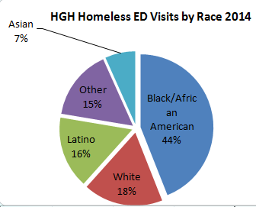 | 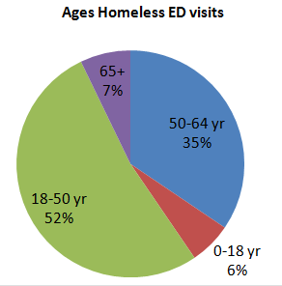 | 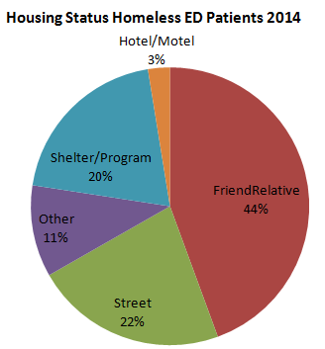
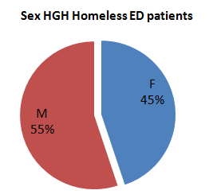 | 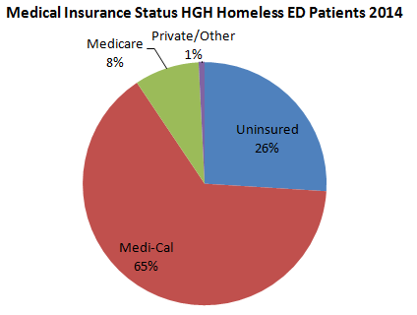
Source: HCH/AHS Data 2014
Types of ED visits
ACHCHP carried out an analysis of ED utilization data supplied by AHS for patients who were registered as homeless. Diagnosis codes, including diagnosis, accident (E), and supplemental (V) associated with persons experiencing homelessness treated at Highland ED during 2014 are analyzed in Figure 62 and Figure 62B):
Figure 62

Source: HCH/AHS Data 2014
Figure 62 shows primary diagnoses associated with ED visits. The most frequent primary diagnoses for ED visits are injuries caused by musculoskeletal problems, accidents or violence, chronic or acute pain. . Of note are frequent ED visits for mental health and drug/alcohol related conditions, including examinations of homeless persons brought by authorities on route to a psychiatric stay or drug/alcohol detox. Figure 62B lists all recorded diagnosis codes, including secondary codes, which shows the frequency of health conditions such as tobacco use and mental health and drug and alcohol misuse among homeless ED visitors. Noteworthy is the fact that in almost 40% of homeless ED visits, drug/alcohol or mental health conditions were documented as primary or secondary factors (Figure 63):
Figure 62B

Figure 63
Source: HCH/AHS Data 2014

Avoidable ED visits
482 of the 2,674 homeless ED visits, or 18%, can be considered 'Avoidable' by Medi-Cal standards, visits that could have been more appropriately treated in primary or urgent care settings. This is twice the county baseline of avoidable ED visits (9.5%). The vast majority of such visits for the homeless population fall into one of a few categories: psychiatric or other court-ordered examinations, visits to the ED for prescription medication refills, pain (e.g., head and back), and infections (respiratory, UTI, skin).
Homeless Frequent ED Users
Analysis of ED visit data from the first half of 2014 shows that of the 1,305 homeless ED visitors, twenty “high utilizers” made 324 visits or 12% of all visits. These Top 20 patients made between 11 and 55 ED visits each, with an average of 16.1 visits in six months. Homeless patients with at least 3 visits in six months made up over half of total ED visits. Homeless frequent users are largely male (69%), African American (64%), with a median age of 48 years (Figure 65):
Figure 64 | Figure 65  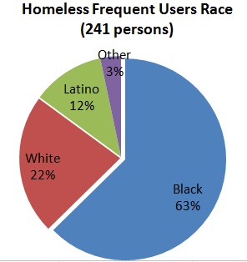
Source: HCH/AHS Data 2014
Mental health, substance abuse and chronic health conditions, are common among high utilizers, reinforcing national trends among high ED utilizers (Figure 64). Substance use was the single most common factor involving the top 20 high ED utilizers. At least 40% of AHS ED high utilizers have had some contact with the HCH program within the past five years.

Appendix 4:
Core Barriers and Health Indicators
(HRSA Need For Assistance Worksheet)

Core Barriers, Core Health Indicators and Other Health Indicators Affecting Homeless:
The Health Resources Services Administration requires HRSA/BPHC Health Center grantees to report on selected core health indicators, barriers, and other health indicators affecting the grantee’s target population. In the case of ACHCHP, the core population is persons experiencing homelessness throughout the catchment area of Alameda County. ACHCHP must present data on 3 selected core barriers and health indicators affecting the population of persons experiencing homelessness in Alameda County:
CORE BARRIERS to primary health care access for people experiencing homelessness within Alameda County:
  - The ratio of population to one Primary Care Physician FTE
General Population: The last published data regarding the ratio of general population to Primary Care Physicians FTE in Alameda County in 2006 was 1,082 residents per primary care physician. According to OSHPD data, there are 133 community primary care physicians, providing safety net care for low-income persons in Alameda County. If we compare that number to the number of persons at or below 100% of the Federal Poverty Level (FPL) in Alameda County (189,466) we arrive at a figure of 1,424 residents per FTE primary care physician, 32% higher than the county average (Figure 66).
Figure 5
This number reveals the challenge faced by the county as health care reform is implemented: Alameda County safety-net primary providers are stretched well beyond capacity, and resources to expand primary care capacity have been slower to come than expected under the Affordable Care Act.
Source: HCH 2014
California continues to have one of the lowest Medicaid reimbursement rates in the nation, and when the ACA-mandated rate increase for primary care physicians expires, and simultaneous 10% cuts in Medi-Cal reimbursement went into effect on 1/1/2015, it will be difficult for those doctors to continue taking on new patients and keep their doors open for business. Growing rolls of Medi-Cal eligible persons and decreasing private providers accepting new Medi-Cal or Medicare patients place greater pressure on community clinics. The result is longer waits for scheduled appointments, and increased pressure on providers and clinics to see more patients in a day and limited lengths of appointments. Currently waits for available appointments range from three weeks to four months at clinics throughout the County.
Homeless Population: Persons experiencing homelessness need comprehensive assessments to address multiple and related care issues, including behavioral health care, in a single appointment. Open scheduling systems, drop-in appointment availability and the ability to flex schedules to address inter-related issues, including provision of enabling services such as case management, benefits advocacy, and housing assessment, is critical. Care needs to be located near other services such as meals and shelter programs to ensure access to care for homeless individuals whose lives can be chaotic, and focused on competing priorities.

  - The percentage of the population at or below 200 percent of poverty
General Population: An estimated 28.7%of the total county population lives at or below 200% poverty. Based on the US Census Bureau 2013 population estimate, this is equal to 453,141 individuals. Approximately 13.2% of the total county population lives below 100% of the FPL, about 208,413 persons.
Homeless Population: According to 2013 HCHP UDS data for patients identifying as homeless at registration for a visit at a safety net clinic, 99.99% of the homeless population is at or below 200% of poverty and 97.1% of the homeless population lives at or below the 100% poverty line. The homeless population has the highest percentage of individuals living in poverty in the county. An obvious implication of this data is the fact that any fee for health care services, at any level, is a significant barrier to care for this population.

  - The percentage of the population that is uninsured
General Population: Through the Affordable Care Act (ACA) and Medi-Cal expansion, some 60,000 persons became eligible for Medi-Cal in 2014. 42,000 of them, including all homeless persons who had received ACHCHP services, were automatically transitioned to Medi-Cal in the beginning of 2014.
Alameda County will have approximately 100,000 persons under 200% of the FPL who are uninsured, approximately 7% of the population. These include undocumented persons ineligible for Medi-Cal, and persons eligible for Medi-Cal who are not enrolled (Figure 67).
Figure 67
Source: HCSA 2014

Homeless Uninsured: According to the 2013 UDS, 74% of homeless patients seen by ACHCHP were uninsured. During 2013, ACHCHP staff worked to transition every eligible person into Medi-Cal, and by late 2014, the number of uninsured homeless served by the HCH program has dropped to 35% (Figure 68).
Figure 68
Source: HCH 2014

HEALTH STATUS/Core Health Indicators of the homeless target population
HRSA-funded Health Center programs are required to report on indicators for each of six core health categories (diabetes, cardiovascular disease, cancer, prenatal and perinatal health, child health, and behavioral health), and two other health and access indicators that best characterize the needs of the homeless target population.
- Diabetes
Diabetes in the Alameda County homeless target population
Diabetes Adult Prevalence Rate (Percentage of Adult Population with diagnosis of Diabetes)
Target – County Homeless Population: 16% (by proxy population method)
Service Area – County General Population: 7.8%

According to the 2010 Alameda County Health Report, there is an overall diabetes rate of 7.8% in Alameda County. To calculate a diabetes prevalence rate specific to the homeless target population at the county level, we look at the race, class and place disparities in diabetes prevalence throughout Alameda County. The racial/ethnic make-up of Alameda County homeless population is skewed towards much higher representation of African Americans, who have a 66% higher rate of diabetes than average. Persons experiencing homelessness in Alameda County share characteristics with lower income ethnic and racial minority populations that also have higher percentages of uninsured, lower educational and literacy levels, and frequent barriers to health care access that would double and sometimes triple baseline mortality rates.
Source: HCSA 2014
Figure 69
UDS roll-out data shows that in California 10.4% of patients of FQHC clinics had a diagnosis of diabetes in 2013. Diabetes diagnosis was self-identified by 16% of respondents in the 2014 HCH Patient Survey, and was a primary or secondary diagnosis in 13.6% of HCH patients treated in mobile clinics and primary settings, and 16.3% of HCH patients treated in a primary care (non-mobile clinic) setting (2012-2013 HCH UDS data). It was also reported at a rate of 15% among homeless persons over age 50.
We believe that the amount of homeless persons with diabetes in Alameda County would be greater than these estimates, and arrived at an estimate of a diabetes prevalence rate of at least 16% among persons experiencing homelessness (Figure 69).
As in the general population, diabetes in the homeless population can lead to serious complications and premature death. Diabetes can lead to blindness, kidney damage, cardiovascular disease, and lower-limb amputations. Persons with poorly controlled diabetes (A1c > 9%) are three times more likely to have severe periodontitis than those without diabetes, and diabetics are more likely to die with pneumonia or influenza than people who do not have diabetes. Homeless adults are already at higher risk for complicated pneumonia and influenza and infections in general. People with diabetes are three times as likely to die of cardiovascular diseases, and smoking and diabetes together make a person 11 times more likely to die of a heart attack or stroke.
A primary goal ACHCHP, is to effectively assist homeless adults with diabetes to lower their risk for complications by controlling blood glucose, blood pressure, and blood lipids.
- Cardiovascular Disease
Hypertension hospital admission in the Alameda County homeless target population
Hypertension hospital admission rate (18 years and older; per 100,000)
Target - County Homeless Population: 3,331 per 100,000 (by proxy population method)
Service Area – County General Population: 1,890 per 100,000 (age adjusted)

For people experiencing homelessness there is a need for assistance to monitor and lower cholesterol and blood pressure, to maintain a healthy weight, to manage or prevent diabetes, to get support for quitting smoking, and as appropriate, to increase physical activity, to reduce their risk of developing heart disease. In the absence of data regarding hypertension hospitalization rates of homeless persons, we used a proxy method to estimate a base number for homeless hypertension hospitalizations. Extrapolating using the race, income and education breakdown of persons experiencing homelessness, we compared this population with that of African American residents of Alameda County who live in high poverty neighborhoods, and used this population as a proxy for all homeless persons throughout Alameda County, arriving at a hypertension hospitalization rate of 3,311 per 100,000, or almost twice the county baseline. See Figure 70.
Figure 70
Source: CAPE 2014
Cardiovascular disease is still the number one cause of mortality in the U.S. There is a high rate of tobacco use among homeless adult populations in Alameda and more support is needed to help individuals to access support for smoking cessation. A high number of homeless adults have mental illness and substance abuse disorders and are at greater risk for weight gain side effects of psychiatric medications, and for interruptions in medication management for hypertension.
- Cancer
Cancer in the Alameda County homeless target population
Percent of adults who currently smoke cigarettes
Target – County Homeless Population: estimated 80%
Service Area – County General Population: 11.7%
National Level: 17.3%

Smoking disproportionately affects the economically disadvantaged and the uneducated in America. It is estimated that between 70% and 80% of homeless adults in the United States smoke tobacco. By comparison, only 17.3% of adults in the national general population are smokers. In Alameda County, about 11.7% of the general population smokes tobacco. A review of smoking status documented by HCH mobile clinic staff in 2012-2013 shows over 80% homeless persons treated on HCH mobile medical clinics patients admitted to being current smokers. According to the data from the HOPE HOME study, 65% of homeless persons 50+ are active smokers. See Figure 71:
Figure 71
Source: HCH 2014

ACHCHP works with partners in the Public Health Department Tobacco program, Behavioral Health Care Services Tobacco Cessation projects, and is working to spearhead efforts to discourage smoking within shelters. Finally ACHCHP is making major quality improvement efforts towards documenting efforts that clinical staff already makes to identify tobacco use status, urge patients to quit, and most importantly, provide homeless patients with support, pharmacologic therapy and counseling to help them quit smoking.
  - Cancer
Prenatal and Perinatal Health in the Alameda County homeless target population
8% Pregnant Low-Income Women smoke during pregnancy
Target – County Homeless Population: 25% (by proxy population method)
Service Area – County General Population: 6.6%
National Median Benchmark: 14.1%

Homeless women are at higher risk to give birth to low birth weight babies as the result of higher rates of alcohol and drug and tobacco use during pregnancy, late entry into prenatal care, interrupted prenatal care, poor diet, unstable housing, stress, and lack support during pregnancy. Homeless persons, especially homeless mentally ill, as well as homeless persons recovering from drug and alcohol abuse, have an unusually high rate of tobacco use, ranging upwards of 70%, and tobacco use is the leading cause of preventable morbidity and mortality in the United States.
The baseline estimate for numbers of women who smoke during pregnancy in Alameda County is 6.6% based on the Maternal and Infant Health Assessment (MIHA) study. Housing status is not factored into this study; however similar studies show elevated levels of smoking by homeless mothers ranging from 9.8% (Los Angeles to 26% (Baltimore PRAM 2013). With this data, we can estimate that the percentage of pregnant women experiencing homelessness who smoke could be approximately 25%. A review of the very small number of pregnant women treated on mobile clinics by the HCH program between 2012-2013 reveals that approximately 75% of them were still smoking.
ACHCHP does not provide prenatal services as part of its HCH program, but does work closely with County programs targeted to women with High Risk Pregnancy who are receiving prenatal care in the community. ACHCHP also works with partners in the Public Health Department Tobacco Cessation program, and is working to spearhead efforts to discourage smoking within shelters. Finally ACHCHP is making major quality improvement efforts towards documenting efforts that clinical staff already makes to identify tobacco use status, urge patients to quit, and most importantly, provide homeless patients with support, pharmacologic therapy and counseling to help them quit smoking.

  - Children’s Health
Child Health in the Alameda County homeless target population
Pediatric asthma hospital admission rate (2-17 year olds; per 100,000)
Target – County Homeless Population: 1,200 per 100,000 (children <5yr)
Service Area – County General Population: 431 per 100,000 (children <5yr)
National Median Benchmark: 116 per 100,000 (2-17 year olds; per 100,000)

In the absence of asthma hospitalization data for children 0-17 experiencing homelessness in Alameda County, a proxy method will be used to arrive at this hospitalization rate. In Alameda County, almost one in five, or 18.6% of children and adolescents ages 0-17 years are estimated to have ever been diagnosed with asthma, compared with 14.8% of children and adolescents in California. Overall hospitalization rates in Alameda County are recorded for 0-5 year olds. Among both males and females, African Americans have three to five times higher asthma hospitalization rates than any other racial/ethnic group in 2009-2011. Using African American boys and girls 5 years and younger, living in Oakland and San Leandro, as a proxy for children experiencing homelessness, we develop an estimated rate of asthma hospitalization for children experiencing homelessness of 1,200 per 100,000 persons.

  - Behavioral Health
Behavioral Health in the Alameda County homeless target population
Percent of adults with at least one major depressive episode in the past year
Target – County Homeless Population: 50% (extrapolation)
Service Area –
Nationwide Benchmark: 6.6%
Alameda County: 8.9% of general population has experienced severe psychological distress in past year

According to State of California estimates Alameda County, some 4.4% of the general population suffers from serious mental illness, a number which jumps by 73% to 7.4% for persons living below 200% of the poverty level. Using a broader definition of need for mental health services, we see that 12.5% of the general population – a number which increases by 50% among persons living below 200% of the poverty level to 18.5%.
The HCH Program estimates that at least 50% of persons experiencing homelessness suffer from moderate to severe depression. Data from the 2003 Health Care for the Homeless (HCH) User Survey, which included HCH participants, revealed that 42% of respondents over the age of 13 reported having experienced at least one symptom of depression in the past month. 47% of homeless women meet the criteria for a diagnosis of major depressive disorder. 67% of homeless patients at the HCH TRUST Clinic were diagnosed with a major depressive disorder, while 8.3% of HCH patients treated at primary care clinics were diagnosed with a major depressive episode during 2012-2013. 30% of HCH patients surveyed disclosed that they suffered from some sort of mental illness. 41% of homeless persons surveyed in the Urban Health Study II reported depression, while 61% of the homeless 50+ year olds reported a history of depression.
Evidence based research shows that mental health screening is important only if the conditions exist to provide supportive and culturally relevant access to treatment for the homeless population, including primary care for chronic health conditions, smoking and drug/alcohol cessation support, benefits advocacy, suicide risk assessment, and access to supportive housing that is integrated into as many settings and sites as possible.
  - Other Conditions #1:
HIV infection prevalence among Persons Experiencing Homelessness in Alameda County
HIV infection prevalence
Target – County Homeless Population: 4.3% of persons experiencing homelessness
Service Area –
Nationwide Benchmark: 0.20% of total population
Alameda County: 0.35% of general population

HIV infection levels are disproportionately high – some 12 times higher than the county rate -- among persons experiencing homelessness in Alameda County. From a 2014 patient survey carried out for the Alameda County HIV Housing Needs Assessment, it is estimated that 187 persons living with HIV are homeless at one point in time in Alameda County, approximately 4.3% of the county homeless population. Another 239 persons living with HIV, or 9%, are unstably housed. Almost one-half (45.2%) of the low-income HIV/AIDS population in Alameda County is now or has recently (i.e., within the past three years) been homeless or unstably housed. An estimated 426 low-income HIV+ residents of Alameda County who are in primary care are homeless or unstably housed; that is, one in four low-income persons living with HIV in the county who does not have a rental subsidy.
Other estimates of HIV seropositivity come from the 2013 Point In Time Count where an estimated 2.3% of homeless persons self-identified as HIV+, and the UCSF HOPE/HOME study, in which 5.5% of the 50+ year old homeless persons in the study self-identified as HIV+.

  - Other Conditions #2:
Oral Health: Visits to Dentist or Dental Clinic in Previous Year
Percent of adults without a visit to a dentist or dental clinic in the past year for any reason
Target – County Homeless Population: estimated 70%
Service Area –
Nationwide Benchmark: 30.4% of total population
Alameda County: 31% of general population

In Alameda County, 69.1% of the general adult population had visited a dentist or dental clinic in the past year for any reason The HCH Program estimates that among homeless persons, this ration is reversed, at least, to an estimate of 70% without a visit to a dentist in the past year. The nationwide NHCHP users study in 2003 found that over half of homeless adults surveyed nationally had not seen a dentist in two years or more. Just 7.8% of the persons experiencing homelessness treated by the HCH program in 2012-2013 were able to access dental treatment through the HCH program. In the HOPE HOME study of homeless 50+ year olds, 71% of respondents had not seen a dentist in the past year, and 40.6% had not seen a dentist in over 5 years, while 93% report missing teeth, almost 60% missing over half of their teeth.

ALAMEDA COUNTY HEALTH DATA PROFILE, 2014 Community Assessment Planning and Evaluation Unit of the Alameda County Public Health Department.
Without Housing, Western Regional Advocacy Project, 2014
HOW ALAMEDA COUNTY’S HOUSING MARKET IS FAILING TO MEET THE NEEDS OF LOW-INCOME FAMILIES, California Housing Partnership Corporation, 2013.
Census: Bay Area leads state in population growth, Contra Costa Times 3/27/2015 http://www.contracostatimes.com/breaking-news/ci_27794736/census-bay-area-leads-state-population-growth
US Census, COMPARATIVE DEMOGRAPHIC ESTIMATES 2011-2013 American Community Survey 3-Year Estimates, Alameda County
Development Without Displacement – Resisting Gentrification in the Bay Area, Causa Justa and Alameda County Public Health Department, 2014.
Development Without Displacement – Resisting Gentrification in the Bay Area, Causa Justa and Alameda County Public Health Department, 2014
HOW ALAMEDA COUNTY’S HOUSING MARKET IS FAILING TO MEET THE NEEDS OF LOW-INCOME FAMILIES, California Housing Partnership Corporation, 2013
https://www.hudexchange.info/resources/documents/HEARTH_HomelessDefinition_FinalRule.pdf
http://bphc.hrsa.gov/policiesregulations/legislation/index.html
http://center.serve.org/nche/ibt/sc_eligibility.php
Key Findings and Policy Implications From the 2013 Alameda Countywide Homeless Count and Survey Report www.everyonehome.org/media/resources_homeless-count13.pdf
U.S. Department of Housing and Urban Development (HUD). (2011). The 2010 Annual Homeless Assessment Report to Congress. Washington, DC. HUD’s 2010 Annual Homeless Assessment Report to Congress , found 649,917 persons homeless in a one-night PITC count in 2010, and reported 1,593,150 persons homeless during the calendar year. This ratio of 2.45, gives us a low-end estimate of 10,452 persons experiencing homelessness as defined by HUD criteria, in Alameda County during 2013.
A New Look at Homelessness in America, Martha Burt, Urban Institute, 2000, http://www.urban.org/publications/900302.html#burt
National Coalition for the Homeless, http://www.nationalhomeless.org/factsheets/How_Many.html
EveryOne Home, Alameda County Housing and Community Development, CY2013 HMIS Utilization Report System Wide without Permanent Supportive Housing and Services to Permanent Supportive Housing.
If a child’s family is homeless (according to HRSA definitions) they are able -- under the federal McKinney-Vento Act -- to access free transportation and to attend their school of origin regardless of where their family temporarily resides. Schools must register homeless children even if they lack normally required documents, such as immunization records or proof of residence. The state of California creates procedures, including dispute resolution procedures, to ensure that homeless children are able to attend school. Local school districts appoint Local Education Liaisons to ensure that school staff is aware of these rights, to provide public notice to homeless families (at shelters and at school) and to facilitate access to school and transportation services.
California Department of Education, California Longitudinal Pupil Achievement Data System (CALPADS) report run 11/20/2014, for academic year 2013-2014.
A New Look at Homelessness in America, Martha Burt, Urban Institute, 2000, http://www.urban.org/publications/900302.html#burt
Home Stretch – Data Summary: July 1, 2014, Housing Services Office, Alameda County Behavioral Health Care Services.
Mortality among homeless adults in Boston: shifts in causes of death over a 15-year period, J.J. O’Connell, JAMA Internal Medicine 2013.
The health of homeless people in high-income countries: descriptive epidemiology, health consequences, and clinical and policy recommendations Fazel, Seena, Kushel. The Lancet 2014.
Chung and Wang, Risk of death among homeless women: a cohort study and review of the literature, CMAJ 2010.
Mortality After Prison Release: Opioid Overdose and Other Causes of Death, Risk Factors, and Time Trends From 1999 to 2009, Annals of Internal Medicine, 2013; National Vital Statistics Report (NVSR) “Deaths: Final Data for 2011.”
Sacramento County Homeless Deaths Report: 2002 - 2013
Seattle King County, Health Care for the Homeless Network Annual Report 2010
We Will Remember 2012:H o m e l e s s D e a t h R e v i e w, Colorado Coalition for the Homeless
DOMICILE UNKNOWN Medical Examiner Review of deaths among people experiencing homelessness in Multnomah County in 2011
Deaths Among Homeless Persons in Santa Barbara County 1/1/2010 to 12/31/2011 Annual Report
Based on OSHPD 2010-2012 Hospital discharge data; #2 ranking of diagnosis groups was “Other”.
Modifiable cardiovascular risk factors among individuals in low socioeconomic communities and homeless shelters, Kim, Family Community Health 2008.
State of the HIV Epidemic in Alameda County, HIV AIDS Epidemiology Unite, ACPHD 2013.
Geriatric syndromes in older homeless adults, Brown, Mitchell. Journal of Internal Medicine, 2012
Unpublished Data from UCSF HOPE HOME Study: Aging Homeless in Oakland, funded by National Institute of Aging, Principal Investigator Margot Kushel MD
The health of homeless people in high-income countries: descriptive epidemiology, health consequences, and clinical and policy recommendations Fazel, Seena, Kushel. The Lancet 2014.
Unpublished Data from UCSF HOPE HOME Study: Aging Homeless in Oakland, funded by National Institute of Aging, Principal Investigator Margot Kushel MD
Going Gray in the Golden State: The Reality of Poverty Among Seniors in Oakland, California. The Oakland Institute 2006
http://www.alamedasocialservices.org/public/services/elders_and_disabled_adults/docs/SENIOR_HOUSING_GUIDE_2012_English.pdf
2013 Alameda Countywide Homeless County and Survey
2013 Alameda Countywide Homeless County and Survey
Unpublished Data, RTI International, Health and Criminal Justice Involvement among Drug Users in Oakland, CA, lead investigator Jennifer Lorvick.
Inside the Safety Net – 2014 Alameda County General Assistance Evaluation, Roots Health, Inc under contract of the Alameda County Social Services Agency.
Estimate made by counting patients not eligible for medi-cal, and covered by HealthPAC, an indigent care health coverage program which covers a primarily undocumented population.
Aging Behind Bars --Trends and Implications of Graying Prisoners in the Federal Prison System, Urban Institute, 2014
R. Jan Gurley, MD http://www.reportingonhealth.org/blogs/more-prisonhomeless-churn 4/11/2011
COMPAS Validation Study: Final Report, California Department of Corrections and Rehabilitation, August 15, 2010
Inside the Safety Net – 2014 Alameda County General Assistance Evaluation, Roots Health, Inc under contract of the Alameda County Social Services Agency.
Alameda County Probation Department Adult Services Division Monthly Post-Release Community Supervision (PRCS) Caseload Update,August 2014
Western Regional Advocacy Project, Ongoing research, Paul Boden, www.wraphome.org, April 2011.
Food insecurity is defined: “limited or inadequate ability to obtain nutritionally adequate and safe foods; the inability to acquire those foods in a socially acceptable way” Local Needs Assessment Youth – Food Stamp Nutrition Education Program Alameda County 10/2010.
Alameda County Food Bank, 2014 Policy Report, www.accfb.org
List of all stakeholders interviewed.
http://www.nhchc.org/wp-content/uploads/2011/10/Housing-is-Health-Care.pdf
http://www.thelancet.com/pdfs/journals/lancet/PIIS0140-6736(14)61133-8.pdf
http://caph.org/wp-content/uploads/2014/12/Whole-Person-Care_Target-Population_Martinez_PPT-and-Handout.pdf
http://www.cnhed.org/blog/2011/11/permanent-supportive-housing-a-cost-effective-alternative-in-the-district-of-columbia/
http://www.pmhs.org/operation-safety-net/
http://www.scvmc.org/services/homeless/Pages/services-programs.aspx
http://dbhids.us/homeless-services/
Alameda County Emergency Solutions Grant funding was cut by 35% between 2012 and 2013, and strict limits imposed on the amount of ESG allocation which can be used for emergency shelters.
2013, Occupational Safety and Health Administration, “Code of Federal Regulations, Title 29 Labor, § 1910.141 Sanitation.” Although the County is not a “workplace,” OSHA calculations are based on biological, health and safety needs appropriate for any concentration or population of individuals. Note that OSHA defines restrooms as necessarily including potable water.
California Office of Statewide Health Planning and Development, Hospital Annual Utilization Data, 2010-2012
California Office of Statewide Health Planning and Development, Hospital Annual Utilization Data, 2013
A L A M E DA C OU N T Y H E A LT H DATA PROFILE, 2014 Alameda County Community Assessment Planning and Evaluation Unit.
Dartmouth Atlas of Health Care, http://www.dartmouthatlas.org/data/region/profile.aspdx?loc=55
California Office of Statewide Health Planning and Development (OSHPD), Primary Care and Specialty Clinics Annual Utilization Data CY 2013.
Increasing Access to Health Care for Low-Income Uninsured Residents of Alameda County, Alameda County 2007 Baseline Assessment, Alameda County Access to Care Collaborative
Alameda Alliance for Health primary care provider search run 11/2014 https://secure.healthx.com/PublicService/ProviderDirectoryV2/ProviderSearch.aspx?bc={f85752f6-5c4d-4326-9ed3-1ef5525b0a18}&serviceid={bdb91e58-8dba-49cd-a075-530c0b565c5f}
Reporting from Alameda County Health Care Services Agency and reporting from ACHCHP social workers 11/2014.
http://factfinder2.census.gov/faces/tableservices/jsf/pages/productview.xhtml?pid=ACS_12_3YR_S2702&prodType=table.
2014 Human Impact Budget Report, Alameda County http://www.acgov.org/hib/reports.htm
County of Alameda, Public Health Department. The Health Of Alameda County, Cities and Places, 2010. Alameda County, CA. September 2010.
Saydah S, Lochner K. Socioeconomic Status and Risk of Diabetes-Related Mortality in the U.S. Public Health Reports 2010;125(3):377-388.
Unpublished Data from UCSF HOPE HOME Study: Aging Homeless in Oakland, funded by National Institute of Aging, Principal Investigator Margot Kushel MD
Socioeconomic Status and Risk of Diabetes-Related Mortality in the United States, Sharon Saydah, PhD, CDC, PHR Webcast, August 31, 2010, www.PublicHealthreports.org
http://www.nationalhomeless.org/factsheets/tobacco.html
Unpublished Data from UCSF HOPE HOME Study: Aging Homeless in Oakland, funded by National Institute of Aging, Principal Investigator Margot Kushel MD
Los Angeles Mommy and Baby (LAMB) Projects survey data 2010, Maryland PRAMS Focus on Homelessness Among Maryland Women Giving Birth 2004-2010
Alameda County Health Data Profile, 2014 County of Alameda Community Assessment Planning and Evaluation department. Pg 80.
California Mental Health Prevalence Estimates by County 2012, based on 2000 census data, California Department of Health Care Services, http://www.dhcs.ca.gov/provgovpart/Documents/CaliforniaPrevalenceEstimates.pdf
http://www.nhchc.org/wp-content/uploads/2012/02/KeyPrevHealthMeas_FINAL.pdf
American Psycological Association, Homelessness and Health, http://www.apa.org/pi/ses/resources/publications/homelessness-health.aspx
Unpublished Data, RTI International, Health and Criminal Justice Involvement among Drug Users in Oakland, CA, lead investigator Jennifer Lorvick.
http://www.uspreventiveservicestaskforce.org/Page/Topic/recommendation-summary/depression-in-adults-screening?ds=1&s=, Among homeless persons, depression screening should be part of preventive care in conjunction with effective delivery of care. Potential barriers to depression screening in homeless health care settings are related to the services required for treatment, including lack of counseling services, specialists who prescribe appropriate medications, pharmaceutical services and ability to maintain routine follow-up care. Cultural beliefs and attitudes regarding mental health issues, including depression, can also be barriers to the provision of depression screening and care. The USPSTF (2009b) recommends screening in clinical settings that have the resources available to provide “adequate diagnosis, effective treatment, and follow-up.” It is unlikely that clinical settings that do not have the resources and support care systems available can positively impact depression outcomes. Therefore, staff-assisted depression care supports should be prioritized so that accurate diagnosis, effective treatment and follow-up can be offered to all individuals presenting for care.
Alameda County AIDS Housing Needs Assessment, 2014, Spiegelman and Associates http://www.acgov.org/cda/hcd/documents/AIDSHousingNeedsAssessment-Part1.pdf
2013 PITC
http://apps.nccd.cdc.gov/BRFSS-SMART/MMSARiskChart.asp?yr=2012&MMSA=281&cat=OH&qkey=8471&grp=0
http://www.nhchc.org/wp-content/uploads/2012/02/hh-0603.pdf
Unpublished Data from UCSF HOPE HOME Study: Aging Homeless in Oakland, funded by National Institute of Aging, Principal Investigator Margot Kushel MD

