SECOND AMENDMENT TO AGREEMENT

This Second Amendment to Agreement (“Second Amendment”) is made by the County of Alameda (“County”) and Roots Community Health Center, (“Contractor”) with respect to that certain agreement (Procurement Contract No. 11961) entered by them on June 2, 2015 and that certain First Amendment to Agreement (“First Amendment”) dated October 11, 2016, (collectively herein, the “Contract” or “Agreement”) pursuant to which Contractor provides street medicine and outreach services to County.

For valuable consideration, the receipt and sufficiency of which are hereby acknowledged, County and Contractor agree to amend the Agreement as follows:

- In consideration for Contractor’s additional services, the County shall pay Contractor in an additional amount not to exceed two hundred twenty one thousand six hundred and twenty-seven dollars ($221,627.00). The not to exceed amount is therefore amended and increased from one million, one hundred and ninety-three thousand, two-hundred and eight dollars ($1,193,208.00) to one million, four hundred and fourteen thousand, eight-hundred and thirty-five dollars ($1,414,835.00) over the term of the Agreement and any amendments; the maximum amount payable to Contractor under Item 20, Termination, is amended from $1,193,208.00 to $1,414,835.00.

- The attached Exhibit A-2 - Program Description and Performance Requirements, is incorporated into this Agreement by this reference; Exhibit A-2 supplements Exhibit A-1, which was attached to the First Amendment.

- The attached Exhibit B-2, Payment Terms is incorporated into this Agreement by this reference and supplements the revised Exhibit B that was attached and incorporated into this Agreement by the First Amendment.

- Except as otherwise stated in this Second Amendment, the terms and provisions of this Second Amendment will be effective as of the date this Second Amendment is executed by the County.

- The term of the Agreement is currently scheduled to expire on April 30, 2019. As of the effective date of this Second Amendment, the term of the Agreement is extended through December 31, 2019.

- Exhibit C, Insurance Requirements, is amended and replaced by the attached Exhibit C, Insurance Requirements.

- DEBARMENT AND SUSPENSION CERTIFICATION:

- By signing this Second Amendment and Exhibit D-2, Debarment and Suspension Certification, which is attached and incorporated in to this Agreement by this reference, Contractor/Grantee agrees to comply with applicable federal suspension and debarment regulations, including but not limited to 7 Code of Federal Regulations (CFR) 246.3, 246.4, 246.6, 248.3, 248.22; 24 CFR 200.31, 1003.608; 28 CFR 83.630, 83.670, 29 CFR 95.13, 97.35, 1470.35; 34 CFR 84.630, 84.670, 206.4, 222.19, 225.3, 226.3, 270.6, 280.3, 303.3, 350.4; 45 CFR 75.205, 75.213, 630.630, 630.670, 1325.9, 1329.3, 1330.2, 1355.30, 1370.3, and Executive Orders 12549 and 12689.

- By signing this agreement, Contractor certifies to the best of its knowledge and belief, that it and its principals:

  - Are not presently debarred, suspended, proposed for debarment, declared ineligible, or voluntary excluded by any federal department or agency;

  - Shall not knowingly enter into any covered transaction with a person who is proposed for debarment under federal regulations, debarred, suspended, declared ineligible, or voluntarily excluded from participation in such transaction.
- County will verify Contractor, its principal and their named subcontractors are not on the Federal debarred, suspended or otherwise excluded list of vendors located at the System for Award Management website (SAM): www.SAM.gov;
  - There is NO FEE to register or maintain your SAM.gov registration.
  - County requires SAM.gov registration to include a DUNS number.
  - DUNS = Data Universal Numbering System: A code required by the federal government for all organizations applying for federal grants. The 9-digit code is issued by the Dun and Bradstreet (D&B) at NO FEE and gives organizations, such as the County useful information for making credit, purchasing and marketing decisions. This code is thus used by the County to evaluate the creditworthiness of grants applicants. Contractors and bidders to various government procurements are also evaluated using DUNS.
  - Get a DUNS: http://www.dnb.com/DUNS-number.html.

- Except as expressly modified by this Second Amendment, all of the terms and conditions of the Contract are and remain in full force and effect.

[SIGNATURE PAGE TO FOLLOW]

IN WITNESS WHEREOF, the parties hereto have executed this Second Amendment to Agreement as of the day and year first above written.

COUNTY OF ALAMEDA |  | CONTRACTOR/COMPANY NAME
By:______________________________  Signature |  | By:_____________________________  Signature
Name:____________________________  (Printed) |  | Name: Noha Aboelata, MD 11  (Printed)
Title: President of the Board of Supervisors |  | Title: Chief Executive Officer 1
 |  | Date:___________________________
Approved as to Form:
DONNA R. ZIEGLER, County Counsel

By:________________________________  K. Joon, Oh, Deputy County Counsel |  | By signing above, signatory warrants and represents that he/she executed this Second Amendment in his/her authorized capacity and that by his/her signature on this Second Amendment, he/she or the entity upon behalf of which he/she acted, executed this Second Amendment

EXHIBIT A-2
PROGRAM DESCRIPTION AND PERFORMANCE REQUIREMENTS

Contracting Department | Health Care Services Agency Administration and Indigent Health
Contractor Name | Roots Community Health Center
Contract Period | May 1, 2019 through December 31, 2019
Type of Services | Street Medicine
Procurement Contract No. | 11961

- Program Name
Oakland STOMP (Street Team Outreach Medical Program)

- Contracted Services

Roots Community Health Center (“Contractor”) shall ensure that funds are used to provide street medicine and medical outreach services to residents experiencing homelessness in East Oakland.

The Oakland STOMP team will provide medical outreach to engage individuals by offering medical care, and referrals to health care, housing navigation, and social services tailored to the needs of people experiencing homelessness in the East Oakland Community. The overall goal of the program is to:

- Provide reliable, quality health care, based on best practices.
- Improve the health and well-being of East Oakland residents experiencing homelessness through expanding access to health care for unsheltered individuals
- Connect individuals to a medical home and other social services.

- Program Information and Requirements
- Program Goals
Contractor shall provide services to accomplish the following goals:

- Contractor shall develop a medical outreach team consisting of one clinician (M.D.), one medical assistant, and two health navigators/care coordinators with expertise in servicing homeless individuals.
- Contractor shall operate street medicine services, including availability of face-to-face provider visits, at least 20 hours per week.
- Contractor shall provide care coordination to achieve overall high-quality care, improve clinical outcomes and client satisfaction to care.
- Health Navigator/Care Coordinator role shall include the following functions: coordinate access to health services including primary care and specialist services; health insurance enrollment of eligible uninsured individuals into Medi-Cal; linkage to public benefits (CalFresh, CalWORKs, GA, Social Security – SSI, SSDI, SSA); and linkage to coordination entry system.
- Contractor shall partner with Housing Resource Centers (HRC) Outreach Assessors to identify and refer clients meeting eligibility criteria to HRC’s services, prioritize clients with the highest vulnerability.
- Contractor shall operate at least one stable primary care clinic site that can serve as a medical home to patients.
- Contractor shall dispense limited medications and laboratory services as part of the street medicine program.
- Contractor shall provide transportation assistance for services to address urgent health needs.
- Contractor shall work, coordinate, and collaborate with homeless service providers and other stakeholders at the request of HCSA to design and/or implement clinical services and operations.
- Contractor shall bill payers including alameda Alliance for Health and Anthem Blue Cross managed Medi-Cal plans for eligible services rendered. Pursuant to the Health Care for the Homeless Sliding Fee Discount Policy, Contractor shall not require payment from homeless individuals for services delivered under this contract.

- Target Population
Contractor shall provide services to the following populations:

- Service Groups
Contractor shall provide services to individuals experiencing homelessness (as defined by HRSA PAL 1992-1 2) who are found at homeless encampments and other locations where homeless individuals spend time in Downtown, West and East Oakland.

- Referral Process to Program
Contractor shall identify eligible individuals at homeless encampments and other locations where homeless individuals spend time in East Oakland. Contractor may also accept potential referrals by phone from other outreach and homeless service providers in the area, including Alameda County Health Care for the Homeless (AHCH).

- Program Eligibility
Contractor shall only serve clients who consent to receiving services.

- Limitations of Service
Contractor shall prioritize staff safety at all times

- Program Requirements
Contractor shall maintain program services at the following minimum levels:

- Program Design
Hours of Operation and Service Delivery Street Locations
Contractor shall provide twenty (20) hours of street medicine per week.

- Consumer/Client Flow
Intake is conducted at the initial visit. At each visit, subjective and objective assessment, impression and plan development, differential diagnosis, and intervention(s) are conducted and documented. Benefits enrollment, housing assessment, linkages and referrals are conducted when indicated.

- Discharge Criteria and Process
n/a

- Service Delivery Sites
Contractor shall provide services at the following location(s):
In addition to providing direct outreach and clinical services and encampments and other locations in Downtown, West and East Oakland where homeless individuals can be found, Contractor shall provide services at the following stable primary care clinic:

9925 International Blvd. #5, Oakland, CA 94603

- Minimum Staffing Qualifications
The medical outreach team will be staffed by a multi-disciplinary team. At least one member of the team shall be a licensed primary care provider credentialed to bill Alameda Alliance for Health for services rendered. Contractor shall have and maintain current job descriptions on file with the HCSA for all personnel whose salaries, wages, and benefits are reimbursable in whole or in part under this agreement. Job descriptions shall specify the minimum qualifications for services to be performed and shall meet the approval of HCSA ACHCH. Contractor shall submit revised job descriptions meeting the approval of HCSA ACHCH prior to implementing any changes or employing persons who do not meet the minimum qualifications on file with HCSA.

- Contract Deliverables and Requirements

- Process Objectives

May 1-July 1
During this period STOMP team will continue to provide services to encampments in East, Downtown and West Oakland per the terms of Standard Service Agreement.

ROOTS shall be responsible for submitting on a monthly basis UDS utilization data for every documented, face-to-face patient clinical and enabling services encounter provided under the terms of this contract. Monthly data utilization reports will follow standards outlined in ACHCH Data and Patient Reporting Requirements attachment.

ROOTS shall be responsible for timely submission of federally required UDS finance, revenue, personnel and patient outcomes data by January 20, 2020.

ROOTS will share with the Alliance on or before June 30, 2019 client data needed to support care transitions, including names and identifying information as well as visit history for STOMP clients who are AAH members. ROOTS will submit similar data (by a mechanism to be determined) in order to identify Anthem or Fee for Service clients by August 30, 2019.

July 1-Dec 31
ROOTS will assist in development and execution of a transition plan by July 31, 2019 to ensure that patients who need or desire care transition are meaningfully connected to ongoing primary care services by December 31, 2019. The plan for transition shall be developed in a work group convened by Alameda Alliance and including HCSA, STOMP and the new Oakland Street Medicine teams.

STOMP will stop accepting new patients and will focus solely on the transition of existing patients. After completion of the plan, ROOTS will meet regularly with the transition group for case conferencing and warm handoffs for those clients most in need.

- Reporting and Evaluation Requirements

Contractor shall submit a Monthly report with the following elements to document progress toward the objectives above.

Utilization – MS Excel file of provider and support staff encounter data site” will include separate codes for medical van, “backpack “encounter, and primary care stable site

Financial – Contract start-to-date budget vs. actual revenue and expenditures, including reimbursement from third-party payers for services provided.

- Reporting Requirements
Contactor shall submit monthly progress reports, referencing the activities and performance measures listed in Section IV.A. of this Exhibit. Progress reports shall include performance measures achieved during the reporting period as well as cumulative, fiscal year-to-date totals. All reports shall be completed and information relayed in a manner so that they can be viewed as public documents.

Contractor shall provide the HCSA with monthly reports utilizing the following schedule.

May 15, 2019 (for the period covering April 1, 2019 through April 30, 2019)
June 15, 2019 (for the period covering May 1, 2019 through May 31, 2019)
July 15, 2019 (for the period covering June 1, 2019 through June 30, 2019)
August 15, 2019 (for the period covering July 1, 2019 through July 31, 2019)
September 15, 2019 (for the period covering August 1, 2019 through August 10, 2019)
October 15, 2019 (for the period covering September 1, 2019 through September 30, 2019)
November 15, 2019 (for the period covering October 1, 2019 through October 31, 2019)
December 15, 2019 (for the period covering November 1, 2019 through November 30, 2019)
January 15, 2020 (for the period covering December 1, 2019 through December 31, 2019)

If reporting requirements cannot be met by above deadlines, Contractor shall immediately contact HCSA with the reason for delay and the estimated date for report completion. It is within the discretion of HCSA to extend any due date. Lack of notification or failure to meet a deadline can result in fund reduction. Contractor shall include submissions of the data reports with each invoice in order to receive payment.

Data Capture for the Homeless Project. Contractor shall capture data on homeless patients identified through the street medicine and outreach project as described in Section V. Data elements may change or additional reports may be required based upon changing requirements of the Health Resources and Services Administration for Community Health Centers.

3. Monitoring of Data Collection. Contractor shall monitor the integrity of all stages of data collection pursuant to this Agreement including, but not limited to, front end performance, homeless patient billing information, and proper completion of intake or other required data forms, as appropriate.

- Other Reporting Requirements
- Contactor shall submit monthly progress reports, referencing the activities and performance measures listed in Sections IV and V of this Exhibit. Progress reports shall include performance measures achieved during the reporting period as well as cumulative, year-to-date totals. All reports shall be completed and information relayed in a manner so that they can be viewed as public documents. Contractor shall not provide any Personally Identifiable Health Information or other confidential or protected data to County. Please use the Secured FTP System to provide any Personally Identifiable Health Information.

- Evaluation Requirements

- Additional Requirements

- Certification/Licensure
Contractor shall have and maintain current DHCS community clinic license

- Entirety of Agreement
Contractor shall abide by all provisions of the Human Services Master Contract General Terms and Conditions, all Exhibits, and all Attachments that are associated with and included in this contract.

EXHIBIT B-2
PAYMENT TERMS

- COMPENSATION TO CONTRACTOR
  - Compensation under the terms and condition of this agreement shall not exceed the amount of $1,414,835 for the duration of this Agreement. Funds shall be used solely in support of the project’s program budget of Exhibit B of the First Amendment and Exhibit B-2 of the Second Amendment.
  - The term of this Agreement shall commence June 2, 2015 and end December 31, 2019.

II. Terms and Conditions of Payment
- Contractor shall invoice the County quarterly for actual expenses incurred. The final invoice shall be for an amount not to exceed the remaining balance of the contract. The final invoice and annual report must be received no later than January 15, 2020.

- Contractor shall submit invoices, with all required progress reports in accordance with the reporting requirements, to Alameda County Health Care Services Agency (HCSA).

- Invoice must be accompanied by reports described in the Exhibit A-2.

- Funds shall be used solely in support of the project’s program budget and may not be used for any purpose other than those specified in this Agreement without prior written approval from the Alameda County Health Care Services Agency. Reimbursement is limited to actual expenses and in accordance to the items and costs as set forth in the Budget Summary.

- County shall use its best efforts to process invoice submitted for reimbursement by contractor within thirty (30) days of receipt of invoice, required report and any other requested documentation. Invoices will be reviewed by and not paid until approved by the Alameda County Health Care Services Agency.

III. Invoicing Procedures
Contractor shall invoice the County in accordance with the schedule of payment in Section II.A.1 above. Invoices must include the Purchase Order (PO) number, service period and all required reports (see Exhibit A, Section VI Reporting and Evaluation Requirements), and shall be sent to:

Alameda County Health Care Services Agency
ATTN: Terri moore, hch contracts manager
1404 franklin street, Ste 200
oakland, ca 94612

Invoices may also be emailed along with required progress reports to the Alameda County Health Care Services Agency Health Care for the Homeless Program. Terri Moore, Contracts Manger at Terri.Moore@acgov.org.

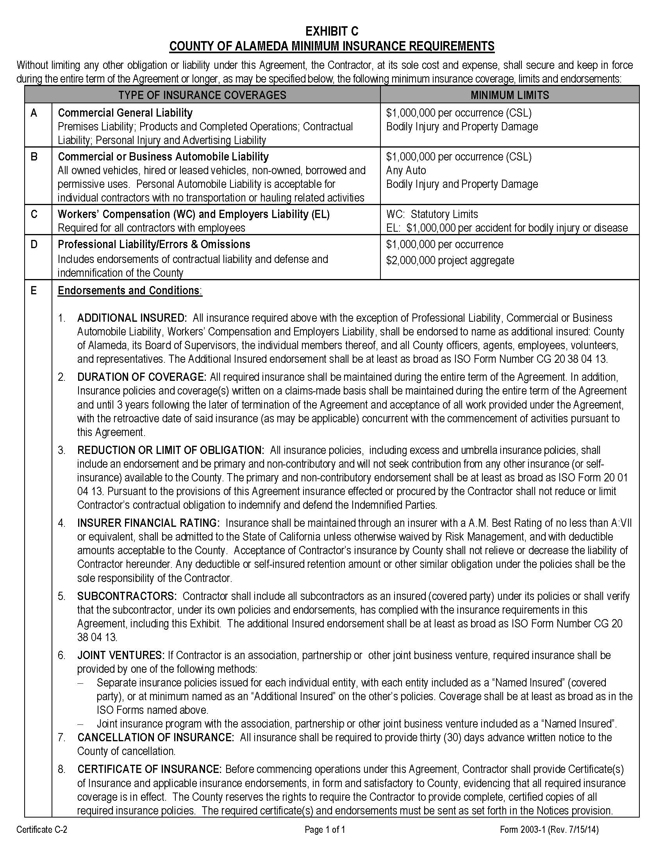

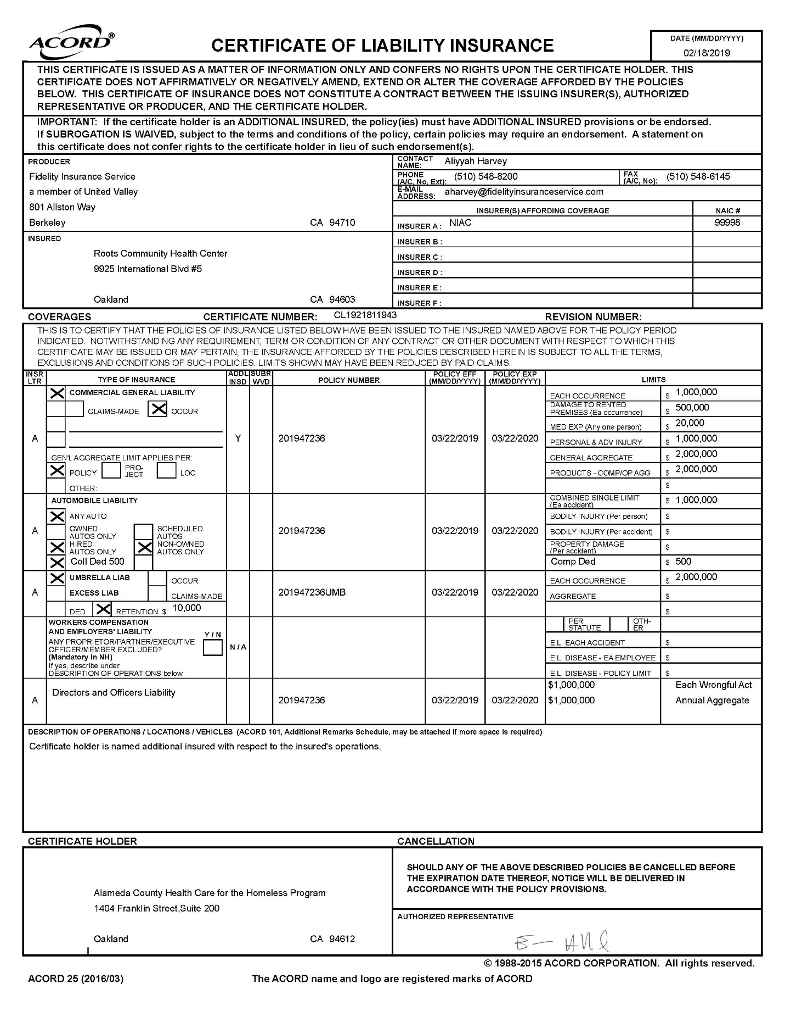

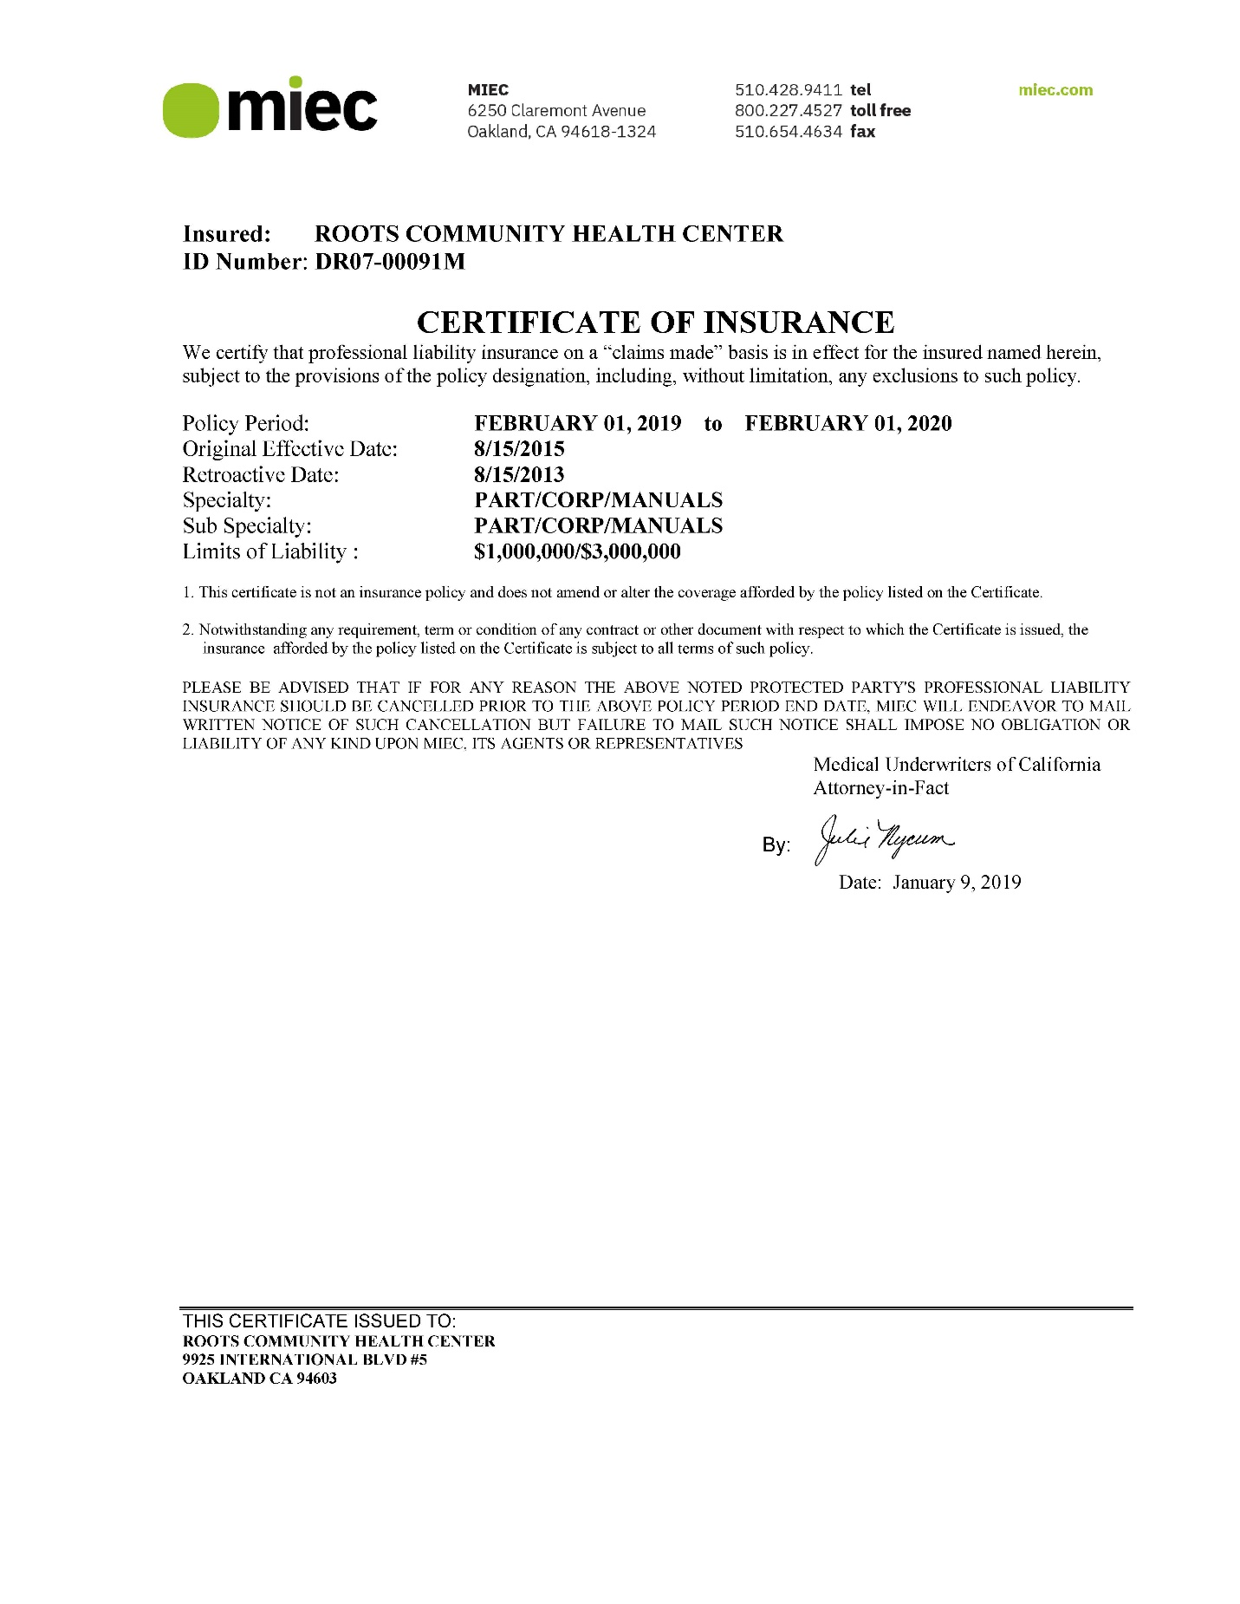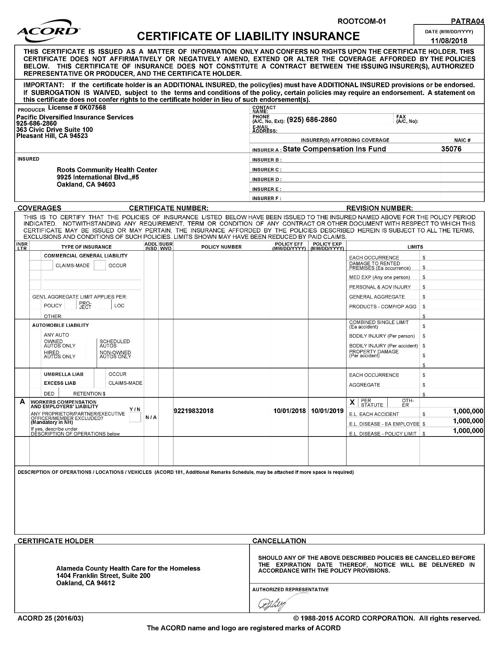

EXHIBIT D-2

COUNTY OF ALAMEDA
DEBARMENT AND SUSPENSION CERTIFICATION

The contractor, under penalty of perjury, certifies that, except as noted below, contractor, its principals, and any named or unnamed subcontractor:

- Is not currently under suspension, debarment, voluntary exclusion, or determination of ineligibility by any federal agency;
- Has not been suspended, debarred, voluntarily excluded or determined ineligible by any federal agency within the past three years;
- Does not have a proposed debarment pending; and
- Has not been indicted, convicted, or had a civil judgment rendered against it by a court of competent jurisdiction in any matter involving fraud or official misconduct within the past three years.

If there are any exceptions to this certification, insert the exceptions in the following space.

Exceptions will not necessary result in denial of award, but will be considered in determining contractor responsibility. For any exception noted above, indicate below to whom it applies, initiating agency, and dates of action.

Notes: Providing false information may result in criminal prosecution or administrative sanctions. The above certification is part of the Standard Services Agreement. Signing this Standard Services Agreement on the signature portion thereof shall also constitute signature of this Certification.

CONTRACTOR: Roots Community Health Center

PRINCIPAL: Noha Aboelata, MD TITLE: Chief Executive Officer

SIGNATURE: ______________________________ DATE: _______________________

