Form 110-8 Rev 09/30/15

COMMUNITY BASED ORGANIZATION
MASTER CONTRACT EXHIBIT A & B COVERSHEET

Dept. Name: HCSA Vendor ID #: 0000032495 Board PO #: ____________________________
Bus Unit: HCSVC Master Contract #: 900077 Procurement Contract #: 17752 Budget Year: 2019
Acct # | Fund # | Dept. # | Program # | Subclass # | Project / Grant # | Amount to be Encumbered | Total Contract Amount
610341 | 10000 | 350106 | 00000 |  |  | $780,176 | $780,176

Justification if partial encumbrance or liquidation requested: ___________________________________________________________________
____________________________________________________________________________________________________________________
Federal Funds Waiver #: ______________________________________________ Contract Maximum: $780,176
Procurement Contract Begin Date: January 1, 2019 Expire Date: December 31, 2019 Period of Funding From: January 1, 2019 to: December 31, 2019
Department Contact: Terri Moore Telephone #: 510-891-8927 QIC Code: 26201
Contractor Name: Alameda Health System
Project Name: Health Care for the Homeless_______________________________
Contractor Address: 141 East 31st Street, Oakland, CA 94602
Remittance Address: Same as Above ALCOLINK Vendor Address #: _____________ BOS Dist. #:
Contractor Telephone #:510-437-5086 Fax #: ___________________ E-mail (Signatory): dfinley@alamedahealthsystem.org
Contractor Contact Person: Heather MacDonald Fine E-mail (Contact): hmacdonald@alamedahealthsystem.org
Contract Service Category: Estimated Units of Service: ___________________________
Method of Reimbursement (Invoicing Procedures): Monthly reports and invoices shall not exceed $65,014.
History of Funding: | Original | Amendment #1 | Amendment #2 | Amendment #3 | Amendment #4
Funding Level | $780,176
Amount of Encumbrance | $780,176
File Date
File / Item #
Reason | Renewal

Funding Source Allocation: | Federal - CFDA #: 93.224 | State | County
 | $616,788 | $ | $163,388

The signatures below signify that the attached Exhibits A and B have been received, negotiated and finalized. The Contractor also signifies agreement with all provisions of the Master Contract.

DEPARTMENT

By
Signature

Print or Type Name

Title: President of Board of Supervisors Date

CONTRACTOR

By
Signature

Delvecchio Finley
Print or Type Name

Title: Chief Executive Officer Date

.
EXHIBIT A
PROGRAM DESCRIPTION AND PERFORMANCE REQUIREMENTS
Contracting Department | Health Care Services Agency Administration and Indigent Health
Contractor Name | Alameda Health System
Contract Period | January 1, 2019 through December 31, 2019
Type of Services | Homeless Health Center
Procurement Contract No. | 17752

This table provides information required by federal government Department of Health and Human Services (HHS) Health Resources Services Agency (HRSA) for subrecipient agreements carried out by Health Center program grantees.
Federal Award Information
Subaward of Federal funds | Yes
AHS Reregistered Name under the Data Universal Number System (DUNS) | Alameda Health System
AHS DUNS number | 103-717-336
AHS EIN | 94-2897258
Federal Award Identification Number | H80CS00049
Federal Award Date | January 1, 2016
Subaward Period of Performance Start & End Date | 1/1/2016 – 12/31/2019
Amount of Federal Funds Obligated by this Action | $616,788
Total Amount of Federal Funds Obligated to the AHS | $616,788
Total Amount of the Federal Award to AHS | $616,788
Federal award project description, as required to be responsive to the Federal Funding Accountability and Transparency Act (FFATA) | Health Center Cluster Funding for Alameda County Health Care for the Homeless Program
Name of Federal Awarding Agency (FAA), Pass-Through Entity (PTE), and Contact Information for Awarding official at Pass-Through Entity | 1) FAA: Health Resources and Services Administration / Bureau of Primary Health Care  2) PTE: Alameda County Health Care for the Homeless Program  3) Contact Information for PTE Awarding Official:  Project Director: Lucy Kasdin LCSW, ACHCH Program Director
CFDA Number and Name | 93.224
Indirect cost rate for the Federal award | None
AHS’s indirect cost rate | 1) Rate: ___10%____________  2) Approved Federally-recognized ICR? (yes/no) _____NO______  3) If no, de minimis cost rate of 10% or negotiated between the parties?  (yes/no) ___YES________
Is the award for research and development? | No

THIS AGREEMENT, Procurement Contract # 17752, is entered into this 1st day of January 2019, by and between COUNTY OF ALAMEDA, California, acting for and on behalf of the Alameda County Health Care Services Agency (“HCSA”), which operates HHS-funded health center Alameda County Health Care for the Homeless (“ACHCH”), and ALAMEDA HEALTH SYSTEM (“AHS” or “Subrecipient”), which operates the following ambulatory care clinics: Eastmont Wellness, Hayward Wellness, Highland Wellness, Highland Wellness HCP Annex, Highland Same Day Clinic, AHS Mobile Health, Highland Dental Clinic, and Newark Wellness (together, the “Clinics”). AHS is referred in this contract as AHS or Subrecipient AHS.
RECITALS/DEFINITIONS
Alameda County Health Care for the Homeless (ACHCH) is the awardee of HRSA grant funding pursuant to Section 330(h) of the Public Health Service Act (PHS)(45 U.S.C. § 254b) to provide health care services for people experiencing homelessness in Alameda County. ACHCH is housed within the Alameda County Health Care Services Agency, governed by the Alameda County Board of Supervisors (“Alameda County BOS”).
ACHCH health center operations are currently governed by co-applicant board Alameda County Health Care for the Homeless Commission (“ACHCH Commission”). The ACHCH Commission shares health center governing authority with the Alameda County BOS and Alameda Health System Board of Trustees. The Co-Applicant Agreement signed on 9/2016 between ACHCH Commission, Alameda Health System Board of Trustees (“AHS BOT”) and the Alameda County BOS delineates health center governance authority between these parties. By July 31, 2019 AHS will implement a new subrecipient health center governance structure, with a new AHS Co-Applicant Board and a new Co-Applicant Agreement. The Co-Applicant agreement delegates the required authorities and functions to the AHS Co-Applicant Board and delineates the roles and responsibilities of AHS and the AHS Co-Applicant Board in carrying out the Health Center program.
Awardee ACHCH provides a sub award of its federal grant funding to Alameda Health System to carry out a part of its Health Center program.
AHS is a public hospital authority governed by the AHS BOT. Per 45 CFR 75.2, as a non-federal entity receiving a sub award to carry out part of awardee ACHCH’s Health Center program, AHS is deemed a subrecipient entity. As a subrecipient entity, AHS is able to determine health center patients; has its performance measured by awardee ACHCH in relation to whether Health Center program objectives are met; is responsible for programmatic decision making; is responsible for adherence to Health Center requirements specified in the Federal award; and in accordance with the Subrecipient Agreement, uses the sub award to carry out a full range of required Health Center activities. As a subrecipient entity, AHS is also required to be compliant with all HRSA Health Center requirements as defined in the most current HRSA Health Center Program Compliance Manual, including having a Co-Applicant governing board.
AHS has ownership and/or control of the Clinics, which constitute sites of service on the ACHCH HRSA Scope of Services.
The HRSA Scope of Project (“HRSA Scope of Project”) under a Section 330 grant defines “the approved service sites, services, providers, service area(s) and target population(s) which are supported (wholly or in part) under the total section 330 grant-related project budget.” (HRSA Policy information Notice, No. 2008-01.) HCSA, through the ACHCH program, and AHS, through its Homeless Coordinating Office (“HCO”), jointly administer the HRSA Scope of Project within AHS Ambulatory Care.
Health Center: The term Health Center is used to describe all eligible patients and the services provided to them within the HRSA Scope of Project at sites located on the HRSA Scope of Project, and the costs, both federal grant and non-grant funded, required to provide such services, and all revenue associated with said services.
Health Center Patient: Any and all patients or clients experiencing homelessness as defined by HHS (see Principles of Practice, BPHC/HRSA/HHS PAL 99–12; PHS Act, section 330(h)(5)(A) (defining “homeless individual”)) who are provided by AHS with services listed on the ACHCH Scope of Services Form 5A at sites listed on the ACHCH Scope of Services Form 5B and reported to ACHCH for inclusion in Uniform Data System (UDS) reporting.
Above all, the parties to the Co-Applicant Agreement acknowledge their mutual commitment and responsibility to work together to serve the best interests of the target population served within the HRSA Scope of Project. Neither the Subrecipient nor ACHCH intend to make any provisions that affect ACHCH’s overall responsibility for the direction of the site and services provided or ACHCH’s accountability to the Federal government. This Subrecipient Agreement is intended to reserve oversight control to ACHCH to enable it to fulfill its responsibilities.
Therefore, the parties agree as follows:
Subrecipient Agreement
PURPOSE
This operating agreement sets forth expectations and establishes administrative, financial and reporting policies, procedures and practices to implement the Subrecipient Agreement effectively and efficiently, and support ACHCH’s efforts to monitor the programmatic efforts carried out by subrecipient AHS, including performance, health center compliance, and ensure sound stewardship of Federal Section 330 grant funds.
TERMS
- REPRESENTATIVES
ACHCH shall identify its official representative, who shall direct all operations of ACHCH, for AHS. AHS shall identify for HCSA its official representative. Communication between ACHCH and AHS for purposes of this grant shall be directed through the so-designated official representatives.
- DUTIES AND RESPONSIBILITIES OF AHS.
- Pursuant to its status as a subrecipient, AHS must certify and demonstrate that it meets all HRSA Health Center requirements under Health Center Program Statute – Section 330 of the PHS Act (42 U.S.C. §254b) and the most recent version of HRSA’s Health Center Program Compliance Manual, as well as any and all applicable terms and conditions of the most recent issuance of the ACHCH health center Notice of Award (NoA).
- Subrecipient AHS is also subject to distinct statutory, regulatory and policy requirements of other Federal programs for which it might be eligible for and in which it might participate as a result of the Health Center Program award or designation such as, but not limited to:
  - Federally Qualified Health Center (FQHC) status, payment rates, and requirements under Titles XVIII (Medicare) and XIX (Medicaid) of the Social Security Act;
  - The 340B Drug Pricing Program;
  - The National Health Service Corps (NHSC) Program; and
  - The Health Center FTCA Medical Malpractice Program.
- Subrecipient AHS is subject to and shall comply with all terms and conditions of the Federal Award, which flow down to Subrecipient AHS, unless a particular section of the terms and conditions of the Federal Award specifically indicates otherwise. AHS is responsible for maintaining its Clinics’ operations, including development and implementation of the Clinics’ operating policies and procedures, in compliance with all Health Center Program requirements and all other applicable Federal, state, and local laws and regulations. This includes but is not limited to those protecting public welfare and the environment and prohibiting discrimination; state facility and licensing laws; state scope of practice laws; Centers for Medicare and Medicaid Services (CMS) Conditions for Coverage for FQHCs; and California Medi-Cal requirements.
- Subrecipient AHS shall on an annual basis demonstrate compliance with HRSA Health Center program requirements through the submission of a compliance Attestation Document (See ATTACHMENT 1A along with submission of required compliance documents outlined in ATTACHMENT 1B). Program monitoring, report and deliverables to monitor progress of compliance with HRSA Health Center requirements and with the terms of this subrecipient agreement shall be carried out on a quarterly basis throughout the year (ATTACHMENT 1Ba). The following is an abbreviated list of key elements of HRSA Health Center compliance, and that subrecipient AHS is required to meet all elements of compliance defined in the most recent version of HRSA’s Health Center Program Compliance Manual:
- Needs Assessment
  - AHS is required to participate in the ACHCH Health Center Needs Assessment process and supply any utilization, geographic, demographic, economic and health status data for health center patients and outcome data for health center patients requested by ACHCH.
- Provision of Required and Additional Health Services
  - AHS shall provide or arrange for the provision of all required and additional health care services to health center patients defined on the most recent HRSA-approved Health Center program Scope of Services Form 5A (ATTACHMENT 1C)
  - AHS shall ensure access to interpretation and translation services that are responsive to the needs of health center patients of limited English-speaking ability.
  - AHS shall provide guidance to appropriate staff members with respect to cultural sensitivities and needs of health center patients.
  - Any required or additional services to be provided on behalf of AHS for health center patients via a formal contract or formal written referral arrangement with a third party must be approved in advance in writing by ACHCH.
- Clinical Staffing
  - AHS shall ensure that it has clinical staff to carry out all required and additional services included in the HRSA-approved scope of project.
  - AHS shall consider the size, demographics, and health needs of its homeless patient population in determining the number and mix of clinical staff necessary to ensure reasonable patient access to health center services.
  - AHS shall demonstrate that it has operating procedures and records for the initial and recurring review of credentials and privileges for all clinical staff members (e.g., licensed independent practitioners (LIPs), other licensed or certified practitioners (OLCPs) providing services on behalf of the health center) who are health center employees, individual contractors, or volunteers, in accordance with the HRSA Health Center Program Compliance Manual.
- Accessible Locations and Hours of Operations
  - AHS shall ensure that the total number and scheduled hours of operation across its service sites are responsive to homeless patient needs by facilitating the ability to schedule appointments and access the health center’s full range of services within the HRSA-approved scope of project and scope of service sites Form 5B (ATTACHMENT 1D).
- Coverage for Medical Emergencies During and After Hours
  - AHS shall maintain provisions for promptly responding to patient medical emergencies both during regular hours and after regularly scheduled hours, in accordance with the HRSA Health Center Program Compliance Manual.
  - AHS Emergency Departments, located in several hospital facility sites (e.g. Highland, San Leandro, John George Psychiatric, Alameda), will serve as the central point in the provision of urgent and emergency care for homeless ACHCH patients, both after hours, and upon referral. AHS shall designate Emergency Department liaisons through whom ACHCH clinical staff coordinates for referral of homeless patients to the Emergency Departments both within and after hours.
- Continuity of Care and Hospital Admitting
  - AHS shall provide required and additional health care services promptly and in a manner which will assure continuity of services to homeless health center patients in accordance with the HRSA Health Center Program Compliance Manual.
  - The ACHCH program shall have a system to ensure admittance of health center patients into AHS Highland Hospital, based upon a workflow developed in 2019 and approved by ACHCH and AHS. Continuity of Care is ensured through communication between ACHCH clinical staff or contractors and appropriate AHS staff including arrangements for hospitalization, discharge planning and patient tracking, and other elements of continuity of care of homeless patients. (See ATTACHMENT 1E.)
- Sliding Scale Fee Discount Program
  - AHS must provide care in a manner such that no health center patient shall be denied service due to an individual’s inability to pay.
  - AHS must maintain a schedule of fees and maintain a schedule of discounts (Sliding Fee Discount Schedule or “SFDS”) in accordance with HRSA regulations and the Health Center Program Compliance Manual. All homeless health center patients facing charges or fees must be informed of AHS Sliding Fee Discount/Charity Care Program and be provided with the opportunity to register for AHS charity care discounts. Beginning 6/1/2019, AHS Homeless Coordination Office will provide ACHCH a quarterly list of homeless health center patients that have been charged fees, and will maintain a process for reversing and correcting any health center patient who is incorrectly charged with fees.
- Quality Improvement / Risk Management
  - AHS must demonstrate to ACHCH that AHS maintains a quality management program that tracks key administrative, financial, and clinical processes/performance measures to assess the quality of health care received by health center patients in its service delivery system. AHS shall maintain a well-documented and accessible risk management and quality improvement program.
  - Patient Safety and Risk Management:
    - AHS is required to ensure an adequate patient safety and risk management program that includes oversight of HRSA-approved scope of services sites. The AHS patient safety and risk management program shall contain updated policies and procedures related to the following health center areas: credentialing and staff privileges, clinician malpractice insurance, patient confidentiality, patient safety events (e.g. including no harm, adverse, close call and hazardous conditions), client grievance, and compliance with Occupational Safety and Health Administration (OSHA) policies. AHS will maintain a current risk management plan and risk management committee. AHS will periodically review the status of health center risk management activities through its BOT, and report annually on said activities to the AHS co-applicant board and the ACHCH Commission.
    - 340B Discount Pharmacy Participation: AHS shall ensure program integrity and maintain accurate records documenting compliance with all 340B Program requirements for all Clinics claiming 340B status under 340B Covered Entity status of ACHCH program. AHS must keep accurate and up to date 340B database information, including recertification information and Authorized Officials, including assigned responsible persons for 340B compliance and quality improvement. Compliance to all 340B standards will be demonstrated to ACHCH through sharing of documentation as needed, through quarterly reporting and through audits and program monitoring on a quarterly basis. ACHCH/AHS 340B policies and procedures are in ATTACHMENT 1F – 340B Pharmacy Compliance.
  - Quality Improvement
The AHS quality improvement (QI) program shall fulfill the requirements set forth in the HRSA Health Center Program Compliance Manual. The AHS QI Program shall include a clearly delineated process for implementing solutions to problems identified through this program. AHS shall include in its quality improvement program:
    - An ambulatory quality management committee (AQMC) that will meet at least quarterly to oversee AHS primary care operations including health center patient care. This group must document (through meeting minutes or other means) review of Health Center patient issues related to access and quality of care.
    - The AQMC shall implement and maintain an incident reporting system to inform the ACHCH Medical Director of any clinical/enabling service incidents involving Health Center patients with a documented resolution of the incident.
    - The AQMC shall annually review a quality improvement plan from each of their primary care sites and inform ACHCH of any changes affecting the care of Health Center patients.
    - AHS shall send at least one representative to bi-monthly ACHCH QI meetings. ACHCH will send a representative to the AHS AQMC meeting.
    - AHS shall maintain a retrievable health record for each health center patient, must protect the confidentiality of patient information and safeguard this information against loss, destruction, or unauthorized use, consistent with federal and state requirements.
    - AHS will ensure the data integrity of its electronic health record (EHR) system by periodically conducting data validation audits to ensure the proper identification of patient homeless/housing status, review access to care data, and quality of care. AHS representatives shall report audit results to the ACHCH Quality Committee as part of a good faith effort to offer transparency of its administrative, clinical and social service processes to ACHCH leadership.
    - Upon reasonable advance notice and during business hours, ACHCH reserves the right to conduct site visits, chart audits/surveys, and develop clinical quality reports, as needed.
    - Patient Satisfaction/Experience data: AHS will provide an annual plan and implementation timeline to ACHCH regarding acquiring and reviewing data on patient experience for its homeless patients receiving services at sites on the ACHCH scope of services.
- Key Management Staff
  - AHS must maintain key management staff sufficient to carry out health center operations. AHS must report to ACHCH the names of current key management positions (key management staff include the AHS Homeless Health Center Director, Chief Executive Officer, Chief Medical Officer, Chief Finance Officer, Director of Ambulatory Care Services, and Chief Information Officer).
  - Homeless Health Center Direction: AHS must ensure compliance with HRSA health center management requirements through a Health Center Director position with a distribution of functions and allocation of time sufficient to carry out approved scope of health center project, including responding to the subrecipient health center governing board (i.e., AHS Co-Applicant Board), and responsible for overseeing key management staff in carrying out day-to-day activities necessary to fulfill the HRSA-approved scope of project.

- Contracts and Sub Awards
  - AHS shall maintain written procurement procedures that comply with federal procurement standards, including a process for ensuring that all procurement costs directly attributable to the federal sub award are allowable, and consistent with Federal Cost Principles (45 CFR 75 Subpart E: Cost Principles).
  - ACHCH must be provided with reasonable access to AHS records and reports related to health center activities in order to ensure that all activities and reporting requirements are being carried out in accordance with the provisions and timelines of the related contract (for example, performance goals are achieved, UDS data are submitted by appropriate deadlines, funds are used for authorized purposes). All health center financial records must be retained in accordance with federal grants policy requirements (45 CFR 75.361).
  - If a portion of the services under this Agreement are to be performed by a third-party, subrecipient AHS must submit a formalized, written agreement to ACHCH administration for written approval prior to the execution of the contract and the provision of services by the subrecipient AHS. Failure by subrecipient AHS to initiate request and receive written prior approval may result in the disallowance of payments related to unapproved services by a third party.
- Conflict of Interest
  - AHS shall maintain and implement written standards of conduct that apply, at a minimum, to its procurements paid for in whole or in part by the Federal sub award, in accordance with the HRSA Health Center Program Compliance Manual.
- Collaborative Relationships
  - AHS shall provide ACHCH with appropriate documents that describe areas of need, coordination or collaboration when requested.
- Financial Management and Accounting Systems
  - In accordance with Health Center Program Compliance Manual, AHS shall utilize a financial management and internal control system that reflects Government Accounting Standards Board (GASB) principles for public agency health centers. AHS financial management system must be able to account for Federal award made under the Health Center Program in order to identify the source (receipt) and application (expenditure) of funds for federally funded activities in whole or in part.
  - AHS must document that any non-grant revenue generated from health center program activities, in excess of what is necessary to support the HRSA-approved total Health Center program project budget, are utilized to further the objectives of the project, by benefiting the current or proposed patient population, and are not utilized for purposes that are specifically prohibited by the HRSA Health Center Program.
- Billing and Collections
  - AHS must maintain clear registration, eligibility, outreach, and enrollment procedures specific to the health center population being served.
  - AHS must maintain billing policies and procedures for health center patients, actively bill to payers, and share specific details of health center patient billing and revenue with ACHCH staff upon request.
  - AHS is required to participate and maintain enrollment in Medi-Cal, Medicare FQHC, and other public or private assistance or insurance programs.
  - A Fee Schedule for all services within the Health Center scope of project must be updated annually and shared with ACHCH program.
  - The health center must operate in a manner such that no patient shall be denied service due to an individual’s inability to pay for such services. Consistent with this commitment, any fees or payments required by the center for health care services may be reduced or waived in accordance with AHS’s sliding fee discount/Charity Care Program.
- Budget
  - AHS must submit an annual budget that reflects projected costs, revenue, and staffing of AHS scope of project health center activities. This budget must be submitted annually in anticipation of ACHCH Budget Period Renewal and/or Services Area Competition.
- Program Monitoring and Data Reporting
  - Subrecipient AHS must comply with the data reporting requirements of Attachment 1H and must submit to the ACHCH program the following data sets required for ACHCH program monitoring of AHS health center compliance, expectations, outcomes and productivity:
    - Monthly Health Center patient UDS utilization and outcomes data set.
    - Required Patient Experience and Quality of Care Measures including HRSA Diabetes Action Plan.
    - Results-Based Accountability (RBA) measures for mobile health services.
    - Access to Care (e.g., next available appointments).
    - Homeless/Housing Status Screening measures.
    - Specific ongoing real-time measures as requested.
    - Short-Term data projects on as-needed basis as requested.
  - Program Monitoring Process: AHS shall participate in a quarterly on-site monitoring of subrecipient compliance and activities. Monitoring activities will include review of compliance documentation, invoices, patient data, quality outcomes and RBA measures, and specific ongoing projects. Upon completion of on-site monitoring visit, ACHCH shall submit a report to AHS for review, with any findings requiring corrective action.
  - Corrective Action procedure: ACHCH shall notify subrecipient AHS when a corrective action plan is required. If AHS fails to meet required program deliverables or demonstrate progress on areas of noncompliance, the ACHCH program may consider progressive sanctions, including financial sanctions and up to and including termination as detailed in Part 3 (Terms and Termination) of this contract.
- Board Authority
  - The ACHCH health center governing board is the Alameda County Health Care for the Homeless Commission (ACHCH Commission), with authorities delineated through the Co-Applicant Agreement signed by the AHS Board of Trustees, the County of Alameda Board of Supervisors, and the ACHCH Commission.
  - Subrecipient AHS cannot restrict or infringe upon the ACHCH Commission’s required authorities and functions with respect to carrying out the health center program project.
  - Subrecipient AHS must send a representative to monthly ACHCH Commission meetings and must provide information and data as requested to the ACHCH Commission to help them assess and evaluate health center activities.
  - By July 31, 2019, HRSA-required changes to the ACHCH governance structure are to be implemented by AHS in accordance with the Governance Conditions Action Plan submitted by AHS and ACHCH on 2/2019 and approved by HRSA. A Co-applicant agreement will be developed and signed between AHS BOT and a newly-developed patient-majority AHS Co-Applicant Board. The Co-Applicant agreement delegates the required authorities and functions to the AHS Co-Applicant Board and delineates the roles and responsibilities of AHS and the AHS Co-Applicant Board in carrying out the Health Center Program.
  - It is mutually agreed by the parties to this Agreement that the AHS Co-Applicant Board shall carry out its governance authorities and responsibilities in accordance with the provisions set forth by HRSA (including Health Center Program Compliance Manual), the AHS Co-Applicant agreement, and the AHS Co-Applicant Board Bylaws.

- Use of Pass-through Funds
Subrecipient AHS will also follow the following terms in the use of pass-through federal grant funds to meet certain objectives of the ACHCH health center program. The use of pass-through funding is described in this Use of Pass-through Funds section:

Homeless Health Center and Mobile Health Program $780,176
- Scope of work
ACHCH federal pass-through funds are dedicated towards staffing and maintenance required to: a) Provide AHS-based mobile health medical and enabling services operations by site AHS HCH Mobile Health Unit #1; b) Activities to improve health center patient care, specifically focused on providing services to patients defined as “literally” homeless (i.e., homeless as defined by HUD); and c) support AHS homeless health center system-wide management, patient services, coordination and health center compliance.

AHS HCH Mobile Health Unit #1 shall provide patient care, including face-to-face visits with a physician and/or mid-level practitioner, at least four days (30 hours) a week and serve a population of which at least 90% are homeless based upon HRSA/HHS homeless patient definition. Mobile health services shall be managed by ACHCH-funded Practice Manager overseeing a multidisciplinary mobile health services team.

- AHS’s responsibilities in this collaboration include:

- AHS Homeless Health Center Director
During this CY2019 contract period, AHS will identify and hire a 0.50FTE Homeless Health Center Director responsible for responsible for overseeing and interacting with other key AHS management staff in carrying out the day-to-day activities necessary to fulfill the HRSA-approved scope of project, reporting to the AHS Co-Applicant Board, ensuring compliance with HRSA health center regulations, directing health center Quality Improvement efforts, and partnering with the HCH program.
- Mobile Health Operations: AHS must develop a Mobile Health Program Design to be approved by ACHCH during CY2019. The Mobile Health Program Design will include attention to:
      - Key Mobile Health Program design elements,
      - Mobile Health staffing roles and responsibilities,
      - Hours of operation and timeliness,
      - Site selection and relationships,
      - Patient flow and productivity,
      - Types of services provided,
      - Revenue planning to sustain Mobile Clinic operations,
      - Patient experience surveying,
      - Staff training and skills development procedures,
      - Results-Based Accountability measures to guide Mobile Health outcomes, and
      - Operational and Clinical policies and procedures needed to effectively operate Mobile Health services, including:
        - Enrollment and Registration;
        - Maintaining medical records;
        - Health Insurance enrollment services;
        - Billing and Sliding Scale Fee Schedule procedures;
        - Enabling services and referral tracking;
        - Evaluation and treatment of medical conditions;
        - Dispensing medications/pharmacy; and
        - Arranging follow-up patient care both within AHS and within ACHCH system of care.
- Health Center Patient Care: ACHCH pass-through funding is intended to support activities of oversight and coordination of AHS homeless health center patient care and services at AHS scope of services clinics.
- Health center patient access to AHS clinical medical homes and services, and coordination for homeless referrals and scheduling.
- Evaluation and coordination of required enabling, behavioral, and specialty care services for literally homeless health center patients at AHS clinics.
- Patient experience/patient satisfaction at AHS clinics.
- Staff training and evaluation of homeless screening and best practices.
- Evaluation and coordination of referrals within AHS system and integration of health center patients to ACHCH and community homeless resources, services and care.

- Mobile Health and Health Center Patient Care Staffing:
During this CY2019 contract period, all mobile health staffing and service provisions shall transition from mixed ACHCH/AHS staffing to solely AHS-staffed. The transition shall be completed by August 31, 2019. Under the terms of this pass-through contract, AHS is responsible for hiring and directing the work of the following Mobile Health clinic positions.
- Practice Manager: Direct and oversee mobile health clinic services, procedures, training, scheduling, ensuring continuity of care, referrals and community resources for mobile health operations; Direct and oversee health center patient care services for literally homeless patients at AHS scope of services primary care clinics.
- Mobile Health Specialist: Van driver, housekeeping, support services.
- CHOW: Case Management, patient referrals, registration, follow up.
- Medical Director: Medical Direction and clinical oversight of medical services on mobile health clinic.
- Nurse Practitioner: Direct clinical care provision on mobile health unit
- Medical Support Staff: Registration and eligibility, benefits and administration for mobile health services.
See CY2019 Budget for details of FTE and amounts.

- The County of Alameda is the owner of AHS HCH Mobile Clinic #1. With regard to Mobile Health unit care and maintenance, AHS must provide:
- Medical supplies, lab supplies, and medication
- Maintenance and repairs for clinical areas and equipment
- Information technology support
- Secure parking spaces and regular security services to ensure the safety of Mobile Clinic and Mobile Clinic staff.
- Consistent cleaning on weekdays including sanitizing counters, mopping floors, vacuuming carpets, cleaning toilets and examination area, cleaning walls, emptying trash, and replacing liners.
- Biohazard storage, removal, and incident clean up and response.
- Resources, equipment and organizing for “black bag” (i.e., portable clinical services not carried out on mobile health clinic) when mobile health clinic is not operational.

Data and Utilization:
- Eligibility, registration, clinical, and enabling services provided by AHS staff will be documented in AHS information systems.
- Patient utilization data will be provided in monthly utilization reporting to ACHCH (see Attachment 1H).

Deliverables, Outcomes and Measurements
- In 2019, AHS shall provide services at mobile clinic sites, providing medical visits and enabling services in goals to be established.
- RBA shall be the framework used by AHS in its health center quality management program for mobile health services. AHS will incorporate RBA measures to track performance in serving homeless patients. RBA measures to be tracked shall be agreed upon by ACHCH and AHS during CY2019.
- Patient experience will be documented through a patient experience survey tool created specifically for the homeless population. Survey results will be provided to ACHCH on a monthly basis.
- Contract Deliverables and Requirements

- Detailed Contract Deliverables (that include Process Objectives)

Subrecipient shall provide the following services/deliverables: Improve patient health for adults impacted by social determinants, especially homelessness, by providing convenient care on location and linkage to primary care and other organizations.
Process Objectives | “How Much”  Performance Measure | Data Collection Tool
By December 31, 2019, AHS MOBILE CLINIC shall provide convenient care services to a minimum 540 unduplicated patients (45/monthly) | # of unduplicated AHS patients who receive convenient clinical care at Mobile Health | NextGen EHR
By December 31, 2019, AHS MOBILE CLINIC shall provide vaccination services for 250 patients | # patients offered vaccines | NextGen HER  AC database
By December 31, 2019, 270 AHS MOBILE CLINIC patients will be screened for Depression | # patients w/ screening for Depression | NextGen EHR
By December 31, 2019, 270 AHS MOBILE CLINIC patients will be screened for tobacco use | # patients w/ screening for Tobacco | NextGen EHR
By December 31, 2019, 270 AHS MOBILE CLINIC patients will be screened for Sexual Orientation /Gender Identity (SOGI) | # patients w/ screening for SOGI | NextGen EHR
By December 31, 2019 at least 200 AHS patients will have completed the patient experience survey | # of unique patients that have completed the patient experience survey | Patient Satisfaction Survey  NextGen EHR
By December 31st, 2019 AHS Mobile Clinic leadership/staff will meet/round with four community providers at least twice a year. | # of community partners with whom AHS met/rounded  # of times AHS met with community partners | Rounding log

- Quality Objectives
Contractor shall meet the following outcomes:
Quality Objective | “How Well”  Performance Measure | Data Collection Tool
By 12/31/19, 80% of patients who completed the patient satisfaction survey will say that they felt respected. | % of survey participants who report that they felt respected. | HCH Patient Satisfaction Survey
By December 31, 2019, 80% of patients offered a vaccine will be properly documented as administered or refused | % of patients who have documentation of administration/refusal | NextGen EHR
By 12/31/19, 100% of Mobile Clinic team will have documentation re: training in at least one of the following: Motivational Interviewing, Trauma-Informed Care, Screening Brief Intervention and Referral to Treatment, Harm Reduction, Violence Prevention, de-escalation, NVC, patient safety planning | % mobile team members who have documented training in at least one listed area | Documentation of training
By December 31, 2019, 80% of survey participants will report the care they received is helping them move in a positive direction | % of patients who believe the care they received is helping them move in a positive direction | HCH Patient Survey (entered into Surveygizmo)
By 12/31/19, 80% of patients who completed the patient satisfaction survey will say that they didn’t feel judged in any way. | % of patients surveyed who didn’t feel judged in any way. | HCH Patient Satisfaction Survey
By December 31st, 75% of shelter sites have a current site agreement. | % of sites with a signed current site agreement | Site agreements

- Impact Objectives
Contractor shall meet the following outcomes:
Impact Objective | “Is anyone better off”  Performance Measure | Data Collection Tool
By December 31, 2019, 25% (n=135) of patients will have had an AHS brick and mortar visit within 12 months of mobile visit. (baseline – 22%) | % of patients with at least 1 visit within 12 months of mobile visit | NextGen HER  Soarian Monthly List
By December 31, 2019, AHS Mobile Clinic will provide vaccines to 35% of patients to whom it was offered (baseline 32%). | % increase in completed vaccinations | NextGen EHR  AC reconciliation documentation
By December 31, 2019, 10% of patients who screen positive for depression will have follow up plan, referral and/or intervention documented in the EHR (baseline 0%)  By December 31, 2019, 10% of patients who screen positive for depression have an improved PHQ9 score at follow up screening | % of patients screened positive who have documented counseling/education  % of patients diagnosed with Depression with a follow up plan/referral/intervention | NextGen EHR
By December 31, 2019, 35% of all patients with a positive tobacco screen will have counseling/education documented in EHR (baseline 32%) | % of patients screened positive who have documented counseling/education  # of patients who screened positive for smoking who accept a referral for follow-up tobacco cessation support. | NextGen EHR
By December 31, 2019, 25% of patients will have completed SOGI data recorded in EHR (baseline 7%). | % of patients with completed SOGI documentation | NextGen EHR
By December 31, 2019, the average score for “likely to refer a friend or family member” for Mobile Health will be above 80% | % “likely to refer a friend or family member” | Patient Satisfaction Survey  NextGen EHR
By December 31, 2019, the average score for quality of partnership/collaboration is above 7.5 on a scale of 10. | Average score for quality of partnership/ collaboration (no current baseline) | Rounding Log

- Reporting and Evaluation Requirements
- Process Performance Measures
- # of unduplicated AHS patients who receive convenient clinical care at Mobile Health
- # patients offered vaccines
- # patients w/ screening for Depression
- # patients w/ screening for Tobacco
- # patients w/ screening for SOGI
- # of unique patients that have completed the patient experience survey
- # of community partners with whom AHS met/rounded
- # of times AHS met with community partners

- Quality Performance Measures
- % of survey participants who report that they felt respected
- % of patients who have documentation of administration/refusal of vaccine offered
- % mobile team members who have documented training in at least one listed area
- % of patients who believe the care they received is helping them move in a positive direction
- % of patients surveyed who didn’t feel judged in any way.
- % of sites with a signed current site agreement

- Impact Performance Measures
- % of patients with at least 1 visit within 12 months of mobile visit
- % increase in completed vaccinations
- % of patients diagnosed with Depression with a follow up plan/referral/intervention
- % of patients screened positive have improved PHQ9 score
- % of patients screened positive who have documented counseling/education
- # of patients who screened positive for smoking who accept a referral for follow-up tobacco cessation support
- % of patients with completed SOGI documentation
- % likely to refer a friend or family member
- Average score for quality of partnership/ collaboration

- ACHCH’s responsibilities in this collaboration include:
    - Meet regularly with AHS Homeless Coordination Office staff to develop a mobile schedule including site selection and frequency of visits.
    - With regard to Mobile Health unit care and maintenance, provide:
      - Fuel,
      - Vehicle insurance, and
      - Maintenance and repairs for the portions of the vehicle not used for clinical care (i.e., transmission, engine, body, equipment, etc.)

- AHS & ACHCH’s mutual responsibilities in this collaboration include:
  - The parties shall jointly work to meet the objectives of the Homeless Health Center and Mobile Health program.
  - Mobile Health will be co-branded as an AHS clinic in partnership with Alameda County Health Care Services Agency. Mobile unit signage changes should only take place with prior written approval by Alameda County Health Care Services Agency.
  - Mobile Health service sites and schedules will be developed jointly by AHS and ACHCH staff.
  - ACHCH shall participate in the development and approval of AHS Mobile Health Program Design.

Federal Funding Limitations for Use of Pass-Through Funds:
Pursuant to the FY 2018 Consolidated Appropriations Act (Public Law 115-141), it is also a requirement and the responsibility of subrecipient AHS to acknowledge HRSA when describing projects or programs funded in whole or in part with HRSA funds. AHS is also required to demonstrate compliance with statutory provisions that limit the use of federal funds in the manners outlined in Public Law 115-141.

- Communication
- AHS will maintain a Homeless Coordination Office to support the organizational needs to track data, maintain compliance with regulatory and contractual requirements, and to provide support to staff serving patients experiencing homelessness. The Homeless Coordination Office is the liaison between AHS and ACHCH and is charged with monitoring the Section 330(h) program requirements, providing written reports to ACHCH and AHS departments, Boards, councils, and committees. The Homeless Coordination Office Manager sits on the Ambulatory Operations Council, and may participate in other ad hoc committees throughout AHS to maintain a system-wide perspective on the patient experience, processes, and outcomes for patients experiencing homelessness.
- AHS shall inform HCSA’s designated official, designated pursuant to Section 1 above, of Clinic developments likely to affect ACHCH. HCSA shall confirm the receipt of these communications in writing. Such developments include the following, without limitation:
  - Requests for the addition or discontinuation of any services provided at the Clinics pursuant to this Agreement; and
  - The results of any federal or state government audits of Clinic services provided pursuant to this Agreement, if AHS determines that such results are likely to affect ACHCH.
- Within 30 days of the execution date of this contract, Contractor shall provide updated information and documentation to the HCSA Designated Official for the following information categories:
  - EXECUTIVE DIRECTOR: Name/Title
  - BOARD OF DIRECTORS: Names/Titles
  - STATE LICENSURE:
i. Highland Wellness, Eastmont Wellness, Same Day Clinic, Newark Wellness, Mobile Health, Highland Care Pavilion and Hayward Wellness Center are exempt from licensure per Section 1206 (b) of the CA Health and Safety Code.
  - DUNS: #800778909
  - PROOF OF FEDERAL GOVERNMENT SYSTEM OF AWARD MANAGEMENT (SAM) REGISTRATION
  - NAME, TITLE, EMAIL ADDRESS, AND PHONE NUMBER OF AHS CONTACT PERSONS FOR SPECIFIC COMPONENTS RELATED TO THIS AGREEMENT:
- PROGRAMMATIC AND ACCESS ISSUES
- MEDICAL SERVICE SUPERVISION
- FISCAL ISSUES
- DATA ISSUES
- MOBILE CLINIC MAINTENANCE AND REPAIR
- OFFICE AND STORAGE SPACE
- INSURANCE
AHS shall provide to the HCSA Designated Official updated information or documentation regarding any of the information categories above within 15 days after a change or an update is required.
- AHS shall secure and maintain, or cause to be secured and maintained, with respect to the Clinics, during the term of this Agreement, Worker’s Compensation and Employer’s Liability, Comprehensive General and Professional Liability (including Personal Injury, Products and Completed Operations Liability and Blanket Automobile Liability) insurance providing minimum limits of liability as mutually agreed. Such insurance may be included as part of larger policies which cover other, similar activities of AHS. Details and definitions are further outlined in Exhibit C, attached hereto and made a part of this Agreement.
- Additional Contract Provisions.
AHS agrees to meet the following requirements:
- AHS shall receive prior written approval from Alameda County Health Care for the Homeless for the location of any new program facilities.
- AHS shall send a representative to the Alameda County Health Care for the Homeless Quality Committee and Outreach Provider meetings held regularly to update fellow providers on services, discuss problems, and address issues of common concern.
- AHS shall send representatives to regular monthly meetings of the Alameda County Health Care for the Homeless Commission.
- AHS shall ensure the eligibility of every individual service pursuant to this Agreement and to use such intake forms or such other documentation as HCSA may prescribe to document eligibility.

- DUTIES AND RESPONSIBILITIES OF HCSA
- Compliance with Applicable Laws.
HCSA shall have sole responsibility of the operation of ACHCH in accordance with all applicable federal and state laws and regulations, including those related to Section 330(h) grantees.
- Monitoring of AHS Homeless Health Center Program Programmatic Efforts
  - Confirmation that AHS meets all applicable HRSA 330(h) Health Center Program requirements. HCSA Designated Official will be responsible for receiving and reviewing and evaluating AHS HRSA Health Center compliance attestation and required compliance documentation carried out by Homeless Coordination Office staff on an annual basis. AHS Designated Official shall present all attestation and compliance documents on or by June 30 of each year for review by HCSA Designated Official.
  - Procedure for monitoring programmatic efforts: HCSA Designated Official and staff will monitor AHS programmatic effort through quarterly site monitoring visits and dedicated participation in joint operational meetings. HCSA Designated Official and staff will carry out quarterly on-site monitoring meetings with AHS Designated Official/Homeless Office staff to monitor other administrative, financial, and reporting requirements of the grant, as detailed in Section 2.16.b, Program Monitoring and Data Reporting, of this agreement.
- Submission of Records to Governmental Entities.
ACHCH shall be responsible for the submission of any documentation to HRSA, as is required for Section 330 grantees, and as is required as a condition of AHS or HCSA’s participation in Medicaid/Medi-Cal in relation to services rendered at the Clinics. Such documentation includes without limitation annual reports, budgets or other materials documenting services provided to the homeless population at the Clinics.
- Communication.
HCSA shall include AHS’s Designated Official, designated pursuant to Section 1 above, in all distribution lists for clinical service providers to ACHCH. HCSA shall promptly notify AHS of any and all developments that may affect AHS’s role in ACHCH or its delivery of services pursuant to this Agreement. AHS shall confirm the receipt of these communications in writing. Such communications shall include without limitation:
  - Any correspondence to or from HRSA that could affect duties and responsibilities of AHS or HCSA under this Agreement or AHS or HCSA’s participation in Medicaid/Medi-Cal,
  - Any changes in Federal or State laws, regulations, or policies that may reasonably affect the rendering of services by AHS pursuant to this Agreement,
  - Timely notification of upcoming health center audits.
- Delineating Authority.
HCSA, with the assistance of AHS, shall develop an organizational chart delineating the linkages between HCSA and AHS for purposes of ACHCH.
- TERM AND TERMINATION.
  - The term of this Agreement shall commence as of January 01, 2019 and shall continue in full force and effect until December 31, 2019, unless sooner terminated as herein provided.
  - Corrective Action Procedures: ACHCH, as a pass-through entity, is responsible for: (i) monitoring subrecipient activities to provide reasonable assurance that the subrecipient AHS administers federal awards in compliance with federal requirements; (ii) ensuring required audits are performed and requiring subrecipient AHS to take prompt corrective action on any monitoring or audit finding; and (iii) evaluating the impact of subrecipient activities on its ability to comply with applicable federal regulations. In the event of failure by AHS to meet compliance or contracted obligations, ACHCH designated officials shall require AHS to develop a corrective action plan in an agreed-upon timely manner. Failure to comply with corrective action plan will result in financial sanctions up to and including termination of subrecipient agreement.
  - Termination
  - Upon Notice. Either party may terminate this Agreement without cause upon not less than sixty (60) days prior written notice to the other party.
  - Upon Material Change in Circumstances. This Agreement may be terminated by either party upon not less than thirty (30) days prior written notice to the other party, in the event of substantive change in the federal law or regulations governing ACHCH and/or AHS and its Clinics, or in the event of decreased or elimination of funding, such that the intention of either of the parties in entering this Agreement has been materially altered.

- MISCELLANEOUS TERMS.
- Form of Agreement.
This Agreement is intended as the complete integration of all understandings between the parties with respect to the subject matter of this Agreement. This Agreement supersedes any other agreements with respect to its subject matter, and no other provisions or documentation not contained or expressly incorporated in this Agreement shall form a part of this Agreement. Any amendments shall be in writing signed by both parties. The following exhibits that are attached to this Agreement is expressly incorporated in this Agreement by this reference: Exhibit A (which includes Attachments 1A, 1B, 1B.a, 1C, 1D, 1E, 1F, 1G, and 1H) Exhibit B, Exhibit C, Exhibit D, Exhibit E, and Exhibit F.
- Signatory.
By signing this Agreement, signatory warrants and represents that he/she executed this Agreement in his/her authorized capacity and that by his/her signature on this Agreement, he/she or the entity upon behalf of which he/she acted, executed this Agreement.
- No Third Party Beneficiaries.
This Agreement shall not confer any benefit or rights upon any person other than AHS and HCSA, and no third party shall be entitled to enforce any obligation, responsibility or claim of either party to this Agreement, unless expressly provided otherwise. It is the express intention of HCSA and AHS that any third party receiving services or benefits pursuant to this Agreement shall be deemed to be an incidental beneficiary only.
- Independent Contractors.
The relationship between the parties will be that of independent contractors, and nothing in this Agreement shall be construed to establish a partnership, joint venture, or other relationship between the parties, nor between either party or the employees of the other party.
- No Discrimination in Employment.
In connection with the performance of work under this Agreement, HCSA and AHS agree not to refuse to hire, discharge, promote or demote, or to discriminate in matters of compensation against any person otherwise qualified, solely because of race, color, religion, national origin, gender, age, military status, sexual orientation, marital status, or physical or mental disability; and further agree to insert the foregoing provision in all subcontracts hereunder.
- Notices.
Notices concerning termination of this Agreement, notice of alleged or actual violation of the terms or provisions of this Agreement, and other notices shall be given to each party at:
Alameda County Health Care for the Homeless Program  Colleen Chawla, Director  Health Care Services Agency  1000 San Leandro Blvd., Ste. 300  San Leandro, CA 94577  Colleen.chawla@acgov.org | Alameda Health System  Delvecchio Finley, CEO  Alameda Health System  1411 East 31st Street  Oakland, CA 94602-1018  Dfinley@alamedahealthsystem.org
Said notice shall be delivered personally during normal business hours to the appropriate office as indicated above; or by prepaid U.S. Certified Mail, Return Receipt Requested; or by email. Mailed notice shall be deemed effective upon deposit with the U.S. Postal Service; email notices shall be deemed effective only upon the receiving party’s written confirmation of receipt. The parties may from time to time designate substitute addresses or persons where and to whom such notices are to be mailed or delivered, but such substitutions shall not be effective until actual receipt of written notification.
- Assignment or Subcontracting
Neither party will assign, pledge, transfer, or subcontract its duties and rights in this Agreement, in whole or in part, without first obtaining the prior written consent of the other party.
- No Waiver of Rights
No assent or waiver, expressed or implied, to or of any breach of a covenant, provision, or condition of this Agreement shall be construed as a waiver of any other breach.
- Governing Law.
This Agreement shall be construed and enforced in accordance with the laws of California.
- Paragraph Headings
The captions and headings set forth in this Agreement are for convenience of reference only, and shall not be construed to define or limit its terms and provisions.
- Counterparts
This Agreement may be executed in counterparts, each of which shall be deemed to be an original, and all of which, taken together, shall constitute one and the same instrument.
- NATURE OF RELATIONSHIP
- Neither ACHCH nor any of its personnel providing services under this Agreement shall be considered to be employees of AHS.
- Neither AHS nor any of its personnel providing services under this agreement shall be considered to be employees of ACHCH. In carrying out the work contemplated herein, AHS shall comply with all applicable federal and state workers’ compensation and liability laws and regulations with respect to the officers, agents and/or employees conducting and participating in the work; and agrees that such officers, agents, and/or employees will be considered as independent contractors and shall not be treated or considered in any way as officers, agents and/or employees of County.
- CONFIDENTIALITY
- Both AHS and ACHCH (and their employees, agents, and contractors) shall maintain the confidentiality of all patient and/or individual agency information in accordance with all applicable state and federal laws and regulations regarding the confidentiality of such information. Both AHS and ACHCH (and their employees, agents, and contractors) shall not divulge such confidential information to any third parties without the patient’s or agency’s prior written consent, except, as to patients, except as authorized by law or as necessary to treat such patient.
- AHS and ACHCH shall comply with all requirements established by HIPAA and other applicable confidentiality laws and regulations regarding safeguarding and protecting individually identifiable health information from unauthorized disclosure.
- AHS and ACHCH shall ensure that their respective employees, agents, and contractors are aware of and shall comply with the aforementioned obligations.

[THE REMAINDER OF THIS PAGE IS INTENTIONALLY LEFT BLANK]

EXHIBIT B
PAYMENT TERMS
- Budget Summary
Budget Item | Program Total | ACHCH Pass-through Funding
Personnel Expenses
AHS Homeless Health Center Director (MD) |  | $163,388
Mobile Health Specialist 1.0 (Mobile Health) |  | $66,262
CHOW 1.0 (Mobile Health) |  | $63,107
Medical Assistant 1.0 (Mobile Health) |  | $63,107
Medical Director .1 (Mobile Health) |  | $31,158
Practice Manager 1.0FTE |  | $141,107
Nurse Practitioner .13 (Mobile Health) |  | $37,105
Medical Support Staff 1.0 (Mobile Health) |  | $63,107
Benefits |  | $102,462
Personnel Expenses Subtotal |  | $735,903
Operating Expenses
Routine Maintenance |  | $1,800
Mobile Health IT |  | $8,400
Office Supplies |  | $1,500
Medical Supplies |  | $1,500
Consumable Incentives for Patients |  | $1,000
Pharmacy |  | $10,000
Training |  | $5,000
Operating Expenses Subtotal |  | $24,200
Indirect Expenses (Not to exceed 10.0% of total allocation) |  | $20,173.00
Total |  | $780,176
County is not obligated to pay actual expenses exceeding the amounts set forth in the Budget Summary under the column “ACHCH Pass-through Funding”, unless prior written approval for those expenses has been obtained and appropriate budget adjustments are made so that the total budget amount is not exceeded.
II. Terms and Conditions of Payment
- Reimbursement
  - Contractor shall invoice the County during the contract period for actual expenses incurred according to the following schedule:
Invoice | Service Period | Submission Deadline
1st | January 1, 2019 through January 31, 2019 | February 15th, 2019
2nd | February 1, 2019 through February 28, 2019 | March 15th 2019
3rd | March 1, 2019 through March 31, 2019 | April 15th 2019
4th | April 1, 2019 through April 30, 2019 | May 15th 2019
5th | May 1, 2019 through May 31, 2019 | June 15th 2019
6th | June 1, 2019 through June 30, 2019 | July 15th 2019
7th | July 1, 2019 through July 31, 2019 | August 15th 2019
8th | August 1, 2019 through August 31, 2019 | September 15th 2019
9th | Sept 1, 2019 through Sept 30, 2019 | October 15th 2019
10th | October 1, 2019 through October 31, 2019 | November 15th 2019
11th | November 1, 2019 through November 30, 2019 | December 15th 2019
12th | December 1, 2019 through December 31, 2019 | January 15th 2020

  - Contractor shall invoice the County on a monthly basis during the contract period for actual expenses incurred. Total payment under the terms of this Agreement shall not exceed $780,176 and monthly payments may not exceed $65,014 without prior written approval from Alameda County Health Care Services Agency (HCSA). The last invoice shall be based on actual expenses incurred, but shall not exceed the remaining balance of the contract and must be received no later than January 15, 2020.
  - Contractor shall submit invoices, with all required progress reports in accordance with the reporting requirements, to HCSA.
  - Funds shall be used solely in support of the project’s program budget and may not be used for any purpose other than those specified in this Agreement without prior written approval from HCSA. Reimbursement is limited to actual expenses and in accordance to the items and costs as set forth in the Budget Summary.
  - County shall use its best efforts to process invoice submitted for reimbursement by contractor within thirty (30) working days of receipt of invoice, required report and any other requested documentation. Invoices will be reviewed by and not paid until approved by HCSA.

- Invoicing Procedures
Contractor shall invoice the County in accordance with the schedule of payment in Section II.A.1 above. Invoices must include the Purchase Order (PO) number, service period and all required reports (see Exhibit A, Section VI Reporting Requirements), and shall be sent to:

Alameda County Health Care Services Agency
ATTN: Terri moore, AChch contracts manager
1404 franklin street, Ste 200
oakland, ca 94612

Invoices may also be emailed along with required progress reports to the Alameda County Health Care Services Agency Health Care for the Homeless Program. Terri Moore, Contracts Manger at Terri.Moore@acgov.org.

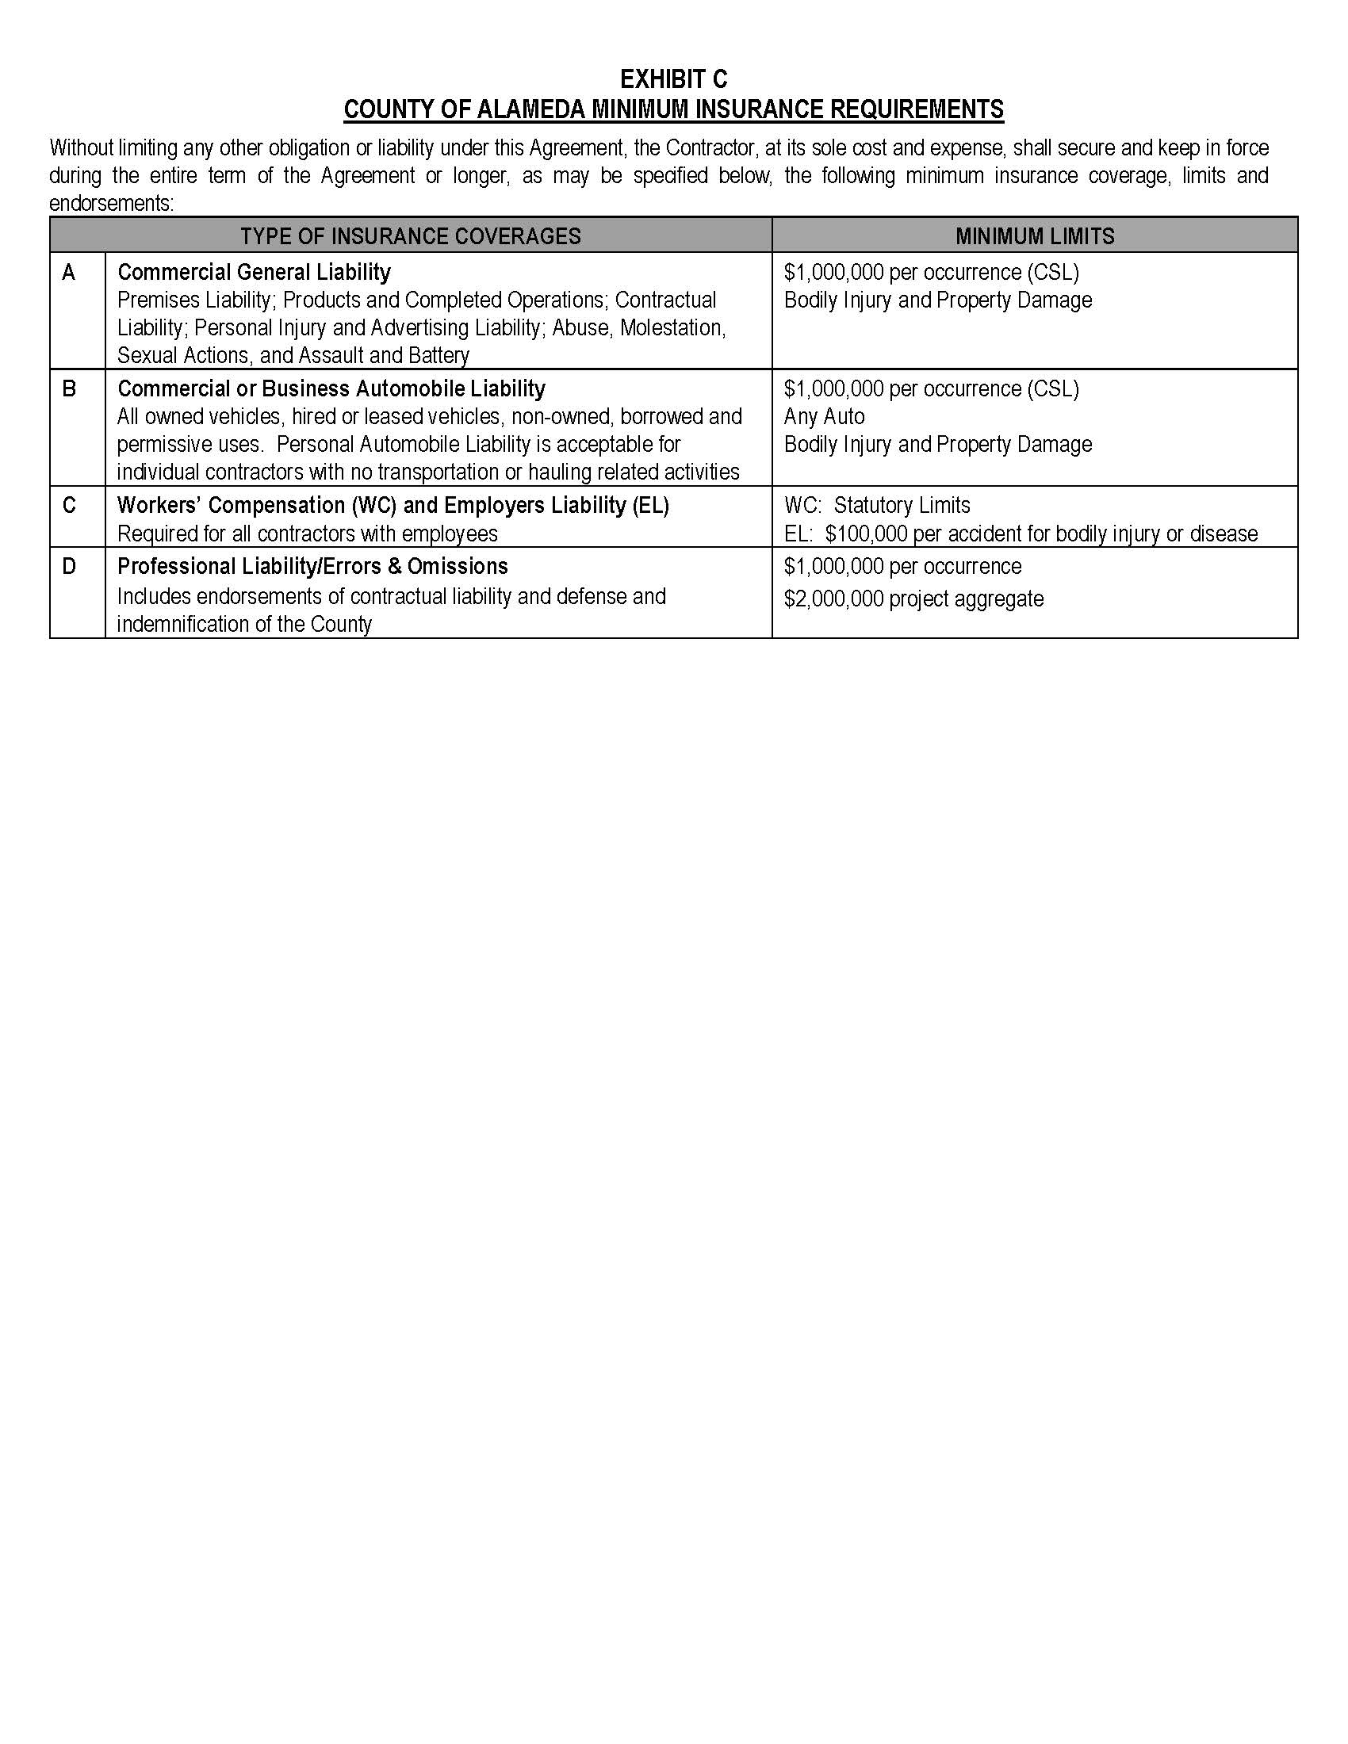
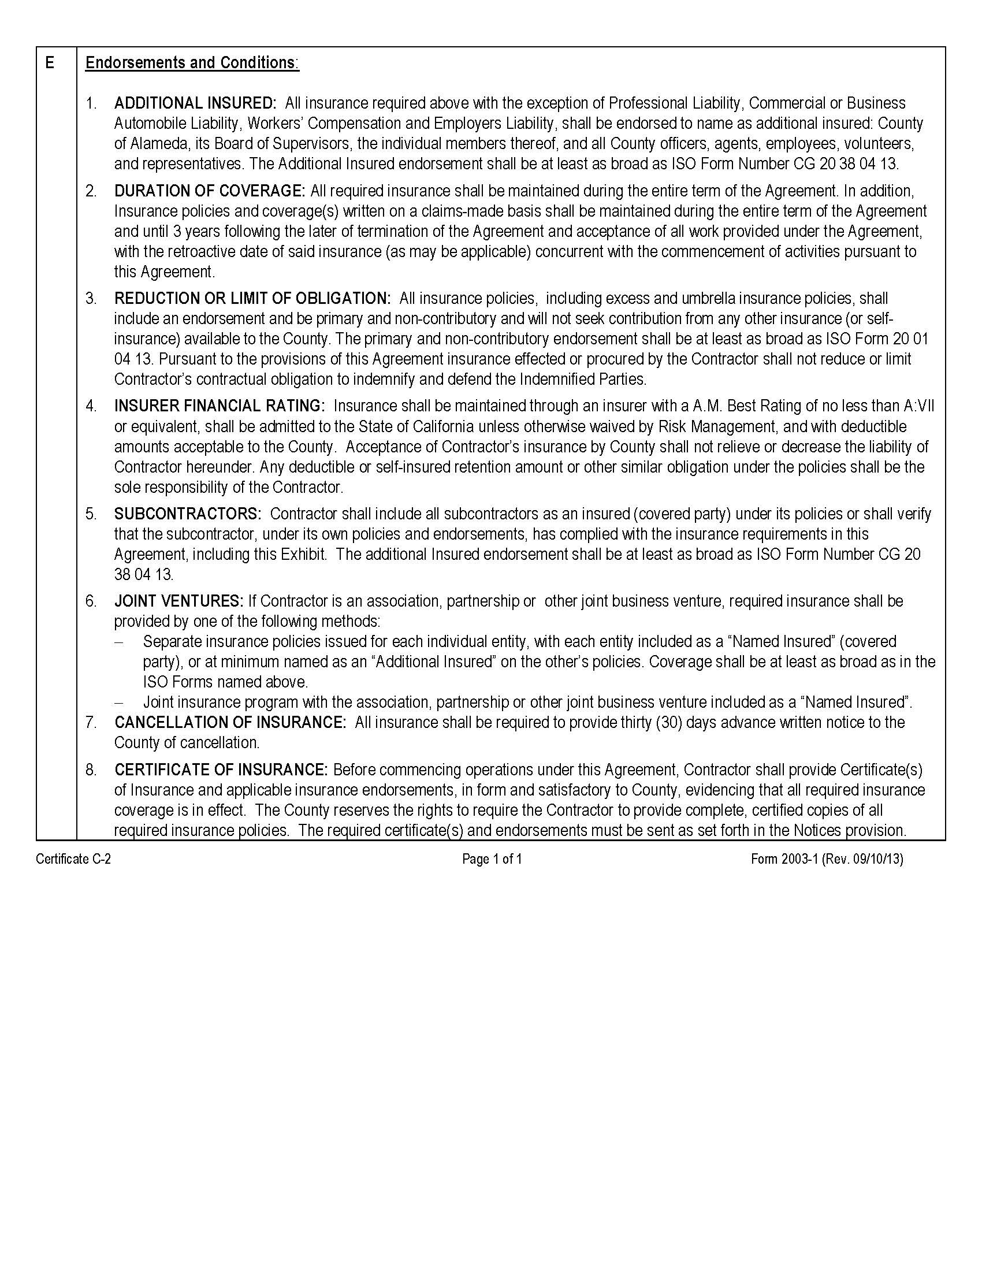

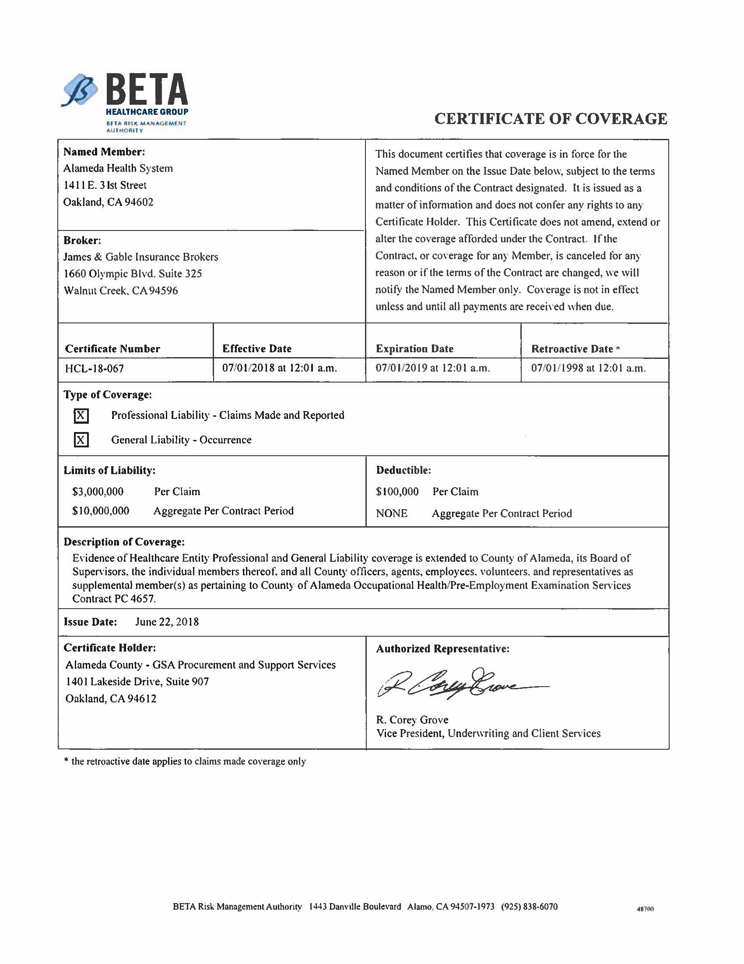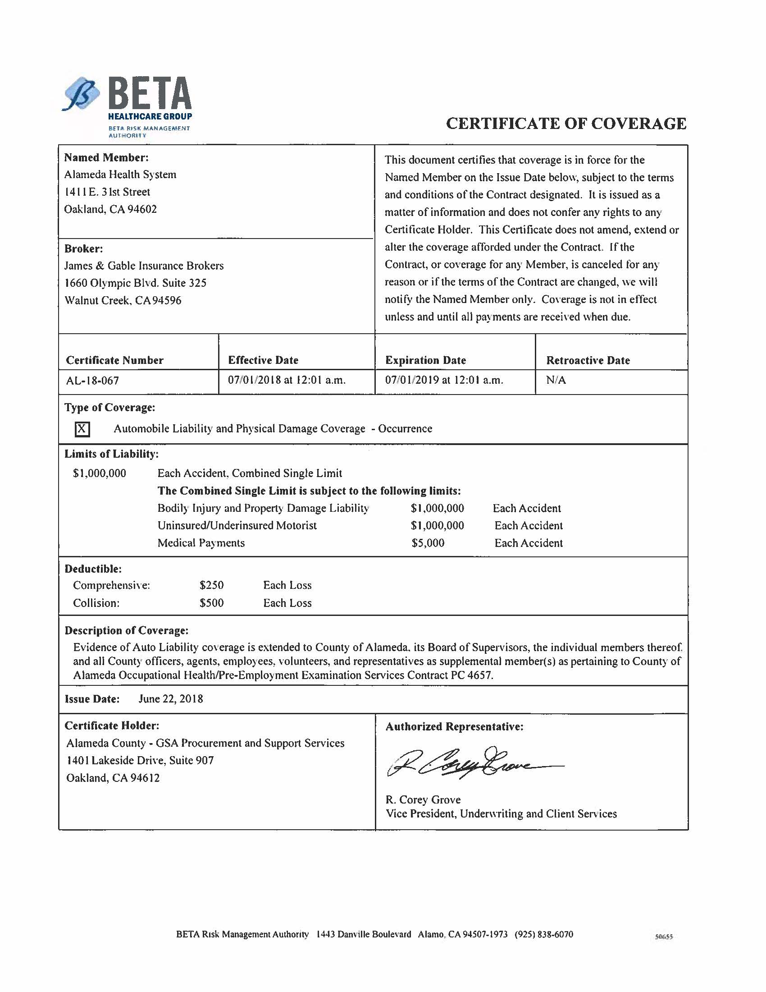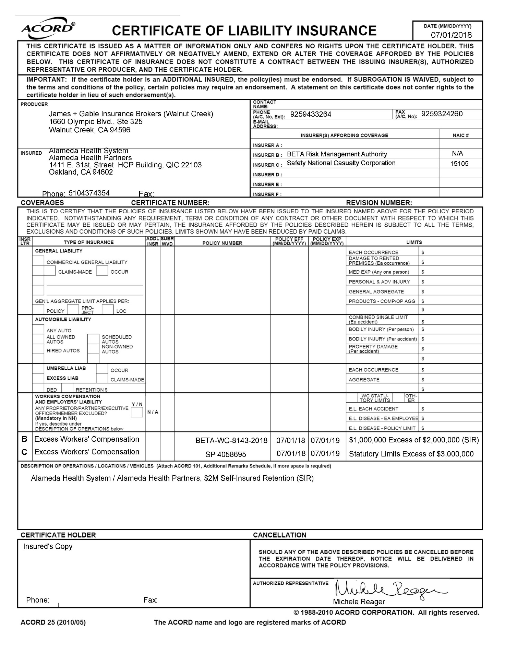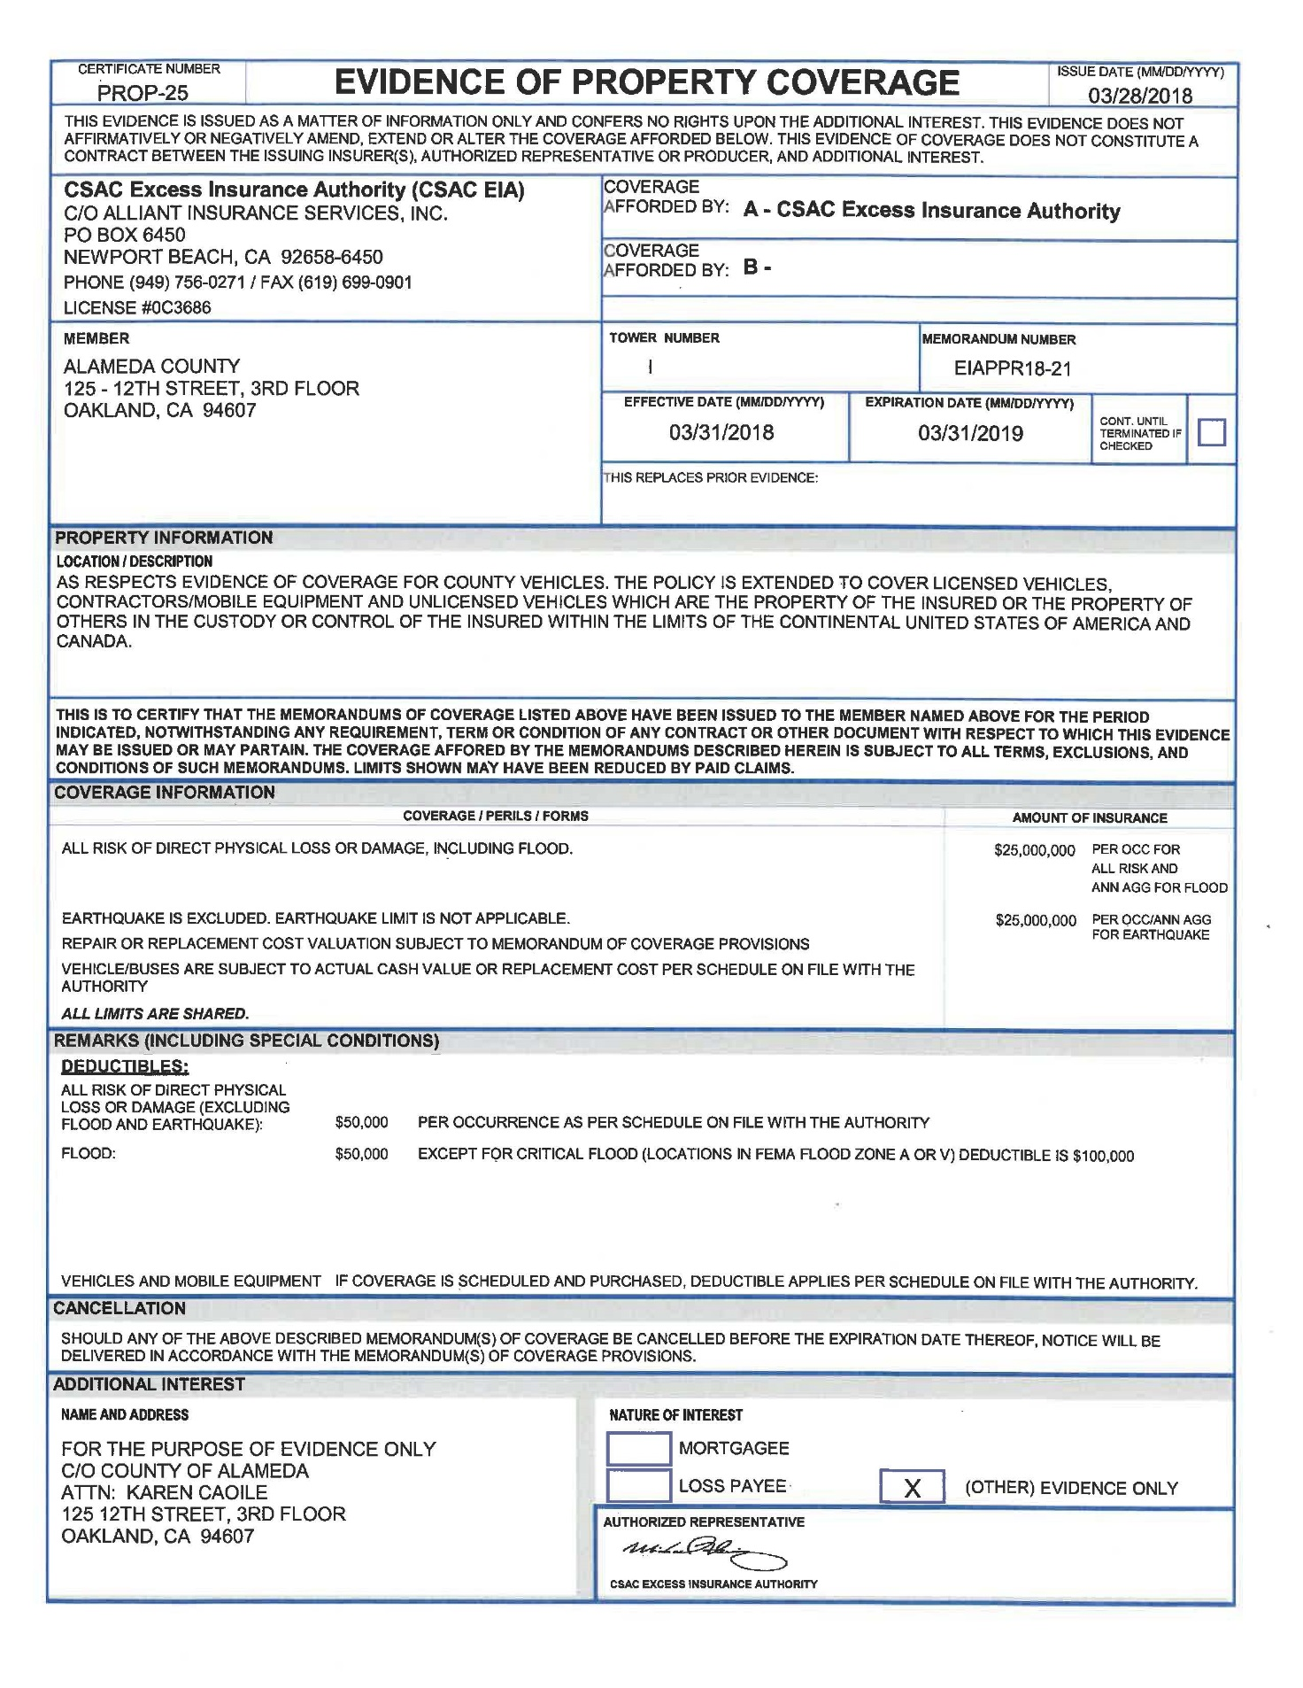

EXHIBIT D

COUNTY OF ALAMEDA
DEBARMENT AND SUSPENSION CERTIFICATION
(Applicable to all agreements funded in part or whole with federal funds and contracts over $25,000).
The contractor, under penalty of perjury, certifies that, except as noted below, contractor, its principals, and any named and unnamed subcontractor:
- Is not currently under suspension, debarment, voluntary exclusion, or determination of ineligibility by any federal agency;
- Has not been suspended, debarred, voluntarily excluded or determined ineligible by any federal agency within the past three years;
- Does not have a proposed debarment pending; and
- Has not been indicted, convicted, or had a civil judgment rendered against it by a court of competent jurisdiction in any matter involving fraud or official misconduct within the past three years.
If there are any exceptions to this certification, insert the exceptions in the following space.

Exceptions will not necessarily result in denial of award, but will be considered in determining contractor responsibility. For any exception noted above, indicate below to whom it applies, initiating agency, and dates of action.
Notes: Providing false information may result in criminal prosecution or administrative sanctions. The above certification is part of the Standard Services Agreement. Signing this Standard Services Agreement on the signature portion thereof shall also constitute signature of this Certification.

CONTRACTOR: Alameda Health System

PRINCIPAL: Delvecchio Finley TITLE: Chief Executive Officer

SIGNATURE: ______________________________ DATE: ______________________

EXHIBIT E

HIPAA BUSINESS ASSOCIATE AGREEMENT
This Exhibit, the HIPAA Business Associate Agreement (“Exhibit”) supplements and is made a part of the underlying agreement (“Agreement”) by and between the County of Alameda, (“County” or “Covered Entity”) Alameda Health System (“Contractor” or “Business Associate”) to which this Exhibit is attached. This Exhibit is effective as of the effective date of the Agreement.
I. RECITALS
Covered Entity wishes to disclose certain information to Business Associate pursuant to the terms of the Agreement, some of which may constitute Protected Health Information (“PHI”);
Covered Entity and Business Associate intend to protect the privacy and provide for the security of PHI disclosed to Business Associate pursuant to the Agreement in compliance with the Health Insurance Portability and Accountability Act of 1996, Public Law 104-191 (“HIPAA”), the Health Information Technology for Economic and Clinical Health Act, Public Law 111-005 (the “HITECH Act”), the regulations promulgated thereunder by the U.S. Department of Health and Human Services (the “HIPAA Regulations”), and other applicable laws; and
The Privacy Rule and the Security Rule in the HIPAA Regulations require Covered Entity to enter into a contract, containing specific requirements, with Business Associate prior to the disclosure of PHI, as set forth in, but not limited to, Title 45, sections 164.314(a), 164.502(e), and 164.504(e) of the Code of Federal Regulations (“C.F.R.”) and as contained in this Agreement.

II. STANDARD DEFINITIONS
Capitalized terms used, but not otherwise defined, in this Exhibit shall have the same meaning as those terms are defined in the HIPAA Regulations. In the event of an inconsistency between the provisions of this Exhibit and the mandatory provisions of the HIPAA Regulations, as amended, the HIPAA Regulations shall control. Where provisions of this Exhibit are different than those mandated in the HIPAA Regulations, but are nonetheless permitted by the HIPAA Regulations, the provisions of this Exhibit shall control. All regulatory references in this Exhibit are to HIPAA Regulations unless otherwise specified.
The following terms used in this Exhibit shall have the same meaning as those terms in the HIPAA Regulations: Data Aggregation, Designated Record Set, Disclosure, Electronic Health Record, Health Care Operations, Health Plan, Individual, Limited Data Set, Marketing, Minimum Necessary, Minimum Necessary Rule, Protected Health Information, and Security Incident.
The following term used in this Exhibit shall have the same meaning as that term in the HITECH Act: Unsecured PHI.

III. SPECIFIC DEFINITIONS
Agreement. “Agreement” shall mean the underlying agreement between County and Contractor, to which this Exhibit, the HIPAA Business Associate Agreement, is attached.
Business Associate. “Business Associate” shall generally have the same meaning as the term “business associate” at 45 C.F.R. section 160.103, the HIPAA Regulations, and the HITECH Act, and in reference to a party to this Exhibit shall mean the Contractor identified above. “Business Associate” shall also mean any subcontractor that creates, receives, maintains, or transmits PHI in performing a function, activity, or service delegated by Contractor.
Contractual Breach. “Contractual Breach” shall mean a violation of the contractual obligations set forth in this Exhibit.
Covered Entity. “Covered Entity” shall generally have the same meaning as the term “covered entity” at 45 C.F.R. section 160.103, and in reference to the party to this Exhibit, shall mean any part of County subject to the HIPAA Regulations.
Electronic Protected Health Information. “Electronic Protected Health Information” or “Electronic PHI” means Protected Health Information that is maintained in or transmitted by electronic media.
Exhibit. “Exhibit” shall mean this HIPAA Business Associate Agreement.
HIPAA. “HIPAA” shall mean the Health Insurance Portability and Accountability Act of 1996, Public Law 104-191.
HIPAA Breach. “HIPAA Breach” shall mean a breach of Protected Health Information as defined in 45 C.F.R. 164.402, and includes the unauthorized acquisition, access, use, or Disclosure of Protected Health Information which compromises the security or privacy of such information.
HIPAA Regulations. “HIPAA Regulations” shall mean the regulations promulgated under HIPAA by the U.S. Department of Health and Human Services, including those set forth at 45 C.F.R. Parts 160 and 164, Subparts A, C, and E.
HITECH Act. “HITECH Act” shall mean the Health Information Technology for Economic and Clinical Health Act, Public Law 111-005 (the “HITECH Act”).
Privacy Rule and Privacy Regulations. “Privacy Rule” and “Privacy Regulations” shall mean the standards for privacy of individually identifiable health information set forth in the HIPAA Regulations at 45 C.F.R. Part 160 and Part 164, Subparts A and E.
Secretary. “Secretary” shall mean the Secretary of the United States Department of Health and Human Services (“DHHS”) or his or her designee.
Security Rule and Security Regulations. “Security Rule” and “Security Regulations” shall mean the standards for security of Electronic PHI set forth in the HIPAA Regulations at 45 C.F.R. Parts 160 and 164, Subparts A and C.

IV. PERMITTED USES AND DISCLOSURES OF PHI BY BUSINESS ASSOCIATE
Business Associate may only use or disclose PHI:
A. As necessary to perform functions, activities, or services for, or on behalf of, Covered Entity as specified in the Agreement, provided that such use or Disclosure would not violate the Privacy Rule if done by Covered Entity;
B. As required by law; and
C. For the proper management and administration of Business Associate or to carry out the legal responsibilities of Business Associate, provided the disclosures are required by law, or Business Associate obtains reasonable assurances from the person to whom the information is disclosed that the information will remain confidential and used or further disclosed only as required by law or for the purposes for which it was disclosed to the person, and the person notifies Business Associate of any instances of which it is aware in which the confidentiality of the information has been breached.

V. PROTECTION OF PHI BY BUSINESS ASSOCIATE
A. Scope of Exhibit. Business Associate acknowledges and agrees that all PHI that is created or received by Covered Entity and disclosed or made available in any form, including paper record, oral communication, audio recording and electronic display, by Covered Entity or its operating units to Business Associate, or is created or received by Business Associate on Covered Entity’s behalf, shall be subject to this Exhibit.
B. PHI Disclosure Limits. Business Associate agrees to not use or further disclose PHI other than as permitted or required by the HIPAA Regulations, this Exhibit, or as required by law. Business Associate may not use or disclose PHI in a manner that would violate the HIPAA Regulations if done by Covered Entity.

C. Minimum Necessary Rule. When the HIPAA Privacy Rule requires application of the Minimum Necessary Rule, Business Associate agrees to use, disclose, or request only the Limited Data Set, or if that is inadequate, the minimum PHI necessary to accomplish the intended purpose of that use, Disclosure, or request. Business Associate agrees to make uses, Disclosures, and requests for PHI consistent with any of Covered Entity’s existing Minimum Necessary policies and procedures.
D. HIPAA Security Rule. Business Associate agrees to use appropriate administrative, physical and technical safeguards, and comply with the Security Rule and HIPAA Security Regulations with respect to Electronic PHI, to prevent the use or Disclosure of the PHI other than as provided for by this Exhibit.

E. Mitigation. Business Associate agrees to mitigate, to the extent practicable, any harmful effect that is known to Business Associate of a use or Disclosure of PHI by Business Associate in violation of the requirements of this Exhibit. Mitigation includes, but is not limited to, the taking of reasonable steps to ensure that the actions or omissions of employees or agents of Business Associate do not cause Business Associate to commit a Contractual Breach.
F. Notification of Breach. During the term of the Agreement, Business Associate shall notify Covered Entity in writing within twenty-four (24) hours of any suspected or actual breach of security, intrusion, HIPAA Breach, and/or any actual or suspected use or Disclosure of data in violation of any applicable federal or state laws or regulations. This duty includes the reporting of any Security Incident, of which it becomes aware, affecting the Electronic PHI. Business Associate shall take (i) prompt corrective action to cure any such deficiencies and (ii) any action pertaining to such unauthorized use or Disclosure required by applicable federal and/or state laws and regulations. Business Associate shall investigate such breach of security, intrusion, and/or HIPAA Breach, and provide a written report of the investigation to Covered Entity’s HIPAA Privacy Officer or other designee that is in compliance with 45 C.F.R. section 164.410 and that includes the identification of each individual whose PHI has been breached. The report shall be delivered within fifteen (15) working days of the discovery of the breach or unauthorized use or Disclosure. Business Associate shall be responsible for any obligations under the HIPAA Regulations to notify individuals of such breach, unless Covered Entity agrees otherwise.
G. Agents and Subcontractors. Business Associate agrees to ensure that any agent, including a subcontractor, to whom it provides PHI received from, or created or received by Business Associate on behalf of Covered Entity, agrees to the same restrictions, conditions, and requirements that apply through this Exhibit to Business Associate with respect to such information. Business Associate shall obtain written contracts agreeing to such terms from all agents and subcontractors. Any subcontractor who contracts for another company’s services with regards to the PHI shall likewise obtain written contracts agreeing to such terms. Neither Business Associate nor any of its subcontractors may subcontract with respect to this Exhibit without the advanced written consent of Covered Entity.
H. Review of Records. Business Associate agrees to make internal practices, books, and records relating to the use and Disclosure of PHI received from, or created or received by Business Associate on behalf of Covered Entity available to Covered Entity, or at the request of Covered Entity to the Secretary, in a time and manner designated by Covered Entity or the Secretary, for purposes of the Secretary determining Covered Entity’s compliance with the HIPAA Regulations. Business Associate agrees to make copies of its HIPAA training records and HIPAA business associate agreements with agents and subcontractors available to Covered Entity at the request of Covered Entity.
I. Performing Covered Entity’s HIPAA Obligations. To the extent Business Associate is required to carry out one or more of Covered Entity’s obligations under the HIPAA Regulations, Business Associate must comply with the requirements of the HIPAA Regulations that apply to Covered Entity in the performance of such obligations.
J. Restricted Use of PHI for Marketing Purposes. Business Associate shall not use or disclose PHI for fundraising or Marketing purposes unless Business Associate obtains an Individual’s authorization. Business Associate agrees to comply with all rules governing Marketing communications as set forth in HIPAA Regulations and the HITECH Act, including, but not limited to, 45 C.F.R. section 164.508 and 42 U.S.C. section 17936.
K. Restricted Sale of PHI. Business Associate shall not directly or indirectly receive remuneration in exchange for PHI, except with the prior written consent of Covered Entity and as permitted by the HITECH Act, 42 U.S.C. section 17935(d)(2); however, this prohibition shall not affect payment by Covered Entity to Business Associate for services provided pursuant to the Agreement.
L. De-Identification of PHI. Unless otherwise agreed to in writing by both parties, Business Associate and its agents shall not have the right to de-identify the PHI. Any such de-identification shall be in compliance with 45 C.F.R. sections 164.502(d) and 164.514(a) and (b).

M. Material Contractual Breach. Business Associate understands and agrees that, in accordance with the HITECH Act and the HIPAA Regulations, it will be held to the same standards as Covered Entity to rectify a pattern of activity or practice that constitutes a material Contractual Breach or violation of the HIPAA Regulations. Business Associate further understands and agrees that: (i) it will also be subject to the same penalties as a Covered Entity for any violation of the HIPAA Regulations, and (ii) it will be subject to periodic audits by the Secretary.

VI. INDIVIDUAL CONTROL OVER PHI
- Individual Access to PHI. Business Associate agrees to make available PHI in a Designated Record Set to an Individual or Individual’s designee, as necessary to satisfy Covered Entity’s obligations under 45 C.F.R. section 164.524. Business Associate shall do so solely by way of coordination with Covered Entity, and in the time and manner designated by Covered Entity.

- Accounting of Disclosures. Business Associate agrees to maintain and make available the information required to provide an accounting of Disclosures to an Individual as necessary to satisfy Covered Entity’s obligations under 45 C.F.R. section 164.528. Business Associate shall do so solely by way of coordination with Covered Entity, and in the time and manner designated by Covered Entity.

- Amendment to PHI. Business Associate agrees to make any amendment(s) to PHI in a Designated Record Set as directed or agreed to by Covered Entity pursuant to 45 C.F.R. section 164.526, or take other measures as necessary to satisfy Covered Entity’s obligations under 45 C.F.R. section 164.526. Business Associate shall do so solely by way of coordination with Covered Entity, and in the time and manner designated by Covered Entity.

VII. TERMINATION
- Termination for Cause. A Contractual Breach by Business Associate of any provision of this Exhibit, as determined by Covered Entity in its sole discretion, shall constitute a material Contractual Breach of the Agreement and shall provide grounds for immediate termination of the Agreement, any provision in the Agreement to the contrary notwithstanding. Contracts between Business Associates and subcontractors are subject to the same requirement for Termination for Cause.

- Termination due to Criminal Proceedings or Statutory Violations. Covered Entity may terminate the Agreement, effective immediately, if (i) Business Associate is named as a defendant in a criminal proceeding for a violation of HIPAA, the HITECH Act, the HIPAA Regulations or other security or privacy laws or (ii) a finding or stipulation that Business Associate has violated any standard or requirement of HIPAA, the HITECH Act, the HIPAA Regulations or other security or privacy laws is made in any administrative or civil proceeding in which Business Associate has been joined.

- Return or Destruction of PHI. In the event of termination for any reason, or upon the expiration of the Agreement, Business Associate shall return or, if agreed upon by Covered Entity, destroy all PHI received from Covered Entity, or created or received by Business Associate on behalf of Covered Entity. Business Associate shall retain no copies of the PHI. This provision shall apply to PHI that is in the possession of subcontractors or agents of Business Associate.

If Business Associate determines that returning or destroying the PHI is infeasible under this section, Business Associate shall notify Covered Entity of the conditions making return or destruction infeasible. Upon mutual agreement of the parties that return or destruction of PHI is infeasible, Business Associate shall extend the protections of this Exhibit to such PHI and limit further uses and Disclosures to those purposes that make the return or destruction of the information infeasible.

VIII. MISCELLANEOUS
- Disclaimer. Covered Entity makes no warranty or representation that compliance by Business Associate with this Exhibit, HIPAA, the HIPAA Regulations, or the HITECH Act will be adequate or satisfactory for Business Associate’s own purposes or that any information in Business Associate’s possession or control, or transmitted or received by Business Associate is or will be secure from unauthorized use or Disclosure. Business Associate is solely responsible for all decisions made by Business Associate regarding the safeguarding of PHI.

- Regulatory References. A reference in this Exhibit to a section in HIPAA, the HIPAA Regulations, or the HITECH Act means the section as in effect or as amended, and for which compliance is required.

- Amendments. The parties agree to take such action as is necessary to amend this Exhibit from time to time as is necessary for Covered Entity to comply with the requirements of HIPAA, the HIPAA Regulations, and the HITECH Act.

- Survival. The respective rights and obligations of Business Associate with respect to PHI in the event of termination, cancellation or expiration of this Exhibit shall survive said termination, cancellation or expiration, and shall continue to bind Business Associate, its agents, employees, contractors and successors.

- No Third Party Beneficiaries. Except as expressly provided herein or expressly stated in the HIPAA Regulations, the parties to this Exhibit do not intend to create any rights in any third parties.

- Governing Law. The provisions of this Exhibit are intended to establish the minimum requirements regarding Business Associate’s use and Disclosure of PHI under HIPAA, the HIPAA Regulations and the HITECH Act. The use and Disclosure of individually identified health information is also covered by applicable California law, including but not limited to the Confidentiality of Medical Information Act (California Civil Code section 56 et seq.). To the extent that California law is more stringent with respect to the protection of such information, applicable California law shall govern Business Associate’s use and Disclosure of confidential information related to the performance of this Exhibit.

- Interpretation. Any ambiguity in this Exhibit shall be resolved in favor of a meaning that permits Covered Entity to comply with HIPAA, the HIPAA Regulations, the HITECH Act, and in favor of the protection of PHI.

This EXHIBIT, the HIPAA Business Associate Agreement is hereby executed and agreed to by CONTRACTOR:

Name: Alameda Health System

By (Signature): ___________________________________

Print Name: Delvecchio Finley

Title: Chief Executive Officer

Exhibit F

Audit Requirements

The County contracts with various organizations to carry out programs mandated by the Federal and State governments or sponsored by the Board of Supervisors. Under the Single Audit Act Amendments of 1996 (31 U.S.C.A. §§ 7501-7507) and Board policy, the County has the responsibility to determine whether organizations receiving funds through the County have spent them in accordance with applicable laws, regulations, contract terms, and grant agreements. To this end, effective with the first fiscal year beginning on and after December 26, 2014, the following are required.

- AUDIT REQUIREMENTS

  - Funds from Federal Sources:

    - Non-Federal entities which are determined to be subrecipients by the supervising department according to 2 CFR § 200.330 and which expend annual Federal awards in the amount specified in 2 CFR § 200.501 are required to have a single audit performed in accordance with 2 CFR § 200.514.

2. When a non-Federal entity expends annual Federal awards in the amount specified in 2 CFR § 200.501(a) under only one Federal program (excluding R&D) and the Federal program's statutes, regulations, or terms and conditions of the Federal award do not require a financial statement audit of the auditee, the non-Federal entity may elect to have a program-specific audit conducted in accordance with 2 CFR § 200.507 (Program Specific Audits).
3. Non-Federal entities which expend annual Federal awards less than the amount specified in 2 CFR § 200.501(d) are exempt from the single audit requirements for that year except that the County may require a limited-scope audit in accordance with 2 CFR § 200.503(c) .
  - Funds from All Sources:
Non-Federal entities which expend annual funds from any source (Federal, State, County, etc.) through the County in an amount of:
    - $100,000 or more must have a financial audit in accordance with the U.S. Comptroller General’s Generally Accepted Government Auditing Standards (GAGAS) covering all County programs.
    - Less than $100,000 are exempt from these audit requirements except as otherwise noted in the contract.
Non-Federal entities that are required to have or choose to do a single audit in accordance with 2 CFR Subpart F, Audit Requirements are not required to have a financial audit in the same year. However, Non-Federal entities that are required to have a financial audit may also be required to have a limited-scope audit in the same year.

  - General Requirements for All Audits:
    - All audits must be conducted in accordance with Generally Accepted Government Auditing Standards issued by the Comptroller General of the United States (GAGAS).
    - All audits must be conducted annually, except for biennial audits authorized by 2 CFR § 200.504 and where specifically allowed otherwise by laws, regulations, or County policy.
    - The audit report must contain a separate schedule that identifies all funds received from or passed through the County that is covered by the audit. County programs must be identified by contract number, contract amount, contract period, and amount expended during the fiscal year by funding source. An exhibit number must be included when applicable.
    - If a funding source has more stringent and specific audit requirements, these requirements must prevail over those described above.

- AUDIT REPORTS

  - For Single Audits
    - Within the earlier of 30 calendar days after receipt of the auditor’s report or nine months after the end of the audit period, the auditee must electronically submit to the Federal Audit Clearinghouse (FAC) the data collection form described in 2 CFR § 200.512(b) and the reporting package described in 2 CFR § 200.512(c). The auditee and auditors must ensure that the reporting package does not include protected personally identifiable information. The FAC will make the reporting package and the data collection form available on a web site and all Federal agencies, pass-through entities and others interested in a reporting package and data collection form must obtain it by accessing the FAC. As required by 2 CFR § 200.512(a) (2), unless restricted by Federal statutes or regulations, the auditee must make copies available for public inspection.
A notice of the audit report issuance along with two copies of the management letter with its corresponding response should be sent to the County supervising department within ten calendar days after it is submitted to the FAC. The County supervising department is responsible for forwarding a copy of the audit report, management letter, and corresponding responses to the County Auditor within one week of receipt.

  - For Audits other than Single Audits
At least two copies of the audit report package, including all attachments and any management letter with its corresponding response, should be sent to the County supervising department within six months after the end of the audit year, or other time frame as specified by the department. The County supervising department is responsible for forwarding a copy of the audit report package to the County Auditor within one week of receipt.

- AUDIT RESOLUTION
Within 30 days of issuance of the audit report, the entity must submit to its County supervising department a corrective action plan consistent with 2 CFR § 200.511(c) to address each audit finding included in the current year auditor’s report. Questioned costs and disallowed costs must be resolved according to procedures established by the County in the Contract Administration Manual. The County supervising department will follow up on the implementation of the corrective action plan as it pertains to County programs.

- ADDITIONAL AUDIT WORK
The County, the State, or Federal agencies may conduct additional audits or reviews to carry out their regulatory responsibilities. To the extent possible, these audits and reviews will rely on the audit work already performed under the audit requirements listed above.

EXHIBIT A,
ATTACHMENT 1A Program Compliance Attestation

SECTION 330 PROGRAM COMPLIANCE AND ATTESTATION

I attest that Alameda Health System Ambulatory Care Services is in full compliance with the following program and operational requirements:
_____1) Maintain and complete a current Health Center Compliance Plan
_____2) Retain at all times a designated agency Health Center Compliance Officer and inform ACHCH of changes within 14 days
- Name of current AHS Health Center Compliance Officer _________________________
_____3) Have reviewed Exhibit 1B, Select Key Submission Requirements, including due dates, and will submit required documents to ACHCH in accordance with this schedule or will request up to a 30-day extension if needed.

Signature:
Title: Date:

Date Received |  | Grants Manager Initials / Date |  | Contracts manager  Initials / Date |  | Program Director Initials / Date

EXHIBIT A,
ATTACHMENT 1B Required Compliance Documents
Agreement Section Requirement | BPHC OSV Program Requirement | Description | Due date to ACHCH | Documentation
AHS has received and reviewed most recent HRSA Health Center Compliance Guide
2.01 (a) Needs Assessment | I. Needs Assessment | For service area and populations served by AHS: geographic, demographic, and economic factors; health care and other resources; health status |  | .
2.05 (d) Patient Rights | II. Services | Documentation that all patients receive a written patient rights policy and grievance procedure. |  | Policies & Procedures & sample Patient Rights Notice in all languages issued  All sites post a copy of patient rights and grievance policy & procedures in appropriate languages.
2.11 Consumer Participation | IV. Governance  19 Board Composition | Annually nominate minimum one qualified consumer of services for ACHCH consideration for ACHCH CCAB membership; designate staff liaison | Upon request, typically May | Nomination Form
3.03 Billing and Collections | III. Management and Finance  13. Billing and Collections | Systems in place to maximize collections and reimbursement for costs in providing health services, including written billing, credit and collection policies and procedures in accordance with Section 330(k)(3)(F) and (G) of the PHS Act | Upon request | Documentation of written billing, credit and collections policies and procedures
3.10 Audit | III. Mgmt & Finance  12. Financial Mgmt & Control Policies | Annual audit by independent CPA | Within 30 days of AHS receipt or within 180 calendar days after AHS fiscal year end date, whichever occurs first | Audit, 990, Management Letter, BOT minutes documenting review
4.02 Management Team | III. Mgmt & Finance  9. Key Mgmt Staff | 1) Written notification of any changes in key leadership:  Administrative  Financial  Medical; and  Other key staff involved in Grant implementation | Within 14 days following knowledge of impending or actual change(s) | 1) Email notification to ACHCH Program Director Administration  2) Written letter with Resume/CV
4.05 Quality Improvement and Quality Assurance Program and Standards of Care | II. Services  8. Quality Improvement/ Assurance Plan | 1) Participation in at least 75% of ACHCH QI Committee meetings  2) Attestation of adoption of ACHCH Data Validation policy  3) AHS ACQC reviews QI plan submissions from designated primary care sites.  4) Submission of clinical quality measures and operational and empanelment data  5) Other regular and requested QI activities as delineated in Sec. 4.05(b) | 1) As scheduled by ACHCH  4) As agreed upon between AHS and ACHCH QI staff  5) As specified by ACHCH Medical Director of CQI and/or the ACHCH QC | - Meeting attendance  - Formal letter/email to ACHCH Director regarding receipt and review of annual QI plans.  - As agreed upon between AHS and ACHCH QI staff  - As agreed upon between AHS and ACHCH QI staff
4.07 Contracts, Referrals and Other Affiliations (b) Referrals | II. Services  2. Required & Additional Services | Referral procedures for all services in scope, demonstrated by completion of ACHCH “ACHCH AHS Service Delivery” table and with content consistent with HRSA requirements
4.10 Client Grievance Procedure, inclusive of (a) – (c) | II. Services | Annually submit copy to ACHCH | May 31 | Copy of Client Grievance Procedure with revision date.
6.01 Oversight (b)  See Exhibits  G & H | III. Mgmt & Finance  10. Contractual/ Affiliation Agreements | 1) Conduct self-assessment of compliance with 18 program requirements per HRSA BPHC Health Center Compliance Manual  OR  Utilize findings of a ACHCH-approved independently administered OSV  2) If not in compliance, create and submit to ACHCH 180-day corrective action plan; submit quarterly updates and notification of completion to ACHCH | 1) a) First: written assessment based on preparation for August 2019 OSV due to ACHCH by July 30, 2019  - Annual self-assessment due annually, January 30 of each year. | 1) Completed Compliance Self-Assessment or assessment by 3rd party approved by ACHCH  2) Corrective action plans based on self-assessments conducted in preparation for August 2019 OSV; to be monitored by ACHCH through annual updates.
6.03 Corrective Action Process | III. Mgmt & Finance  10. Contractual /Affiliation Agreements | Notify ACHCH of any actual or suspected instances of non-compliance, material weaknesses or financial, clinical and/or personnel mismanagement deficiencies related to the services and/or the Grant | As soon as practicable but no later than ten days after discovery | Letter
General | ALL sections, esp. III. Mgmt & Finance  10. Contractual/ Affiliation Agreements | Notify ACHCH of any changes in scope of services, budget, services provided, and service sites | Within 14 days after knowledge of impending change | Letter
Sliding Fee Scale Policy | II. Services  7. Sliding Fee Discounts | Written documentation of BOT approved SSFS Policy that is consistent with ACHCH SSFS policy and current with Federal Poverty level | June 30 | Copy of SSFS Policy; BOT minutes
Staffing: Credentialing and Privileging | II. Services  3. Staffing  6. Hospital Admitting Privileges and Continuum of Care | Staff appropriately licensed, credentialed and privileged (Section 330(a)(1), (b)(1)­(2), (k)(3)(C), and (k)(3)(I) of the PHS Act), as evidenced by Credentialing and Privileging policies and procedures that meet the requirements in HRSA Policy Information Notices (PIN) 2002­22 and 2001­16 |  | Copies of CMO job description and Credentialing and Privileging policies and procedures
Hours | II. Services  4. Accessible Hours of Operation/ Locations  5. After Hours Coverage | Written documentation and written justification/request for exception if no after-hours/weekend hours |  | Documentation of current hours; written justification/request for exception
Scope of Project | II. Services  2. Required & Additional Services  16. Scope of Project |  |  | BOT minutes;  Regular reports as requested to ACHCH Commission

EXHIBIT A,
ATTACHMENT 1B.a

ACHCH/Alameda Health System
Subrecipient Monitoring Procedure
Quarterly Site Visit Schedule GY2019

FY Quarter | Date | On Site Visit Quarterly Focus
Q 3 | January 25 2019 | Data Systems/Reporting/Eligibility:  - Scope of Project Review  - Hours, Patient Accessible Services  - Patient Eligibility and Screening  - Culturally Appropriate Care  - Data-Based Reports EHR review
Q 4 | April 26 2019 | Financial and Revenue Systems:  - Budget for Scope of Project  - HCH  - SFDP  - Fees, Billing and Collections  - Revenue Sources  - Contractual/Affiliation Agr.  - Audit Review  - Financial Policies  - 340B Review
Q 1 | July 26 2019 | Clinical & Quality Systems:  - Staff Credentialing  - Clinical Staffing  - Continuum of Care  - Risk Management  - Emergency coverage/after hours  - Quality Improvement Program
Q 2 | October 25 2019 | Management:  - Management Team  - Grievance procedures/Patient Rights  - Governance  - Consumer Participation  - Needs Assessment
EXHIBIT A,
ATTACHMENT 1C HRSA Health Center Scope of Project Form 5A

Approved Required Services 4/27/2019
Service Type | Service Delivery Methods
 | Column I. Direct  (Health Center Pays) | Column II. Formal Written Contract/Agreement  (Health Center Pays) | Column III. Formal Written Referral Arrangement  (Health Center DOES NOT pay)
General Primary Medical Care | X | X
Diagnostic Laboratory |  | X
Diagnostic Radiology |  | X
Screenings | X | X
Coverage for Emergencies During and After Hours |  | X
Voluntary Family Planning |  | X
Immunizations | X | X
Well Child Services |  | X
Gynecological Care |  | X
Obstetrical Care
Prenatal Care |  | X
Intrapartum Care (Labor & Delivery) |  | X
Postpartum Care |  | X
Preventive Dental |  | X
Pharmaceutical Services | X | X
ACHCH Required Substance Abuse Services | X | X | X
Case Management | X | X | X
Eligibility Assistance | X | X
Health Education | X | X
Outreach | X | X
Transportation | X | X
Translation | X | X | X

Approved Additional Services
Service Type | Service Delivery Methods
 | Column I. Direct  (Health Center Pays) | Column II. Formal Written Contract/Agreement  (Health Center Pays) | Column III. Formal Written Referral Arrangement  (Health Center DOES NOT pay)
Additional Dental Services |  | X
Behavioral Health Services
Mental Health Services | X | X
Optometry |  | X
Complementary and Alternative Medicine |  | X
Additional Enabling/Supportive Services | X | X

Approved Specialty Services
Service Type | Service Delivery Methods
 | Column I. Direct  (Health Center Pays) | Column II. Formal Written Contract/Agreement  (Health Center Pays) | Column III. Formal Written Referral Arrangement  (Health Center DOES NOT pay)
Podiatry |  | X
Psychiatry | X | X
Ophthalmology  Endocrinology  Cardiology  Pulmonology  Dermatology  Gastroenterology  Advanced Diagnostic Radiology |  | X  X  X  X  X  X
Other – Orthopedics  Other – Urology  Other – Hematology/Oncology  Other – Rheumatology  Other – Nephrology  Other – ENT  Other - Neurology |  | X  X  X  X  X  X  X

EXHIBIT A,
Attachment 1D – Health Center Scope of Services Sites Form 5B

Form 5B Sites on Scope of Services Details 4/27/2019
Site Highland Dental Clinic is currently in HRSA Change In Scope Process for HRSA approval to add the clinic to HRSA Form 5B.
Site Id: BPS-H80-012973Site Status: Active
Site Information
Site Name | SAME DAY CLINIC AT HIGHLAND WELLNESS | Physical Site Address | 1411-E.31st Street Highland Care Pavilion 4th Floor Corridor SC 4100, Same Day Clinic (includes Exam Rooms 4709 through 4822 and Fast Track Exam Area), Oakland, CA 94602
Site Type | Service Delivery Site | Site Phone Number | (510) 437-4778
Web URL | http://www.highlandwellnessahs.org/same-day-clinic
Location Type | Permanent | Site Setting | Hospital
Date Site was Added to Scope | 09/30/2013 | Site Operational Date | 09/08/2013
FQHC Site Medicare Billing Number Status | Application for this site has not yet been submitted to CMS | Medicare Billing Number  (Required if "This site has a Medicare billing number" is selected in 'FQHC Site Medicare Billing Number Status' field.)
FQHC Site National Provider Identification (NPI) Number  (Optional field) | 1740332931 | Total Hours of Operation  (when Patients will be Served per Week) | 45.00
Saved Months of Operation | January, February, March, April, May, June, July, August, September, October, November, December
Number of Contract Service Delivery Locations  (Required only for 'Migrant Voucher Screening' Site Type) |  | Number of Intermittent Sites  (Required only for 'Intermittent' Site Type)
Site Operated by | Subrecipient

Subrecipient or Contractor Information
(Required only if 'Subrecipient or Contractor' is selected in 'Site Operated By' field)
Subrecipient/Contractor Organization Name | Subrecipient/Contractor Organization Physical Site Address | Subrecipient/Contractor EIN
Alameda Health System Ambulatory Health Care Services | 15400 Foothill Blvd.,  San Leandro, CA 94578 | 94-3302014

Service Area Zip Code (Include only those from which the majority of the patient population will come)
Saved Service Area Zip Code(s) | 94609, 94619, 94606, 94611, 94608, 94603, 94621, 94607, 94605, 94610, 94602, 94612, 94601

Site Id: BPS-H80-021939Site Status: Active
Site Information
Site Name | HIGHLAND WELLNESS HCP ANNEX | Physical Site Address | 1411 E. 31ST Street HIGHLAND CARE PAVILION FLOORS 4 & 5, EXCLUDING "HIGHLAND WELLNESS SAME DAY CLINIC", OAKLAND, CA 94602
Site Type | Service Delivery Site | Site Phone Number | (510) 437-4800
Web URL
Location Type | Permanent | Site Setting | Hospital
Date Site was Added to Scope | 03/26/2019 | Site Operational Date | 03/28/2019
FQHC Site Medicare Billing Number Status |  | Medicare Billing Number  (Required if "This site has a Medicare billing number" is selected in 'FQHC Site Medicare Billing Number Status' field.)
FQHC Site National Provider Identification (NPI) Number  (Optional field) |  | Total Hours of Operation  (when Patients will be Served per Week) | 64.00
Saved Months of Operation | January, February, March, April, May, June, July, August, September, October, November, December
Number of Contract Service Delivery Locations  (Required only for 'Migrant Voucher Screening' Site Type) |  | Number of Intermittent Sites  (Required only for 'Intermittent' Site Type)
Site Operated by | Subrecipient

Subrecipient or Contractor Information
(Required only if 'Subrecipient or Contractor' is selected in 'Site Operated By' field)
Subrecipient/Contractor Organization Name | Subrecipient/Contractor Organization Physical Site Address | Subrecipient/Contractor EIN
ALAMEDA HEALTH SYSTEM AMBULATORY HEALTH CARE SERVICES | 15400 FOOTHILL BLVD,  SAN LEANDRO, CA 94578 | 94-3302014

Service Area Zip Code (Include only those from which the majority of the patient population will come)
Saved Service Area Zip Code(s) | 94612, 94607, 94603, 94602, 94601

Site Information
Site Name | HAYWARD WELLNESS | Physical Site Address | 664 SOUTHLAND MALL, HAYWARD, CA 94545-2150
Site Type | Service Delivery Site | Site Phone Number | (510) 266-1700
Web URL | http://www.wintonahs.org/
Location Type | Permanent | Site Setting | All Other Clinic Types
Date Site was Added to Scope | 12/11/2014 | Site Operational Date | 12/11/2014
FQHC Site Medicare Billing Number Status | This site has a Medicare billing number | Medicare Billing Number  (Required if "This site has a Medicare billing number" is selected in 'FQHC Site Medicare Billing Number Status' field.) | 751807
FQHC Site National Provider Identification (NPI) Number  (Optional field) | 1033241633 | Total Hours of Operation  (when Patients will be Served per Week) | 60.00
Saved Months of Operation | January, February, March, April, May, June, July, August, September, October, November, December
Number of Contract Service Delivery Locations  (Required only for 'Migrant Voucher Screening' Site Type) |  | Number of Intermittent Sites  (Required only for 'Intermittent' Site Type)
Site Operated by | Subrecipient

Subrecipient or Contractor Information
(Required only if 'Subrecipient or Contractor' is selected in 'Site Operated By' field)
Subrecipient/Contractor Organization Name | Subrecipient/Contractor Organization Physical Site Address | Subrecipient/Contractor EIN
ALAMEDA HEALTH SYSTEM AMBULATORY HEALTH CARE SERVICES | 15400 FOOTHILL BLVD,  SAN LEANDRO, CA 94578-1284 | 93-3302014

Service Area Zip Code (Include only those from which the majority of the patient population will come)
Saved Service Area Zip Code(s) | 94544, 94541, 94577, 94579, 94580, 94545, 94542, 94546, 94578, 94552

Site Information
Site Name | HIGHLAND WELLNESS | Physical Site Address | Koret Building Floors 6 & 7 Highland General Hospital Campus 1411 E. 31st Street, Oakland, CA 94602-1018
Site Type | Service Delivery Site | Site Phone Number | (510) 437-5039
Web URL | http://www.alamedahealthsystem.org/locations/
Location Type | Permanent | Site Setting | Hospital
Date Site was Added to Scope | 12/13/2017 | Site Operational Date | 12/13/2017
FQHC Site Medicare Billing Number Status |  | Medicare Billing Number  (Required if "This site has a Medicare billing number" is selected in 'FQHC Site Medicare Billing Number Status' field.)
FQHC Site National Provider Identification (NPI) Number  (Optional field) |  | Total Hours of Operation  (when Patients will be Served per Week) | 62.00
Saved Months of Operation | January, February, March, April, May, June, July, August, September, October, November, December
Number of Contract Service Delivery Locations  (Required only for 'Migrant Voucher Screening' Site Type) |  | Number of Intermittent Sites  (Required only for 'Intermittent' Site Type)
Site Operated by | Subrecipient

Subrecipient or Contractor Information (Required only if 'Subrecipient or Contractor' is selected in 'Site Operated By' field)
Subrecipient/Contractor Organization Name | Subrecipient/Contractor Organization Physical Site Address | Subrecipient/Contractor EIN
ALAMEDA HEALTH SYSTEM AMBULATORY HEALTH CARE SERVICES | 15400 Foothill Blvd,  San Leandro, CA 94578-3746 | 94-3302014

Service Area Zip Code (Include only those from which the majority of the patient population will come)
Saved Service Area Zip Code(s) | 94607, 94602, 94603, 94601, 94605, 94621

Site Information
Site Name | ALAMEDA HEALTH SYSTEM AMBULATORY HEALTH CARE SERVICES | Physical Site Address | 15400 FOOTHILL BLVD BLDG A 38, SAN LEANDRO, CA 94578
Site Type | Administrative | Site Phone Number | (510) 895-7301
Web URL | http://www.alamedahealthsystem.org
Location Type | Permanent | Site Setting | All Other Clinic Types
Date Site was Added to Scope | 04/23/2013 | Site Operational Date | 04/01/2013
FQHC Site Medicare Billing Number Status | This site is neither permanent nor seasonal per CMS | Medicare Billing Number  (Required if "This site has a Medicare billing number" is selected in 'FQHC Site Medicare Billing Number Status' field.)
FQHC Site National Provider Identification (NPI) Number  (Optional field) |  | Total Hours of Operation  (when Patients will be Served per Week) | 40.00
Saved Months of Operation | January, February, March, April, May, June, July, August, September, October, November, December
Number of Contract Service Delivery Locations  (Required only for 'Migrant Voucher Screening' Site Type) |  | Number of Intermittent Sites  (Required only for 'Intermittent' Site Type)
Site Operated by | Subrecipient

Subrecipient or Contractor Information (Required only if 'Subrecipient or Contractor' is selected in 'Site Operated By' field)
Subrecipient/Contractor Organization Name | Subrecipient/Contractor Organization Physical Site Address | Subrecipient/Contractor EIN
ALAMEDA COUNTY MEDICAL CENTER AMBULATORY HEALTH CA | 15400 FOOTHILL BLVD,  SAN LEANDRO, CA 94578 | 94-3302014

Service Area Zip Code (Include only those from which the majority of the patient population will come)
Saved Service Area Zip Code(s)

Site Information
Site Name | NEWARK WELLNESS | Physical Site Address | 6066 Civic Terrace Ave, Newark, CA 94560-3746
Site Type | Service Delivery Site | Site Phone Number | (510) 505-1600
Web URL | www.newarkahs.org
Location Type | Permanent | Site Setting | All Other Clinic Types
Date Site was Added to Scope | 09/01/1988 | Site Operational Date | 09/01/1988
FQHC Site Medicare Billing Number Status | Application for this site has not yet been submitted to CMS | Medicare Billing Number  (Required if "This site has a Medicare billing number" is selected in 'FQHC Site Medicare Billing Number Status' field.)
FQHC Site National Provider Identification (NPI) Number  (Optional field) | 1922131804 | Total Hours of Operation  (when Patients will be Served per Week) | 40.00
Saved Months of Operation | January, February, March, April, May, June, July, August, September, October, November, December
Number of Contract Service Delivery Locations  (Required only for 'Migrant Voucher Screening' Site Type) |  | Number of Intermittent Sites  (Required only for 'Intermittent' Site Type)
Site Operated by | Subrecipient

Subrecipient or Contractor Information (Required only if 'Subrecipient or Contractor' is selected in 'Site Operated By' field)
Subrecipient/Contractor Organization Name | Subrecipient/Contractor Organization Physical Site Address | Subrecipient/Contractor EIN
ALAMEDA HEALTH SYSTEM AMBULATORY HEALTH CARE SERVICES | 15400 FOOTHILL BLVD,  SAN LEANDRO, CA 94578-3746 | 94-3302014

Service Area Zip Code (Include only those from which the majority of the patient population will come)
Saved Service Area Zip Code(s) | 94586, 94538, 94536, 94560, 94539, 94555, 94587

Site Information
Site Name | EASTMONT WELLNESS | Physical Site Address | 6955 Foothill Blvd, Oakland, CA 94605-2455
Site Type | Service Delivery Site | Site Phone Number | (510) 567-5700
Web URL | www.eastmontahs.org
Location Type | Permanent | Site Setting | All Other Clinic Types
Date Site was Added to Scope | 09/01/1988 | Site Operational Date | 09/01/1988
FQHC Site Medicare Billing Number Status | This site has a Medicare billing number | Medicare Billing Number  (Required if "This site has a Medicare billing number" is selected in 'FQHC Site Medicare Billing Number Status' field.) | 751805
FQHC Site National Provider Identification (NPI) Number  (Optional field) | 1104959089 | Total Hours of Operation  (when Patients will be Served per Week) | 40.00
Saved Months of Operation | January, February, March, April, May, June, July, August, September, October, November, December
Number of Contract Service Delivery Locations  (Required only for 'Migrant Voucher Screening' Site Type) |  | Number of Intermittent Sites  (Required only for 'Intermittent' Site Type)
Site Operated by | Subrecipient

Subrecipient or Contractor Information (Required only if 'Subrecipient or Contractor' is selected in 'Site Operated By' field)
Subrecipient/Contractor Organization Name | Subrecipient/Contractor Organization Physical Site Address | Subrecipient/Contractor EIN
ALAMEDA HEALTH SYSTEM AMBULATORY HEALTH CARE SERVICES | 15400 FOOTHILL BLVD,  SAN LEANDRO, CA 94578-0159 | 94-3302014

Service Area Zip Code (Include only those from which the majority of the patient population will come)
Saved Service Area Zip Code(s) | 94621, 94577, 94603, 94606, 94619, 94601, 94602, 94605, 94578

Site Information
Site Name | AHS ACHCH MOBILE CLINIC #1 | Physical Site Address | 15400 Foothill Blvd, San Leandro, CA 94578-3746
Site Type | Service Delivery Site | Site Phone Number | (510) 437-5086
Web URL
Location Type | Mobile Van | Site Setting | All Other Clinic Types
Date Site was Added to Scope | 08/01/2016 | Site Operational Date | 08/01/2016
FQHC Site Medicare Billing Number Status | Number is pending; application for this site has been submitted to CMS | Medicare Billing Number  (Required if "This site has a Medicare billing number" is selected in 'FQHC Site Medicare Billing Number Status' field.)
FQHC Site National Provider Identification (NPI) Number  (Optional field) |  | Total Hours of Operation  (when Patients will be Served per Week) | 35.00
Saved Months of Operation | January, February, March, April, May, June, July, August, September, October, November, December
Number of Contract Service Delivery Locations  (Required only for 'Migrant Voucher Screening' Site Type) |  | Number of Intermittent Sites  (Required only for 'Intermittent' Site Type)
Site Operated by | Subrecipient

Subrecipient or Contractor Information (Required only if 'Subrecipient or Contractor' is selected in 'Site Operated By' field)
Subrecipient/Contractor Organization Name | Subrecipient/Contractor Organization Physical Site Address | Subrecipient/Contractor EIN
ALAMEDA HEALTH SYSTEM AMBULATORY HEALTH CARE SERVICES | 15400 FOOTHILL BLVD,  SAN LEANDRO, CA 94578-3746 | 94-3302014

Service Area Zip Code (Include only those from which the majority of the patient population will come)
Saved Service Area Zip Code(s) | 94609, 94544, 94541, 94602, 94603, 94601, 94612, 94608, 94621, 94607

EXHIBIT A,
Attachment 1E

TRANSFER AGREEMENT
BETWEEN
Alameda Health System
1411 E. 31st St
Oakland CA 94602
AND
Alameda County Health Care for the Homeless
Health Care Services Agency
1404 Franklin Street #200
Oakland CA 94601

To facilitate continuity of care and the timely transfer of patients and records between the hospital and the facility, the parties named above agree as follows:
- When a patient's need for transfer of care from the Alameda County Health Care for the Homeless to Alameda Health System has been determined and substantiated by the patient's physician or clinical provider, Alameda Health System agrees to admit the patient as promptly as possible, provided admission requirements in accordance with federal and state laws and regulations are met.
- Alameda County Health Care for the Homeless will send with each patient at the time of transfer, or in the case of emergency, as promptly as possible, the completed transfer and referral forms mutually agreed upon to provide the medical and administrative information necessary to determine the appropriateness of the placement and to enable continuing care to the patient. The transfer and referral forms will include such information as current medical findings, diagnoses, a brief summary of the course of treatment followed in the transferring institution, nursing and dietary information, ambulation status, and pertinent administrative and social information, as appropriate.
- Alameda Health System shall make available its diagnostic and therapeutic services, including emergency dental care, on an outpatient basis as ordered by the attending physician subject to federal and state laws and regulations.
- Each institution responsible for the patient shall be accountable for the recognition of need for social services and for prompt reporting of such needs to the local welfare department or other appropriate sources.
- Alameda County Health Care for the Homeless will be responsible for the transfer or other appropriate disposition of personal effects, particularly money and valuables, and information related to these items.
- Alameda County Health Care for the Homeless will be responsible for effecting the transfer of the patient, including arranging for appropriate and safe transportation and care of the patient during the transfer in accordance with applicable federal and state laws and regulations.
- Charges for services performed by either facility shall be collected by the institution rendering such services, directly from the patient, third-party payor, or other sources normally billed by the institution. Neither facility shall have any liability to the other for such charges.
- The governing body of each facility shall have exclusive control of policies, management, assets, and affairs of its respective institutions. Neither institution shall assume any liability by virtue of the agreement for any debts or other obligations incurred by the other party to this agreement, except as specified in the provisions of the Master Contract.
- Nothing in this agreement shall be construed as limiting the rights of either institution to contract with any other facility on a limited or general basis.
- This agreement shall be maintained in the facilities' files.

__________________________________  Designated Official ACHCH | __________________________________  Designated Official AHS

EXHIBIT A,
ATTACHMENT 1F
AHS Child Site 340B Monitoring Procedures

Alameda Co. Health Care Service Agency (HCSA) 340B Program Compliance Oversight

340B ID: CH09087A (Parent covering the following Alameda Health System (AHS) Child Sites)
- Eastmont Wellness Center CH09087B
- Newark Health Center CH09087C
- Hayward Wellness Center CH09087W

1. The 340B covered Child Sites will have established policies and procedures related to:
- Procurement (including purchasing, ordering, invoice processing)
- Inventory
- Dispensing/distribution
- Replenishment
- Contract pharmacies
- Medi-Cal billing and preventing duplicate discounts

2. Each covered Child Site will have the following items readily available:
- Current Medicare Cost Report
- Signed contract pharmacy agreement(s)
- Current site listing of providers eligible to write 340B prescriptions (updated monthly)

3. Child Site review activities
- Annually, prior to OPA recertification by HCSA, review all Office of Pharmacy Affairs (OPA) eligibility requirements, indigent care agreement with state/local government, and MediCare Cost Report (Worksheet E, Part A and Worksheet A)
- On a monthly basis, review the standard Audit Report produced by Sentry Data Systems for 5 randomly selected NDCs (print screenshots, including “drill down” for any discrepancies between medications ordered and allocated)
- On a monthly basis, complete an Eligibility Audit Report of at least 5 randomly selected prescription samples
- On a monthly basis, complete a Picking Up Medications Audit Report of at least 5 randomly selected prescription samples
- On an annual basis, complete a contract pharmacy audit including a review of that pharmacy’s compliance with the established Contract Pharmacy Procedure
- Maintain auditable records of the above review activities

4. Quarterly oversight of each Child Site's 340B activity by HCSA Pharmacist
- Review monthly self-audit reports for issues and trends
- Using Sentry Data Systems and One-E-App, randomly review 10 prescriptions from each Child Site using Claims Report under Claims heading to confirm client and prescriber 340B Program eligibility for each prescription.
- Maintain auditable records of the above review activities

EXHIBIT A,
ATTACHMENT 1G

ACHCH SLIDING FEE DISCOUNT POLICY AND SCHEDULE

ACHCH HEALTH CENTER SLIDING FEE DISCOUNT POLICY

PURPOSE
The purpose of this Policy is to describe how Alameda County Health Care for the Homeless minimizes financial barriers to health care services available to persons experiencing homelessness while maximizing revenue to support those services in compliance with HRSA regulations.
SCOPE/COVERAGE
Applies to all services within the HRSA-approved Scope of Project of the HCH program whether delivered directly by Alameda County employees or under contract or subrecipient agreements.
PROVISIONS
Directly-Provided Services
- There are never cash transactions in services provided directly by HCH staff in HCH office or portable care settings. Any patient who is assessed any charges in accordance with the ACHCH Sliding Fee Discount Procedure will have fees paid by the HCH program using non-federal funds.
- HCH staff will inform patients of Sliding Fee Discount Program availability at all contracted and subrecipient programs to whom health center patients are referred.
Contracted Services
- All patients seeking healthcare services at HCH contracted and subrecipient service sites are assured that they will be served regardless of ability to pay. No one is refused service because of lack of financial means to pay.
- HCH contractors and subrecipient programs must offer a Sliding Fee Discount Program. The program must apply to all patients receiving services under the terms of the agreement with HCH and must operate in accordance with most recently updated version of the HRSA Health Center Program Compliance Manual.
- Self-declaration of income and homeless housing status must be allowed for patients served under the terms of an agreement with HCH. Patients without proof of income are allowed to provide a verbal or signed statement of income, which may include a reason they are unable to provide independent verification.
- Nominal fees are waived for patients served under the terms of contractual agreement with HCH. Patients who are served at non-portable care sites who earn above 100% of the Federal Poverty Level must be charged according to the Sliding Scale Fee Discount Schedule, and offered charity/alternative payment of nominal fees, paid with non-Federal funds.
- Under no circumstance shall any HCH-contracted provider refer any balances owed by a homeless health center patient for ACHCH health center-covered services to any collections agency for payment. In the event of substantial non-payment of balances owed for health center-covered services, contracted provider may choose to contact HCH program staff for consultation and if necessary, payment with non-federal funds.

RESOURCES:
https://bphc.hrsa.gov/programrequirements/compliancemanual/index.html
ACHCH Sliding Scale Fee Discount Schedule Notice
REVISION HISTORY
Version | Description of change | Approved by ACHCH Commission | Edit Date
0 | Original |  | 8/2015
1 | Updated HRSA Health Center Compliance Manual | 6/15/2018 | 6/15/2018
2 | Updated with SFDS charge information | 11/16/2018 | 11/16/2018
3 | Updated with HRSA language; | 12/22/2018 | 12/19/2018

Alameda County Health Care for the Homeless

2019 Sliding Scale Fee Schedule

No qualified resident of Alameda County experiencing homelessness who is being treated by ACHCH health center or by a contractor of ACHCH health center under the terms of our homeless grant will be denied basic services (primary care, dental, substance abuse, mental health) for inability to pay a sliding scale or nominal fee, regardless of income.

ACHCHP Sliding Scale Fee Schedule 2019
Poverty Level 2019: |  | At or below 100% | 101%-150% | 151%-175% | 176-200% | >200%
family Size | Federal Poverty Level (Annual) | Monthly Income
1 | $12,490 | $1,041 | $1,561 | $1,821 | $2,076 | $2,082
2 | $16,910 | $1,409 | $2,114 | $2,466 | $2,811 | $2,818
3 | $21,330 | $1,778 | $2,666 | $3,111 | $3,546 | $3,555
4 | $25,750 | $2,146 | $3,219 | $3,755 | $4,281 | $4,292
5 | $30,170 | $2,514 | $3,771 | $4,400 | $5,016 | $5,028
6 | $34,590 | $2,883 | $4,324 | $5,044 | $5,751 | $5,765
7 | $39,010 | $3,251 | $4,876 | $5,689 | $6,485 | $6,502
8 | $43,430 | $3,619 | $5,429 | $6,334 | $7,220 | $7,238
For each additional person, add | $4,420 | $368 | $553 | $645 | $735 | $737
Patient Charge |  | 0 | $1* | $2* | $3* | No Discount*

*Patients experiencing homelessness who earn above 100% of the Federal Poverty Level who receive care at clinic sites are eligible to receive full payment for any charges, through state or locally-funded discount programs. Any patient who has questions or feels that they are being charged inappropriately can call the ACHCH program at 510-891-8950.

Exhibit A,
ATTACHMENT 1H

ACHCH DATA AND PATIENT VISIT REPORTING REQUIRMENTS AND DEFINITIONS

ACHCH Patient Visit Utilization Data Reporting
Reportable Visits:
Reportable visits are documented, individual, face-to-face contacts between a patient and a licensed or credentialed provider who exercises independent, professional judgment in providing services. Health centers should count only visits that meet all these criteria.
To count as reportable visits, the services must be documented in a chart that is kept by the contracted provider. Included in patient visit documentation maintained by contracted provider should be consent documentation and verification of release of information signed by patient.

Submission of Reportable Visits
ACHCH contractors are required to submit a monthly report of all reportable health center visits provided by contractor. This report should be submitted before the 15th of the following month. Submission must be made in excel format through a secure FTP system arranged by the ACHCH program.

Required patient data for each reported visit
Required patient data for each reported visit is sent to and stays in the possession of ACHCH. Date required for each reported visit includes the following:
Visit Provider Type | Visit Subsite | Patient Social Security Number
Patient First Name | Patient Last Name | Patient Birth Date
Patient Gender Identity | Patient Ethnicity | Patient Race
Patient Sex assigned at birth | Patient Sexual Orientation
Patient Diagnosis for clinical encounters | Visit Enabling Service Codes for enabling service encounters | Visit CPT Codes for clinical encounters
Patient Monthly Income | Patient Income Source | Patient Medical Payer Source
Patient Homeless Status | Patient Translation Needed | Patient Veteran Status

This required patient data is detailed later in this document.

Provider Types
Health center staff must be a provider for purposes of providing countable visits. Please note: Not all health center staff who interact with patients qualify as providers. The 2018 UDS Manual provides a list of health center personnel and the usual status of each as a provider or non-provider for UDS reporting purposes.

Independent Professional Judgment
To meet the criterion for independent professional judgment, providers must be acting on their own, not assisting another provider, when serving the patient. Independent judgment implies the use of the professional skills gained through formal training and experience and unique to that provider or other similarly or more intensively trained providers.
For example, a nurse assisting a physician during a physical examination by taking vital signs, recording a history, or drawing a blood sample does not receive credit as a separate visit.

Counting Multiple Visits by Category of Service
Multiple visits occur when a patient has more than one visit with the ACHCH health center in a day. Most commonly, a patient may receive both a medical visit and an enabling visit at the same time. These distinct services must be provided by two distinct providers working in the capacity of their credentialed position (for example an MD does not report enabling services encounters). Multiple visits must be reported as distinct visits (i.e. separate rows when electronically reported).
On any given day, a patient may have only one visit per service category, as described below.

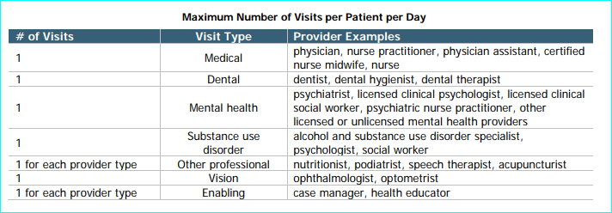
- Patient Consent and HIPAA acknowledgement
- Specific definitions for each Data Reporting element
- PHI reporting procedures
- Incomplete data – returned data reports
- Different Attachment for RBA/Quality Reporting Requirements by each contractor

Visit Provider Type | Enter the type of provider providing a documented, face-to-face encounter. Encounter type is either Service/Enabling or Clinical; provider type must correspond to encounter type. (I.e. Nurse – Medical or Case Manager – Service/Enabling).
Visit Subsite | Name of site where services provided.
Patient Social Security Number | xxx-xx-xxx
Patient First Name
Patient Last Name
Patient Birth Date | dd/mm/yyyy
Patient Gender Identity | M/F
Patient Ethnicity | UDS Ethnicity Categories:  1. Latino or Hispanic  2. Not Hispanic  3. Unknown/Refused
Patient Race | UDS Race Categories:  1. White  2. Asian  3. Native Hawaiian  4. Other Pacific Islander  5. Black/African-American  6. American Indian/Alaska Native  7. More than one race  8. Unreported/refused to report
Patient Sex assigned at birth
Patient Sexual Orientation
Patient Diagnosis for clinical encounters | ICD10 Code for Clinical Encounters (including Mental Health & Clinical substance use). ADA Codes for Dental Visits
Visit Enabling Service Codes for enabling service encounters | ACHCH Enabling Services Types for Services Encounters only. A medical encounter will NOT include any services code types. A service encounter will not include any ICD10 codes. Medical and Service encounters provided by two different providers in the same day are submitted as two separate visits.  1. Medical Referral  2. Health/Financial Benefits Counseling  3. Housing Assistance  4. Employment Assistance  5. Food Assistance  6. Nutrition Education  7. Other Health Education  8. Alcohol/Drug Counseling/Referral  9. Mental Health Counseling/Referral  10. Transportation Assistance  11. Dental Referral  12. Optometry Referral  13. Other  14. Dental Case Management
Visit CPT Codes for clinical encounters
Patient Monthly Income | $ Amount
Patient Income Source | 1. GA  2. WIC  3. Wages, Pension or Employment  4. VA  5. Food Stamps  6. Unemployment  7. None  8. Other  10.SSI/SSA  11. Unknown  12. Cal Works/TANF  12. Child Support  (#9 missing on purpose)
Patient Medical Payer Source | Medical Payor source for patient.  8. Medi-Cal FFS  9. Medicare  10. Private Insurance  11. Sliding Scale  12. VA Medical  13. Other  14. None  15. Unknown  16. HealthPAC  18. Medi-Care Managed Care Alameda Alliance  19. Medi-Care Managed Care Blue Cross  20. Medi-Medi  (#1-7, #17 missing on purpose)
Patient Homeless Status | Patients must be screened for homelessness and most recent housing status inputted for every visit.  1. Not currently homeless  2. Shelter  3. Recovery Center  4. Doubling up  5. Street  6. Transitional  7. Homeless-Unknown Situation  8. Other  10. Hotel/Motel  14. Permanent supportive housing  (#9, #11-13 missing on purpose)
Patient Translation Needed | A. English  B. Spanish  J. Other
Patient Veteran Status | Y or N

