Form 110-8 Rev 09/30/15

**COMMUNITY BASED ORGANIZATION**

**MASTER CONTRACT EXHIBIT A & B COVERSHEET**

Dept. Name: HCSA Vendor ID #: 0000028398 Board PO #: ____________________________

Bus Unit: HCSVC Master Contract #: 900131 Procurement Contract #: 16879 Budget Year: 2020

|  |  |  |  |  |  |  |  |
| --- | --- | --- | --- | --- | --- | --- | --- |
| Acct # | Fund # | Dept # | Program # | Subclass # | Project / Grant # | Amount to be Encumbered | Total Contract Amount |
| 610341 | 10000 | 350106 | 40362 |  |  | $1,576,211 | $2,831,548 |
|  |  |  |  |  |  |  |  |
|  |  |  |  |  |  |  |  |

Justification if partial encumbrance or liquidation requested: $1,255,337 was encumbered in FY 18-19. This amendment is for time extension

and an additional encumbrance request for $1,471,030 in FY 19-20

Federal Funds Waiver #: ______________________________________________ Contract Maximum: $ 2,831,548

Procurement Contract Begin Date: July 1, 2018 Expire Date: June 30, 2020 Period of Funding From: July 1, 2018 to: June 30, 2020

Department Contact: Terri Moore Telephone #: 510-891-8927 QIC Code: 26201

Contractor Name: Lifelong Medical Care

Project Name: Lifelong Medical Care – Trust Clinic______________________________­­­_

Contractor Address: P.O. Box 1124 Berkeley, CA 94712-2247

Remittance Address: Same as Above ALCOLINK Vendor Address #: _____________ BOS Dist. #:

Contractor Telephone #:510-981-4177 Fax #: _510-981-4191_ E-mail (Signatory): [mlynch@lifelongmedical.org](mailto:mlynch@lifelongmedical.org)

Contractor Contact Person: Deborah Workman E-mail (Contact): [dworkman@lifelongmedical.org](mailto:dworkman@lifelongmedical.org)

Contract Service Category: TRUST Clinic Outpatient Primary Care and Behavioral Health Services Estimated Units of Service: __________________________

Method of Reimbursement (Invoicing Procedures): Quarterly reports, monthly invoices, not to exceed $9,242.70/month.

|  |  |  |  |  |  |
| --- | --- | --- | --- | --- | --- |
| History of Funding: | Original | Amendment #1 | Amendment #2 | Amendment #3 | Amendment #4 |
| Funding Level | $1,255,337 | $1,576,211 |  |  |  |
| Amount of Encumbrance | $1,255,337 | $1,576,211 |  |  |  |
| File Date |  |  |  |  |  |
| File / Item # |  |  |  |  |  |
| Reason | Renewal | Time extension and Augmentation |  |  |  |

|  |  |  |  |
| --- | --- | --- | --- |
| Funding Source Allocation: | Federal - CFDA #: __________ | State | County |
|  | $ | $ | $1,576,211 |

The signatures below signify that the attached Exhibits A and B have been received, negotiated and finalized. The Contractor also signifies agreement with all provisions of the Master Contract.

**DEPARTMENT**

By­ ­

Signature

­ Colleen Chawla

Print or Type Name

Title­: Health Care Services Agency Director Date: ­

**CONTRACTOR**

By­ ­

Signature

Martin Lynch

Print or Type Name

Title­: Executive Director/CEO Date ­

.

**EXHIBIT A -1**

**ADDITIONAL PROGRAM DESCRIPTION AND PERFORMANCE REQUIREMENTS**

**Lifelong Medical Care for Trust Clinic**

**For the period if 7/1/18 – 6/-30/20**

|  |  |
| --- | --- |
| **Contracting Department** | Health Care Services Agency Administration and Indigent Health |
| **Contractor Name** | LifeLong Medical Care |
| **Original Master Contract Period** | 7/1/18 – 6/30/19 |
| **Original Master Contract Amount** | $1,255,337 |
| **First Amendment Contract Period** | 7/1/18 – 6/30/2020 (a twelve month extension) |
| **First Amendment Amount** | $2,831,548 (increase of $1,576,211) |
| **Type of Services** | TRUST Clinic Outpatient Primary Care Integrated Behavioral Health Services |
| **Contract PO Number** | 7624 |
| **Procurement Contract No.** | 16879 |

This Exhibit A-1 replaces the original Exhibit A.

1. **Program Name**

TRUST Clinic

1. **Contracted Services**

Contractor shall provide:

1. Drop-in access to primary care medical, behavioral, and health coaching services.
2. On-site services to engage patients:
   1. Welcoming waiting room environment (e.g., coffee, snacks, computer access);
   2. Showers and assistance with other basic needs;
   3. Waiting room engagement and safety facilitator.
3. Behavioral health intake at first visit for all new TRUST clients. The intake process may be adjusted based on patient population needs and upon mutual agreement with the County.
4. Utilization of care plans by a multi-disciplinary team which is intended to coordinate care and to drive and track the progress of patients based on patient-derived collaborative goals. Completed care plan includes:
   * 1. Patient-derived, collaborative goals;
     2. Initial assessment and action steps to improve the status of health, income, housing, and transportation;
     3. Plan for coordination with outside agencies, such as case management; Documented updates to the care plan at each encounter with a health coach to track progress.
5. Comprehensive primary care including:
   1. Integrated medical and mental health care with capacity to serve highly complex adults with multiple medical, behavioral, and social conditions;
   2. Medication assisted treatment (MAT) for substance use disorders including maintenance of buprenorphine treatment;
   3. Coordination with County specialty mental health providers (e.g., case managers and service teams); HCSA will collaborate with the contractor in providing clinical staff for on-site behavioral health services including but not limited to: individual and group psychotherapy, psychiatric medication management, and buprenorphine treatment induction.
   4. Linkage to dental services;
   5. Health Coaching (individuals and groups);
   6. Disability documentation;
   7. Housing Coordination.
6. Team-based care including:
   1. Integrated case conferences and daily huddles
   2. Shared care plan for each unique client and tracking of progress over time for housing, income, and chronic health conditions including physical, mental or substance use disorders;
   3. Coordination with external treating providers and case managers.
7. Individual and group therapy options, including documented attempts to link patients to external therapy providers when internal services are not available.
8. Medi-Cal and HealthPAC enrollment and renewal assistance.
9. Collaborate with health plans and the County to track utilization of emergency, inpatient, and crisis health care services. Tracking of client data electronically through an Electronic Health Record, CHCN and health plan data sets and reports, and other electronic systems; generate reports for quality assurance and financial analysis. HCSA will assist with securing utilization that is not already available through the Contractor’s EHR and CHCN and health plan data sets and reports.

1. **Program Information and Requirements**
2. **Program** **Goals**

Contractor shall provide services to accomplish the following goals:

1. Improved physical and behavioral health status;
2. Reduced utilization of emergency, inpatient, and crisis health care services;
3. Housing stability through partnerships and collaborations with other community-based organizations;
4. Increased income through benefits enrollment and support of disability cases through adequate and timely documentation.
5. **Target Population**

Contractor shall provide services to the following populations:

1. **Service Group Criteria**

Contractor shall provide services to Alameda County residents who are homeless and/or high-utilizers of emergency, inpatient, and crisis services.

1. **Referral Process to Services**
   1. For clients meeting Service Group Criteria, referral by self or by a Community-Based Organization (CBO).
   2. Contractor shall accept referrals from the Alameda County Health Care Services Agency.
2. **Program Eligibility**

Contractor shall only serve clients who are:

* Homeless, low-income, with a chronic disability; and/or
* High-utilizer clients of emergency, inpatient, and crisis health care services who may be better served in a community-based outpatient setting; and/or
* Clients of an Alameda County Behavioral Health (ACBH) service team; and
* Not currently engaged in primary care elsewhere or have significant reason they would be better off receiving primary care at TRUST.

1. **Limitations of Service**

N/A

1. **Program Requirements**

Contractor shall maintain program services at the following minimum levels:

1. **Program Design**

The TRUST Clinic is a multi-service clinic designed to improve the health status of people who are homeless, including providing assistance with housing and income supports.

The TRUST clinic is designed to provide a combination of clinical services and wrap-around non-clinical support services to address the social determinants of health that impact people who are homeless.

The TRUST client population has a high prevalence of trauma, mental illness, substance use disorders and complex and chronic medical conditions. The severity of mental illness in the TRUST Clinic population ranges from mild/moderate to severe mental illness coupled with low-levels of functioning. People who are high-utilizers of emergency, inpatient, and crisis health care services are better served in a community based outpatient setting like the TRUST clinic.

The TRUST Clinic is a collaboration of the Contractor, Alameda County HCSA Health Care for the Homeless, and Behavioral Health Care Services. This contract acknowledges the unique aspects of this partnership which, in part, seeks to break down historical barriers to care between primary care and behavioral health care in the safety net of Alameda County.

The Contractor’s role is to operate the TRUST clinic including the provision of FQHC services and additional outlined contracted services, and to provide contract oversight, quality assurance and quality improvement.

1. Contract shall assign an administrative lead and a clinical champion to meet with HCSA monthly and to serve as the primary point persons for all contract deliverables including clinical, administrative, and financial reports. Suggested leads are the TRUST Center Director/Manager and Associate Medical Director.
2. Contractor shall participate in and meet requirements of monthly to bi-monthly health Care for the Homeless Quality meetings.
3. Ten percent of Contractor’s operational hours shall be spent on quality improvement activities (e.g., closing clinic on Tuesday mornings for quality assurance and improvement activities). Documentation of the 10% quality improvement time must include:
   1. 1 hour weekly multi-disciplinary case conference structured to support team learning and integrated care approach;
   2. 1 hour weekly staff training to reinforce evidenced-based practices and reduce burnout. Submit a training schedule within 1 month of commencement of contract covering: de-escalation, trauma-informed care, motivational interviewing, burnout prevention/wellness, harm-reduction, mental health first aid, housing first, and effective disability documentation for clinicians. HCSA will provide additional in-kind support in the form of trainers, evidence-based training curricula, and technical assistance.
   3. Bi-weekly individual and group supervision for health coaches for appropriate patient panel management and to support staff wellness and burnout prevention.
   4. Convene regular meetings of a consumer advisory group (i.e., TRUST Partners) comprised of at least 8 consumers to provide input to the Center Manager on clinic protocols and clinic development. Contractor will budget for at least $25 in incentive gift cards for each consumer per meeting to help with ongoing recruitment.
4. Contractor shall have a process for staff to report sentinel events as defined by the Joint Commission, including a death of a patient, which will lead to a subsequent investigation, summary, and next steps, all of which must be reported within 8 weeks of the event being reported. If the current, established plan is changed LifeLong will submit to HCSA with the following monthly report.
5. It is the responsibility of the contractor to ensure that all services are provided in accordance with pertinent laws, regulations, codes and permits; professionally recognized standards; prevailing standards of medical practice in the community; and all provisions of this contract, including record-keeping and reporting requirements, whether provided by Contractor at a Contractor site, or through referral to an outside provider.
6. Contractor shall deliver health services that demonstrate a high quality of care as defined by prevailing professional standards, by HCSA, and by consumers of these services. These services shall be provided by Contractor in a manner consistent with principles of professional practice and ethical conduct and reflect concern for the acceptability, accessibility, and cost of services.
7. Contractor shall promptly handle complaints, appeals, and grievances. An individual may file a complaint, appeal or grievance with the County or the Contractor. If an individual files a complaint, appeal, or grievance with Contractor, the county delegates to Contractor the responsibility of handling in a professional manner and in accordance with all County policies that complaint, appeal or grievance. At no time shall an individual’s medical condition be permitted to deteriorate because of delay in provision of care that Contractor disputes. Fiscal and administrative concerns shall not influence the independence of the medical decision-making process to resolve any medical disputes between an individual and Contractor. Contractor shall establish and maintain a written policy which describes the Contractor’s internal process for resolving patient and potential patient complaints and grievances. The policy shall be made available for review upon County’s request. The Contractor shall designate a contact person for the County to contact regarding complaints, appeals and grievances that are filed with the County.
8. **Consumer/Client Flow**
9. Drop-in access to primary care medical, behavioral, and health coaching services.
10. On-site services to engage patients:
    1. Welcoming waiting room environment (e.g., coffee, snacks, computer access);
    2. Showers and assistance with other basic needs;
    3. Waiting room engagement and safety facilitator.
11. Behavioral health intake at first visit for all new TRUST clients. The intake process may be adjusted based on patient population needs and upon mutual agreement with the County.
12. A completed care plan for each active patient within 30 days of assignment to TRUST by clinical or non-clinical staff including documentation of housing and income status in the Electronic Health Record (EHR).
13. A 1 FTE PCP panel size of up to 750 patients.
14. Administration of the ACHCH patient experience survey on a continuous basis.
15. Report on patient experience and clinical quality by the TRUST Center Director/Manager and Associate Medical Director to the TRUST consumer advisory board on an annual basis.
16. **Discharge Criteria and Process**

A patient discharge policy and procedure will be developed in collaboration with the county and submitted within one month of the start of this contract.

1. **Hours of Operation**

Contractor shall maintain the following minimum hours of operation:

36 hours a week open for patient care,

Mon, Wed, Thurs, Fri: 8:30 am – 4:30 pm,

Tues: 1:00 – 4:30 pm

1. **Service Delivery Sites**

Contractor shall provide services at the following location(s):

386 14th Street, Oakland, CA 94612

1. **Minimum Staffing Qualifications**
2. Contractor shall have and maintain current job descriptions on file with HCSA for all personnel whose salaries, wages, and benefits are reimbursable in whole or in part under this agreement. Submission of current job descriptions will be required within one month of commencement of contract. Job descriptions shall specify the minimum qualifications for services to be performed and shall meet the approval of HCSA. Contractor shall submit revised job descriptions meeting the approval of the Department prior to implementing any changes or employing persons who do not meet the minimum qualifications on file with the HCSA.
3. Contractor shall submit an updated organizational chart reflecting all positions in the clinic within one month of commencement of contract.
4. Contractor will develop a workforce retention plan to reduce staff turnover that is typically associated with homeless services, as well as for financial incentives for high-performing frontline staff as determined by contractor.
5. Contractor will budget for 3 staff members (at least 2 non-clinical, frontline members) to attend the National Health Care for the Homeless Conference in May 2020.
6. **Contract Deliverables and Requirements**

|  |  |
| --- | --- |
| **Reports** | **Frequency** |
| Program and Clinical Quality Improvement  12-month calendar and the identified staff lead for:   * Weekly case conferences * Weekly staff training * Bi-weekly individual and group supervision * Regular consumer advisory group meetings | July 31, 2019 |
| Staffing   * Organizational chart, staff job descriptions, and retention plan | July 31, 2019 |
| Care Plan   * % of patients with a care plan | Monthly |
| Utilization Report   * Microsoft Excel file of encounter data (see Attachment A1) * Trust Productivity Report (see Attachment A2) | Monthly |
| Program and Clinical Quality Reports   * Population-level reports, including the following standard clinical quality measures: PHQ-9, AUDIT, PCL, blood pressure, HgbA1c, tobacco use, cancer screenings, HIV, hepatitis C | Monthly |
| Access Reports   * Microsoft Excel file of referrals to Trust including date source, and kept vs. not kept * Microsoft Excel file of monthly number of walk-in visits seen and not seen on the same day | Monthly |
| Financial Reports   * Trust Income Statement (Attachment A3) * Trust Site Visit Report (Attachment A4) | Monthly |
| CAHPS Patient Experience Survey Report | Quarterly |
| Uniform Data System Outcome Report applying to prior calendar year for TRUST Clinic site only (Per 2014 UDS Manual, see pp. 109-110 re: Table 7, Sections B and C) | Annually |

1. **Detailed Contract Deliverables (that include Process Objectives )**

Contractor shall provide the following services/deliverables:

|  |  |  |
| --- | --- | --- |
| **Process Objectives** | **“How Much”**  **Performance Measure** | **Data Collection Tool** |
| * By June 30, 2020, LMC-Trust Clinic shall provide integrated primary care services to a minimum 540 new Trust patients (45/monthly ) | * # of new unduplicated Trust patients who received integrated primary care services * # of active patients (patients with 3 or more face-to-face visits in 12 months with at least 1 PCP visit | * NextGen EHR |
| * By June 39, 2020, LMC-Trust Clinic shall provide primary care medical and behavioral health services through a minimum of 255 walk-in encounters each month   (n=3,060 encounters/yr)  (ACCESS) | * # of walk-in medical encounters (billable or non-billable) * # of walk-in behavioral health encounters (billable or non-billable) | * App/Registration Database |
| * By June 30, 2020, 350 LMC-TRUST CLINIC patients with at least two primary care visits (within a fiscal year) will be screened for four diseases/conditions:   + Hepatitis C   + HIV   + Hypertension * Diabetes | * + # patients w/>=2PC visits (within a fiscal year) who received screening for four diseases/ conditions:   + Hepatitis C   + HIV   + Hypertension   + Diabetes | * NextGen EHR |
| * By June 30, 2020 at least 500 Trust patients will have completed the HCH patient experience survey at least once | * # of unique patients that have completed the patient experience survey | * HCH Patient Experience Survey |
| * By June 30, 2020, LMC-Trust Clinic licensed BH providers will complete behavioral health intakes for 300 new patients. | * # of Behavioral Health intakes completed by licensed behavioral health providers | * NextGen EHR (first intake/BH intake/progress notes) |
| * By June 30, 2020, 540 active patients will have completed a housing status assessment. | * # of active patients completing a housing status assessment | * Care Management template |
| * By June 30th, 2019, 540 active patients on a Health Coach panel had at least 1 completed touch per month | * # of active patients on health panel with at least one completed touch per month | * Care Management template |

1. **Quality Objectives**

Contractor shall meet the following outcomes:

|  |  |  |
| --- | --- | --- |
| **Quality Objective** | **“How Well”**  **Performance Measure** | **Data Collection Tool** |
| * By June 30, 2020, 80% of survey participants will report the care they received is helping them move in a positive direction | * % of patients who believe the care they received is helping them move in a positive direction | * HCH Patient Experience Survey |
| * By June 30, 2020, 80% of patients who completed the patient satisfaction survey will say that they felt respected. | * % of survey participants who report that they felt respected. | * HCH Patient Experience Survey |
| * By June 30, 2020, 80% of patients who completed the patient satisfaction survey will say that they didn’t feel judged in any way. | * % of survey participants who didn’t feel judged in any way. | * HCH Patient Experience Survey |
| * By June 30, 2020, LMC-Trust Clinic leadership, clinicians, and front-line staff will review its patient experience data at least four times during 2019-20. | * # of times LMC-Trust Clinic leadership and front-line staff review patient experience data. | * Meeting Minutes/ surveygizmo downloads * Lifelong Survey quarterly reports |
| * By June 30, 2020, 80% of active patients will have completed an income and expense assessment in the IC plan | * % of active patients who have completed an income and expense assessment in Integrated Care Plan | * NextGen   (first intake/BH intake/progress notes |
| * By June 30, 2020, 80% of active TRUST patients on a Health Coach panel will have had at least 1 completed touch per month | * % of patients on Health Coach panel with at least one completed Health Coach touch per month | * ICP Template |

**C. Impact Objectives**

Contractor shall meet the following outcomes:

|  |  |  |
| --- | --- | --- |
| **Impact Objective** | **“Is anyone better off?”**  **Performance Measure** | **Data Collection Tool** |
| * By June 30, 2020, 50% (n=270) of patients will have had at least 3 visits, on separate days, within the first six months of program participation | * % of patients with at least 3 visits on separate dates within the first six months of program participation | * NextGen EHR |
| * By June 30, 2020, LMC-Trust Clinic will improve access to its service providers (w/billable svcs. /activities) by increasing the number of walk-in encounters completed by 30%. | * % increase in completed walk-in encounters by service providers billing for services/activities. | * NextGen EHR |
| * By June 30, 2020, 65% of all patients diagnosed with Hep C will be cured. * By June 30, 2020, 30% of all patients with a positive HIV result will achieve viral control * By June 30, 2020, 50% of active patients with a hypertension diagnosis will achieve blood pressure control. * By June 30, 2020, 80% of active patients diagnosed with diabetes achieve HbA1c control | * % of patients diagnosed with Hep C who were cured. * % of patients screened positive for HIV with an undetectable viral load <20 copies * % of active patients screened positive for hypertension with last SBP <140mm hg and last DBP < 90mm hg * % of active patients screened positive for diabetes who achieve HbA1c control (<9%) | * NextGen EHR |
| * By June 30, 2020, 80% of respondents who completed a HCH patient experience survey indicate they would refer friends/family to TRUST | * % of respondents who indicated they would refer friends/family to TRUST | * HCH Patient Survey surveygizmo |
| * By June 30, 2019, the net promoter score for the Lifelong quarterly survey will improve by 15% | * % improvement in net promoter score | * Lifelong Satisfaction Survey |
| * By June 30, 2020, 100% of new patients with at least two completed visits will have completed an integrated care plan | * % of patients who have an integrated care plan in their electronic health record. | * NextGen EHR |
| * By June 30, 2020, at least 50% of housing referral specialist patients will have a completed CES assessment and appropriate housing readiness docs for high need patients (top 400 on by names list/CE list) –HMIS * By June 30, 2020, 95% of qualified patients were connected to the coordinated entry system | * # of Housing Referral Specialist patients who completed CES assessment and appropriate housing readiness docs * % qualified patients connected to coordinated entry system | * Excel Worksheet * HMIS/Clarity |
| * By June 30, 2020, 80% of patients with Health Coach services received referrals for community based resources | * % of patients with Health Coach Services referred for community based resources. | NextGen HER  Housing tracking sheet |

1. **Reporting and Evaluation Requirements**
2. **Reporting Requirements**

Monthly reports shall be due by the 20th day of the month following the end of the month. Quarterly reports shall be due by the 20th day of the month following the end of the quarter. Annual UDS Report shall be due January 15th 2020.

Contractor is required to enter Result Based Accountability (RBA) Measures in the County’s Clear Impact Software by the 15th of the month.

1. **Process Performance Measures**

|  |
| --- |
| 1. # of new unduplicated Trust patients who received integrated primary care services |
| 1. # of active patients (patients with 3 or more face-to-face visits in 12 months with at least 1 PCP visit) |
| 1. # of walk-in medical encounters (billable/non-billable) |
| 1. # of walk-in behavioral health encounters (billable/non-billable) |
| 1. # of patients with >=2PC visits (within a fiscal year) who received screening for four diseases/conditions: Hep C/HIV/Hypertension/Diabetes |
| 1. # of unique patients that have completed the patient experience survey |
| 1. # of Behavioral Health intakes completed by licensed behavioral health providers |
| 1. # of active patients completing a housing status assessment |
| 1. # of active patients on health panel with at least one completed touch per month |

1. **Quality Performance Measures**

|  |
| --- |
| 1. % of patient who believe the care they received is helping them move in a positive direction |
| 1. % of survey participants who report that they felt respected |
| 1. % of survey participants who didn’t feel judged in any way |
| 1. % of times Trust Clinic leadership and frontline staff review patient experience data |
| 1. % of new patients with at least two completed visits who have completed a behavioral health intake |
| 1. % of active patients who have completed an income and expense assessment in Integrated Care Plan |
| 1. % of patients on Health Coach panel with at least one completed Health Coach touch per month |

1. **Impact Performance Measures**

|  |
| --- |
| 1. % of patients with at least 3 visits on separate dates within the first six months of program participation |
| 1. % increase in completed walk-in encounters by service providers billing for services/activities |
| 1. % of patients diagnosed with Hep C who were cured |
| 1. % of patients screened positive for HIV with an undetectable viral load <20 copies |
| 1. % of active patients screened positive for hypertension with last SBP<140mm hg and last DBP<90mm hg |
| 1. % of active patients screened positive for diabetes who achieve HbA1c control (<9%) |
| 1. % of respondents who indicated they would refer friends/family to Trust |
| 1. % improvement in net promoter score |
| 1. % of patients who have an integrated care plan in their electronic health record |
| 1. %of housing referral specialist patients who completed CES assessment & housing readiness docs |
| 1. % of qualified patients connected to coordinated entry system |
| 1. % of patients with Health Coach Services referred for community based resources |

1. **Other Reporting Requirements**

Contactor shall submit **monthly** progress reports, referencing the activities and performance measures listed in Sections IV and V of this Exhibit. Progress reports shall include performance measures achieved during the reporting period as well as cumulative, year-to-date totals. All reports shall be completed and information relayed in a manner so that they can be viewed as public documents.

1. **Evaluation Requirements**

Contractor shall submit periodic and annual reviews of program delivery and fiscal reporting as required by County, State, and Federal funding sources.

1. **Additional Requirements**
2. **Certification/Licensure**

Contractor shall have and maintain current:

Contractor shall maintain all required licenses and special permits issued by federal, state, and local agencies to the services it provides, including but not limited to the California Health and Safety Code, Division 2, and Title 22 and Title 17 Code of Regulations, or successors thereto.

Contractor shall obtain and maintain credentialing under the Alameda Alliance for Health and Anthem Blue Cross.

Contractor shall maintain certification to participate in the Medicare and Medi-Cal programs under Title 18 and 19 of the federal Social Security Act, and/or all other such future programs necessary to fulfill its obligation under this Agreement.

Contractor shall notify the contract manager immediately by telephone, and in writing within five days, when there is a change in the license and/or certification of any program, service, department, or facility providing services under this Agreement.

Contractor shall ensure that all personnel are licensed, certified, and credentialed in accordance with all legal requirements, and are qualified by training and experience to perform the services they are assigned to perform.

As a contractor providing services within the ACHCH health center scope of project, LifeLong TRUST is responsible for maintaining its operations, including development and implementation of its own operating procedures, in compliance with HRSA Health Center Program requirements listed under Health Center Program Statute- Section 330 of the Public Health Service (PHS) Act (42 U.S.C §254b), as defined in the most recent version of HRSQ’s Health Center Program Compliance Manual. Additionally, LifeLong must comply with any homeless population-specific ACHCH health center policies, such as Sliding Scale Fee Discount policy. All clinical and enabling services reported to ACHCH must be included in the most current ACHCH HRSA health center scope of project.

1. **Other Requirements**
2. The Alameda County Health Care for the Homeless is funded by taxpayers’ dollars. As such, it is important that the public be informed about the organizations that are receiving funds through Alameda County Health Care Services Agency (HCSA). Therefore, Contractor shall acknowledge the use of Health Care for the Homeless and Mental Health Service Act (MHSA) funding in statements or printed materials as outlined in the guidelines listed below:
3. Contractor shall announce funding award only after
   1. the contract has been fully executed and
   2. announcement of activities have been discussed with the Health Care for the Homeless Administrator.
4. Contractor shall agree to use official attribution logos and language provided by HCSA for promotional materials, public awareness campaigns and/or special events.
5. Contractor shall acknowledge Health Care for the Homeless funding in all materials produced for the purpose of public education and outreach regarding the recipient’s funded project. These materials would include, but are not limited to, brochures, flyers, media ads or public service announcements, presentations and handouts, telephone hold messages and outdoor ads. All printed materials and promotional products will include the following language:

**Funded by Alameda County Health Care for the Homeless and the Mental Health Services Act (MHSA)**

1. Materials produced with Health Care for the Homeless funding may be reproduced only if no changes are made to the content or design of the material, it contains the appropriate acknowledgement of funding from Health Care for the Homeless and MHSA, and the recipient will not be additionally reimbursed for use or reproduction.
2. Alameda County reserves the right to request additional information. The approval of County to a requested change shall not release Contractor from its obligations under this Agreement.
3. **Patient Satisfaction Surveys**

Contractor shall provide surveys (provided by contractor/ACHCH Quality Committee) to their target population that include questions about the services the contractor provides to ACHCH patients as follows:

ACHCH Patient Experience Survey

1. **Entirety of Agreement**

Contractor shall abide by all provisions of the Human Services Master Contract General Terms and Conditions, all Exhibits, and all Attachments that are associated with and included in this contract.

Contractor agrees to the supplemental terms and conditions contained in the following attachments to this Exhibit A-1:

* Attachment A1—Required utilization data
* Attachment A2— TRUST Productivity
* Attachment A3 – TRUST Income Statement
* Attachment A4—TRUST Site Visit Report
* Attachment A5— TRUST Patient Experience Survey Instrument

**EXHIBIT B-1**

**ADDITIONAL TERMS AND CONDITIONS FOR PAYMENT**

**Contracting Departmen**t:Health Care Services Agency

**Contractor Name:**  LifeLong Medical Care

**Contract Period:** July 1, 2018 – June 30, 2020

**Contract Amount:** $1,255,337

**First Amendment Amount:** $2,831,548 (increase of $1,576,211)

**Types of Services:** Outpatient Primary Care

**Contract PO Number: 7624**

**Procurement Contract Number: 16879**

This Exhibit B-1 is in addition to and does not replace Exhibit B in the original contract except that Attachment B1 replaces the Attachment B1 in the original contract.

1. Budget
   1. Contractor shall use all payments solely in support of the program budget, set forth as follow in Attachments B1 (Detailed budget—July 1, 2019 – June 30, 2020).
   2. Total budget must include in-kind County services including facility use and licensed County staff services to the clinic that are billable to Medi-Cal.
   3. Contractor shall maintain a project ledger to adequately identify all expenditures and revenues related to this grant. All journals and ledgers should be kept current. Posting should occur at least on a monthly basis.
   4. Contractor must request written approval from the County of any variance of ten percent or greater between actual costs and approved budget costs for Personnel and/or Operating Expenses.
2. Terms and Conditions of Payment
   1. The total amount paid under the terms of this Agreement shall not exceed $2,831,548.
   2. From July 1, 2019 through June 30, 2020, County shall reimburse Contractor in 12 monthly payments for budgeted expenditures contingent on the receipt of the deliverables listed below.
      1. Monthly budget to actual expense report.
      2. Year-to-date budget to actual expense report.
      3. Timely and complete reports in accordance with the schedule outlined in Exhibit A-1, Contract Deliverables and Requirements.
3. Invoicing Procedures
   1. Contractor shall submit a properly completed payment invoice to Alameda County on a monthly basis for operational and program-related expenditures incurred by Contractor while providing and/or arranging for the provision of services pursuant to this Agreement. Contractor or designee certifying the delivery of services shall sign invoices and the accuracy of the information provided in these documents. Each invoice shall include the name and telephone number of a designated contact person for follow-up purposes.

Invoices shall be submitted to:

Alameda County Health Care for the Homeless

1404 Franklin Street, Suite 200

Oakland, CA 94612

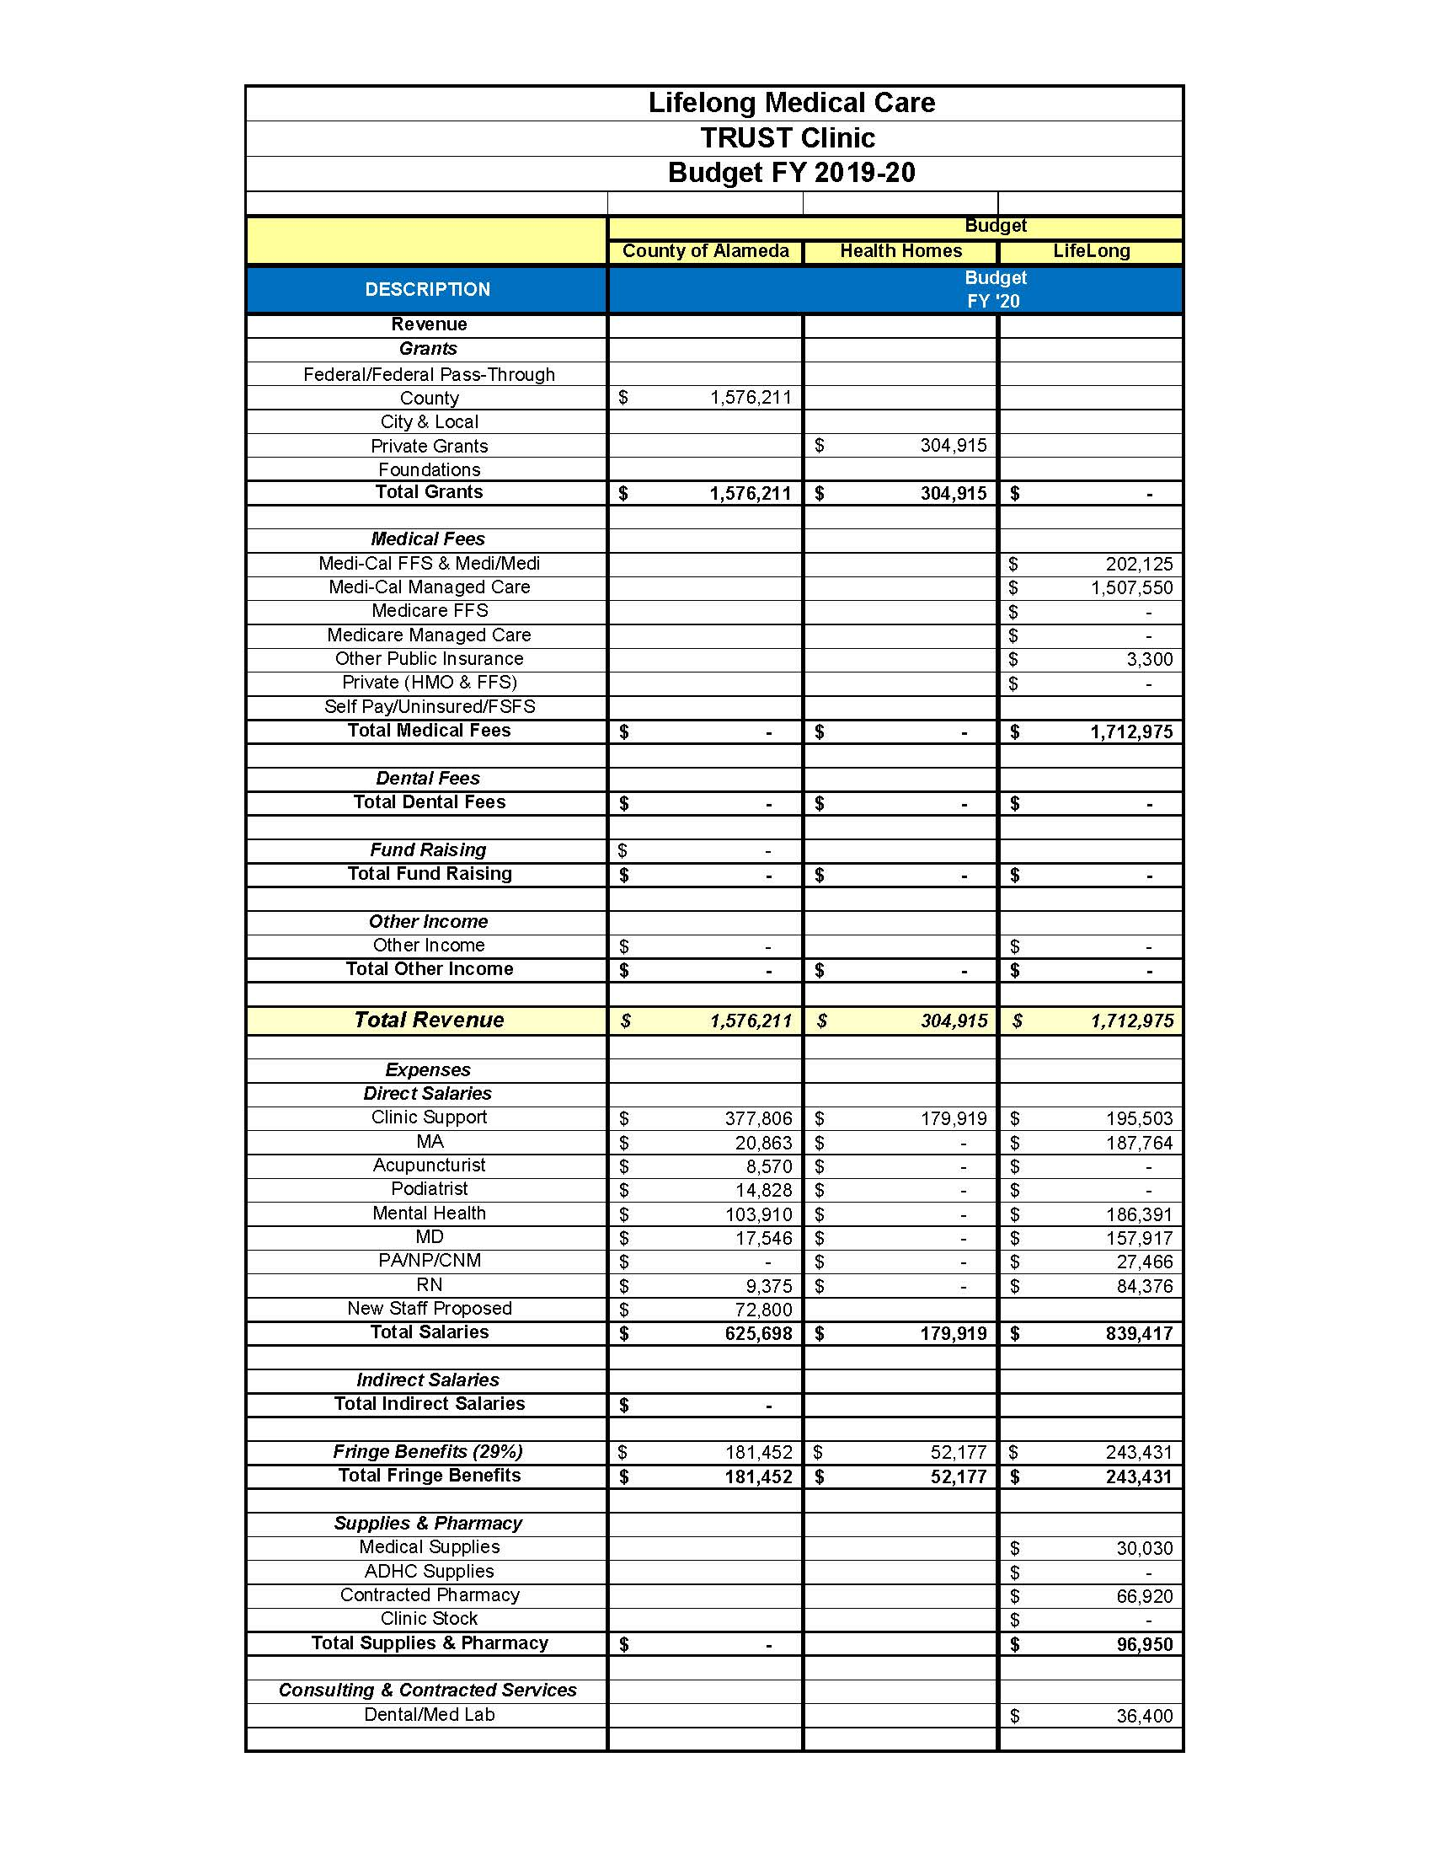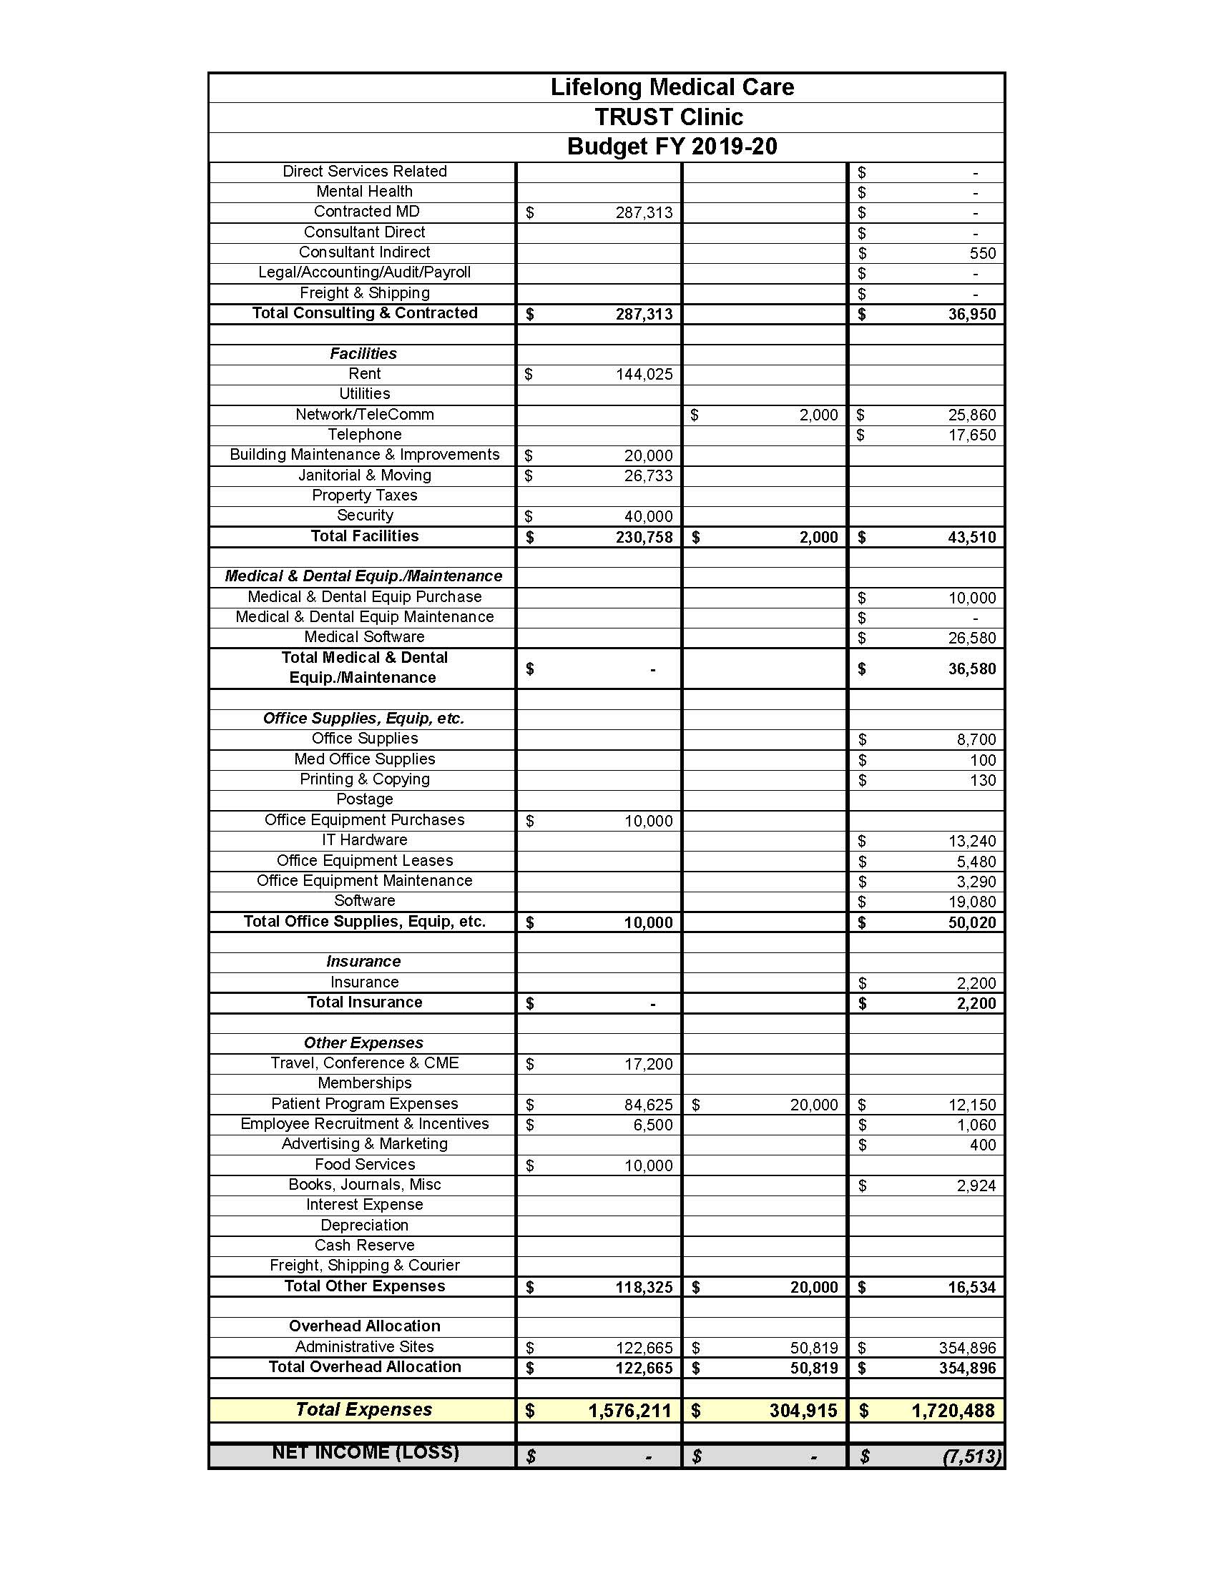

ATTACHEMENT B1



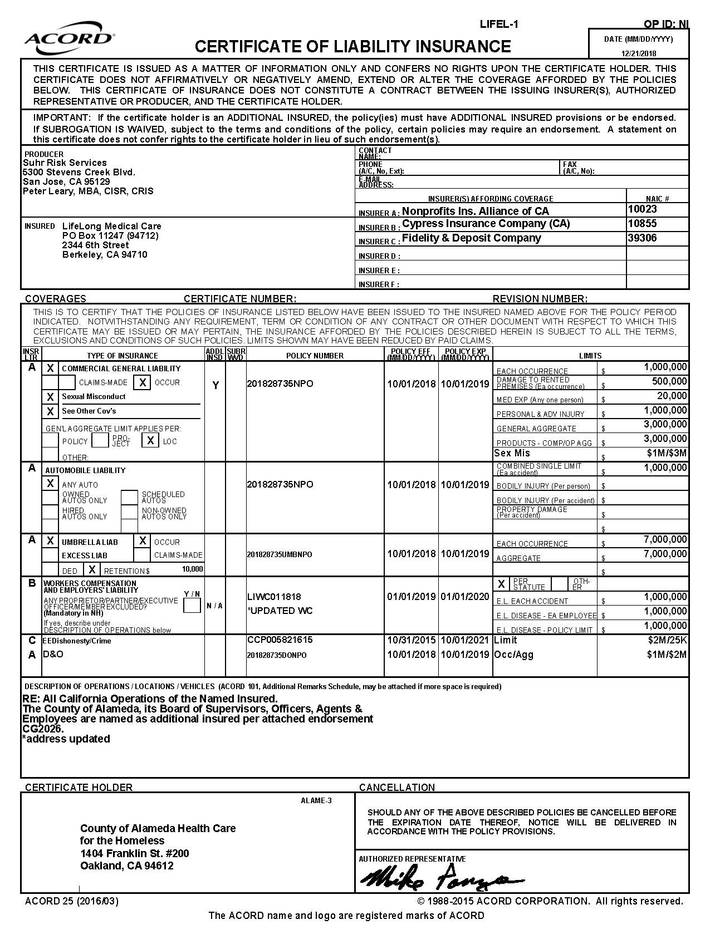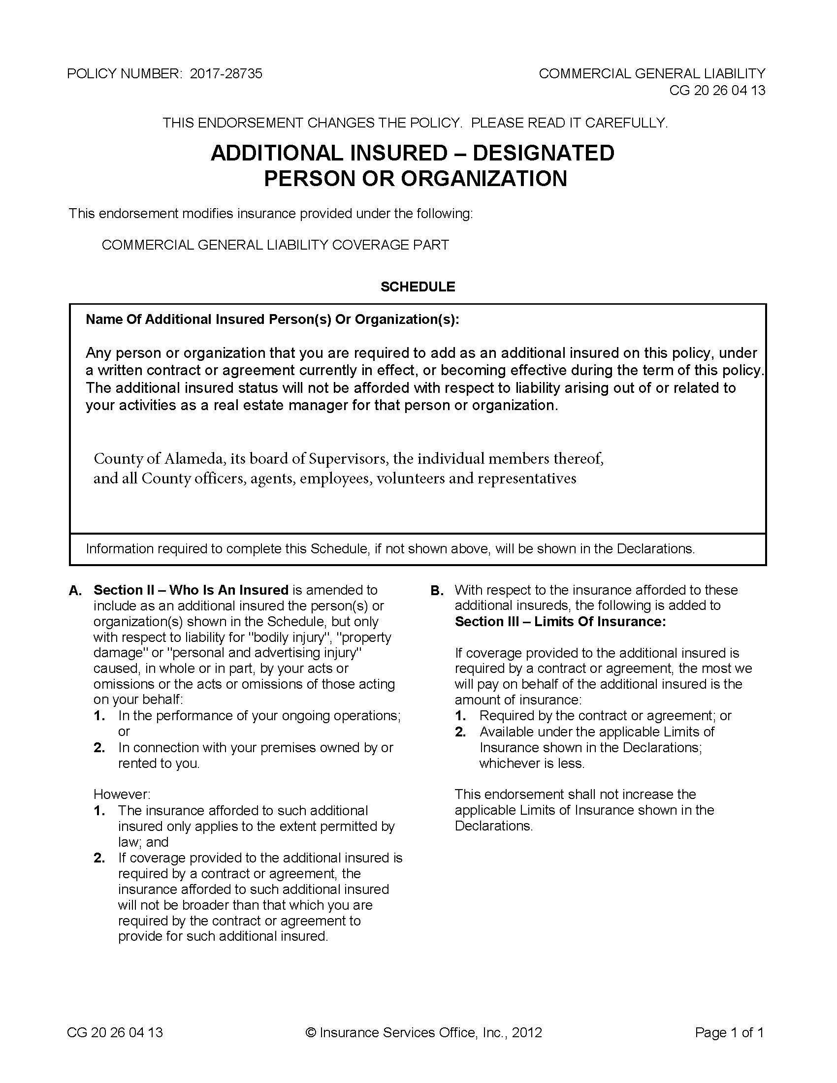

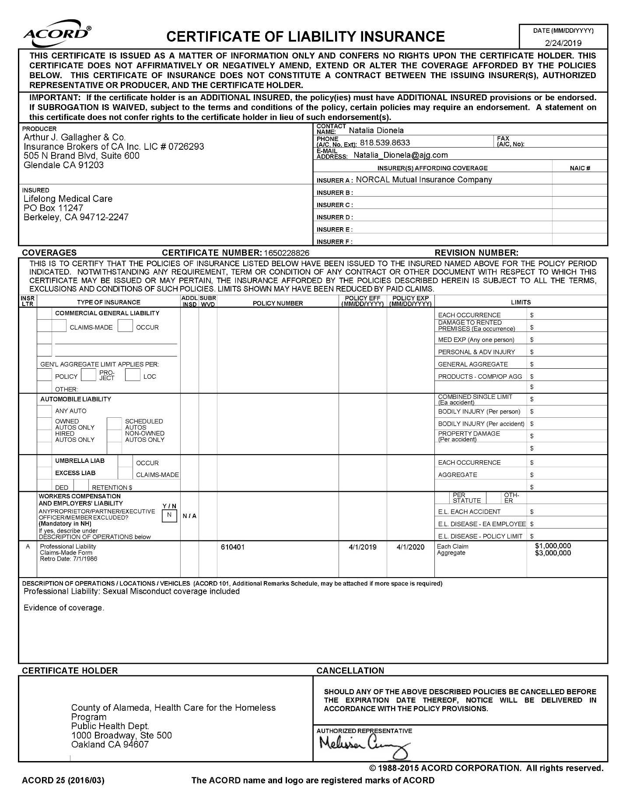

**EXHIBIT F**

Audit Requirements

The County contracts with various organizations to carry out programs mandated by the Federal and State governments or sponsored by the Board of Supervisors. Under the Single Audit Act Amendments of 1996 (31 U.S.C.A. §§ 7501-7507) and Board policy, the County has the responsibility to determine whether organizations receiving funds through the County have spent them in accordance with applicable laws, regulations, contract terms, and grant agreements. To this end, effective with the first fiscal year beginning on and after December 26, 2014, the following are required.

1. **AUDIT REQUIREMENTS**
   1. **Funds from Federal Sources:**
      1. Non-Federal entities which are determined to be subrecipients by the supervising department according to 2 CFR § 200.330 and which expend annual Federal awards in the amount specified in 2 CFR § 200.501 are required to have a single audit performed in accordance with 2 CFR § 200.514.

2. When a non-Federal entity expends annual Federal awards in the amount specified in 2 CFR § 200.501(a) under only one Federal program (excluding R&D) and the Federal program's statutes, regulations, or terms and conditions of the Federal award do not require a financial statement audit of the auditee, the non-Federal entity may elect to have a program-specific audit conducted in accordance with 2 CFR § 200.507 (Program Specific Audits).

3. Non-Federal entities which expend annual Federal awards less than the amount specified in 2 CFR § 200.501(d) are exempt from the single audit requirements for that year except that the County may require a limited-scope audit in accordance with 2 CFR § 200.503(c) .

* 1. Funds from All Sources:

Non-Federal entities which expend annual funds from any source (Federal, State, County, etc.) through the County in an amount of:

* + 1. $100,000 or more must have a financial audit in accordance with the U.S. Comptroller General’s Generally Accepted Government Auditing Standards (GAGAS) covering all County programs.
    2. Less than $100,000 are exempt from these audit requirements except as otherwise noted in the contract.

Non-Federal entities that are required to have or choose to do a single audit in accordance with 2 CFR Subpart F, Audit Requirements are not required to have a financial audit in the same year. However, Non-Federal entities that are required to have a financial audit may also be required to have a limited-scope audit in the same year.

* 1. General Requirements for All Audits:
     1. All audits must be conducted in accordance with Generally Accepted Government Auditing Standards issued by the Comptroller General of the United States (GAGAS).
     2. All audits must be conducted annually, except for biennial audits authorized by 2 CFR § 200.504 and where specifically allowed otherwise by laws, regulations, or County policy.
     3. The audit report must contain a separate schedule that identifies all funds received from or passed through the County that is covered by the audit. County programs must be identified by contract number, contract amount, contract period, and amount expended during the fiscal year by funding source. An exhibit number must be included when applicable.
     4. If a funding source has more stringent and specific audit requirements, these requirements must prevail over those described above.

1. **AUDIT REPORTS**
   1. For Single Audits
      1. Within the earlier of 30 calendar days after receipt of the auditor’s report or nine months after the end of the audit period, the auditee must electronically submit to the Federal Audit Clearinghouse (FAC) the data collection form described in 2 CFR § 200.512(b) and the reporting package described in 2 CFR § 200.512(c). The auditee and auditors must ensure that the reporting package does not include protected personally identifiable information. The FAC will make the reporting package and the data collection form available on a web site and all Federal agencies, pass-through entities and others interested in a reporting package and data collection form must obtain it by accessing the FAC. As required by 2 CFR § 200.512(a)(2), unless restricted by Federal statutes or regulations, the auditee must make copies available for public inspection.
      2. A notice of the audit report issuance along with two copies of the management letter with its corresponding response should be sent to the County supervising department within ten calendar days after it is submitted to the FAC. The County supervising department is responsible for forwarding a copy of the audit report, management letter, and corresponding responses to the County Auditor within one week of receipt.
   2. For Audits other than Single Audits

At least two copies of the audit report package, including all attachments and any management letter with its corresponding response, should be sent to the County supervising department within six months after the end of the audit year, or other time frame as specified by the department. The County supervising department is responsible for forwarding a copy of the audit report package to the County Auditor within one week of receipt.

1. **AUDIT RESOLUTION**

Within 30 days of issuance of the audit report, the entity must submit to its County supervising department a corrective action plan consistent with 2 CFR § 200.511(c) to address each audit finding included in the current year auditor’s report. Questioned costs and disallowed costs must be resolved according to procedures established by the County in the Contract Administration Manual. The County supervising department will follow up on the implementation of the corrective action plan as it pertains to County programs.

1. **ADDITIONAL AUDIT WORK**

The County, the State, or Federal agencies may conduct additional audits or reviews to carry out their regulatory responsibilities. To the extent possible, these audits and reviews will rely on the audit work already performed under the audit requirements listed above.

NAME: **Lifelong Medical Care**

PRINCIPAL: **Martin Lynch** TITLE: **Executive Director/CEO**

SIGNATURE: DATE:

**EXHIBIT E**

**HIPAA BUSINESS ASSOCIATE AGREEMENT**

This Exhibit, the HIPAA Business Associate Agreement (“Exhibit”) supplements and is made a part of the underlying agreement (“Agreement”) by and between the County of Alameda, (“County” or “Covered Entity”) and Lifelong Medical Care (“Contractor” or “Business Associate”) to which this Exhibit is attached. This Exhibit is effective as of the effective date of the Agreement.

**I. RECITALS**

Covered Entity wishes to disclose certain information to Business Associate pursuant to the terms of the Agreement, some of which may constitute Protected Health Information (“PHI”);

Covered Entity and Business Associate intend to protect the privacy and provide for the security of PHI disclosed to Business Associate pursuant to the Agreement in compliance with the Health Insurance Portability and Accountability Act of 1996, Public Law 104-191 (“HIPAA”), the Health Information Technology for Economic and Clinical Health Act, Public Law 111-005 (the “HITECH Act”), the regulations promulgated thereunder by the U.S. Department of Health and Human Services (the “HIPAA Regulations”), and other applicable laws; and

The Privacy Rule and the Security Rule in the HIPAA Regulations require Covered Entity to enter into a contract, containing specific requirements, with Business Associate prior to the disclosure of PHI, as set forth in, but not limited to, Title 45, sections 164.314(a), 164.502(e), and 164.504(e) of the Code of Federal Regulations (“C.F.R.”) and as contained in this Agreement.

**II. STANDARD DEFINITIONS**

Capitalized terms used, but not otherwise defined, in this Exhibit shall have the same meaning as those terms are defined in the HIPAA Regulations. In the event of an inconsistency between the provisions of this Exhibit and the mandatory provisions of the HIPAA Regulations, as amended, the HIPAA Regulations shall control. Where provisions of this Exhibit are different than those mandated in the HIPAA Regulations, but are nonetheless permitted by the HIPAA Regulations, the provisions of this Exhibit shall control. All regulatory references in this Exhibit are to HIPAA Regulations unless otherwise specified.

The following terms used in this Exhibit shall have the same meaning as those terms in the HIPAA Regulations: Data Aggregation, Designated Record Set, Disclosure, Electronic Health Record, Health Care Operations, Health Plan, Individual, Limited Data Set, Marketing, Minimum Necessary, Minimum Necessary Rule, Protected Health Information, and Security Incident.

The following term used in this Exhibit shall have the same meaning as that term in the HITECH Act: Unsecured PHI.

**III. SPECIFIC DEFINITIONS**

*Agreement.* “Agreement” shall mean the underlying agreement between County and Contractor, to which this Exhibit, the HIPAA Business Associate Agreement, is attached.

*Business Associate.* “Business Associate” shall generally have the same meaning as the term “business associate” at 45 C.F.R. section 160.103, the HIPAA Regulations, and the HITECH Act, and in reference to a party to this Exhibit shall mean the Contractor identified above. “Business Associate” shall also mean any subcontractor that creates, receives, maintains, or transmits PHI in performing a function, activity, or service delegated by Contractor.

*Contractual Breach.* “Contractual Breach” shall mean a violation of the contractual obligations set forth in this Exhibit.

*Covered Entity. “*Covered Entity” shall generally have the same meaning as the term “covered entity” at 45 C.F.R. section 160.103, and in reference to the party to this Exhibit, shall mean any part of County subject to the HIPAA Regulations.

*Electronic Protected Health Information*. “Electronic Protected Health Information” or “Electronic PHI” means Protected Health Information that is maintained in or transmitted by electronic media.

*Exhibit.* “Exhibit” shall mean this HIPAA Business Associate Agreement.

*HIPAA.* “HIPAA” shall mean theHealth Insurance Portability and Accountability Act of 1996, Public Law 104-191.

*HIPAA Breach.* “HIPAA Breach” shall mean a breach of Protected Health Information as defined in 45 C.F.R. 164.402, and includes the unauthorized acquisition, access, [use](http://www.hipaasurvivalguide.com/hipaa-regulations/164-103.php#use), or [Disclosure](http://www.hipaasurvivalguide.com/hipaa-regulations/160-103.php#disclosure) of [Protected Health Information](http://www.hipaasurvivalguide.com/hipaa-regulations/160-103.php#protected-health-information) which compromises the [security](http://www.hipaasurvivalguide.com/hipaa-regulations/164-304.php#security) or privacy of such information.

*HIPAA Regulations.* “HIPAA Regulations” shall mean the regulations promulgated under HIPAA by the U.S. Department of Health and Human Services, including those set forth at 45 C.F.R. Parts 160 and 164, Subparts A, C, and E.

*HITECH Act.* “HITECH Act” shall mean the Health Information Technology for Economic and Clinical Health Act, Public Law 111-005 (the “HITECH Act”).

*Privacy Rule and Privacy Regulations.* “Privacy Rule” and “Privacy Regulations” shall mean the standards for privacy of individually identifiable health information set forth in the HIPAA Regulations at 45 C.F.R. Part 160 and Part 164, Subparts A and E.

*Secretary.* “Secretary” shall mean the Secretary of the United States Department of Health and Human Services (“DHHS”) or his or her designee.

*Security Rule and Security Regulations*. “Security Rule” and “Security Regulations” shall mean the standards for security of Electronic PHI set forth in the HIPAA Regulations at 45 C.F.R. Parts 160 and 164, Subparts A and C.

**IV. PERMITTED USES AND DISCLOSURES OF PHI BY BUSINESS ASSOCIATE**

Business Associate may only use or disclose PHI:

A. As necessary to perform functions, activities, or services for, or on behalf of, Covered Entity as specified in the Agreement, provided that such use or Disclosure would not violate the Privacy Rule if done by Covered Entity;

B. As required by law; and

C. For the proper management and administration of Business Associate or to carry out the legal responsibilities of Business Associate, provided the disclosures are required by law, or Business Associate obtains reasonable assurances from the person to whom the information is disclosed that the information will remain confidential and used or further disclosed only as required by law or for the purposes for which it was disclosed to the person, and the person notifies Business Associate of any instances of which it is aware in which the confidentiality of the information has been breached.

**V. PROTECTION OF PHI BY BUSINESS ASSOCIATE**

A. *Scope of Exhibit*. Business Associate acknowledges and agrees that all PHI that is created or received by Covered Entity and disclosed or made available in any form, including paper record, oral communication, audio recording and electronic display, by Covered Entity or its operating units to Business Associate, or is created or received by Business Associate on Covered Entity’s behalf, shall be subject to this Exhibit.

B. *PHI Disclosure Limits.* Business Associate agrees to not use or further disclose PHI other than as permitted or required by the HIPAA Regulations, this Exhibit, or as required by law. Business Associate may not use or disclose PHI in a manner that would violate the HIPAA Regulations if done by Covered Entity.

C. *Minimum Necessary Rule.* When the HIPAA Privacy Rule requires application of the Minimum Necessary Rule, Business Associate agrees to use, disclose, or request only the Limited Data Set, or if that is inadequate, the minimum PHI necessary to accomplish the intended purpose of that use, Disclosure, or request. Business Associate agrees to make uses, Disclosures, and requests for PHI consistent with any of Covered Entity’s existing Minimum Necessary policies and procedures.

D. *HIPAA Security Rule*. Business Associate agrees to use appropriate administrative, physical and technical safeguards, and comply with the Security Rule and HIPAA Security Regulations with respect to Electronic PHI, to prevent the use or Disclosure of the PHI other than as provided for by this Exhibit.

E. *Mitigation*. Business Associate agrees to mitigate, to the extent practicable, any harmful effect that is known to Business Associate of a use or Disclosure of PHI by Business Associate in violation of the requirements of this Exhibit. Mitigation includes, but is not limited to, the taking of reasonable steps to ensure that the actions or omissions of employees or agents of Business Associate do not cause Business Associate to commit a Contractual Breach.

F*. Notification of Breach*. During the term of the Agreement, Business Associate shall notify Covered Entity in writing within twenty-four (24) hours of any suspected or actual breach of security, intrusion, HIPAA Breach, and/or any actual or suspected use or Disclosure of data in violation of any applicable federal or state laws or regulations. This duty includes the reporting of any Security Incident, of which it becomes aware, affecting the Electronic PHI. Business Associate shall take (i) prompt corrective action to cure any such deficiencies and (ii) any action pertaining to such unauthorized use or Disclosure required by applicable federal and/or state laws and regulations. Business Associate shall investigate such breach of security, intrusion, and/or HIPAA Breach, and provide a written report of the investigation to Covered Entity’s HIPAA Privacy Officer or other designee that is in compliance with 45 C.F.R. section 164.410 and that includes the identification of each individual whose PHI has been breached. The report shall be delivered within fifteen (15) working days of the discovery of the breach or unauthorized use or Disclosure. Business Associate shall be responsible for any obligations under the HIPAA Regulations to notify individuals of such breach, unless Covered Entity agrees otherwise.

G*. Agents and Subcontractors*. Business Associate agrees to ensure that any agent, including a subcontractor, to whom it provides PHI received from, or created or received by Business Associate on behalf of Covered Entity, agrees to the same restrictions, conditions, and requirements that apply through this Exhibit to Business Associate with respect to such information. Business Associate shall obtain written contracts agreeing to such terms from all agents and subcontractors. Any subcontractor who contracts for another company’s services with regards to the PHI shall likewise obtain written contracts agreeing to such terms. Neither Business Associate nor any of its subcontractors may subcontract with respect to this Exhibit without the advanced written consent of Covered Entity.

H*. Review of Records.* Business Associate agrees to make internal practices, books, and records relating to the use and Disclosure of PHI received from, or created or received by Business Associate on behalf of Covered Entity available to Covered Entity, or at the request of Covered Entity to the Secretary, in a time and manner designated by Covered Entity or the Secretary, for purposes of the Secretary determining Covered Entity’s compliance with the HIPAA Regulations. Business Associate agrees to make copies of its HIPAA training records and HIPAA business associate agreements with agents and subcontractors available to Covered Entity at the request of Covered Entity.

I. *Performing Covered Entity’s HIPAA Obligations.* To the extent Business Associate is required to carry out one or more of Covered Entity’s obligations under the HIPAA Regulations, Business Associate must comply with the requirements of the HIPAA Regulations that apply to Covered Entity in the performance of such obligations.

J. *Restricted Use of PHI for Marketing Purposes.* Business Associate shall not use or disclose PHI for fundraising or Marketing purposes unless Business Associate obtains an Individual’s authorization. Business Associate agrees to comply with all rules governing Marketing communications as set forth in HIPAA Regulations and the HITECH Act, including, but not limited to, 45 C.F.R. section 164.508 and 42 U.S.C. section 17936.

K. *Restricted Sale of PHI.* Business Associate shall not directly or indirectly receive remuneration in exchange for PHI, except with the prior written consent of Covered Entity and as permitted by the HITECH Act, 42 U.S.C. section 17935(d)(2); however, this prohibition shall not affect payment by Covered Entity to Business Associate for services provided pursuant to the Agreement.

L*. De-Identification of PHI.* Unless otherwise agreed to in writing by both parties, Business Associate and its agents shall not have the right to de-identify the PHI. Any such de-identification shall be in compliance with 45 C.F.R. sections 164.502(d) and 164.514(a) and (b).

M. *Material Contractual Breach.* Business Associate understands and agrees that, in accordance with the HITECH Act and the HIPAA Regulations, it will be held to the same standards as Covered Entity to rectify a pattern of activity or practice that constitutes a material Contractual Breach or violation of the HIPAA Regulations. Business Associate further understands and agrees that: (i) it will also be subject to the same penalties as a Covered Entity for any violation of the HIPAA Regulations, and (ii) it will be subject to periodic audits by the Secretary.

**VI. INDIVIDUAL CONTROL OVER PHI**

1. *Individual Access to PHI.* Business Associate agrees to make available PHI in a Designated Record Set to an Individual or Individual’s designee, as necessary to satisfy Covered Entity’s obligations under 45 C.F.R. section 164.524. Business Associate shall do so solely by way of coordination with Covered Entity, and in the time and manner designated by Covered Entity.
2. *Accounting of Disclosures.* Business Associate agrees to maintain and make available the information required to provide an accounting of Disclosures to an Individual as necessary to satisfy Covered Entity’s obligations under 45 C.F.R. section 164.528. Business Associate shall do so solely by way of coordination with Covered Entity, and in the time and manner designated by Covered Entity.
3. *Amendment to PHI.* Business Associate agrees to make any amendment(s) to PHI in a Designated Record Set as directed or agreed to by Covered Entity pursuant to 45 C.F.R. section 164.526, or take other measures as necessary to satisfy Covered Entity’s obligations under 45 C.F.R. section 164.526. Business Associate shall do so solely by way of coordination with Covered Entity, and in the time and manner designated by Covered Entity.

**VII. TERMINATION**

1. *Termination for Cause.* A Contractual Breach by Business Associate of any provision of this Exhibit, as determined by Covered Entity in its sole discretion, shall constitute a material Contractual Breach of the Agreement and shall provide grounds for immediatetermination of the Agreement, any provision in the Agreement to the contrary notwithstanding. Contracts between Business Associates and subcontractors are subject to the same requirement for Termination for Cause.
2. *Termination due to Criminal Proceedings or Statutory Violations.* Covered Entity may terminate the Agreement, effective immediately, if (i) Business Associate is named as a defendant in a criminal proceeding for a violation of HIPAA, the HITECH Act, the HIPAA Regulations or other security or privacy laws or (ii) a finding or stipulation that Business Associate has violated any standard or requirement of HIPAA, the HITECH Act, the HIPAA Regulations or other security or privacy laws is made in any administrative or civil proceeding in which Business Associate has been joined.
3. *Return or Destruction of PHI.* In the event of termination for any reason, or upon the expiration of the Agreement, Business Associate shall return or, if agreed upon by Covered Entity, destroy all PHI received from Covered Entity, or created or received by Business Associate on behalf of Covered Entity. Business Associate shall retain no copies of the PHI. This provision shall apply to PHI that is in the possession of subcontractors or agents of Business Associate.

If Business Associate determines that returning or destroying the PHI is infeasible under this section, Business Associate shall notify Covered Entity of the conditions making return or destruction infeasible. Upon mutual agreement of the parties that return or destruction of PHI is infeasible, Business Associate shall extend the protections of this Exhibit to such PHI and limit further uses and Disclosures to those purposes that make the return or destruction of the information infeasible.

**VIII. MISCELLANEOUS**

1. *Disclaimer.* Covered Entity makes no warranty or representation that compliance by Business Associate with this Exhibit, HIPAA, the HIPAA Regulations, or the HITECH Act will be adequate or satisfactory for Business Associate’s own purposes or that any information in Business Associate’s possession or control, or transmitted or received by Business Associate is or will be secure from unauthorized use or Disclosure. Business Associate is solely responsible for all decisions made by Business Associate regarding the safeguarding of PHI.
2. *Regulatory References*. A reference in this Exhibit to a section in HIPAA, the HIPAA Regulations, or the HITECH Act means the section as in effect or as amended, and for which compliance is required.
3. *Amendments*. The parties agree to take such action as is necessary to amend this Exhibit from time to time as is necessary for Covered Entity to comply with the requirements of HIPAA, the HIPAA Regulations, and the HITECH Act.
4. *Survival*. The respective rights and obligations of Business Associate with respect to PHI in the event of termination, cancellation or expiration of this Exhibit shall survive said termination, cancellation or expiration, and shall continue to bind Business Associate, its agents, employees, contractors and successors.
5. *No* *Third Party Beneficiaries.* Except as expressly provided herein or expressly stated in the HIPAA Regulations, the parties to this Exhibit do not intend to create any rights in any third parties.
6. *Governing Law.* The provisions of this Exhibit are intended to establish the minimum requirements regarding Business Associate’s use and Disclosure of PHI under HIPAA, the HIPAA Regulations and the HITECH Act. The use and Disclosure of individually identified health information is also covered by applicable California law, including but not limited to the Confidentiality of Medical Information Act (California Civil Code section 56 *et seq.*). To the extent that California law is more stringent with respect to the protection of such information, applicable California law shall govern Business Associate’s use and Disclosure of confidential information related to the performance of this Exhibit.
7. *Interpretation*. Any ambiguity in this Exhibit shall be resolved in favor of a meaning that permits Covered Entity to comply with HIPAA, the HIPAA Regulations, the HITECH Act, and in favor of the protection of PHI.

This EXHIBIT, the HIPAA Business Associate Agreement is hereby executed and agreed to by

**CONTRACTOR:**

**Name: Lifelong Medical Care**

**By (Signature):** ____________________________________

**Print Name: Martin Lynch**

**Title: Executive Director/CEO**

**EXHIBIT D**

**COUNTY OF ALAMEDA**

**DEBARMENT AND SUSPENSION CERTIFICATION**

(Applicable to all agreements funded in part or whole with federal funds and contracts over $25,000).

**The contractor, under penalty of perjury, certifies that, except as noted below, contractor, its principals, and any named and unnamed subcontractor:**

* **Is not currently under suspension, debarment, voluntary exclusion, or determination of ineligibility by any federal agency;**
* **Has not been suspended, debarred, voluntarily excluded or determined ineligible by any federal agency within the past three years;**
* **Does not have a proposed debarment pending; and**
* **Has not been indicted, convicted, or had a civil judgment rendered against it by a court of competent jurisdiction in any matter involving fraud or official misconduct within the past three years.**

**If there are any exceptions to this certification, insert the exceptions in the following space.**

**Exceptions will not necessarily result in denial of award, but will be considered in determining contractor responsibility. For any exception noted above, indicate below to whom it applies, initiating agency, and dates of action.**

**Notes: Providing false information may result in criminal prosecution or administrative sanctions. The above certification is part of the Standard Services Agreement. Signing this Standard Services Agreement on the signature portion thereof shall also constitute signature of this Certification.**

CONTRACTOR: Lifelong Medical Care

PRINCIPAL: Martin Lynch TITLE: Executive Director/CEO

SIGNATURE: ______________________________ DATE: ______________________

EXHIBIT o

COUNTY OF ALAMEDA

The Iran Contracting Act (ICA) of 2010

For Procurements of $1,000,000 or more

The California Legislature adopted the Iran Contracting Act (ICA) to respond to policies of Iran in a uniform fashion (PCC § 2201(q)). The ICA prohibits persons engaged in investment activities in Iran from bidding on, submitting proposals for, or entering into or renewing contracts with public entities for goods and services of one million dollars ($1,000,000) or more (PCC § 2203(a)). A person who “engages in investment activities in Iran” is defined in either of two ways:

1. The person provides goods or services of twenty million dollars ($20,000,000) or more in the energy sector of Iran, including a person that provides oil or liquefied natural gas tankers, or products used to construct or maintain pipelines used to transport oil or liquefied natural gas, for the energy sector of Iran; or
2. The person is a financial institution (as that term is defined in 50 U.S.C. § 1701) that extends twenty million dollars ($20,000,000) or more in credit to another person, for 45 days or more, if that person will use the credit to provide goods or services in the energy sector in Iran and is identified on a list created by the California Department of General Services (DGS) pursuant to PCC § 2201(b) as a person engaging in the investment activities described in paragraph 1 above.

By signing below, I hereby certify that as of the time of bidding or proposing for a new contract or renewal of an existing contract, neither I nor the company I own or work for are identified on the DGS list of ineligible persons and neither I nor the company I own or work for are engaged in investment activities in Iran in violation of the Iran Contracting Act of 2010.

If either I or the company I own or work for are ineligible to bid or submit a proposal or to renew a contract, but I believe I or it qualifies for an exception listed in PCC § 2202(c), I have described in detail the nature of the exception:

NAME: **Lifelong Medical Care**

PRINCIPAL: **Martin Lynch** TITLE: **Executive Director/CEO**

SIGNATURE: DATE:

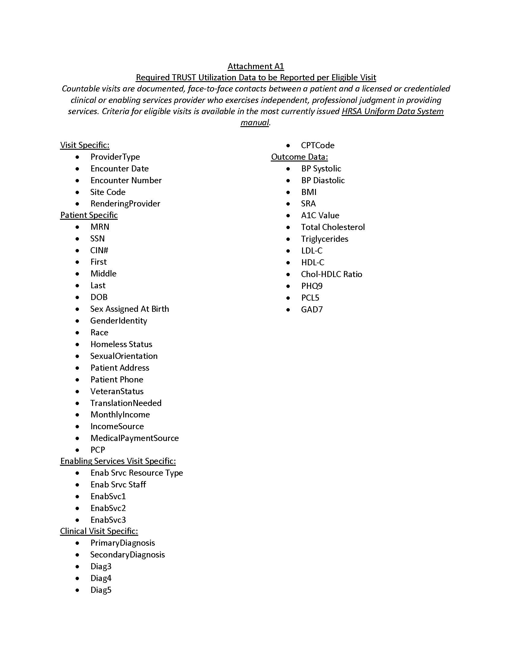

ATTACHMENT A2



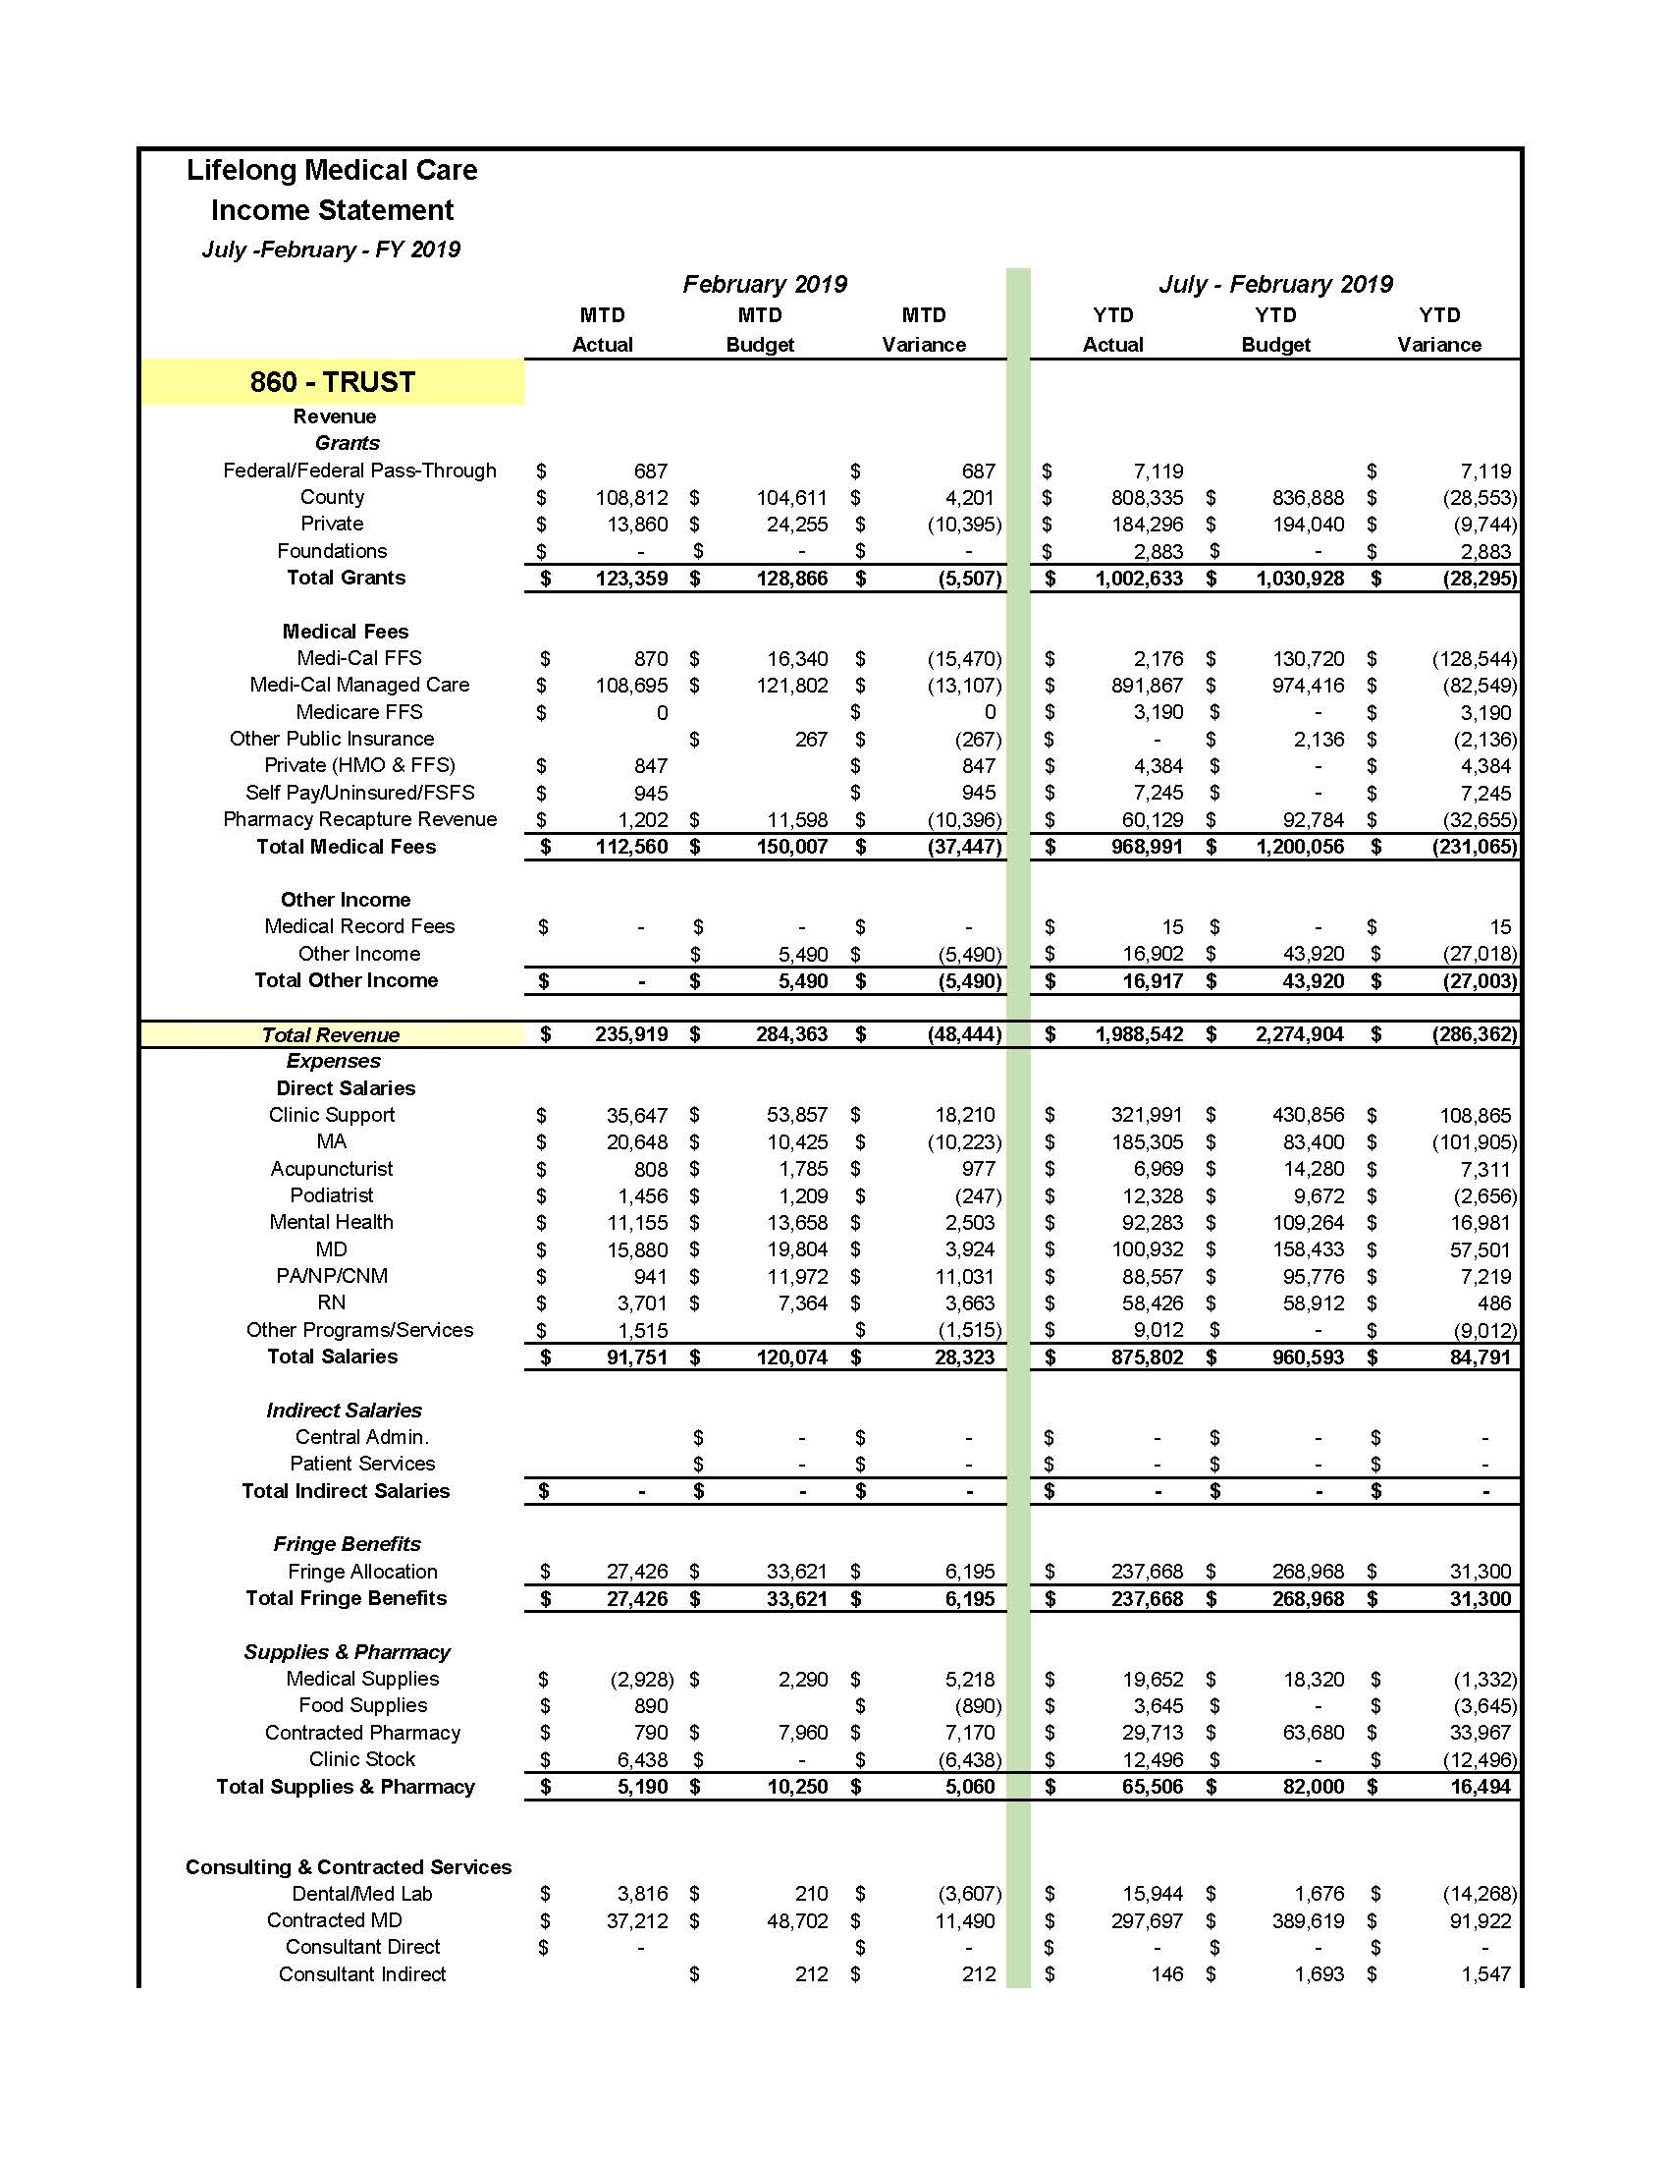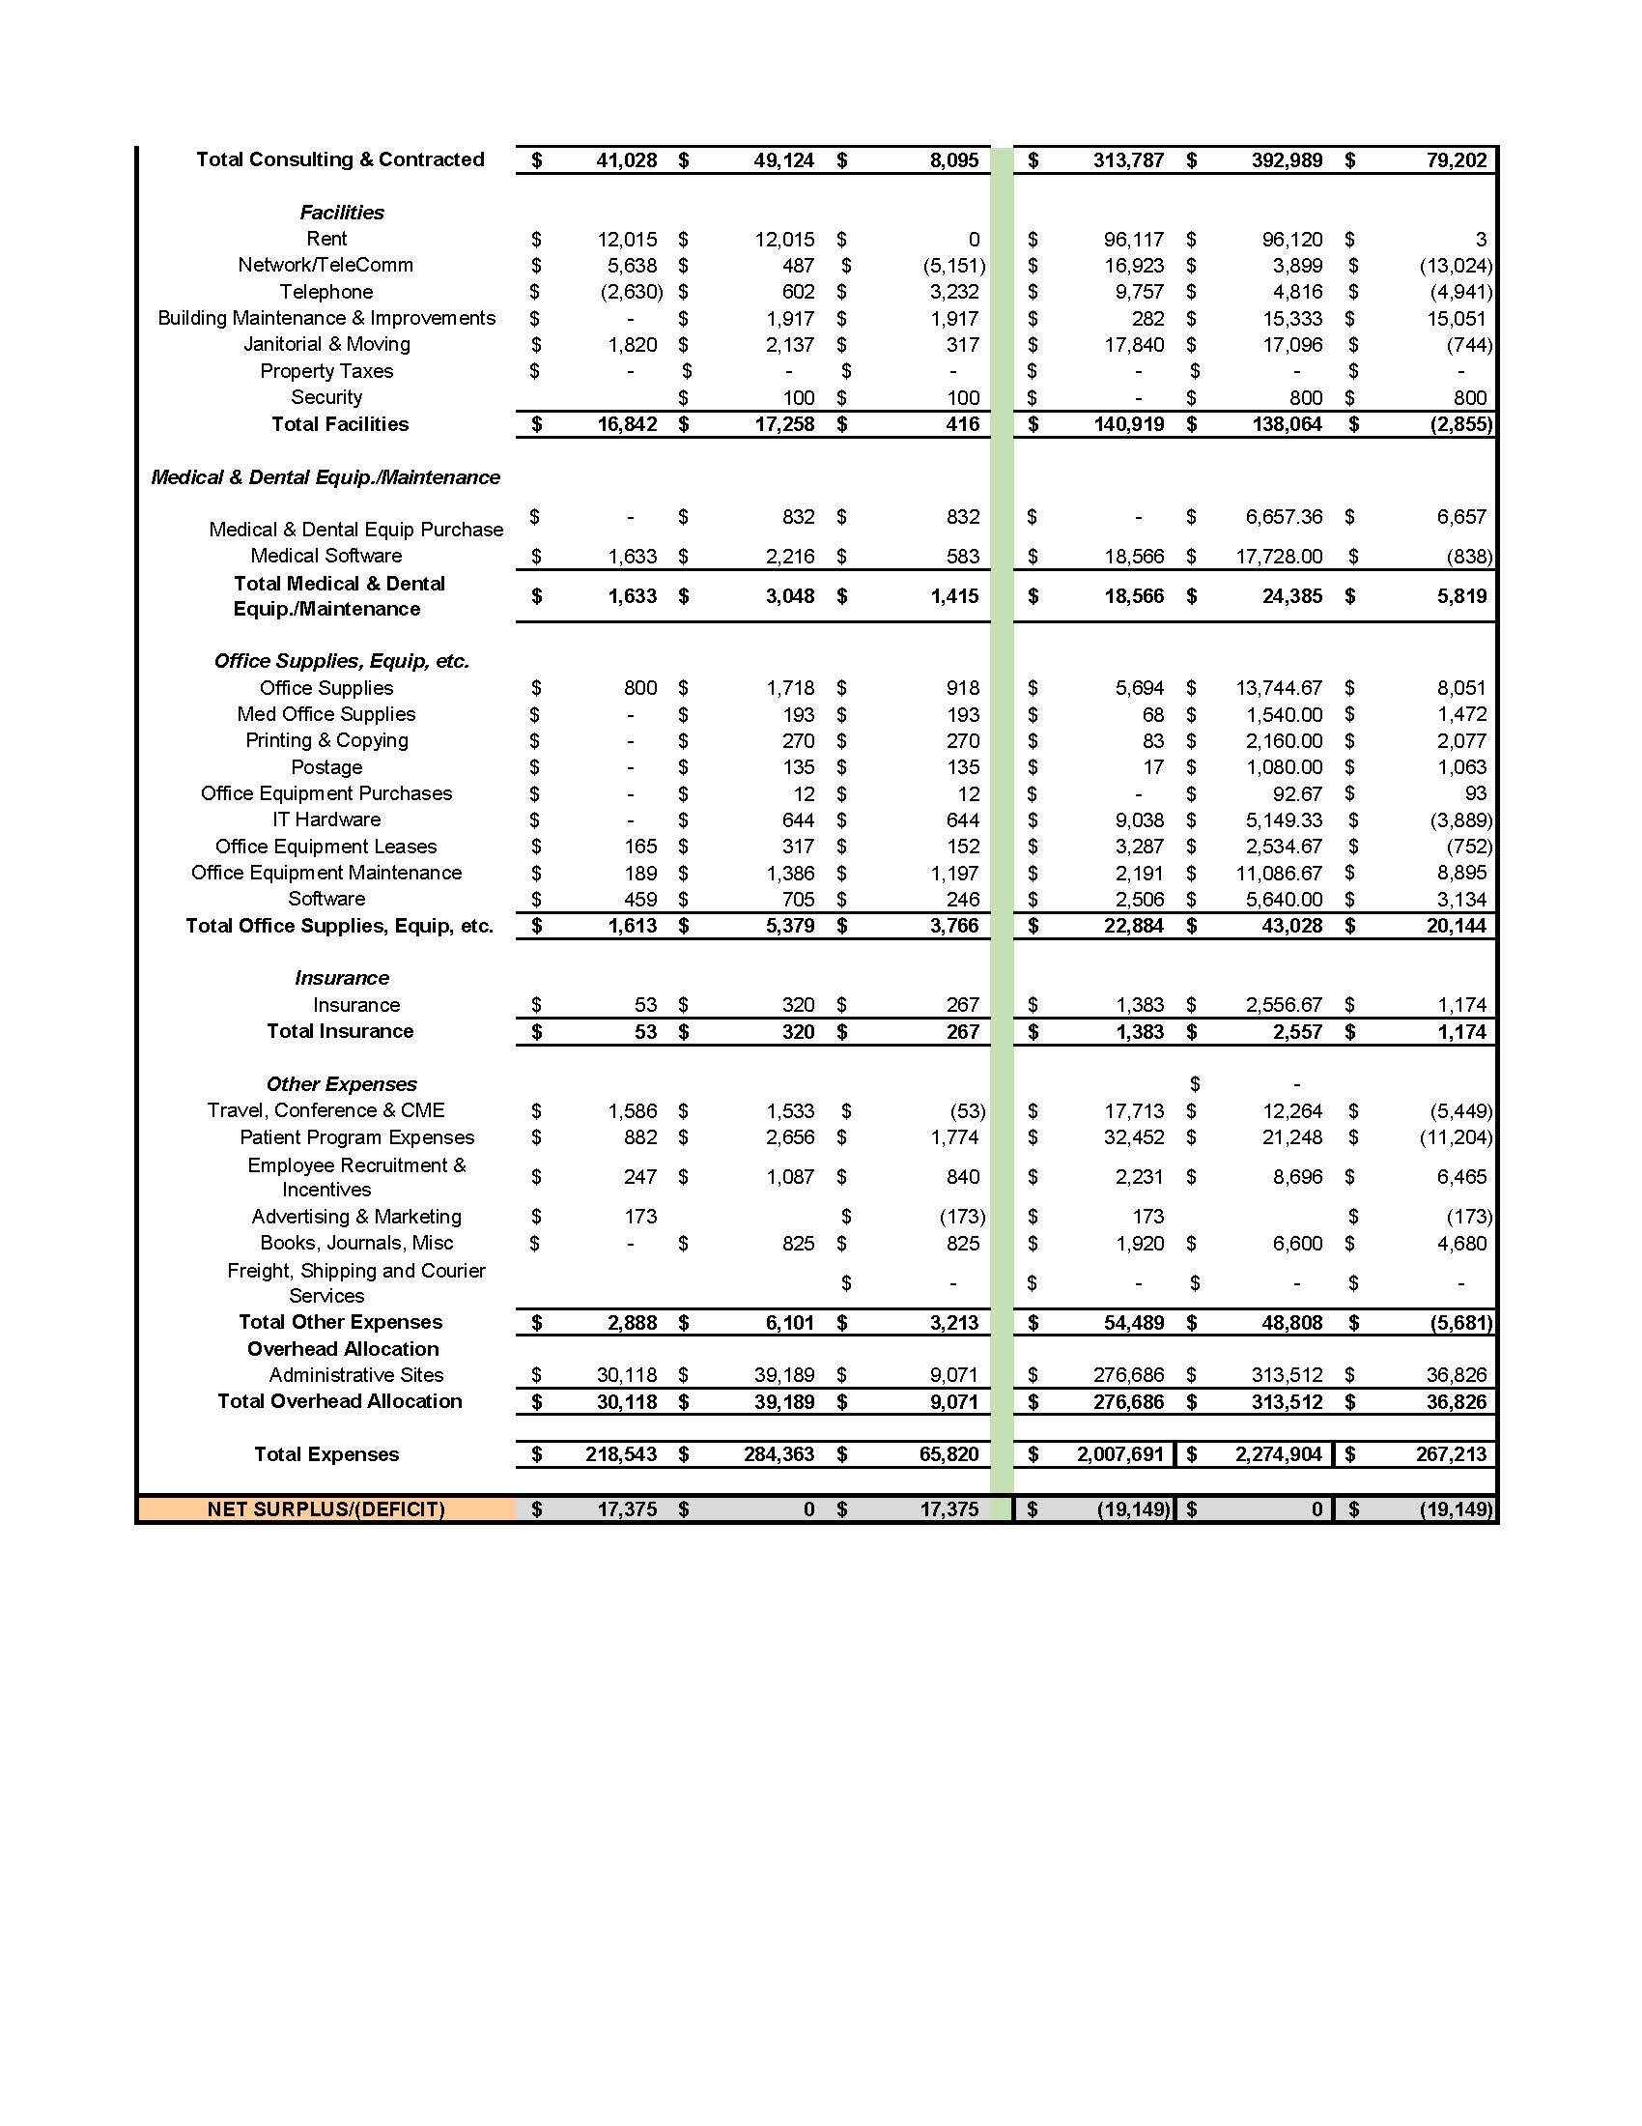

ATTACHMENT A3

ATTACHMENT A4

