FIRST AMENDMENT TO AGREEMENT

This First Amendment to Agreement (“First Amendment”) is made by the County of Alameda (“County”) and Payam Zarehbin dba Fruitvale Optometry, (“Contractor”) with respect to that certain agreement entered by them on May 22, 2018 (referred to herein as the “Contract”) pursuant to which Contractor provides optometry services to County.

For valuable consideration, the receipt and sufficiency of which are hereby acknowledged, County and Contractor agree to amend the Agreement in the following respects:

- Except as otherwise stated in this First Amendment, the terms and provisions of this Amendment will be effective as of the date this First Amendment is executed by the County.

- The term of the Agreement is currently scheduled to expire on June 30, 2019. As of the date this First Amendment is executed by the County, the term of the Agreement is extended through June 30, 2020. References to the contract period in Exhibit A and Exhibit B are updated accordingly.

- In consideration for Contractor’s additional services, the County shall pay Contractor in an additional amount not to exceed one hundred thousand dollars ($100,000). As a result of these additional services the not to exceed amount has increased from seventy thousand dollars ($70,000) to one hundred seventy thousand dollars ($170,000) over the term of the Agreement and any amendments.

- Item 20 of the Standard Services Agreement has been amended as follows:

The County has and reserves the right to suspend, terminate or abandon the execution of any work by the Contractor without cause at any time upon giving to the Contractor prior written notice. In the event that the County should abandon, terminate or suspend the Contractor’s work, the Contractor shall be entitled to payment for services provided hereunder prior to the effective date of said suspension, termination or abandonment. Said payment shall be computed in accordance with Exhibits B and B-1 hereto, provided that the maximum amount payable to Contractor for its optometry services for homeless persons shall not exceed one hundred thirty thousand U.S. dollars ($170,000) payment for services provided hereunder prior to the effective date of said suspension, termination or abandonment.

- The attached Exhibit A-1, Additional Services, is added to the original Scope of Services and is hereby incorporated into this Agreement by this reference.

- The attached Exhibit B-1 Additional Payment Terms, is added to the original Payment Terms and is hereby incorporated into this Agreement by this reference.

- The attached Exhibit C is incorporated into this Agreement by this reference.

- The attached Exhibit D is incorporated into this Agreement by this reference.

- DEBARMENT AND SUSPENSION CERTIFICATION:

- By signing this First Amendment and Exhibit D-1, Debarment and Suspension Certification, Contractor/Grantee agrees to comply with applicable federal suspension and debarment regulations, including but not limited to 7 Code of Federal Regulations (CFR) 246.3, 246.4, 246.6, 248.3, 248.22; 24 CFR 200.31, 1003.608; 28 CFR 83.630, 83.670, 29 CFR 95.13, 97.35, 1470.35; 34 CFR 84.630, 84.670, 206.4, 222.19, 225.3, 226.3, 270.6, 280.3, 303.3, 350.4; 45 CFR 75.205, 75.213, 630.630, 630.670, 1325.9, 1329.3, 1330.2, 1355.30, 1370.3, and Executive Orders 12549 and 12689.

- By signing this agreement, Contractor certifies to the best of its knowledge and belief, that it and its principals:

  - Are not presently debarred, suspended, proposed for debarment, declared ineligible, or voluntary excluded by any federal department or agency;

  - Shall not knowingly enter into any covered transaction with a person who is proposed for debarment under federal regulations, debarred, suspended, declared ineligible, or voluntarily excluded from participation in such transaction.

- Except as expressly modified by this First Amendment, all of the terms and conditions of the Contract are and remain in full force and effect.

IN WITNESS WHEREOF, the parties hereto have executed this First Amendment to the Agreement as of the day and year first above written.

COUNTY OF ALAMEDA |  | CONTRACTOR/COMPANY NAME
By:______________________________  Signature |  | By:_____________________________  Signature
Name:____________________________  (Printed) |  | Name:__________________________  (Printed)
Title: President of the Board of Supervisors |  | Title:___________________________
 |  | Date:___________________________
Approved as to Form:

By:________________________________  K. Joon Oh, Deputy County Counsel |  | By signing above, signatory warrants and represents that he/she executed this First Amendment in his/her authorized capacity and that by his/her signature on this First Amendment, he/she or the entity upon behalf of which he/she acted, executed this First Amendment

EXHIBIT A-1
Additional Scope of Services
Optometry Services for the Homeless

Contractor Name: Payam Zarehbin - Fruitvale Optometry
Contracting Department: Health Care Services Agency Health Care for the Homeless
Contract Period: 2/01/18– 6/30/20
Contract Amount: $170,000

- SERVICE DEFINITION AND BACKGROUND

  - BACKGROUND

Alameda County Health Care for the Homeless (ACHCH) intends to provide optometry services to homeless population in north Alameda County. Optometry Services include conducting routine eye exams, prescribing glasses/contacts, identifying related systemic conditions affecting the eye, and treating injuries and disorders of the visual system, according to the definitions by Health Resources and Services Administration (HRSA).

Fruitvale Optometry was selected by ACHCH through a RFQ process in January 2017 to provide optometry services to homeless patients referred by ACHCH at the Fruitvale Optometry Clinic located at 3301 E 12st Street, Oakland, CA 94601.

This Standard Services Agreement will provide funding for contractor to provide optometry services to homeless patients referred by ACHCH from the period of 02/1/18 - 6/30/20 in the amount not to exceed $170,000.

  - DEFINITIONS

- Optometry Visit – diagnostic, preventive and therapeutic services delivered in a face-to-face visit by an optometrist licensed by the CA Board of Optometry. To be included as a visit, services rendered must be documented in a chart or electronic health record maintained by the contractor. The visit will be documented and submitted to ACHCH in the monthly report. The primary diagnosis code (ICD-10, CPT) to indicate the type of service provided will be included for each visit.

- Optometry Services assess the health of the eyes and related structures. These services include conducting routine eye exams, prescribing glasses/contacts, identifying related systemic conditions affecting the eye, and treating injuries and disorders of the visual system (HRSA service definition).

- Health Center Patient is a patient referred by the ACHCH program and meets the Health and Human Services definition of homelessness stated above.

- PROGRAM NAME: Optometry Services for Alameda County Health Care for the Homeless Health Center Patients.

- TERMS/SCOPE OF SERVICE

Contractor shall complete following deliverables within the timeline.

DELIVERABLES | TIMELINE | MEASURABLE OUTCOME
- Contractor shall provide optometry services to ACHCH health center patients referred to Contractor by ACHCH staff | 7/1/18 to 6/30/20 | Monthly report to include  - Number of referrals received from ACHCH  - Number of ACHCH health center patients who have received services (routine eye exams, glasses/contact prescription, diagnostic and treatment services, in-depth testing, following visits, etc.)
- Contractor shall exert its best efforts to schedule referred clients for an appointment within one weeks of receiving referral. If a delay in scheduling an appointment occurs, Contractor shall inform ACHCH direct services staff of this delay in writing within 24 hours of receiving referral via phone. | 7/1/18 to 6/30/20 | Monthly Report to include:  - Number of ACHCH health center patients received same week visit schedule  - % of patients did not receive same week schedule
- For clients requiring services beyond an eye exam, Contractor shall accurately diagnose the condition to determine the need for additional services. Such additional services include in depth testing and/or follow-up visits. | 7/1/18 to 6/30/20 | Monthly Report to include:  - Number of requests for in-depth testing and following visits
- For clients requiring additional lens (e.g. contact lenses) options or frames outside of the single vision, bifocal or safety vision glasses, Contractor shall accurately provide itemized cost when invoicing. | 7/1/18 to 6/30/20 | Monthly Report to include:  - Number of cost proposals submitted to ACHCH for additional lens/contact lenses
- Contractor will only be reimbursed for optometry visits for uninsured ACHCH health center persons, or for visits/services which are not reimbursable by payers including Alameda County HealthPAC, Medi-Cal, Medicare or private insurers. | 7/1/19 to 6/30/20 | Monthly Report to include:  - In all visits to the Fruitvale Optometry, % of County reimbursable visits/services.
- Contractor will participate in Health Care for the Homeless Quality Improvement program, which includes: monitor and improve patient experience though regular patient surveys and other means, involve all program staff in quality improvement activities and have a representative present during ACHCH Quality Committee. | 7/1/19 to 6/30/20 | Monthly Report to  Include:  ACHCHP Patient Satisfaction Survey

- SPECIAL REQUIREMENTS
Contractors are expected to comply with the following special requirements:
- Quality of Care
The organization delivers health services that demonstrate a high quality of care as defined by prevailing professional standards, the contracting agency, Alameda County Health Care Services Agency and by consumers of these services. These services are provided in a manner consistent with principles of professional practice and ethical conduct and reflect concern for the acceptability, accessibility, availability, and cost of services.
- Quality Assurance
The organization demonstrates a consistent endeavor to deliver patient care that is effective within available resources and consistent with achievable goals. A major component in the application of this principle is the operation of a quality assurance program.
- Medical Records
The organization maintains a medical/optometric record system that permits prompt retrieval of information. Medical records are legible, documented accurately in a timely manner, and readily accessible to health care practitioners.
- Concern for Cost of Care
Concern for cost of care is demonstrated through regular assessment of relevance of health care, absence of duplicative diagnostic procedures, appropriateness of treatment frequency, and the use of ancillary services.
- Practice of Professional Staff
Professional staff practice their profession in an ethical and legal manner.
- Reporting of Communicable Diseases
Timely reporting of communicable diseases, occupational illness or injury, child abuse, and pesticide-related illnesses shall be performed in conformance with existing State and County reporting requirements.
- Availability of Translator Services
If 10% of the patient population is monolingual in a same language other than English, translator services in that language will be available.

- DATA REPORTING
Contractor shall ensure regular data capture and report generation, integrity assurance and delivery timelines in relation to services it provides on behalf of Alameda County Health Care for the Homeless.
- Data Capture: Contractor shall capture data on homeless status of Clinic patients referred by ACHCH direct services staff, in accordance with the federal definition of homelessness via registration and eligibility criteria. Contractor shall exert its best efforts to capture and report data elements, including but not limited to, elements unique to the most current U.S. Dept. of Health and Human Services (DHHS), Health Resources and Services Administration (HRSA), Bureau of Primary Health Care (BPHC) Uniform Data System (UDS) annual reporting required of the Homeless Project:
  - Patient Demographics: race, ethnicity, age, sex, gender identity and sexual orientation, family status, language, poverty level, insurance status, housing status;
  - Staffing FTEs by position and encounters;
  - Primary diagnoses for medical visits and specialty provided;
  - Direct and Indirect expenses for homeless patient encounters and services (UDS Table 8A); and,
  - Charges, collections and allowances on homeless patient encounters and services (UDS Table 9D).
- Data Reporting: Contractor agrees to submit monthly patient utilization data (template provided by ACHCH) for services provided to each homeless client served pursuant to the terms of this Agreement and will submit this data in a Microsoft Excel spreadsheet with each corresponding monthly reimbursement request for the homeless optometry services provided. Monthly reports are due on the 15th day following the end of each month for the prior month. Contractor may also be required to generate reports for ACHCH which shall include, but is not limited to, elements unique to the most current HRSA/BPHC Uniform Data System (UDS) annual reporting required of Health Care for the Homeless.
- Monitoring of Data Collection: Contractor shall monitor the integrity of all stages of data collection pursuant to this Agreement including, but not limited to, front end performance, homeless patient billing information, and regular training of Clinic staff on federal criteria for homelessness and proper completion of intake or other required data forms.

EXHIBIT B-1
Alameda County Health Care for the Homeless (ACHCH)
FRUITVALE OPTOMETRY
ADDITIONAL TERMS AND CONDITIONS FOR PAYMENT

A. Budget (July 1, 2018 – June 30, 2020)

SERVICE DESCRIPTION | Rate | Maximum Reimbursement
For patients referred by ACHCH
A. Reimbursement for optometry services as defined in Exhibit A, Scope of Services:  1. Eye exams | Range from $42.71 to $76.11 based on patient's condition | $ 20,000
2. Additional optometry services. | case-by-case basis, requiring pre-approval by ACHCH
B. Reimbursement for glasses |  | $ 80,000
1. Single vision | $ 99
2. Bifocal Glasses | $ 159
3. Safety Glasses/Glasses for Children
3a. Single Vision | $ 149
3b. Bifocal | $ 209
4. Additional optometry services not included above | case-by-case basis, requiring pre-approval by ACHCH
Not to Exceed Total Amount |  | $ 100,000
Budget modification must be approved by ACHCH

COMPENSATION TO CONTRACTOR:
1. Compensation under the terms and conditions of this Agreement shall not exceed the amount of $170,000.00 for the duration of this Agreement, unless otherwise amended.
2. The term of this Agreement shall commence February 01, 2018 and end June 30, 2020.

B. RATE OF COMPENSATION:
1. Reimbursement for optometry services as defined in Exhibit A, Scope of Services:
- Contractor shall request a minimum of $42.71 and a maximum of $76.11 for eye exams. Eye exam fees shall be calculated by the Contractor depending on the complexity of the exam; patients with no medical eye conditions beyond the need for glasses will be billed at a lower rate, while patients with medical eye conditions requiring more time to accurately diagnose will be billed at a higher rate.
- Contractor shall request written authorization including an itemized cost proposal from ACHCH for clients requiring additional optometry services. ACHCH shall grant authorization on a case-by-case basis.

2. Reimbursement for glasses:
- ACHCH shall reimburse Contractor for glasses (including frame and lens) at the following rates:
- Single vision glasses: $99.00
- Bifocal glasses: $159.00
- Safety glasses/glasses for children (includes shatter proof polycarbonate lenses):
  - Single vision: $149.00
  - Bifocal: $209.00
- Contractor shall request written authorization from ACHCH for clients requiring glasses or optometry services other than those listed within Exhibit B Section B above. ACHCH shall grant authorization on a case-by-case basis.

C. BUDGETARY REQUIREMENTS:
- Contractor shall establish a separate account for all financial transactions involving Health Care for the Homeless funds.
- Contractor shall maintain a project ledger to adequately identify all expenditures related to Health Care for the Homeless. All journals and ledgers should be kept current. Posting should occur at least on a monthly basis.

D. BILLING REQUIREMENTS:
- Contractor shall submit a properly completed payment invoice to Health Care for the Homeless on a monthly basis for operational and program-related expenditures incurred by Contractor while providing and/or arranging for the provision of services pursuant to this Agreement. Contractor or designee certifying the delivery of services shall sign invoices and the accuracy of the information provided in these documents. Each invoice shall include PO number, invoice number, service period, as well as the name, telephone number of a designated contact person for follow-up purposes.

Invoices shall be submitted to:
Alameda County Health Care for the Homeless
Attn: Contracts Manager
1404 Franklin Street, Suite 200
Oakland, CA 94612

- County, or its designated agent, agrees to process and pay monthly invoices submitted by Contractor within thirty (30) days from receipt of properly completed invoice for services and expenditures covered under this Agreement.

- The County and/or Auditor-Controller may withhold payment of all or a portion of Contractor's claim for reimbursement of expenses when the Contractor has not complied with provisions of the current or a prior Agreement. Such matters of non-compliance may include, but are not restricted to, the delivery of patient and related services, submission of homeless client service data and requested reports, submission of reimbursement request supporting documents which verify expenditures incurred, maintenance of proper records, submission of homeless client revenue reports, disallowance as a result of interim audit or financial compliance evaluations, or other conditions as required in this Agreement by Federal, State or County regulations.

If payment of claims is to be delayed, the following procedures will be followed:

- Contractor shall be notified by telephone within seven (7) working days of the receipt by County of Contractor's claim if there is a reason for delaying or withholding payment.

- The County shall provide written confirmation of reason(s) for delaying or withholding payment if the matter cannot be resolved within ten (10) working days of receipt of claim.

- The County shall not be required to give written notice of the withholding action if an invoice must be held pending revisions, corrections or amendments. It is the Contractor's responsibility to correct invoice documents. In all cases, the Contractor shall be notified of the errors and corrective action needed. The withholding action shall be discussed with the Contractor at the time errors are brought to the Contractor's attention. The County may, with Contractor's consent, make minor adjustments on invoices to correct mathematical/typographical errors to expedite the claims process.

- Contractor shall submit all claims for reimbursement under this Agreement within sixty (60) days following the expiration of this Agreement. All claims submitted after sixty (60) days following the expiration date of this Agreement will not be subject to reimbursement by the County. Any "obligations incurred" which are included in the claims for reimbursement and paid by the County, but which remain unpaid by the Contractor after sixty (60) days following the expiration date of the Agreement will be disallowed under audit by the County.

E. SUB-CONTRACTOR REQUIREMENTS:
- If a portion of the services under this Agreement are to be performed by a third-party, Contractor must submit a formalized agreement to Health Care for the Homeless Administration for approval prior to the execution of the contract and the provision of services by the sub-contractor. Failure to initiate request and receive written prior approval of sub-contractor may result in the disallowance of payments to the third-party.
- Contractor shall ensure that all sub-contracts, scopes of services, line item budgets and budget narratives are submitted in the format as set forth by County and Federal mandates. The decision to approve or disapprove any sub-contracts will be based on the information contained in the contract documents. Therefore the contracts must, as applicable, describe the activities or functions involved, a time schedule, a justification for the performance by a third-party, rate of compensation, a breakdown of and justification for the estimated costs, including the manner in which indirect costs, if any, will be reimbursed, the grant policies and requirements that are applicable to sub-contractor, other policies and procedures to be followed, the maximum amount of money for which Contractor may become liable under the agreement, and the cost principles to be used in determining allowable costs in the case of cost-type contracts.
- Contractor shall reimburse subcontractors or personal consultants only for those services actually provided or for those activities actually performed. There shall be no advance payments to subcontractors or personal consultants.

F. FINANCIAL CONTROLS, RECORDS, AUDIT, AND REPORTING REQUIREMENTS:

Contractor shall bear financial responsibility for the provision of services rendered by the Clinic(s) to the homeless population referred by Alameda County Health Care for the Homeless. Contractor shall be responsible for the operations of, and provision of services through, the Clinic(s).
- Financial Controls: Contractor has established and will administer the overall charge structure and systems for eligibility determination, billing, and collection for the Clinic(s), all in accordance with applicable Federal and State laws and regulations and its own internal policies. Contractor shall issue bills and collect and retain payment for services and materials furnished by or through the Clinic(s); Health Care for the Homeless Administration shall bear no responsibility for Clinic billing or collections.
- Financial Records: Contractor has sole authority over accounting and systems for the development, preparation and safekeeping of records and books of account relating to the business and affairs of the Clinic(s), including the preparation and submission of any cost reports, supporting data and other materials in connection with reimbursement under Medicaid and other third-party payment contracts and programs, in which the Clinic(s) may from time to time participate.
- Audit: Contractor will participate in an annual fiscal audit to be pre-scheduled and conducted by Health Care for the Homeless Administration. The fiscal audit will include a financial review of one quarter reimbursement request, specifically: verification of all related financial support documentation utilized in the development of the specific reimbursement request; and, examination of Contractor financial recordkeeping systems and procedures relative to the development of the reimbursement request and receipt of payment. Upon completion of the annual fiscal audit Health Care for the Homeless Administration will provide Contractor a findings report with applicable corrective measures, as necessary. Timelines for executing applicable corrective measures to be negotiated between Contractor and Health Care for the Homeless Administration

- Financial Reporting: Contractor is required to provide Health Care for the Homeless Administration annual financial information related to homeless patient-related revenue as required in, but not limited to, the most current Uniform Data System (UDS) annual report and as mandated by the U.S. Health Resources and Services Administration (HRSA), Bureau of Primary Health Care (BPHC). Health Care for the Homeless Administration will send written request for necessary financial information and provide timelines, updates regarding financial information requirements, reporting tools and/or formatted tables, and specific instruction.

G. PATIENT MEDICAL DATA RECORDS AND AUDIT REQUIREMENTS:

Contractor shall provide homeless patients with optometry services set forth in Exhibit A during the term of this Agreement, complying with all applicable licensure and regulatory standards, insuring that its providers provide documented services in accordance with all applicable patient rights, confidentiality and grievance procedures.

  - Medical Records: Contractor is solely responsible for maintenance and safekeeping of patient medical records, documenting medical and case management services provided to patients.
  - Audit: Contractor will participate in an annual audit to be pre-scheduled and conducted by Health Care for the Homeless Administration. The patient medical record audit will include review of selected patient medical and case management records. Upon completion of the audit Health Care for the Homeless Administration will provide Contractor a findings report with applicable corrective measures, as necessary. Timelines for executing applicable corrective measures shall be established by Health Care for the Homeless Administration.

H. LOCAL AND NATIONAL EVALUATION PARTICIPATION:
Contractor shall participate in any activities required for the Health Care for the Homeless local and national evaluation component. This includes but is not limited to the collection of data, attendance at meetings and participation in site visits.

- OTHER PROVISIONS:

- The continuation of this Contract and payments hereunder shall be subject to the availability of Federal funds to Alameda County Health Care for the Homeless from the Department of Health and Human Services. Alameda County Health Care for the Homeless agrees to notify the Contractor in writing of any grant modifications, payment delays, or cancellations of the Department of Health and Human Services grant.
- This Contract may be suspended by Alameda County Health Care for the Homeless if funds are not made available for this Contract under the Department of Health and Human Services grant, or if the Department of Health and Human Services suspends or reduces the grant for any reason. Alameda County Health Care for the Homeless agrees to notify the Contractor in writing of any action.
- This Contract may be terminated by Alameda County Health Care for the Homeless if the Department of Health and Human Services terminates or reduces funding. Alameda County Health Care for the Homeless agrees to notify the Contractor in writing of any action.

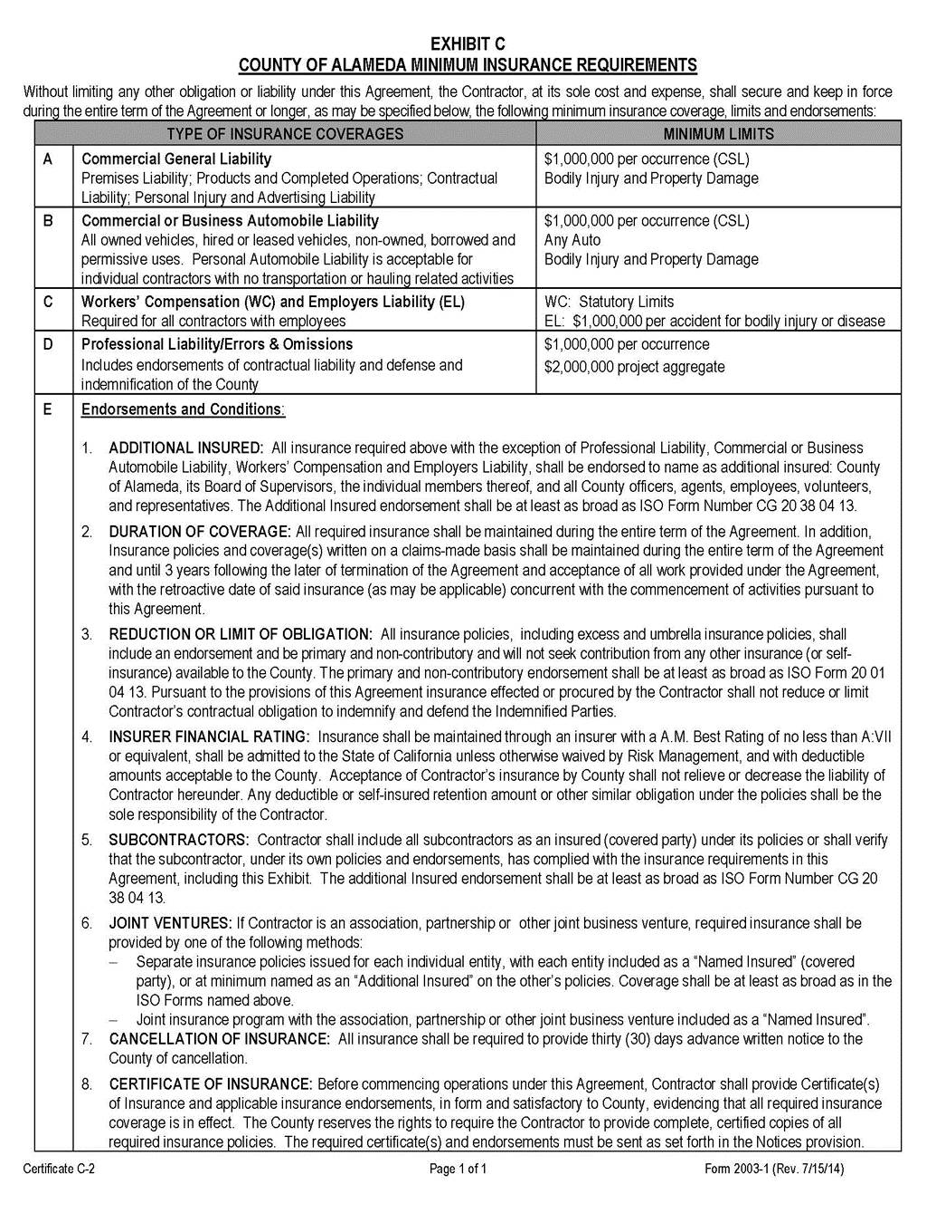

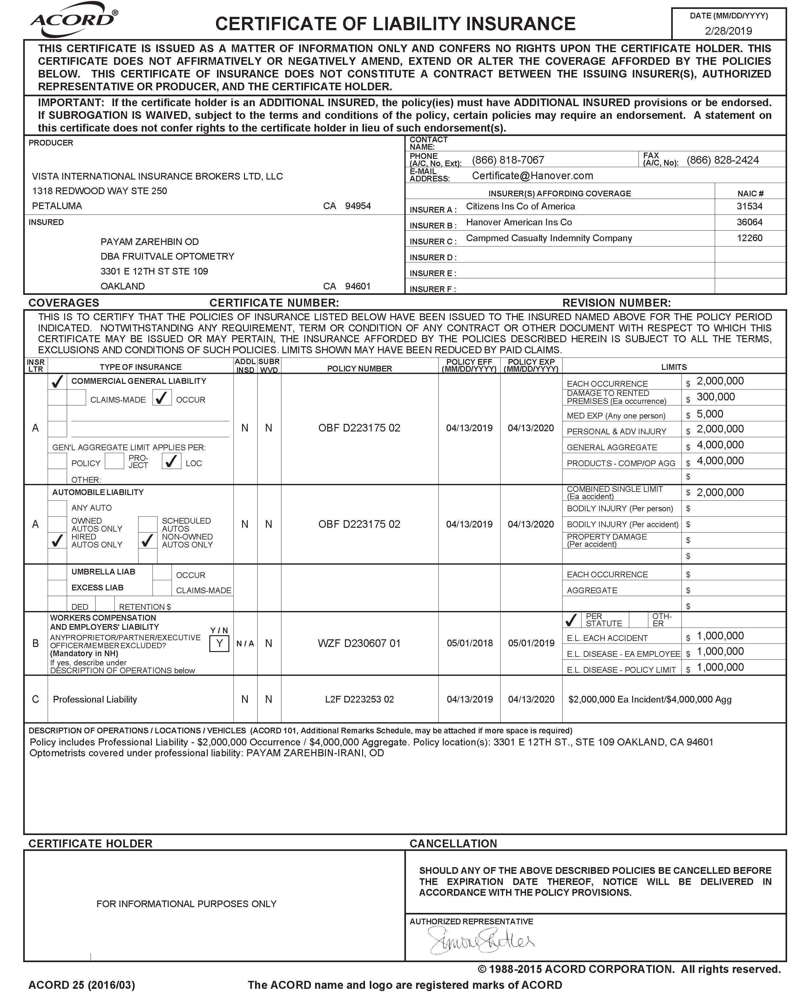

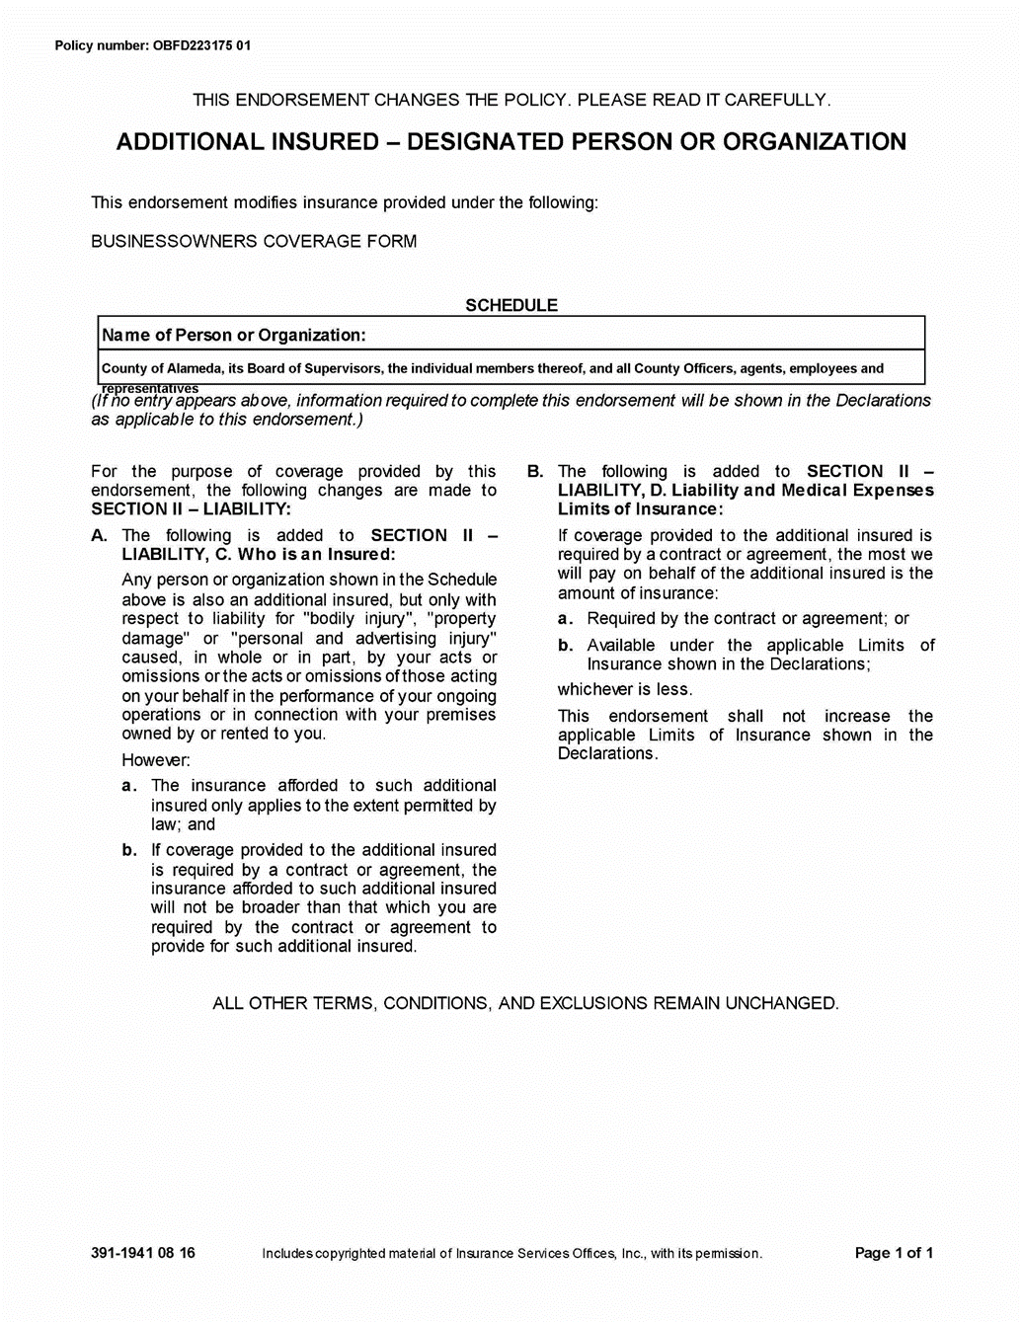

EXHIBIT D-1
COUNTY OF ALAMEDA
DEBARMENT AND SUSPENSION CERTIFICATION
(Applicable to all agreements funded in part or whole with federal funds and contracts over $25,000).

The contractor, under penalty of perjury, certifies that, except as noted below, contractor, its principals, and any named and unnamed subcontractor:

- Is not currently under suspension, debarment, voluntary exclusion, or determination of ineligibility by any federal agency;
- Has not been suspended, debarred, voluntarily excluded or determined ineligible by any federal agency within the past three years;
- Does not have a proposed debarment pending; and
- Has not been indicted, convicted, or had a civil judgment rendered against it by a court of competent jurisdiction in any matter involving fraud or official misconduct within the past three years.

If there are any exceptions to this certification, insert the exceptions in the following space.

Exceptions will not necessarily result in denial of award, but will be considered in determining contractor responsibility. For any exception noted above, indicate below to whom it applies, initiating agency, and dates of action.

Notes: Providing false information may result in criminal prosecution or administrative sanctions. The above certification is part of the Standard Services Agreement. Signing this Standard Services Agreement on the signature portion thereof shall also constitute signature of this Certification.

CONTRACTOR: Payam Zarehbin – Fruitvale Optometry

PRINCIPAL: Genesta Zarehbin TITLE: Practice Manager

SIGNATURE: ______________________________ DATE: ________________________

QUESTIONNAIRE FOR DETERMINING THE WITHHOLDING STATUS

INSTRUCTIONS: This questionnaire is to be completed by the County department for services contracts and must be included as part of the contract package. Be sure to answer all of the questions in Sections I and II and to complete the certifications on page 2. Sections III and IV contain supplemental questions to be answered for contractors in certain service categories.

CONTRACTOR NAME: Fruitvale Optometry DEPT #:

TITLE/SERVICE: Optometry services

DEPT. CONTACT: Terri Moore PHONE: 510-891-8927

- INFORMATION ABOUT THE CONTRACTOR | YES | NO
- Is the contractor a corporation or partnership? | ( ) | (X)
- Does the contractor have the right per the contract to hire others to do the work agreed to in the contract? | ( ) | (X)

- If the answer to BOTH questions is YES, provide the employer ID number here:
No other questions need to be answered. Withholding is not required.

- If the answer to question 1 is NO and 2 is YES, provide the individual social security number here:
No other questions need to be answered. Withholding is not required.

- If the answer to question 2 is NO, continue to Section II.

- RELATIONSHIP OF THE PARTIES | YES |  | NO
- Does the County have the right to control the way in which the work will be done, i.e., will the County be able to specify the sequence of steps or the processes to be followed if it chooses to do so? | ( ) |  | (X)
- Is the contractor restricted from performing similar services for other businesses while he is working for the County? | ( ) |  | (X)
- Will the contractor be working for more than 50% of the time for the County (50% = 20 hrs/wk; 80 hrs/mo)? | ( ) |  | (X)
- Is the relationship between the County and the contractor intended to be ongoing? | ( ) |  | (X)
- FOR CONSULTANTS, PROJECT MANAGERS, PROJECT COORDINATORS |  | YES |  | NO
- Is the contractor being hired for a period of time rather than for a specific project? |  | ( ) |  | (X)
- Will payment be based on a wage or salary (as opposed to a commission or lump sum)? |  | ( ) |  | (X)

- FOR PHYSICIANS, PSYCHIATRISTS, DENTISTS, PSYCHOLOGISTS | YES | NO
- Will the agreement be with an individual who does not have an outside practice? | ( ) | ( )
- Will the contractor work more than an average of ten hours per week?  IF THE ANSWER TO QUESTION 2 IS YES, ANSWER QUESTION 3. | ( ) | ( )
- Will the County provide more than 20% of the contractor’s income? | ( ) | ( )
- If the answer to either question 2, or if required, question 3 is NO, the entire answer is NO.

A “YES” answer to any of the questions in Section II, or, if applicable, Sections III or IV constitutes justification for paying the contractor through the payroll system as an “employee for withholding purposes.”

CERTIFICATIONS:

I hereby certify that the answers to the above questions accurately reflect the anticipated working relationship for this contract.

Contractor Signature |  | Agency/Department Head/Designee Signature
Genesta Zarehbin |  | Colleen Chawla
Printed Name |  | Printed Name
Date |  | Date

