The COVID-19 VACCINE is coming!
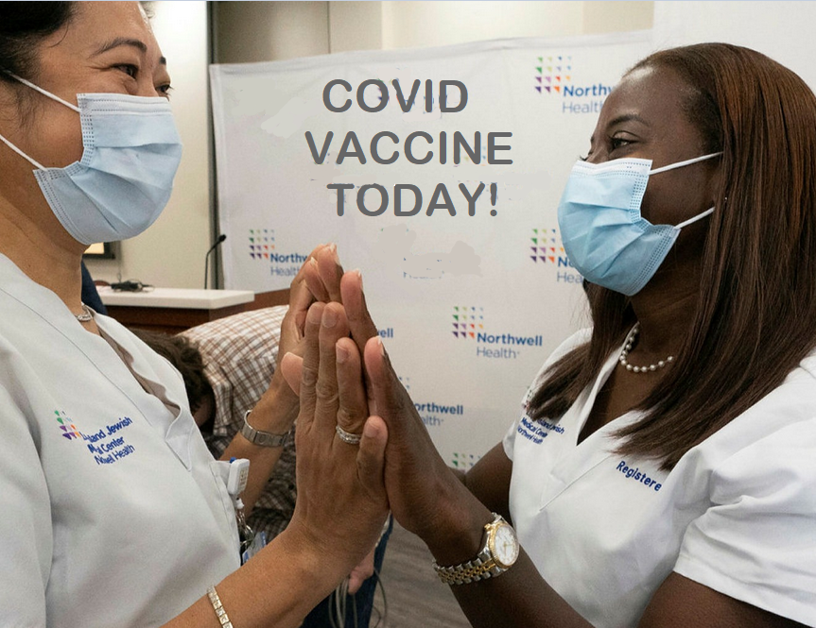
Protect yourself.
Protect your loved ones.
Protect your community.
Help end the pandemic.

1st dose
Date:
Time:
Location:

2nd dose
Date:
Time:
Location:

Ask the shelter staff for more details or if you have questions.

